CS231A
Computer Vision: From 3D Reconstruction to Recognition

Luke Jaffe

Problem Set 3
Due 02/28/2018

1 Space Carving

a) The first step in space carving is to generate the initial voxel grid that we will carve into.
Complete the function form initial voxels(). Submit an image of the generated voxel
grid and a copy of your code.

def form_initial_voxels(xlim, ylim, zlim, num_voxels):
'''
FORM_INITIAL_VOXELS create a basic grid of voxels ready for carving

Arguments:
xlim - The limits of the x dimension given as [xmin xmax]

ylim - The limits of the y dimension given as [ymin ymax]

zlim - The limits of the z dimension given as [zmin zmax]

num_voxels - The approximate number of voxels we desire in our grid

Returns:
voxels - An ndarray of size (N, 3) where N is approximately equal the
num_voxels of voxel locations.

voxel_size - The distance between the locations of adjacent voxels
(a voxel is a cube)

Our initial voxels will create a rectangular prism defined by the x,y,z
limits. Each voxel will be a cube, so you'll have to compute the
approximate side-length (voxel_size) of these cubes, as well as how many
cubes you need to place in each dimension to get around the desired
number of voxel. This can be accomplished by first finding the total volume of
the voxel grid and dividing by the number of desired voxels. This will give an
approximate volume for each cubic voxel, which you can then use to find the
side-length. The final "voxels" output should be a ndarray where every row is
the location of a voxel in 3D space.
'''
# Get length of each side of space
xsize, ysize, zsize = diff(xlim), diff(ylim), diff(zlim)
# Compute total volume
total_volume = xsize*ysize*zsize
# Divid total volume by number of voxels to get volume per voxel
voxel_volume = total_volume / num_voxels
# SIde length of a voxel is cube root of volume
voxel_size = np.cbrt(voxel_volume)
# Compute position of each voxel
voxels = np.mgrid[
xlim[0]:xlim[1]:voxel_size,
ylim[0]:ylim[1]:voxel_size,
zlim[0]:zlim[1]:voxel_size].reshape(3, -1).T

return voxels, voxel_size

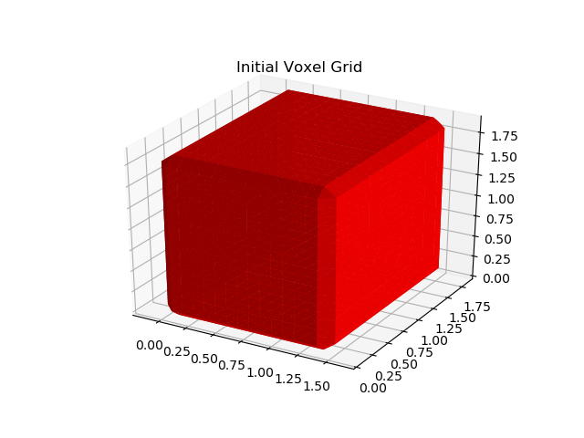

b) Now, the key step is to implement the carving for one camera. To carve, we need the camera frame and the silhouette associated with that camera. Then, we carve the silhouette from our voxel grid. Implement this carving process in carve(). Submit your code and a picture of what it looks like after one iteration of the carving.

def carve(voxels, camera):
'''
CARVE: carves away voxels that are not inside the silhouette contained in
the view of the camera. The resulting voxel array is returned.

Arguments:
voxels - an Nx3 matrix where each row is the location of a cubic voxel

camera - The camera we are using to carve the voxels with. Useful data
stored in here are the "silhouette" matrix, "image", and the
projection matrix "P".

Returns:
voxels - a subset of the argument passed that are inside the silhouette
'''
# Convert voxels to homogeneous coordinates
hvoxels = np.concatenate([voxels, np.ones((voxels.shape[0], 1))], axis=1)
# Project the voxels into pixels in the image
hpixels = np.dot(camera.P, hvoxels.T)
# Convert pixels from homogeneous to euclidean
pixels = (hpixels[:2, :]/hpixels[2, :]).T
# Get silhouette dimensions
Y, X = camera.silhouette.shape
# Round projected pixel positions to ints
pixels = np.round(pixels).astype(int)
# First, get indeces of pixels inside the bounds of the silhouette
boundedx = np.logical_and(pixels[:, 0] > 0, pixels[:, 0] < X)
boundedy = np.logical_and(pixels[:, 1] > 0, pixels[:, 1] < Y)
bounded = np.logical_and(boundedx, boundedy)
bounded_pixels = pixels[bounded]
xidx = bounded_pixels[:, 0]
yidx = bounded_pixels[:, 1]
# Then, check indeces of these pixels which fall under the silhouette
sil_idx = camera.silhouette[yidx, xidx].astype(bool)
# Index voxels first by bounded indeces, then by silhouette indeces
return voxels[bounded][sil_idx]

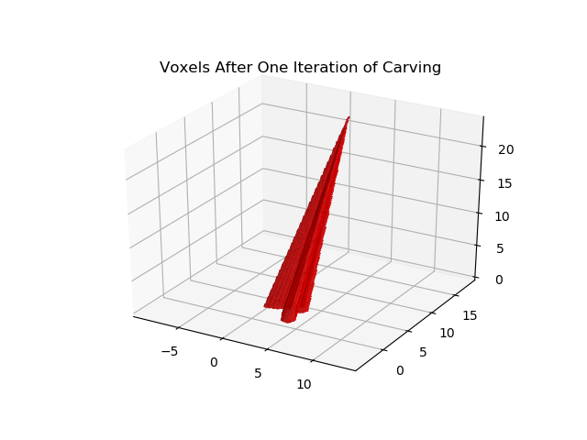

c) The last step in the pipeline is to carve out multiple views. Submit the final output after all carvings have been completed, using num voxels ≈ 6, 000, 000.

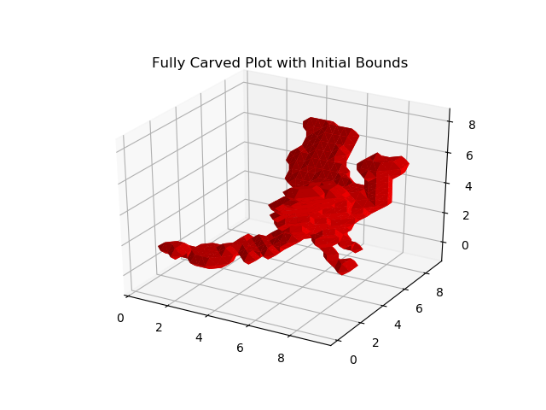

d) Complete the method get voxel bounds() and change the variable estimate better bounds in the main() function to True. Submit your new carving, which is hopefully more detailed, and your code.

def get_voxel_bounds(cameras, estimate_better_bounds = False, num_voxels = 4000):
'''
GET_VOXEL_BOUNDS: Gives a nice bounding box in which the object will be carved
from. We feed these x/y/z limits into the construction of the inital voxel
cuboid.

Arguments:
cameras - The given data, which stores all the information
associated with each camera (P, image, silhouettes, etc.)

estimate_better_bounds - a flag that simply tells us whether to set tighter
bounds. We can carve based on the silhouette we use.

num_voxels - If estimating a better bound, the number of voxels needed for
a quick carving.

Returns:
xlim - The limits of the x dimension given as [xmin xmax]

ylim - The limits of the y dimension given as [ymin ymax]

zlim - The limits of the z dimension given as [zmin zmax]

The current method is to simply use the camera locations as the bounds. In the
section underneath the TODO, please implement a method to find tigther bounds:
One such approach would be to do a quick carving of the object on a grid with
very few voxels. From this coarse carving, we can determine tighter bounds. Of
course, these bounds may be too strict, so we should have a buffer of one
voxel_size around the carved object.
'''
camera_positions = np.vstack([c.T for c in cameras])
xlim = [camera_positions[:,0].min(), camera_positions[:,0].max()]
ylim = [camera_positions[:,1].min(), camera_positions[:,1].max()]
zlim = [camera_positions[:,2].min(), camera_positions[:,2].max()]

# For the zlim we need to see where each camera is looking.
camera_range = 0.6 * np.sqrt(diff( xlim )**2 + diff( ylim )**2)
for c in cameras:
viewpoint = c.T - camera_range * c.get_camera_direction()
zlim[0] = min( zlim[0], viewpoint[2] )
zlim[1] = max( zlim[1], viewpoint[2] )

# Move the limits in a bit since the object must be inside the circle
xlim = xlim + diff(xlim) / 4 * np.array([1, -1])
ylim = ylim + diff(ylim) / 4 * np.array([1, -1])

# Get better bounds by carving a small chunk of voxels
if estimate_better_bounds:
# Get initial bounds with few voxels
voxels, voxel_size = form_initial_voxels(xlim, ylim, zlim, num_voxels)
# Carve the voxel block
for c in cameras:
voxels = carve(voxels, c)
# Get the min and max positions in each dimension for the carved block
xmin, ymin, zmin = voxels.min(axis=0)
xmax, ymax, zmax = voxels.max(axis=0)
xlim = np.array([xmin, xmax])
ylim = np.array([ymin, ymax])
zlim = np.array([zmin, zmax])
# Make the minimum difference between min and max bounds
# equal to a factor of the voxel size, 3 works well
# for this example
f = 3
if diff(xlim) < f*voxel_size:
xlim[0] -= f*voxel_size/2
xlim[1] += f*voxel_size/2
if diff(ylim) < f*voxel_size:
ylim[0] -= f*voxel_size/2
ylim[1] += f*voxel_size/2
if diff(zlim) < f*voxel_size:
zlim[0] -= f*voxel_size/2
zlim[1] += f*voxel_size/2

return xlim, ylim, zlim

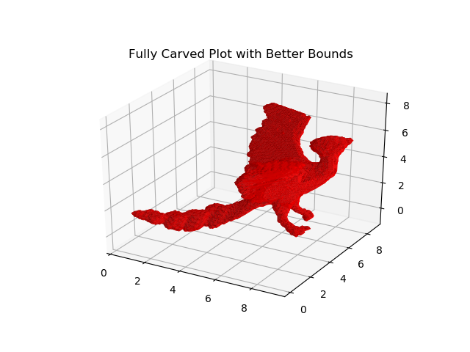

e) Finally, let’s have a fun experiment. Notice that in the first three steps, we used perfect silhouettes to carve our object. Look at the estimate silhouette() function implemented and its output. Notice that this simple method does not produce a really accurate silhouette. However, when we run space carving on it, the result still looks decent!

(i) Why is this the case?

The results looks decent because the silhouette estimate is conservative. The estimate only keeps pixels which have a higher red value than either blue or green, and the original figure is mostly red, while its background is mostly non-red. This way, most of the original figurine pixels will be included, with only some noise from the background. With more views, the noise from any given frame is more likely to be carved out.
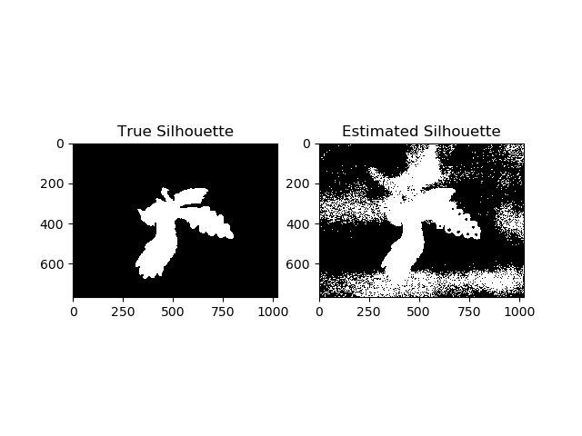
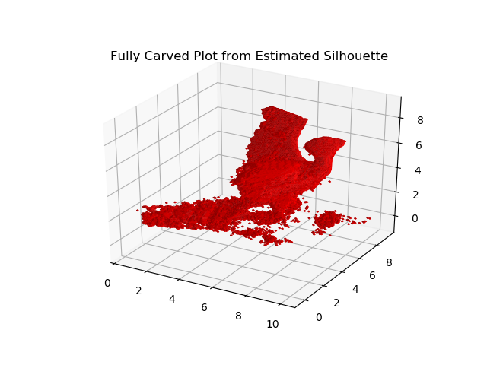

(ii) What happens if you reduce the number of views?

If the number of views are reduced, the noise from the poor silhouette estimate becomes more apparent. Since there are less views to carve out spurious voxels, there will be many more of them from the projected cones of these noisy views.

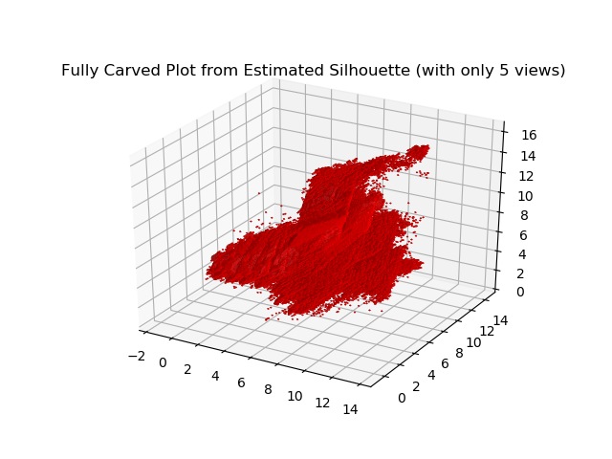

(iii) What if the estimated silhouettes weren’t conservative, meaning that one or a few views had parts of the object missing?

If the estimated silhouettes weren’t conservative, then the opposite problem would be apparent, in which too much of the actual figurine’s space would be carved out of the voxel block. A missing portion in just one view will be missing in the final carve.

2 Single Object Recognition Via SIFT

a) Implement this matching algorithm in the given function match_keypoints() and test its performance using the given code. The matching algorithm should be based on the one used by Lowe in his paper, using the ratio of the two closest matches to determine if a keypoint has a match.

def match_keypoints(descriptors1, descriptors2, threshold = 0.7):
'''
MATCH_KEYPOINTS: Given two sets of descriptors corresponding to SIFT keypoints,
find pairs of matching keypoints.

Note: Read Lowe's Keypoint matching, finding the closest keypoint is not
sufficient to find a match. thresh is the theshold for a valid match.

Arguments:
descriptors1 - Descriptors corresponding to the first image. Each row
corresponds to a descriptor. This is a ndarray of size (M_1, 128).

descriptors2 - Descriptors corresponding to the second image. Each row
corresponds to a descriptor. This is a ndarray of size (M_2, 128).

threshold - The threshold which to accept from Lowe's Keypoint Matching
algorithm

Returns:
matches - An int ndarray of size (N, 2) of indices that for keypoints in
descriptors1 match which keypoints in descriptors2. For example, [7 5]
would mean that the keypoint at index 7 of descriptors1 matches the
keypoint at index 5 of descriptors2. Not every keypoint will necessarily
have a match, so N is not the same as the number of rows in descriptors1
or descriptors2.
'''
# Initialize empty list of matches
match_list = []
for i, d in enumerate(descriptors1):
# Get dist of this element of descriptors1 and all elements
# of descriptors2
dist_arr = np.linalg.norm(descriptors2 - d, axis=1)
# Get the indeces sorted by distance
sorted_idx = dist_arr.argsort()
# Get the two minimum distances
d1, d2 = dist_arr[sorted_idx[:2]]
# Compute the distance ratio
r = d1 / d2
# If the ratio is less than the threshold, we accept this is a match
if r < threshold:
match_list.append([i, sorted_idx[0]])
# Convert the match list to ndarray
matches = np.array(match_list)

return matches

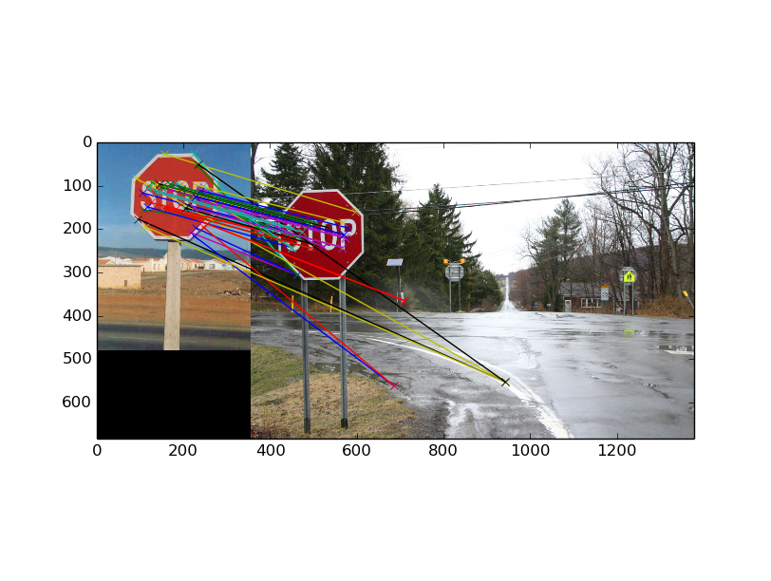
Figure 1: Unrefined Matches

b) Implement this RANSAC algorithm in the given function refine_match() and test its performance. Submit your code and the image showing the inlier matches.

def refine_match(keypoints1, keypoints2, matches, reprojection_threshold = 10,
num_iterations = 1000):
'''
REFINE_MATCH: Filter out spurious matches between two images by using RANSAC
to find a projection matrix.

Arguments:
keypoints1 - Keypoints in the first image. Each row is a SIFT keypoint
consisting of (u, v, scale, theta). Overall, this variable is a ndarray
of size (M_1, 4).

keypoints2 - Keypoints in the second image. Each row is a SIFT keypoint
consisting of (u, v, scale, theta). Overall, this variable is a ndarray
of size (M_2, 4).

matches - An int ndarray of size (N, 2) of indices that indicate what
keypoints from the first image (keypoints1) match with the second
image (keypoints2). For example, [7 5] would mean that the keypoint at
index 7 of keypoints1 matches the keypoint at index 5 of keypoints2).
Not every keypoint will necessarily have a match, so N is not the same
as the number of rows in keypoints1 or keypoints2.

reprojection_threshold - If the reprojection error is below this threshold,
then we will count it as an inlier during the RANSAC process.

num_iterations - The number of iterations we will run RANSAC for.

Returns:
inliers - A vector of integer indices that correspond to the inliers of the
final model found by RANSAC.

model - The projection matrix H found by RANSAC that has the most number of
inliers.
'''

### Normalize points
# Dump scale, angle values for now
xy1 = keypoints1[:, :2]
xy2 = keypoints2[:, :2]
xyh1 = np.concatenate([xy1, np.ones((xy1.shape[0], 1))], axis=1)
xyh2 = np.concatenate([xy2, np.ones((xy2.shape[0], 1))], axis=1)

# Compute translation params
t1 = np.mean(xy1, axis=0)
t2 = np.mean(xy2, axis=0)
# Compute scaling params
msd1 = ((xy1 - t1)**2).sum(axis=1).mean()
msd2 = ((xy2 - t2)**2).sum(axis=1).mean()
s1 = np.sqrt(2/msd1)
s2 = np.sqrt(2/msd2)
# Scale translation params
t1 *= s1
t2 *= s2
# Build transformation matrices
T1 = np.array([
[s1, 0, -t1[0]],
[0, s1, -t1[1]],
[0, 0, 1]
])
T2 = np.array([
[s2, 0, -t2[0]],
[0, s2, -t2[1]],
[0, 0, 1]
])
# Normalize the points
np1 = np.dot(xyh1, T1.T)
np2 = np.dot(xyh2, T2.T)

# Convert back to euclidean
np1 = np1[:, :2]/np1[:, 2][:, np.newaxis]
np2 = np2[:, :2]/np2[:, 2][:, np.newaxis]

# Variables for loop
best_count = 0
best_results = (None, None)
# Iterate num_iterations times
for _ in range(num_iterations):
# Sample 4 points from matches to compute homography
sample_idx = np.random.choice(range(len(matches)), len(matches), replace=False)
sample_matches = matches[sample_idx[:4]]
rem1, rem2 = matches.T
rem_points1 = xyh1[rem1]
rem_points2 = xy2[rem2]

# Compute a (normalized) homograpgy x' = Hx using DLT
row_list = []
for match in sample_matches:
u1, v1, = np1[match[0]]
u2, v2, = np2[match[1]]
row = np.array([
[-u1, -v1, -1, 0, 0, 0, u1*u2, v1*u2, u2],
[0, 0, 0, -u1, -v1, -1, u1*v2, v1*v2, v2],
])
row_list.append(row)
# Form rows into A, to solve Ah = 0
A = np.concatenate(row_list, axis=0)
# Apply SVD
U, d, Vt = np.linalg.svd(A)
# Solution to Ah = 0 is last column of V
h = Vt.T[:, -1]
# Reshape solution to get normalized homography Hn
Hn = h.reshape(3, 3)
# Denormalize Hn to get H
H = np.linalg.pinv(T2).dot(Hn).dot(T1)

### Compute reprojection error for remaining points
# Project the points from image 1 using H
pred_points2 = np.dot(rem_points1, H.T)
# Convert the projected points back to Euclidean
pred_points2 = pred_points2[:, :2]/(pred_points2[:, 2][:, np.newaxis]+1e-8)
# Measure l2norm between predicted and actual points in image 2
dist = np.linalg.norm(pred_points2 - rem_points2, axis=1)
# Compute indeces of good reprojections
good_idx = dist < reprojection_threshold
# Get number of good reprojections
new_count = good_idx.sum()
# Save result if this is best H yet
if new_count > best_count:
best_results = good_idx, H
best_count = new_count

return best_results

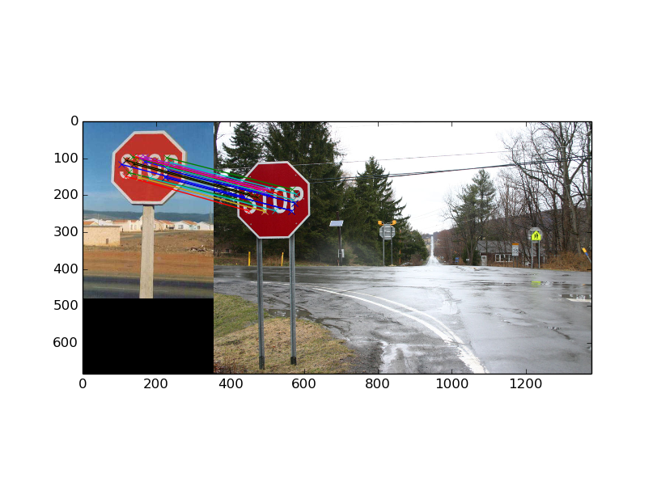
Figure 2: Matches Refined with RANSAC

c) We will now explore some theoretical properties of RANSAC.

(i) If we choose a single random set of matches to compute a homography, as we did above,
what is the probability that this set of matches will produce the correct homography?

The probability of choosing a single sample which is an inlier is:

Assuming sampling with replacement, we need to draw 4 inlier samples to compute the correct homography:

(ii) In terms of , what is the probability that at least one of the samples will produce the correct homography?

The probability that a sample is picked which does not produce the correct homography is:

The probability of choosing such samples in a row, assuming sampling with replacement, is:

Then, the probability of choosing at least one sample which produces the correct homography is just 1 – this probability:

(iii) Combining your answers for the above, if 15% of the samples are outliers and we
want at least a 99% guarantee that at least one of the samples will give the correct
homography, then how many samples do we need?

First, we solve for :

Using the previous equation to solve for :

Since the number of samples must be a natural number, we round up:

d) Now given an object in an image, we want to explore how to find the same object in another
image by matching the keypoints across these two images.

(i) Define the center position, width, height and relative orientation of the predicted bounding box. Assume that the relation between a bounding box and a keypoint in it holds across rotation, translation and scale.

Let the scaling factor be defined as follows:

First, we compute the new width, height, and relative orientation:

Then, we can compute the new u, v positions by using a 2D scale and rotation transforms, S and R respectively:

Where:

Resulting in:

Then we have found all five values .

(ii) Once you have defined the five features of the new bounding box in terms of the
two keypoint features and the original bounding box, briefly describe how you would
utilize the Hough transform to determine the best bounding box in Image 2 given n correspondences.

We use the Hough transform to make a prediction in the presence of considerable noise. By binning parameter estimates for the n correspondences, we

e) Implement the function get_object_region() to recover the position, scale, and orientation
of the objects (via calculating the bounding boxes) in the test images.

3 Histogram of Oriented Gradients

a) The first part of HoG is to compute the gradient across the image. Complete the function
compute gradient() and check it on a simple image to verify correctness. Submit the
angle and magnitude of the gradient of the center pixel of the second test, as well as the
code you wrote.

def compute_gradient(im):
'''
COMPUTE_GRADIENT Given an image, computes the pixel gradients

Arguments:
im - a grayscale image, represented as an ndarray of size (H, W) containing
the pixel values

Returns:
angles - ndarray of size (H-2, W-2) containing gradient angles in degrees

magnitudes - ndarray of size (H-2, W-2) containing gradient magnitudes

The way that the angles and magnitude per pixel are computed as follows:
Given the following pixel grid

P1 P2 P3
P4 P5 P6
P7 P8 P9

We compute the angle on P5 as arctan(dy/dx) = arctan(P2-P8 / P4-P6).
Note that we should be using np.arctan2, which is more numerically stable.
However, this puts us in the range [-180, 180] degrees. To be in the range
[0,180], we need to simply add 180 degrees to the negative angles.

The magnitude is simply sqrt((P4-P6)^2 + (P2-P8)^2)
'''
# Initialize empty angle and magnitude arrays
angles = np.zeros((im.shape[0]-2, im.shape[1]-2))
magnitudes = np.zeros((im.shape[0]-2, im.shape[1]-2))
for i in range(1, im.shape[0]-1):
for j in range(1, im.shape[1]-1):
# Compute dx, dy
dx = im[i][j-1] - im[i][j+1]
dy = im[i-1][j] - im[i+1][j]
# Compute angle
a = np.arctan2(dy, dx)
# Compute magnitude
m = np.sqrt(dx**2 + dy**2)
# Assign computed angles and magnitudes to arrays
angles[i-1, j-1] = np.degrees(a)
magnitudes[i-1, j-1] = m

# Add 180 to angles < 0
angles[angles<0] += 180

return angles, magnitudes

Results:
--------------------------------------------------------------------------------
Part A: Image gradient
--------------------------------------------------------------------------------
Expected angle: 126.339396329
Expected magnitude: 0.423547566786
Checking gradient test case 1: True
Expected angles:
[[100.30484647 63.43494882 167.47119229]
[ 68.19859051 0. 45. ]
[ 53.13010235 64.53665494 180. ]]
Expected magnitudes:
[[11.18033989 11.18033989 9.21954446]
[ 5.38516481 11. 7.07106781]
[15. 11.62970335 2. ]]
Checking gradient test case 2: True

b) The next step of HoG is to compute the histograms for a given grid of gradients. Fill out
the generate histogram() method and verify that it works on our unit test. Submit your
code and the histogram you get on the test case.

def generate_histogram(angles, magnitudes, nbins = 9):
'''
GENERATE_HISTOGRAM Given matrices of angles and magnitudes of the image
gradient, generate the histogram of angles

Arguments:
angles - ndarray of size (M, N) containing gradient angles in degrees

magnitudes - ndarray of size (M, N) containing gradient magnitudes

nbins - the number of bins that you want to bin the histogram into

Returns:
histogram - an ndarray of size (nbins,) containing the distribution
of gradient angles.

This method should be implemented as follows:

1)Each histogram will bin the angle from 0 to 180 degrees. The number of bins
will dictate what angles fall into what bin (i.e. if nbins=9, then first bin
will contain the votes of angles close to 10, the second bin will contain those
close to 30, etc).

2) To create these histogram, iterate over the gradient grids, putting each
gradient into its respective bins. To do this properly, we interpolate and
weight the voting by both its magnitude and how close it is to the average
angle of the two bins closest to the angle of the gradient. For example, if we
have nbins = 9 and receive angle of 20 degrees with magnitude 1, then we the
vote contribution to the histogram weights equally with the first and second bins
(since its closest to both 10 and 30 degrees). If instead, we recieve angle of
25 degrees with magnitude 2, then it is weighted 25% in the first bin and 75%
in second bin, but with twice the voting power.

Mathematically, if you have an angle, magnitude, the center_angle1 of the lower
bin center_angle2 of the higher bin, then:

histogram[bin1] += magnitude * |angle - center_angle2| / (180 / nbins)
histogram[bin2] += magnitude * |angle - center_angle1| / (180 / nbins)

Notice how that we're weighting by the distance to the opposite center. The
further the angle is from one center means it is closer to the opposite center
(and should be weighted more).

One special case you will have to take care of is when the angle is near
180 degrees or 0 degrees. It may be that the two nearest bins are the first and
last bins respectively.
'''
# Initialize empty histogram
histogram = np.zeros(nbins)
# Get linspace of nbins angles
linspace = np.linspace(0, 180, nbins+1)
# Get midpoints of linspace which correspond to histogram bins
midpoints = (linspace[1:] + linspace[:-1]) / 2
nrows, ncols = angles.shape
for i in range(nrows):
for j in range(ncols):
angle, magnitude = angles[i, j], magnitudes[i, j]
# If angle contributes only to 1 bin (falls exactly on midpoint)
if angle in midpoints:
bin_idx = np.where(midpoints==angle)[0][0]
histogram[bin_idx] += magnitude
# If angle contributes to 2 bins
else:
# Special case if angle is near bounds
if angle < midpoints[0] or angle > midpoints[-1]:
# Shift angles below lowest bin to above highest bin
if angle < midpoints[0]:
angle += 180
# Last, first indeces
idx1, idx2 = -1, 0
mp1 = midpoints[idx1]
# Shift lowest midpoint to above highest mipoint
mp2 = midpoints[idx2] + 180
# Typical case
else:
# Get two closest midpoint indices to angle
idx1, idx2 = np.abs(midpoints - angle).argsort()[:2]
# Get two closest midpoint angles to angle
mp1, mp2 = midpoints[idx1], midpoints[idx2]
# Compute histogram contributions
histogram[idx1] += magnitude * abs(angle - mp2) / (180.0 / nbins)
histogram[idx2] += magnitude * abs(angle - mp1) / (180.0 / nbins)

return histogram

Results:
--------------------------------------------------------------------------------
Part B: Histogram generation
--------------------------------------------------------------------------------
Checking histogram test case 1: True
Checking histogram test case 2: True
Submit these results: [3.435 1.915 0.95 0.8 0.45 0.9 0. 0. 0.55 ]

c) Complete compute hog features(), which computes the final HoG features. Submit your
code and the final output, which displays a visual representation of the features.

def compute_hog_features(im, pixels_in_cell, cells_in_block, nbins):
'''
COMPUTE_HOG_FEATURES Computes the histogram of gradients features
Arguments:
im - the image matrix

pixels_in_cell - each cell will be of size (pixels_in_cell, pixels_in_cell)
pixels

cells_in_block - each block will be of size (cells_in_block, cells_in_block)
cells

nbins - number of histogram bins

Returns:
features - the hog features of the image represented as an ndarray of size
(H_blocks, W_blocks, cells_in_block * cells_in_block * nbins), where
H_blocks is the number of blocks that fit height-wise
W_blocks is the number of blocks that fit width-wise

Generating the HoG features can be done as follows:

1) Compute the gradient for the image, generating angles and magnitudes

2) Define a cell, which is a grid of (pixels_in_cell, pixels_in_cell) pixels.
Also, define a block, which is a grid of (cells_in_block, cells_in_block) cells.
This means each block is a grid of side length pixels_in_cell * cell_in_block
pixels.

3) Pass a sliding window over the image, with the window size being the size of
a block. The stride of the sliding window should be half the block size, (50%
overlap). Each cell in each block will store a histogram of the gradients in
that cell. Consequently, there will be cells_in_block * cells_in_block
histograms in each block. This means that each block feature will initially
represented as a (cells_in_block, cells_in_block, nbins) ndarray, that can
reshaped into a (cells_in_block * cells_in_block *nbins,) ndarray. Make sure to
normalize such that the norm of this flattened block feature is 1.

4) The overall hog feature that you return will be a grid of all these flattened
block features.

Note: The final overall feature ndarray can be flattened if you want to use to
train a classifier or use it as a feature vector.
'''

# Compute gradient for image
angles, magnitudes = compute_gradient(im)
H, W = angles.shape

# Compute block size and check valid
block_size = pixels_in_cell*cells_in_block
if block_size % 2 != 0:
raise Exception('Block size must be even, given block size: {}'.format(block_size))

# Compute stride in pixels
stride = block_size // 2
# Compute number of blocks that fit along width and height
# Accounts for sliding window
# Note that the edges are clipped, since they are not part of full blocks
H_blocks = H // stride - 1
W_blocks = W // stride - 1
features = np.zeros((H_blocks, W_blocks, cells_in_block * cells_in_block * nbins))

# Iterate through grads to build HoG
for bi in range(H_blocks):
for bj in range(W_blocks):
# Initialize feature array for current block
block_features = np.zeros((cells_in_block, cells_in_block, nbins))
for ci in range(cells_in_block):
for cj in range(cells_in_block):
# Get indeces for the cell
i = (bi*stride)+(ci*pixels_in_cell)
j = (bj*stride)+(cj*pixels_in_cell)
# Index angles and magnitudes for the cell
cell_angles = angles[i:i+pixels_in_cell, j:j+pixels_in_cell]
cell_magnitudes = magnitudes[i:i+pixels_in_cell, j:j+pixels_in_cell]
# Compute histogram for cell
cell_histogram = generate_histogram(cell_angles, cell_magnitudes, nbins=nbins)
# Store histogram
block_features[ci, cj] = cell_histogram
# Flatten block features
block_features = block_features.flatten()
# Normalize block features
block_features = block_features / (np.linalg.norm(block_features) + 1e-8)
# Store block features
features[bi, bj] = block_features

return features

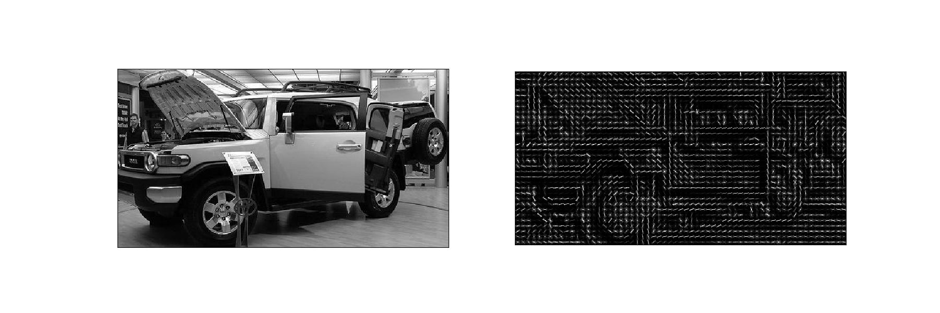
Figure 3: Extracted HOG features from car image.

