CS231A
Computer Vision: From 3D Reconstruction to Recognition

Luke Jaffe

Problem Set 2
Due 02/09/2018

1 Fundamental Matrix Estimation From Point Correspondences

a) Implement the linear least-squares eight point algorithm in lls_eight_point_alg() and report the returned fundamental matrix.

def lls_eight_point_alg(points1, points2, test=False):
'''
LLS_EIGHT_POINT_ALG computes the fundamental matrix from matching points using
linear least squares eight point algorithm
Arguments:
points1 - N points in the first image that match with points2
points2 - N points in the second image that match with points1

Both points1 and points2 are from the get_data_from_txt_file() method
Returns:
Fp - the fundamental matrix such that (points2)^T * Fp * points1 = 0
Please see lecture notes and slides to see how the linear least squares eight
point algorithm works
'''
# Convert point pairs to outer product matrix form
A = []
for p1, p2 in zip(points1, points2):
row = np.outer(p2, p1).reshape(9)
A.append(row)
A = np.array(A)
# Take SVD of matrix
_, _, V = np.linalg.svd(A)
# Last column of V is solution
f = V.T[:, -1]
# Af should be close to 0
if test:
null = A.dot(f)
print 'Af =', null
# Convert solution vector f to fundamental matrix F
F = f.reshape(3, 3)
# Point, F products should be close to 0
if test:
for p1, p2 in zip(points1, points2):
print(p2.T.dot(F).dot(p1))
# SVD again to minimize Frobenius norm
Up, dp, Vp = np.linalg.svd(F)
# Zero out last element of Dp to meet rank 2 constraint
dp[-1] = 0
Dp = np.diag(dp)
# Build Fp from this
Fp = np.dot(Up, np.dot(Dp, Vp))
# Point, F products should be close to 0
if test:
for p1, p2 in zip(points1, points2):
print(p2.T.dot(Fp).dot(p1))

return Fp

Results:
--------------------------------------------------------------------------------
Set: data/set1
--------------------------------------------------------------------------------
p'^T F p = 0.663535589589
Fundamental Matrix from LLS 8-point algorithm:
[[ 1.55218081e-06 -8.18161523e-06 -1.50440111e-03]
[ -5.86997052e-06 -3.02892219e-07 -1.13607605e-02]
[ -3.52312036e-03 1.41453881e-02 9.99828068e-01]]

--------------------------------------------------------------------------------
Set: data/set2
--------------------------------------------------------------------------------
p'^T F p = 0.205365849876
Fundamental Matrix from LLS 8-point algorithm:
[[ -5.63087200e-06 2.74976583e-05 -6.42650411e-03]
[ -2.77622828e-05 -6.74748522e-06 1.52182033e-02]
[ 1.07623595e-02 -1.22519240e-02 -9.99730547e-01]]

b) Implement the normalized eight point algorithm in normalized_eight_point_alg() and report the returned fundamental matrix.

def normalized_eiResults:ght_point_alg(points1, points2, test=False):
'''
NORMALIZED_EIGHT_POINT_ALG computes the fundamental matrix from matching points
using the normalized eight point algorithm
Arguments:
points1 - N points in the first image that match with points2
points2 - N points in the second image that match with points1

Both points1 and points2 are from the get_data_from_txt_file() method
Returns:
F - the fundamental matrix such that (points2)^T * F * points1 = 0
Please see lecture notes and slides to see how the normalized eight
point algorithm works
'''
### Normalize points
# Dump z values for now
xy1 = points1[:, :2]
xy2 = points2[:, :2]
# Compute translation params
t1 = np.mean(xy1, axis=0)
t2 = np.mean(xy2, axis=0)
# Compute scaling params
msd1 = ((xy1 - t1)**2).sum(axis=1).mean()
msd2 = ((xy2 - t2)**2).sum(axis=1).mean()
s1 = np.sqrt(2/msd1)
s2 = np.sqrt(2/msd2)
# Scale translation params
t1 *= s1
t2 *= s2
# Build transformation matrices
T1 = np.array([
[s1, 0, -t1[0]],
[0, s1, -t1[1]],
[0, 0, 1]
])
T2 = np.array([
[s2, 0, -t2[0]],
[0, s2, -t2[1]],
[0, 0, 1]
])
# Normalize the points
np1 = np.dot(points1, T1.T)
np2 = np.dot(points2, T2.T)
# Make sure means are close to zero, and MSD are close to 2
if test:
print 'mean1:', np1.mean(axis=0)
print 'mean2:', np2.mean(axis=0)
print 'msd1:', (np1[:, :2]**2).sum(axis=1).mean()
print 'msd2:', (np2[:, :2]**2).sum(axis=1).mean()
### Call eight point alg on normalized point sets
Fhp = lls_eight_point_alg(np1, np2)
### Denormalize results
F = T2.T.dot(Fhp).dot(T1)

return F

Results:
--------------------------------------------------------------------------------
Set: data/set1
--------------------------------------------------------------------------------
p'^T F p = 0.0302958533132
Fundamental Matrix from normalized 8-point algorithm:
[[ 6.52113484e-07 -5.33615067e-06 8.80860210e-05]
[ -4.91237449e-06 -3.40420428e-07 -6.43807393e-03]
[ -8.56136054e-04 8.84208000e-03 1.45953063e-01]]

--------------------------------------------------------------------------------
Set: data/set2
--------------------------------------------------------------------------------
p'^T F p = 0.0331366910623
Fundamental Matrix from normalized 8-point algorithm:
[[ -1.51007608e-07 2.51618737e-06 -1.56134009e-04]
[ 3.63462620e-06 3.22311660e-07 7.02588719e-03]
[ 2.36155133e-04 -8.53003408e-03 -2.45880925e-03]]

c) In this problem, we provide two datasets, which consist of a pair of images with matching
points. For each of the two eight point algorithms, draw a figure similar to Figure 1, which
shows the selected corresponding points and their epipolar lines, for each dataset. To do
so, fill out the method plot_epipolar_lines_on_images().

def plot_epipolar_lines_on_images(points1, points2, im1, im2, F, im_set=None, alg=None):
'''
PLOT_EPIPOLAR_LINES_ON_IMAGES given a pair of images and corresponding points,
draws the epipolar lines on the images
Arguments:
points1 - N points in the first image that match with points2
points2 - N points in the second image that match with points1
im1 - a HxW(xC) matrix that contains pixel values from the first image
im2 - a HxW(xC) matrix that contains pixel values from the second image
F - the fundamental matrix such that (points2)^T * F * points1 = 0

Both points1 and points2 are from the get_data_from_txt_file() method
Returns:
Nothing; instead, plots the two images with the matching points and
their corresponding epipolar lines. See Figure 1 within the problem set
handout for an example
'''
# Large figure to fit plots without distortion
plt.figure(figsize=(20, 10))
plt.suptitle('{} {}'.format(im_set, alg), fontsize=20)
# Subroutine to draw epipolar lines on one image
def plot_epipolar_line_on_image(points1, points2, im, F, i):
# Set up plot aesthetics
plt.subplot(int('12{}'.format(i)))
plt.imshow(im, cmap='gray')
plt.axis('off')
plt.xlim(0, 512)
plt.ylim(512, 0)
# Solve for epipolar points
# l = [a, b, c] where: ax + by + c = 0
el = np.dot(points2, F)
# Plot each epipolar line
for a, b, c in el:
x = np.arange(0, 512)
y = -(a/b)*x - c/b
# Threshold points so lines are bounded by images
idx1 = y >= 0
idx2 = y <= 512
idx = idx1 & idx2
x = x[idx]
y = y[idx]
plt.plot(x, y, c='red')
# Plot original points on images
x, y, z = zip(*points1)
plt.scatter(x, y, s=80, c='blue', marker=(5, 1))
plt.title('Image {}'.format(i), fontsize=16)

# Plot epipolar lines on first image
plot_epipolar_line_on_image(points1, points2, im1, F, 1)
# Plot epipolar lines on second image
plot_epipolar_line_on_image(points2, points1, im2, F.T, 2)
# Save plots
path = os.path.join('plots', '{}_{}.png'.format(im_set.replace('/', '_'), alg))
plt.savefig(path)

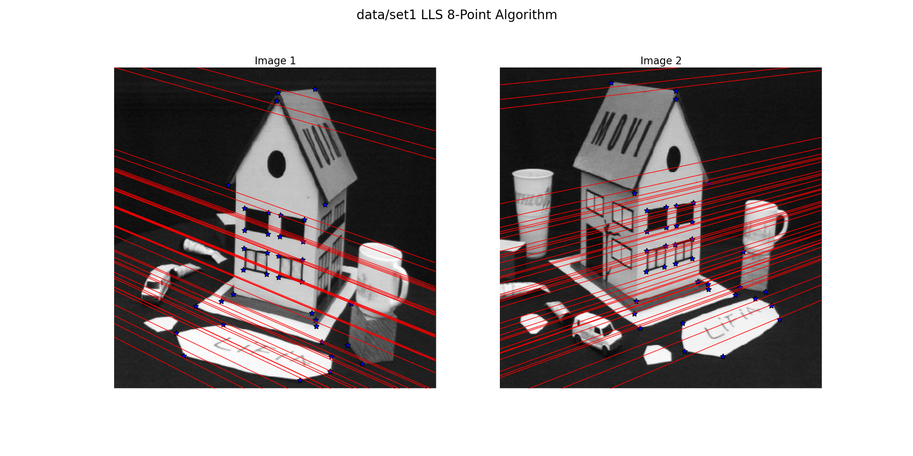

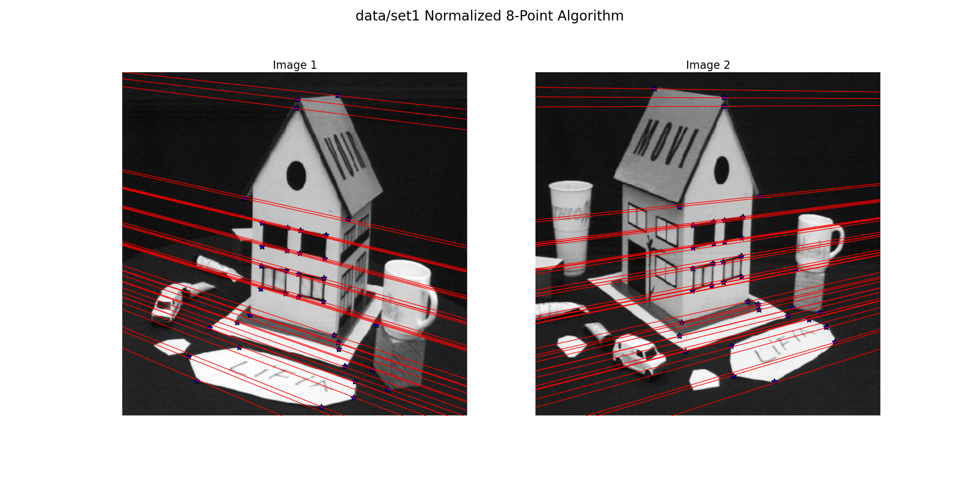

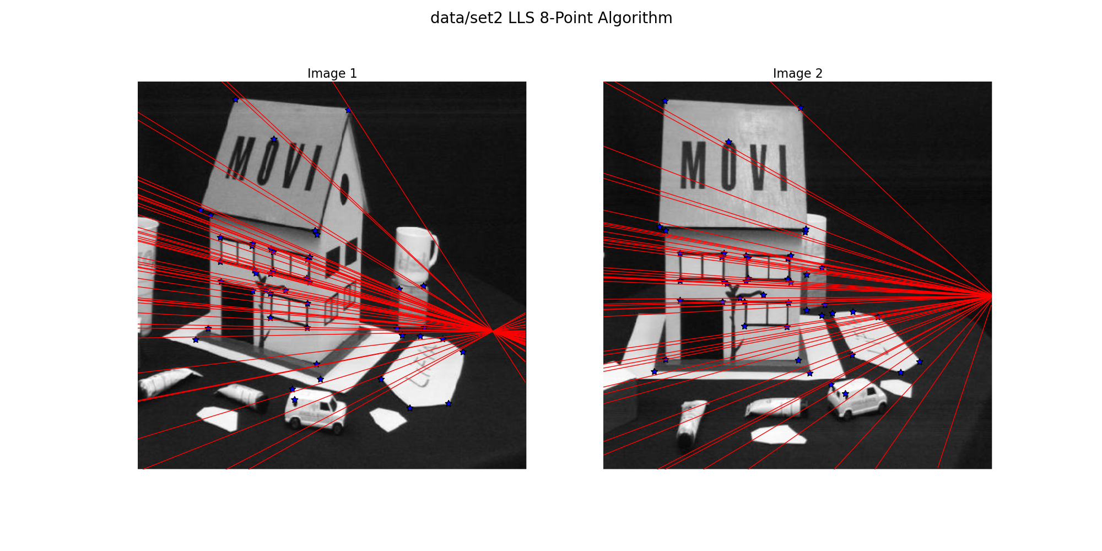

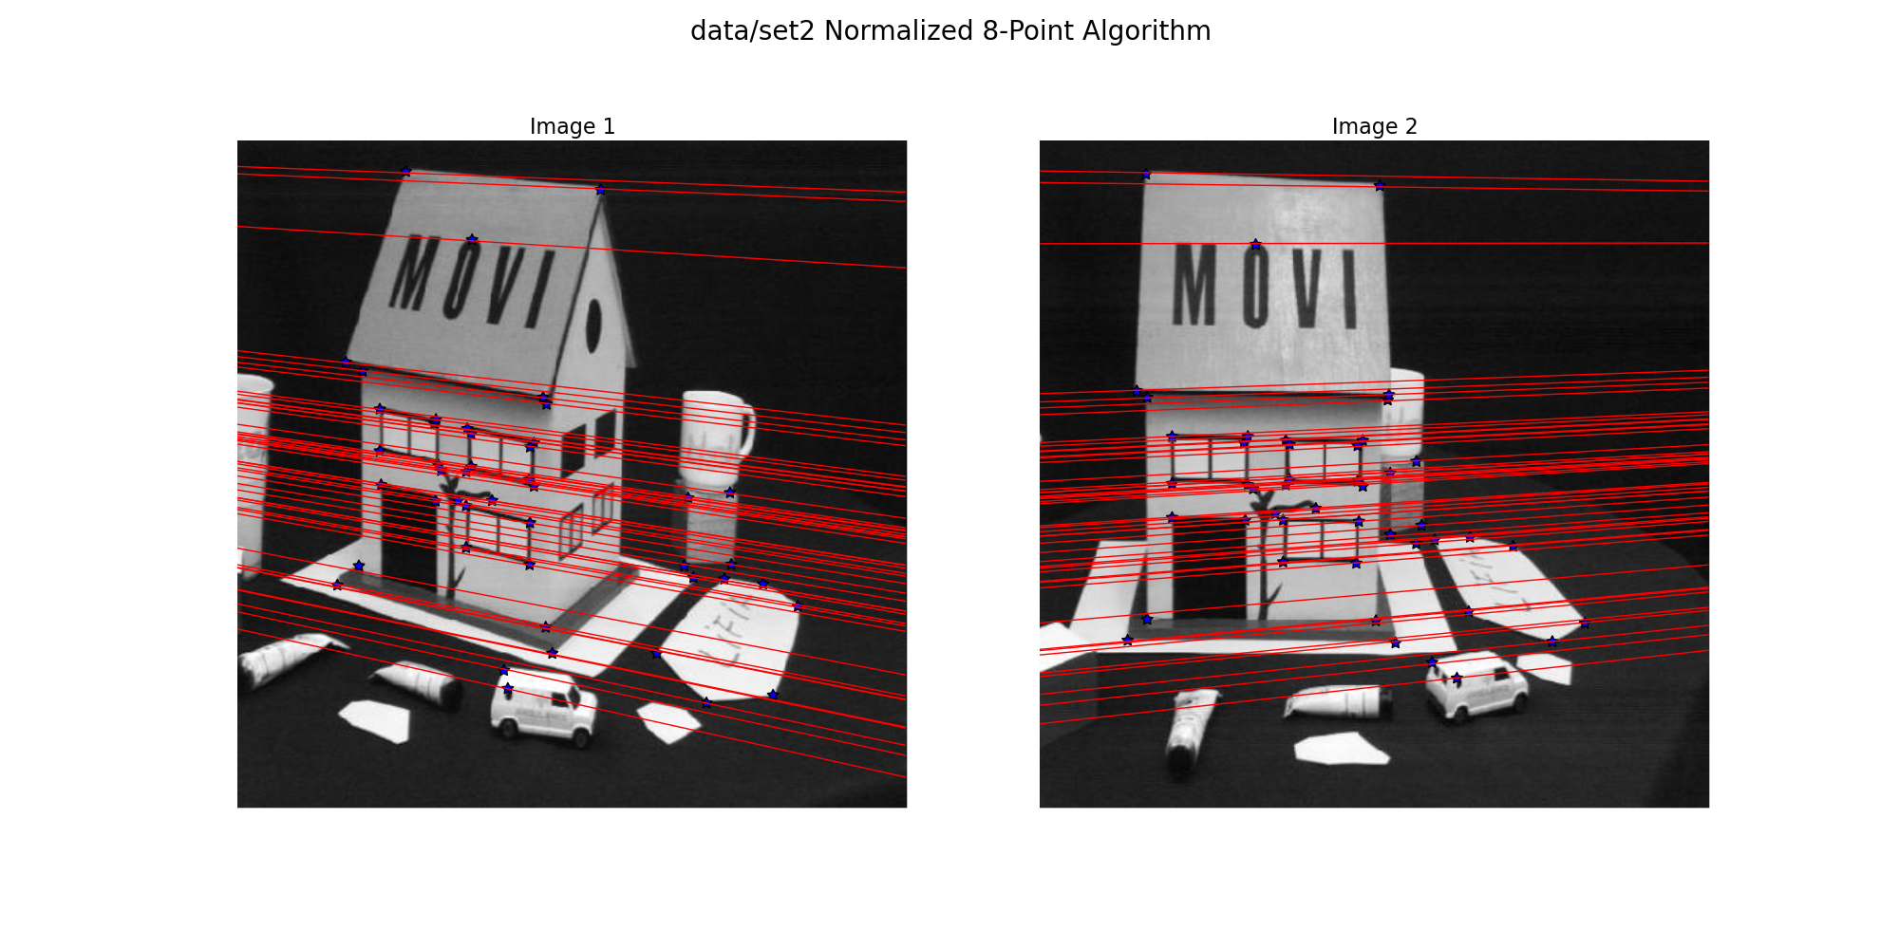

d) After implementing methods to determine the Fundamental matrix, we can now deter-
mine epipolar lines. Specifically to determine the accuracy of our Fundamental matrix, we
will compute the average distance between a point and its corresponding epipolar line in compute_distance_to_epipolar_lines().
def compute_distance_to_epipolar_lines(points1, points2, F):
'''
COMPUTE_DISTANCE_TO_EPIPOLAR_LINES computes the average distance of a set a
points to their corresponding epipolar lines
Arguments:
points1 - N points in the first image that match with points2
points2 - N points in the second image that match with points1
F - the fundamental matrix such that (points2)^T * F * points1 = 0

Both points1 and points2 are from the get_data_from_txt_file() method
Returns:
average_distance - the average distance of each point to the epipolar line
'''
# Compute epipolar lines for points2 using F
el = np.dot(points2, F)
# Normalize lines, points already normalized
ea, eb, ec = el.T
la, lb, lc = ea/np.sqrt(ea**2 + eb**2), eb/np.sqrt(ea**2 + eb**2), ec/np.sqrt(ea**2 + eb**2)
en = zip(la, lb, lc)
dist_list = []
# Measure distance between each epipolar line and correspondig point in points1
for e, p in zip(en, points1):
d = np.dot(e, p)
dist_list.append(d)
# Compute average distance
avg_dist = np.mean(dist_list)
return avg_dist

Results:
--------------------------------------------------------------------------------
Set: data/set1
--------------------------------------------------------------------------------
Distance to lines in image 1 for LLS: -28.0256629375
Distance to lines in image 2 for LLS: -25.1628758
Distance to lines in image 1 for normalized: 0.273431729132
Distance to lines in image 2 for normalized: 0.242586097073
--------------------------------------------------------------------------------
Set: data/set2
--------------------------------------------------------------------------------
Distance to lines in image 1 for LLS: -7.41832342463
Distance to lines in image 2 for LLS: -10.8346831412
Distance to lines in image 1 for normalized: 0.30901933268
Distance to lines in image 2 for normalized: 0.306373738368

2 Matching Homographies for Image Rectification

a)

