CS228: Probabilistic Graphical Models

Homework 3

Luke Jaffe

Due: 02/17/2017
Submitted: 02/19/2017

Problem 1: MAP and MPE

Show that marginal MAP assignments do not always match the MPE assignments.

Observe a simple 2-node network A→B:

A
B

Each variable is binary, and is associated with the following CPDs:

P(A)
A₀ | A₁
0.4 | 0.6

P(B|A)
 | B₀ | B₁
A₀ | 0.4 | 0.6
A₁ | 0.51 | 0.49

To calculate the MPE, we take the argmax of the joint for each variable configuration:
P(A,B) = P(A)*P(B|A)
P(A₀,B₀) = P(A₀)*P(B₀|A₀) = 0.4*0.4 = 0.16
P(A₀,B₁) = P(A₀)*P(B₁|A₀) = 0.4*0.6 = 0.24
P(A₁,B₀) = P(A₁)*P(B₀|A₁) = 0.6*0.51 = 0.306
P(A₁,B₁) = P(A₁)*P(B₁|A₁) = 0.6*0.49 = 0.294

max P(A,B) = P(A₁,B₀) = 0.306
argmax over (A,B) of P(A,B) = {A=A₁, B=B₀}

To calculate the marginal MAP for each variable:
P(A=A₀) = 0.4
P(A=A₁) = 0.6
P(B=B₀) = P(A₀)*P(B₀|A₀) + P(A₁)*P(B₀|A₁) = 0.16 + 0.306 = 0.466
P(B=B₁) = P(A₀)*P(B₁|A₀) + P(A₁)*P(B₁|A₁) = 0.24 + 0.294 = 0.534

So according to the marginal MAP, the most probable assignment is {A=A₁, B=B₁}
As we can see, the MPE assignment and marginal MAP predict different values for B, showing that they do not always match.

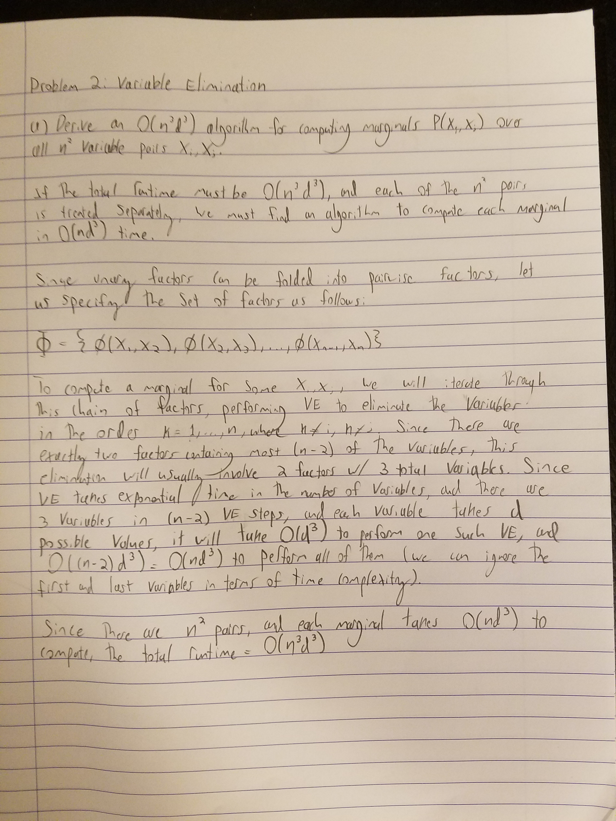
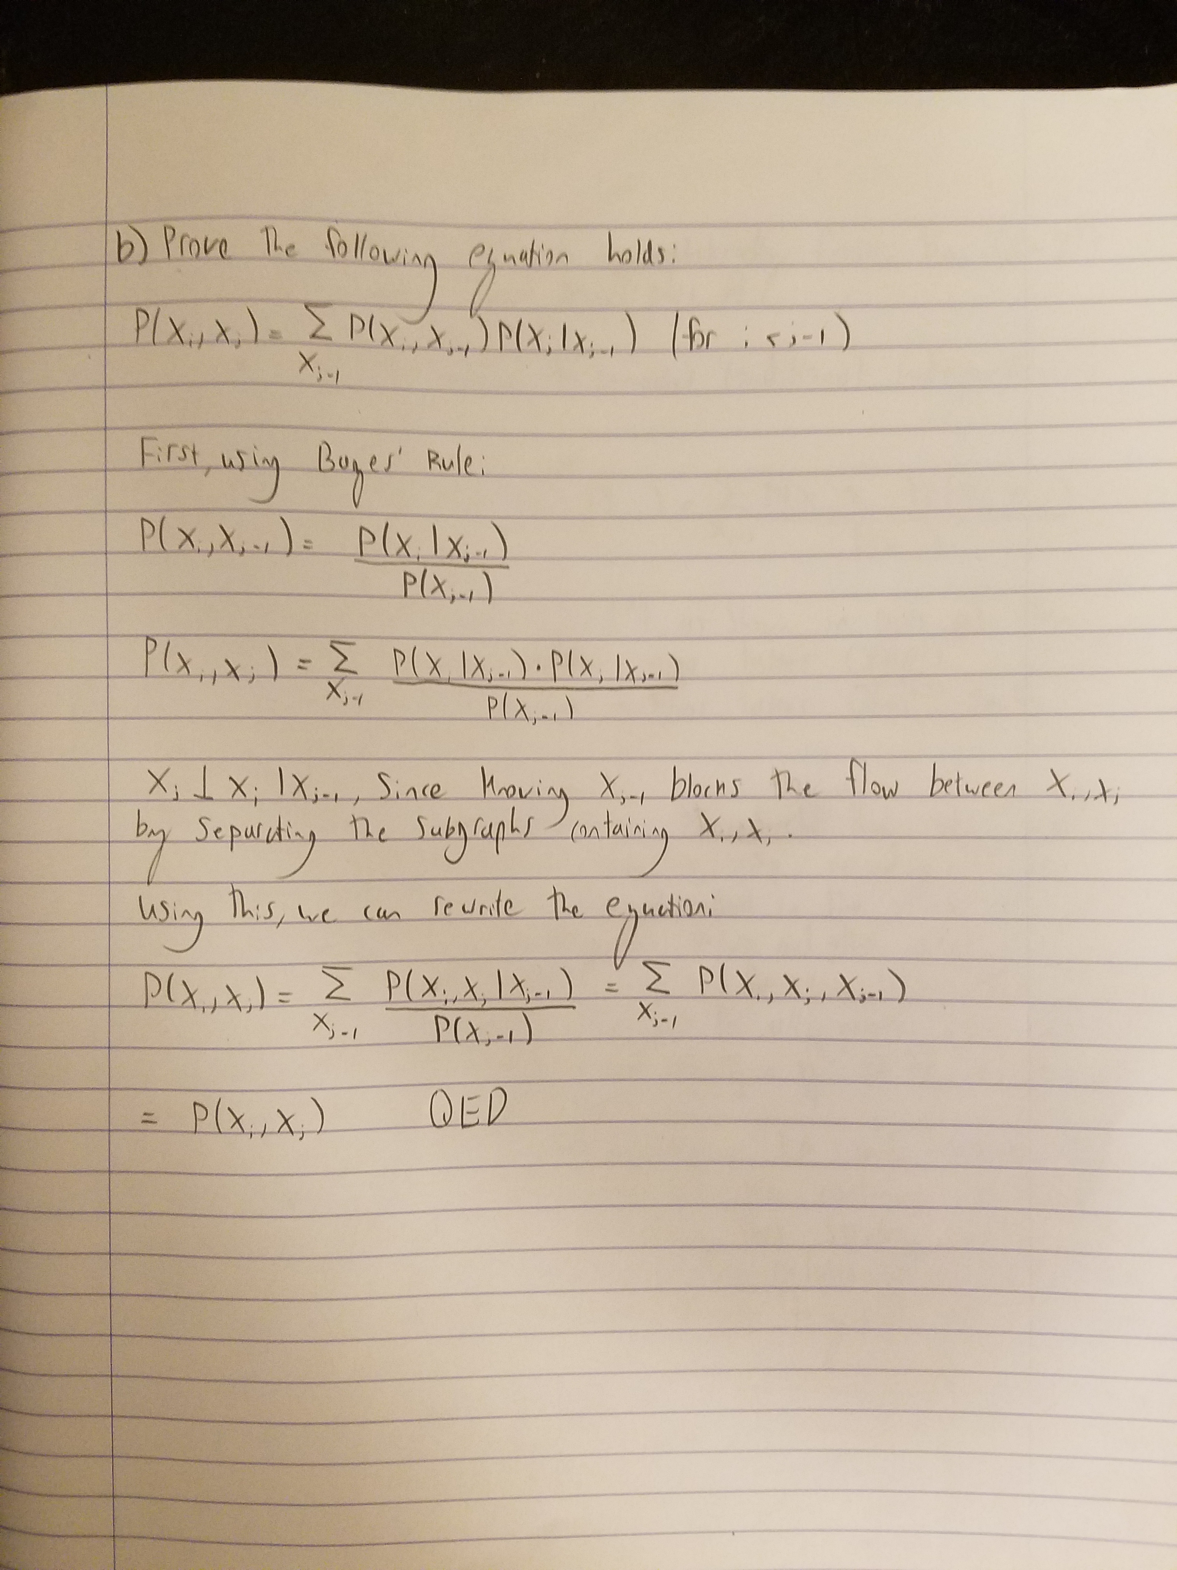
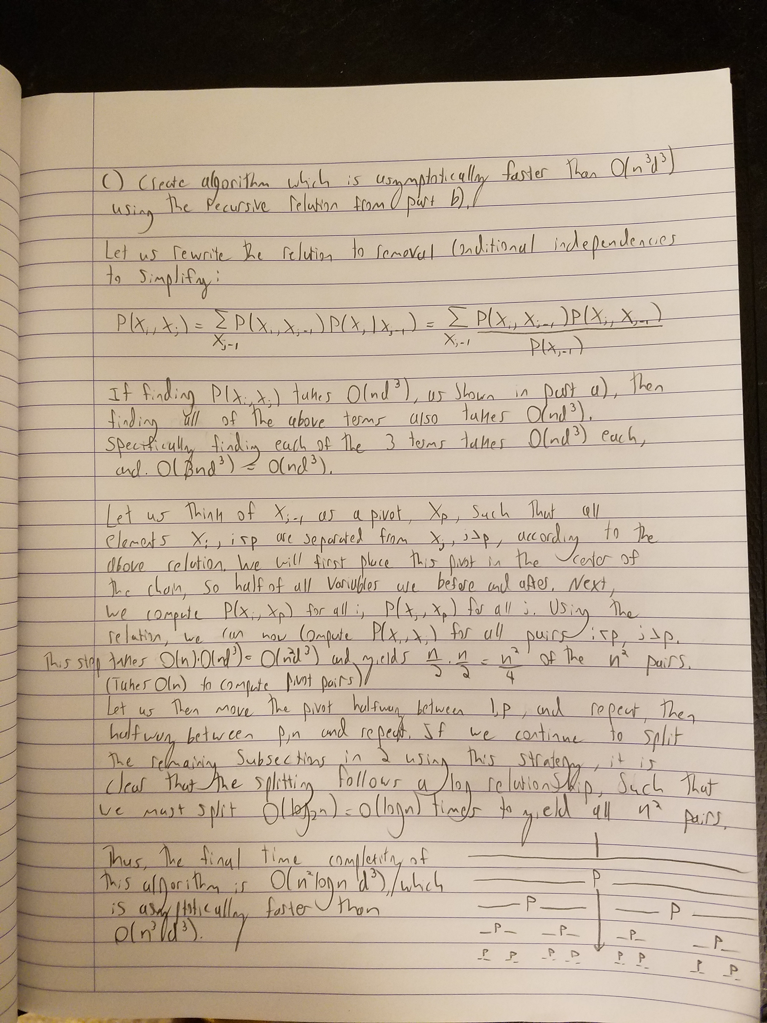
Problem 3: Clique Tree Calibration

a) If we modify a factor in some clique C_{i}, which message updates do we have to perform to recalibrate the tree?

If we modify (the values of) a factor in some clique C_{i}, we must update all messages in the tree leading away from C_{i}, (single pass), since these will be recursively affected by the change. This comes from the message update recurrence relation, which tells us that outgoing messages from some clique C_{i} are affected by the product of all incoming messages to C_{i} and the factor of C_{i}.

b) If we modify a factor in some clique C₁, but we just want the marginal over a single pre-specified variable X_{k}, which message updates do we have to perform?

To calculate the marginal over X_{k}, we must compute the product of a factor of X_{k} with all incoming messages to that factor, and then marginalize out all variables in that factor which are not X_{k}. This means we must recursively update all messages leading away from C_{i} up to any factor of X_{k}. In the best case, X_{k} is in C_{i}, and we do not need to perform any message updates. In the worst case, we must do a full single pass through the tree, as in part a (this will only happen if the cliques are on opposite ends of a tree with no forks i.e. a line).

Problem 4: Importance Sampling

a)

i. Can we compute P(x|e) exactly, in a tractable way?

No, computing this is intractable.

ii. Can we sample directly from P(X|e)?

No, we cannot sample directly from P(X|e).

iii. Can we compute P’(x|e) = P(x,e) exactly, in a tractable way?

Yes, we can compute P(x,e) exactly in a tractable way.

b) Q(X,E) is close to P(X,E)

i. Show how to sample from the posterior in Q.

Form a clique tree where all child/parent pairs are grouped as cliques. Now, incorporate the evidence E=e, and the distribution for the tree will be Q(X,E | E=e). After the clique tree has been calibrated, the belief at a clique over some X and its parents is proportional to Q(X, parents(X) | E=e). Using this, we can use Bayes’ rule to compute Q(X | parents(X), E=e). Then, using the calculated CPDs, we can forward sample from the posterior in Q. This is done by sampling from the first variable, using it in neighboring cliques, and repeating through the clique tree.

ii. Reweight the samples according to the rules of importance sampling.

The weight function can be derived from this as:

w[m] =P’(x[m], e[m]) / Q(x[m], e[m] | e)

iii. Show the form of the final estimator Phat(X=x|E=e) for P(X=x|E=e), in terms of the samples from part i, and the weights from part ii.

The final estimator will take the form:

Phat(X=x | E=e) = [Sum over m of w[m]*1{x[m]=x}] / [Sum over m of w[m]]

Problem 5: Programming Assignment

a)

Code for constructClusterGraph:

def constructClusterGraph(yhat, H, p):
'''
:param - yhat: observed codeword
:param - H parity check matrix
:param - p channel noise probability

return G clusterGraph

You should consider two kinds of factors:
- M unary factors
- N each parity check factors
'''
N = H.shape[0]
M = H.shape[1]
G = ClusterGraph(M)
domain = [0, 1]
G.nbr = [[] for _ in range(M+N)]
G.sepset = [[None for _ in range(M+N)] for _ in range(M+N)]
##############################################################

# Set the variables of G
G.var = range(M)

# Set unary factors
for i in range(M):
val = None
if yhat[i] == 1:
val = np.array([p, 1-p])
else:
val = np.array([1-p, p])

f = Factor(scope=[G.var[i]], card=[len(domain)],
val=val,
name="unary_{}".format(i))
G.factor.append(f)

# Set parity check factors
for i in range(N):
scope = (np.arange(M)[H[i]==1])
card = [len(domain) for _ in range(len(scope))]
poss = list(itertools.product(domain, repeat=len(scope)))
val = np.zeros(card)
for p in poss:
val[p] = 1-np.count_nonzero(p)%2
f = Factor(scope=scope, card=card,
val=val, name="parity_{}".format(i))
G.factor.append(f)

# Initialize sepset of factors
for i in range(M+N):
si = set(G.factor[i].scope)
for j in range(M+N):
sj = set(G.factor[j].scope)
# Only parity factors & unary factors are neighbors with each other
if (len(si) == 1 and len(sj) > 1) or (len(si) > 1 and len(sj) == 1):
shared = list(si.intersection(sj))
# If list of shared vars is empty, don't set
if len(shared) > 0:
G.sepset[i][j] = shared

# Initalize neighbors of factors using sepset
for i in range(M+N):
for j in range(M+N):
if G.sepset[i][j] is not None:
G.nbr[i].append(j)

# Iterate over the sepset to form messages
for i in range(M+N):
for j in range(M+N):
sepset = G.sepset[i][j]
if sepset is not None:
card = [len(domain) for _ in range(len(sepset))]
message = Factor(scope=sepset, card=card,
val=np.ones(card), name="msg_{}_{}".format(i, j))
G.messages[(i, j)] = message.normalize()

##############################################################
return G

Test cases:
The first two test cases do not have the same parity for all factors, while the last case (0-vector) does.

ytest1 = [1, 0, 0, 0, 0]
ytest2 = [0, 1, 0, 0, 0]
ytest3 = [0, 0, 0, 0, 0]

Output:
Doing part (a): Should see 0.0, 0.0, >0.0
(0.0, 0.0, 0.77378093749999988)

b) The ClusterGraph skeleton was used to construct a clique tree implementation of loopy belief propagation, as described in the lecture slides. In each iteration of the algorithm, all messages were passed between factors in both directions. As the messages were computed, they were stored back to the same dictionary, which seemed to increase the speed of convergence considerably. Marginals for each variable were computed by normalizing the product of the unary variable factor and all incoming messages. The argmax of these marginals was taken to get the predicted value of each resulting
codeword bit.

c) The plot for the final iteration was very boring, since the resulting posterior probability vector was the 0-vector. For this reason, I also include a plot from iteration 5. If we decode the iteration 50 result by setting each bit to the maximum of its corresponding marginal, we would find the correct codeword.
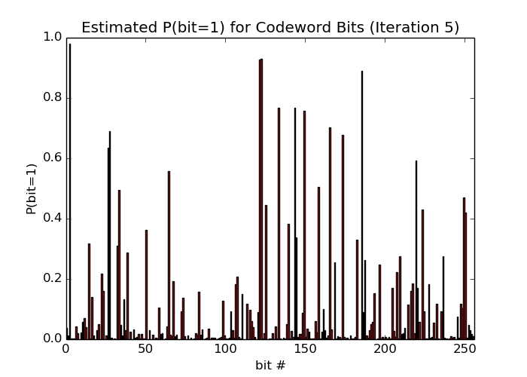

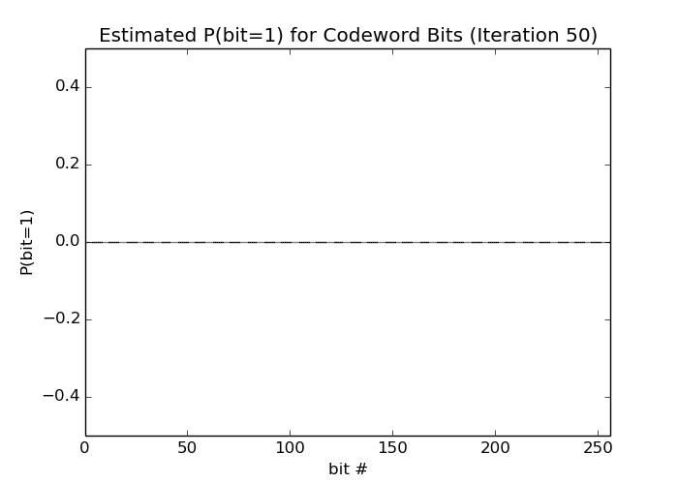

d) Since one of the trials converged at an incorrect solution for P(error) = 0.6, it is arguable whether the algorithm is reliable. If there can be an assurance made that for some error probability, the probability of converging to an incorrect codeword (or not converging at all) is vanishingly small, then the algorithm may be considered reliable for that scenario. Perhaps this is true for a lower probability of error than 0.6 for this case.

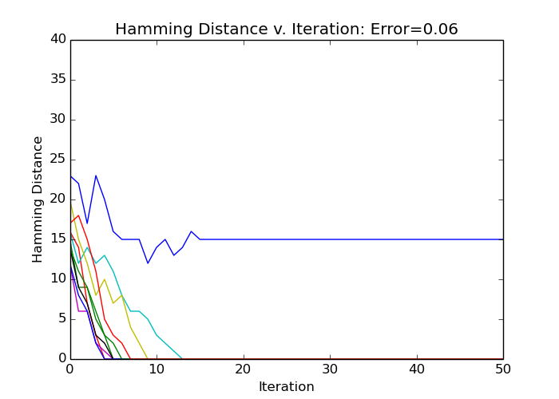
e) For higher error rates, it is clear that the probability of converging to an incorrect codeword increases (or not converging at all). We can see that while only one trial converges at an incorrect result for p(error)=0.6, about half are incorrect for p(error)=0.8, and all but two for p(error)=0.10. In some cases for p(error)=0.10, the converged codeword had more incorrect bits than the original noised codeword. In this way, it seems that p(error) should be 0.5 or less for the decoding to be reliable for this particular setup scheme.

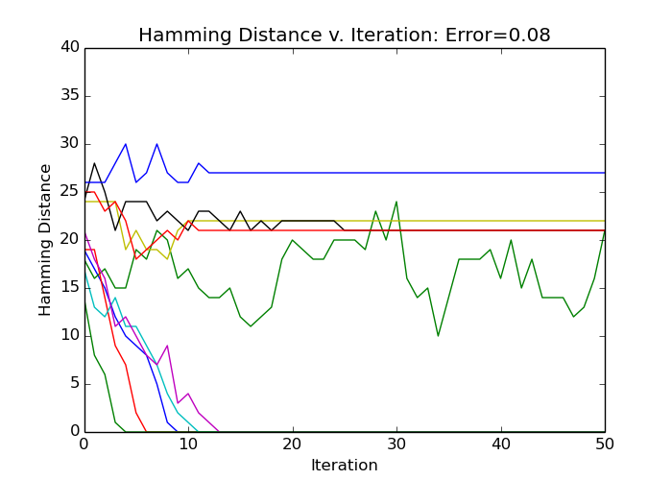

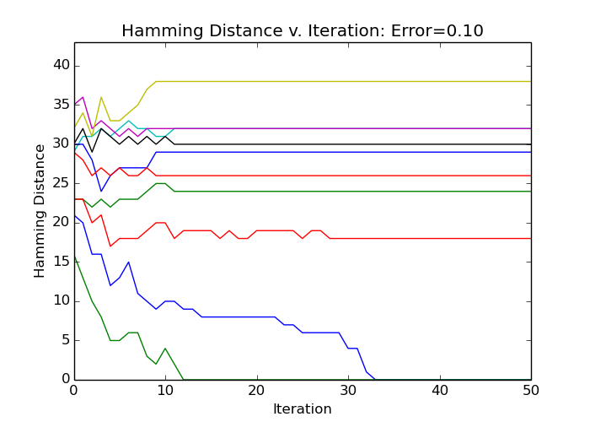

f) The hamming distance from the true codeword for the target iterations are included in a table. As shown in the plots, the original image is fully recovered for p(error)=0.6.

Hamming Distance for Different P(error)
 | Hamming Distance (from truth)
Iteration | P(error) = 0.06 | P(error) = 0.10
0 | 199 | 329
1 | 161 | 331
2 | 137 | 312
3 | 112 | 311
5 | 73 | 302
10 | 12 | 310
20 | 0 | 308
30 | 0 | 308

g) As shown by the included plots, the decoder converges to the correct result for P(error)=0.06, but not for P(error)=0.10. This aligns with the result for parts d/e. It seems that if a sufficient number of parity bits are corrupted, the decoder will always converge to an incorrect solution (or not converge at all). Still, for this example, the decoder was able to recover 21 bits for the higher error rate, meaning it has some utility. Multiple trials with different noise channels should be tested to see if it always converges, and if it does, if it converges to a result which recovers some bits.



