Lucas Kuenneke
May 24, 2009
CS241L-06
Dr. Doom
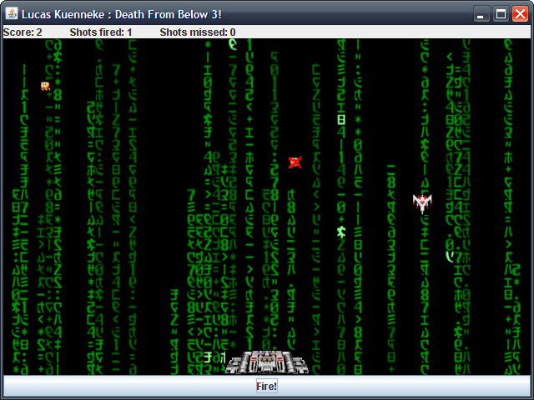
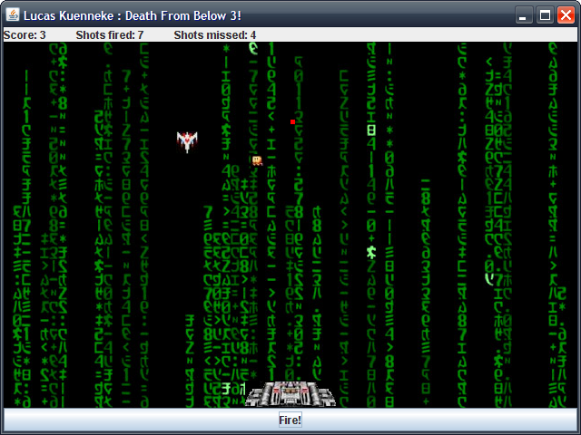

Game play install and everything is standard just simply extract the folder, good luck surviving my game.

