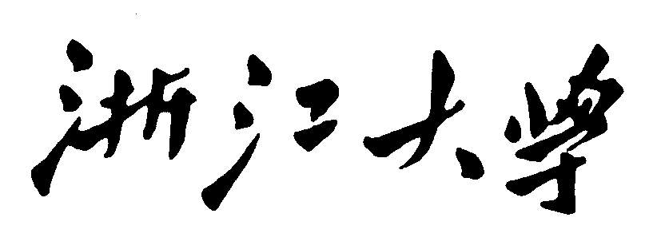

Artificial Intelligence
ParticleFilter for objtracking
Project Report


2020~2021春夏学期 2021 年 5 月 3 日
Categories
Chapter 1: Introduction 3
Chapter 2: Algorithm Specification 3
Chapter 3: Testing Results 4
Chapter 4: Analysis and Comments 5
Problems: 5

Chapter 1: Introduction
Background and Our goals:
This program implements a particle-filter algorithm to track designed target.

Chapter 2: Algorithm Specification
Basic algorithm: particle-filter,
1.Transition (time update)
Each particle is moved by sampling its next position from the transition model
$$x_{t+1}=sample\left(P\left(x_{t+1} | x_{t}\right)\right) forward sampling$$

2. Weighting (Measurement update)
Fix sample observation
Down weight samples based on the evidence (likelihood weighting)
$$w\left(x_{t+1}\right)=P(e_{t+1}|x_{t+1})$$
The probabilities don’t sum to one since all have been down weighted

3. resampling
Rather than tracking weighted samples, we resample from our weighted sample distribution.

Pseudo codes:
Function particle-filtering (e, N, dbn) returns a set of samples for the next time step
Inputs: e, the new incoming evidence
N, the number of samples to be maintained
Dbn : a DBN with prior P(X0),transition model P(X1|X0),sensor model P(E1|X1)
Persistent(static variable): S, a vector of samples of size N, initially generated from P(X0)
Local variables: W, a vector of weights of size N

For I=1 to N do
S[i] <- sample from P(X1|X0 = S[i]) //step1
W[i]<- P(e|X1= S[i]) //step 2
S<- WEIGHTED-SAMPLE-WITH-REPLACEMENT(N,S,W) // step3
Return S.

Chapter 3: Testing Results
Intel(R) Core(TM) i5-8250U CPU @ 1.60GHz 1.80 GHz 运行时cpu占用率25%
阶数 | 100 | 200
1 | 1.56 | 19.73
2 | 1.78 | 17.8
3 | 1.31 | over 60s
4 | 1.88 | over 61s
5 | over13秒 | 59.22
6 | 1.54 | over120s
7 | 1.28 | over120s
8 | over33秒 | over120s
9 | 1.33 | over120s
10 | 1.4 | over120s

Chapter 4: Analysis and Comments
未来期待的改进:
1. 还有一些别的特征匹配模板, 比如

Problems:
问题1 安装出错EnvironmentNotWritableError: The current user does not have write permissions to the target environment.
解决方法: 用管理员身份启动anacoda prompt
问题2 什么是匹配模板?
这里是提取粒子中的灰度, 然后比较.

解决方法: 使用重载方法__lt__，__lt__是python中用于进行特定比较的方法。
例如
def __lt__(self, other):
if self.a == other.a:
return self.b < other.b #1小
else:
return self.a < other.a #小

问题3 怎么实现极大似然估计实现权重?
在opencv中 可以通过函数matchTemplate实现模板匹配，同时有六种相关的匹配算法
cv2.matchTemplate(target,template,cv2.TM_SQDIFF_NORMED)
#执行模板匹配，采用的匹配方式cv2.TM_SQDIFF_NORMED
result = cv2.matchTemplate(target,template,cv2.TM_SQDIFF_NORMED)
#归一化处理
cv2.normalize( result, result, 0, 1, cv2.NORM_MINMAX, -1 )
#寻找矩阵（一维数组当做向量，用Mat定义）中的最大值和最小值的匹配结果及其位置
min_val, max_val, min_loc, max_loc = cv2.minMaxLoc(result)
#匹配值转换为字符串
#对于cv2.TM_SQDIFF及cv2.TM_SQDIFF_NORMED方法min_val越趋近与0匹配度越好，匹配位置取min_loc
#对于其他方法max_val越趋近于1匹配度越好，匹配位置取max_loc

问题4怎么探索每个state？
s1.state =
这样可能会出错。一开始new一个对象然后赋值可以不可以。

问题5怎么计算每个的Manhattan距离？
解决方法:
for i in range(1, child_state.square_size ** 2):
dst_row, dst_col = dst_state.num_pos(i)
chi_row, chi_col = child_state.num_pos(i)
manhattan += abs(dst_row - chi_row) + abs(dst_col - chi_col)

问题6 End of statement expected
解决方法: print(x) 代替 print x

问题7: 为啥他在close list要return ？ 直接判断有了不就跳过吗？
原因: 是的,确实是直接跳过.

问题8: pycharm无法最大化, pycharm最小化打不开。
解决方法: 重装pycharm也不行, 换个项目就可以了.

问题9: ValueError: operands could not be broadcast together with shapes (0,) (3,)
维度不同, 不能相加, 因为 main函数是4维, 而puzzle 一开始是3维度
改了还是有错
ValueError: operands could not be broadcast together with shapes (2,4) (1,2)
原因: 这个加法是不是不能用于numpy的array, numpy.zeros, 和list不一样
4:4有问题, 3:3没问题
解决方法: 调用它的oncemove函数

问题10:死循环in deepcopy y = copier(memo)
RecursionError: maximum recursion depth exceeded while calling a Python object
这是因为stackoverflow了, 回溯太多次了. 这可能是算法的问题，也可能是代码里面的退出条件没加
后来它不报错了, 但是跑两三分钟都跑不出来,
一步步看看, start 复制好像是对的. Move list没有用到, once move也没有问题
if col < curr_state.square_size :
这里好像有问题, 其实是不行的, 这里会做很多不必要的操作, 进去判断了move产生了state之后发现是不行的,
其他三个方向好像是对的.
for i in range(child_state.square_size ** 2):
解决方法:

问题11:
原因:

问题12:
原因:

