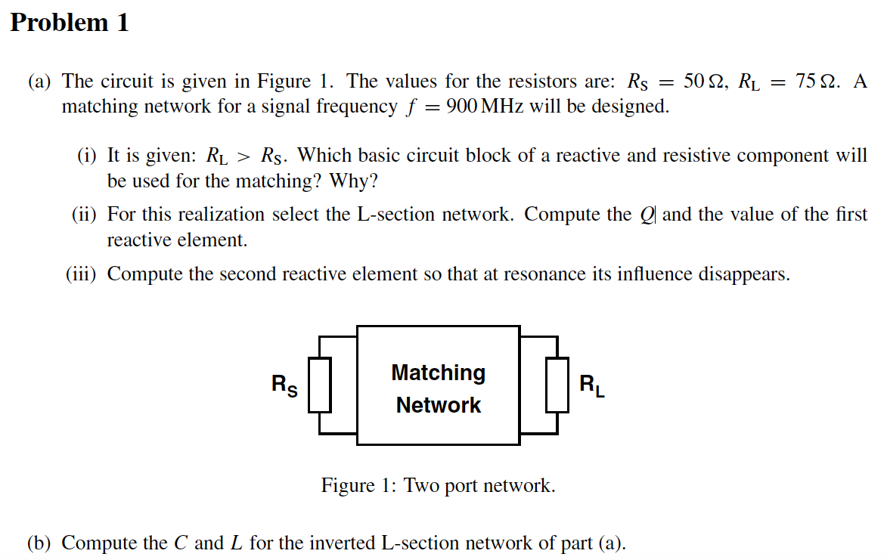

(i)which basic circuit block of a reactive and resistive component will be used for the matching? why?哪种基本的和阻性元件的电路块将被用于匹配。为什么？

反应组件的定义

1：交流电中与电动势相差90°的分量。2：电路两端的电压分量，与电流正交，在交流电路中不产生功率。

(ii)For this realization select the L-section network. Compute the Q and the value of the first reactive element.

为了实现这一点，选择L型截面网络。计算第一个无功元素的值和品质因子。

(iii)Compute the second reactive element so that at resonance its influence disappears. 计算第二个无功元素，让他在共振时其影响消失。

(b) Compute the C and L for the inverted L-section network of part (a).

什么是倒l型匹配电路  
倒l型匹配电路，是由一个电感线圈和一个电容构成。因为电感线圈和电容在电路中的接法像一个倒写的大写英文字母“L”，所以称为倒L型滤波电路。当直流电中的交流成分通过它时，大部分将降落在这个电感线圈上。经过电感线圈滤波后，残余的少量交流成分再经过后面的电容滤波，将进一步被削弱，从而使负载电阻得到了更加平滑的直流电。  
  
倒l型匹配电路有哪些特点  
倒l型匹配电路的滤波性能好坏决定于电感线圈电感量E和电容容量C的乘积，LC的乘积越大，滤波果越好。因为绕制电感线圈成本较高，所以在负载电流不大的场合，电感线圈电感量三可以用得小一些，而把电容容量C用得大一点。这种滤波电路实际上是由一个电容滤波电路和一个倒L型滤波电路串联而成，用多个倒三形电路串联起来，可以进一步改善滤波电路的滤波性能。滤波电路滤波后，其交流成分已大幅度减小，紧接着再经过一个倒L型滤波电路滤波，输出到负载电阻上的直流电压将更加平滑。

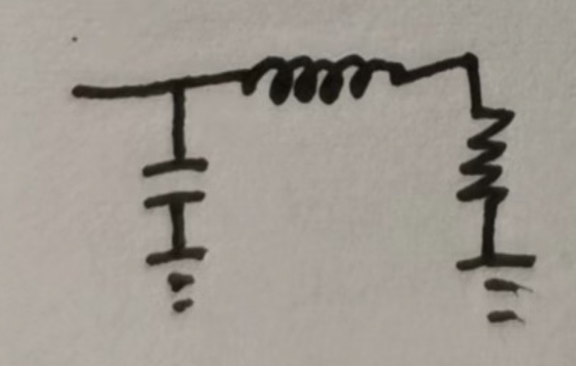

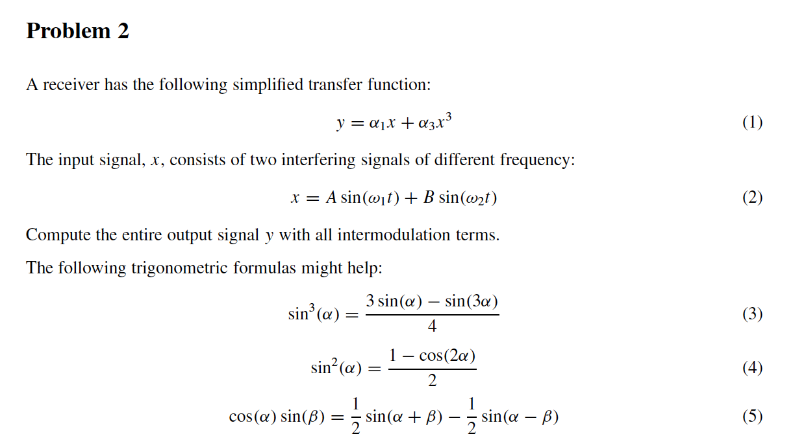A receiver has the following simplified transfer function:

= a1x+ a3x3 (1)

The input signal, *x,* consists of two interfering signals of different frequency:

*x =* A sin(w1t) ***B*** sin (c2t) (2)

Compute the entire output signal y with all intermodulation terms.

The following trigonometric formulas might help:

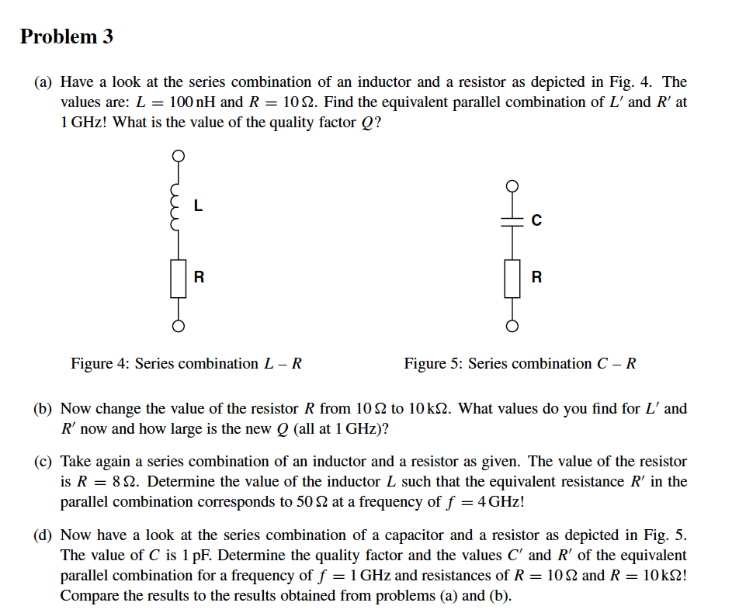

1. Have a look at the series combination of an inductor and a resistor as depicted in Fig. 4. The values are: ***L =*** 100 nH and ***R = 10 欧姆***. Find the equivalent parallel combination of ***L'*** and ***R'*** at 1 GHz! What is the value of the quality factor ***Q?***
2. Now change the value of the resistor ***R*** from 10 2 to 10 k2. What values do you find for ***Lf*** and ***R'*** now and how large is the new ***Q*** (all at 1 GHz)?
3. Take again a series combination of an inductor and a resistor as given. The value of the resistor ***is R =*** 8 O. Determine the value of the inductor ***L*** such that the equivalent resistance ***R'*** in the parallel combination corresponds to 50 Q at a frequency of *f =* 4 GHzl
4. Now have a look at the series combination of a capacitor and a resistor as depicted in Fig. 5. The value of *C* is 1 pF. Determine the quality factor and the values C' and ***R'*** of the equivalent parallel combination for a frequency of f = 1 GHz and resistances of ***R = 10 Q*** and ***R =*** 10 k2 Compare the results to the results obtained from problems (a) and (b).