import java.util.Scanner;

public class score {

public static void main(String args[]) {
Scanner scanner =new Scanner(System.in); // create scanner object
System.out.print("input score");
int assem=0,Archi=0,logic=0,embed = 0,organ=0,sum=0;
organ = scanner.nextInt();
Archi = scanner.nextInt();
logic = scanner.nextInt();
assem = scanner.nextInt();
embed = scanner.nextInt();

sum = (int) (0.8*embed + 0.9*assem+logic +Archi+organ); //0.8 is double
if(sum<0.6*organ) {
sum = (int) (0.6*organ);
}
if(logic<60||Archi<60||organ<60) {
sum = 0;
}

System.out.println(sum/5);
}

}
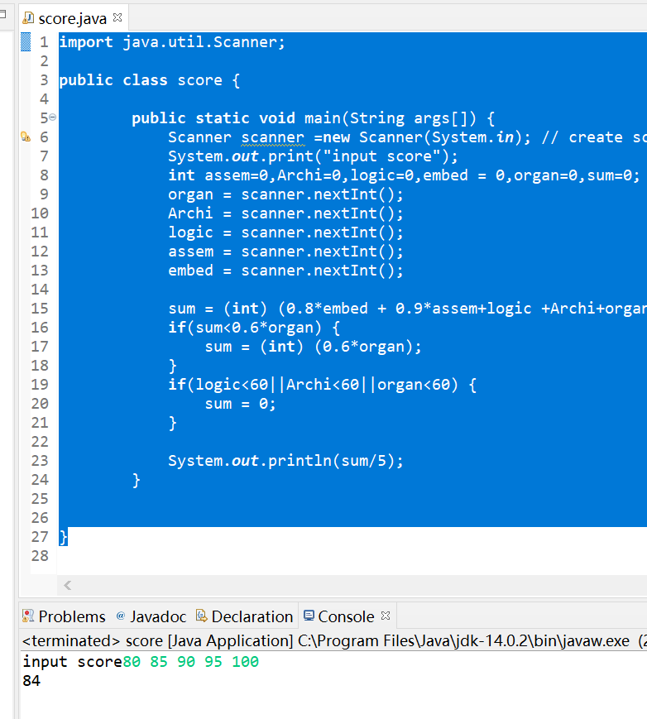
花了30分钟,感觉还有很多要学习的知识,具体的编译错误,通过命令行传入参数还不太会,学习了new scanner来输入,nextint可以自动转换数据类型. Nextline可以输入字符串.
最后别忘了还要关闭scanner.

