**import** java.util.Scanner;

**public** **class** score {

**public** **static** **void** main(String args[]) {

Scanner scanner =**new** Scanner(System.***in***); // create scanner object

System.***out***.print("input score");

**int** assem=0,Archi=0,logic=0,embed = 0,organ=0,sum=0;

organ = scanner.nextInt();

Archi = scanner.nextInt();

logic = scanner.nextInt();

assem = scanner.nextInt();

embed = scanner.nextInt();

sum = (**int**) (0.8*embed + 0.9*assem+logic +Archi+organ); //0.8 is double

**if**(sum<0.6*organ) {

sum = (**int**) (0.6*organ);

}

**if**(logic<60||Archi<60||organ<60) {

sum = 0;

}

System.***out***.println(sum/5);

}

}

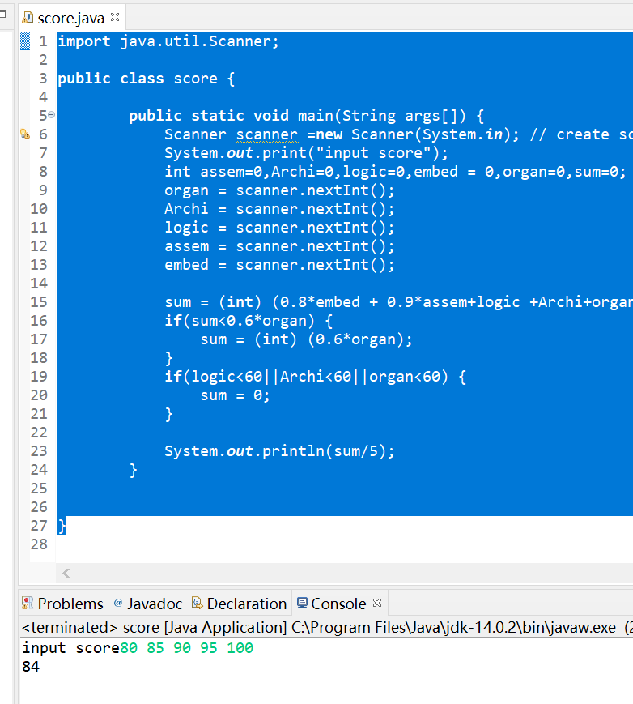

花了30分钟,感觉还有很多要学习的知识,具体的编译错误,通过命令行传入参数还不太会,学习了new scanner来输入,nextint可以自动转换数据类型. Nextline可以输入字符串.

最后别忘了还要关闭scanner.