Integrated writing
TPO 41
The professor starts by saying that much stricter regulations are very significant, though representatives of power firms argue that there are enough environmental regulations. She points out that old regulations are not sufficent. For example, it not require firms to use liner in the old pond, so the coal ash in old pond cause huge damage, plenty of drinkwater has been polluted.
Secondly, she makes a point that strict rules is unlikely to reduce selling of recycled coal ash products. She gives us a example to show that people have accepted the reliable recycled coal ash products. Consumers will not be afraid of the recycling products because of new policy.
Finally, she tells us that actually it may cost 50 billion dollars for disposal and handling costs. However, this amout of money just one percent of electricity companies bill. Therefore, it is worthwhile that spend so much money in creating a clean and green environment.
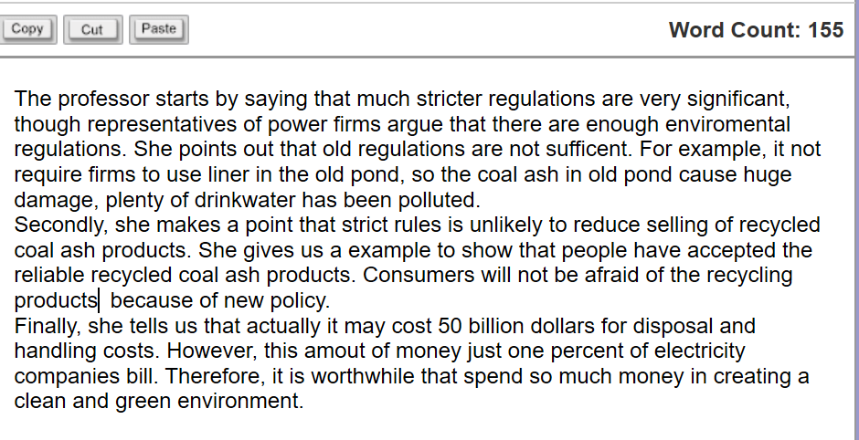

The professor starts by saying that
TPO42
The reading material tells us that xxx. The professor starts by saying that these solutions are perhaps not effective.
First of all, he tells us that one-way glass flacts lights to the birds outside. The birds can't understand the glass which like a mirror. They may see the sky and trees which are flacted by the glass, and then fly toward the glass. So this way can't sort out the problem.
Secondly, colorful window glass also have problems. The birds may misunderstand it as a open hole and fly right through them. What's more, the lights through colorful window are extremely small. It will cause the rooms too dark to work.
Finally, the professor argues that magnetic field solution can't work well. He points out that actually the birds use magnetic fields to guide them at long distance navigation. Such as flying from cold area to warm area in winter. However, the birds just use eyes and lights seeking direction in short distance. Therefore, the magnetic field solution won't have much effort.
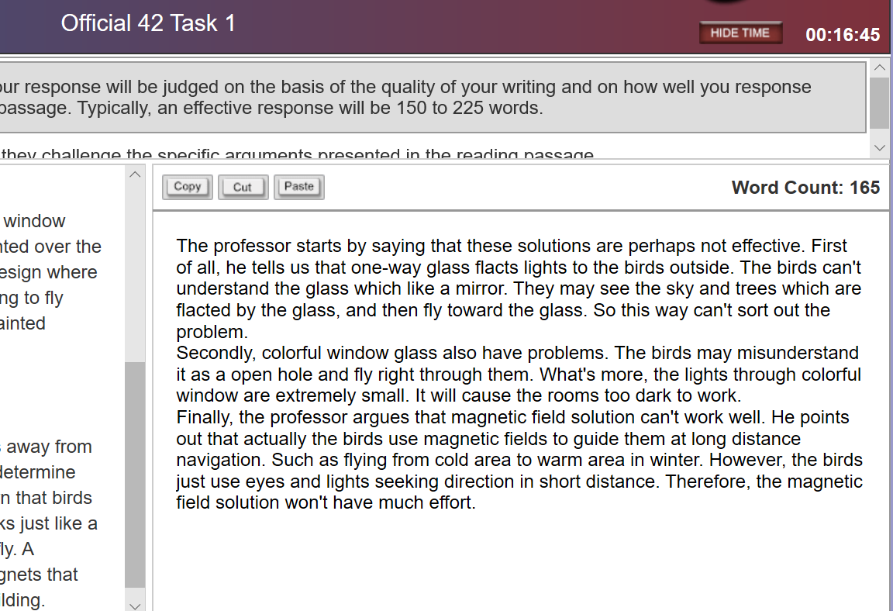

In the reading material, the author proposed three theories about how agnostids may have lived 提出三个 proposed
States their serious weakness
TPO 43
The reading material gives us three theories to explain how agnostids may have lived. However, the professor disagrees all three explaination and states their serious weakness.
First of all, the professor tells us that most of predators have well-developed eyes. But the agnostids only have tiny and poor developed eyes. In fact, they are completely blind. Even if they have other special sense to prey, they can't hunt easily.
Secondly, the professor denys Dwellers theory by arguing that usual seafloor dwellers tend to live in one area for a long time rather than move to new area frequently. Actually, the agnostids often move a long distance to another area. They can move obviously faster than usual seafloor dwellers. So they are not simlar to dwellers.
Finally, the professor gives a point that most of parasites stay on certain organisms and kill off them. But the agnostids seem too large to be a parasites who must living on larger arthropods.
最后这里写错了，没有说出Parasite populations have to stay within certain limits, 我们发现了we've been able to find vast amounts of fossilized individuals



Puts forward several opposite arguments to contradict what is stated in the
Is convinced On the contrary ， the professor maintain that
TPO44
Some archaeologists don't believe that the coin was brought to North America by Norse. But the professor disagrees with them and gives several reasons.
Fisrt of all, the professor admits that the site where the coin was found is far away from the Norse settlements. The professor also points out that people usually traveled great distance at that time. So the coin was possibly carried by someone who have a long travel.
Secondly, although no other coins have been found. It not necessary suggests that the Norse did not bring them to their settlements. The Norse may had packed them up, took them back to European, and left a coin what we have found. That is why we cannot find other coins.
Finally, the author argues that the Norse could not make use of the silver coins. However, the professor tells us that native North Americans were also interest in the silver coins even if they couldn't recognized the coins. They were fond of the beautiful and interesting silver coins. Thus, the reading material's statements are not logic.
没有说出he Norse could have used the coins to trade with them.
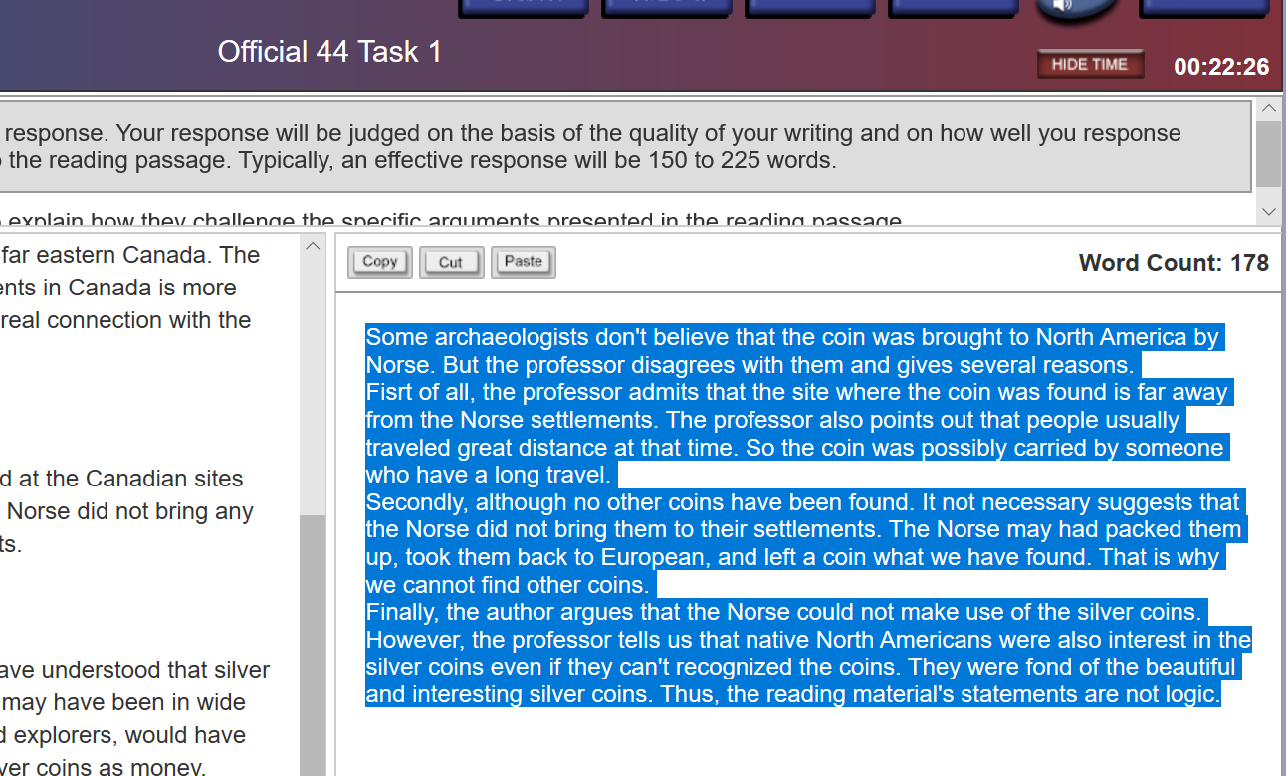

TPO45

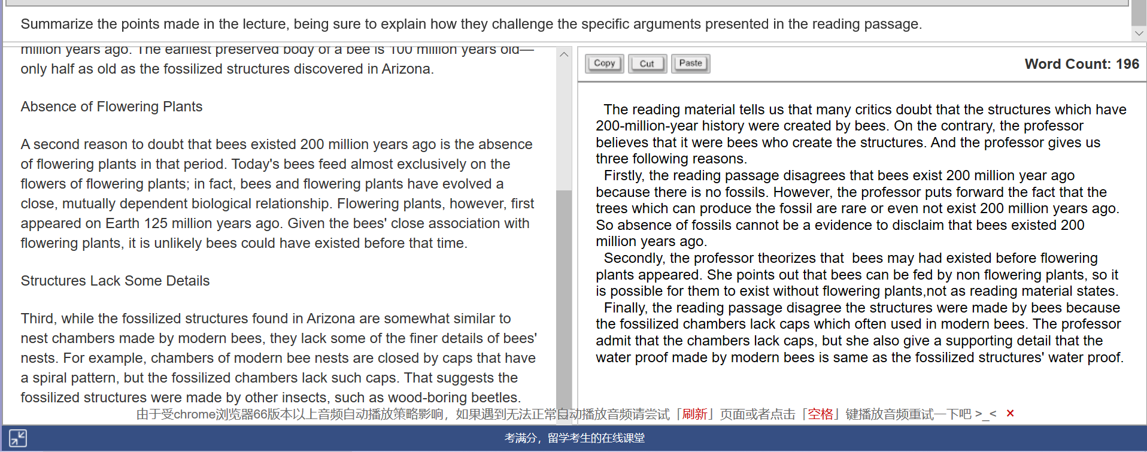
The reading material tells us that many critics doubt that the structures which have 200-million-year history were created by bees. On the contrary, the professor believes that it were bees who create the structures. And the professor gives us three following reasons.
Firstly, the reading passage disagrees that bees exist 200 million year ago because there is no fossils. However, the professor puts forward the fact that the trees which can produce the fossil are rare or even not exist 200 million years ago. So absence of fossils cannot be a evidence to disclaim that bees existed 200 million years ago.
Secondly, the professor theorizes that bees may had existed before flowering plants appeared. She points out that bees can be fed by non flowering plants, so it is possible for them to exist without flowering plants,not as reading material states.
Finally, the reading passage disagree the structures were made by bees because the fossilized chambers lack caps which often used in modern bees. The professor admit that the chambers lack caps, but she also give a supporting detail that the water proof made by modern bees is same as the fossilized structures' water proof.

Independent writing
TPO41
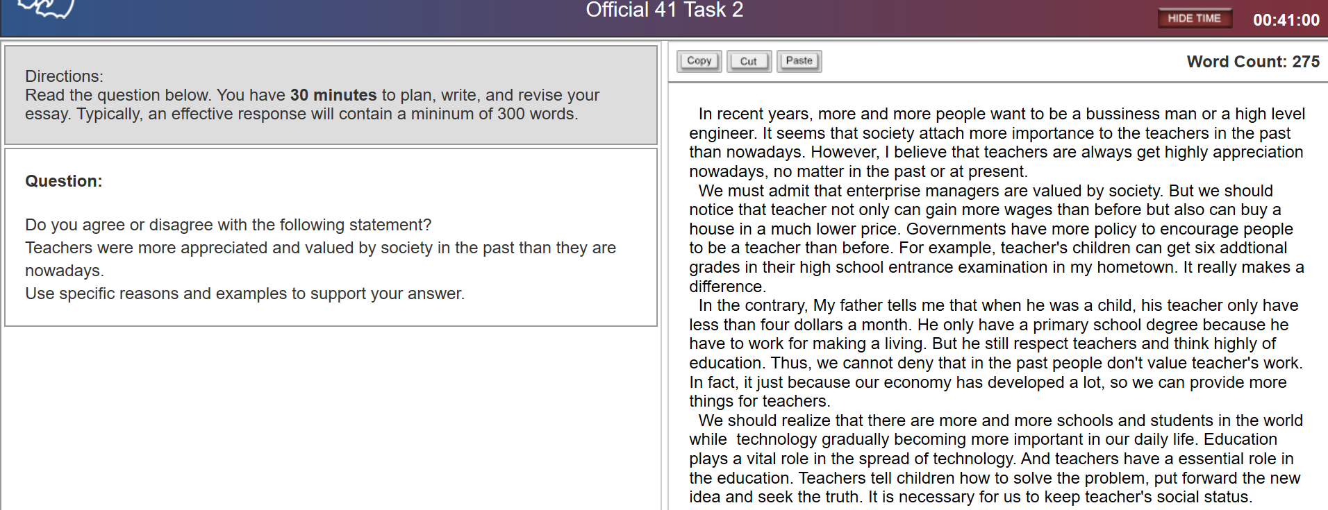
In recent years, more and more people want to be a bussiness man or a high level engineer. It seems that society attach more importance to the teachers in the past than nowadays. However, I believe that teachers are always get highly appreciation nowadays, no matter in the past or at present.
We must admit that enterprise managers are valued by society. But we should notice that teacher not only can gain more wages than before but also can buy a house in a much lower price. Governments have more policy to encourage people to be a teacher than before. For example, teacher's children can get six addtional grades in their high school entrance examination in my hometown. It really makes a difference.
In the contrary, My father tells me that when he was a child, his teacher only have less than four dollars a month. He only have a primary school degree because he have to work for making a living. But he still respect teachers and think highly of education. Thus, we cannot deny that in the past people don't value teacher's work. In fact, it just because our economy has developed a lot, so we can provide more things for teachers.
We should realize that there are more and more schools and students in the world while technology gradually becoming more important in our daily life. Education plays a vital role in the spread of technology. （为什么？例子没有举出来。不能只泛泛而谈，）And teachers have a essential role in the education. I still remember many words my teacher have told us. These words are definitely change many children's attuitide to knowledge, to science, and even to life.
Teachers tell children how to solve the problem, put forward the new idea and seek the truth. It is necessary for us to keep teacher's social status.
范文：
因为在当今社会，对受过高等教育或有特定技能的员工的要求越来越高，这正是老师能给你的。例如，在你找到一份高薪工作之前，你必须获得研究生学位。相比之下，那些只有高中文凭的人可能无法让面试官阅读他们的简历！不管多么不公平，社会就是这样运作的。因此，教师通过传授我们考试所需的技能，帮助我们获得名牌大学的文凭，对我们的生活产生了巨大的影响。（ 就业 ——对比论证 。nation 可以直接in some Chinese cities）
几年前，没有人关心老师的生活，也没有人关心孩子的学习成绩，因为人们担心自己的生活。相比之下，随着社会的进步，如今父母的社会资源更加丰富。他们努力提高孩子的教育水平，更多地关注教育最终将提高教师在社会中的价值。例如，在中国的一些城市，名师的工资远远超过了普通工薪阶层的工资。（父母家长，生活变化。）
第三，大多数文化都有尊师重教的传统，希望这一传统不会丧失。这是因为教师致力于教育孩子成为更好的人，遵守特定社会的规则，这对于任何文明的传承都至关重要。例如，在许多国家有一个专门为教师设立的日子，叫做教师节。在那一天，老师收到学生的鲜花是很常见的。这是教师在当今社会仍然受到尊重和赞赏的又一个例子。(文化传统)

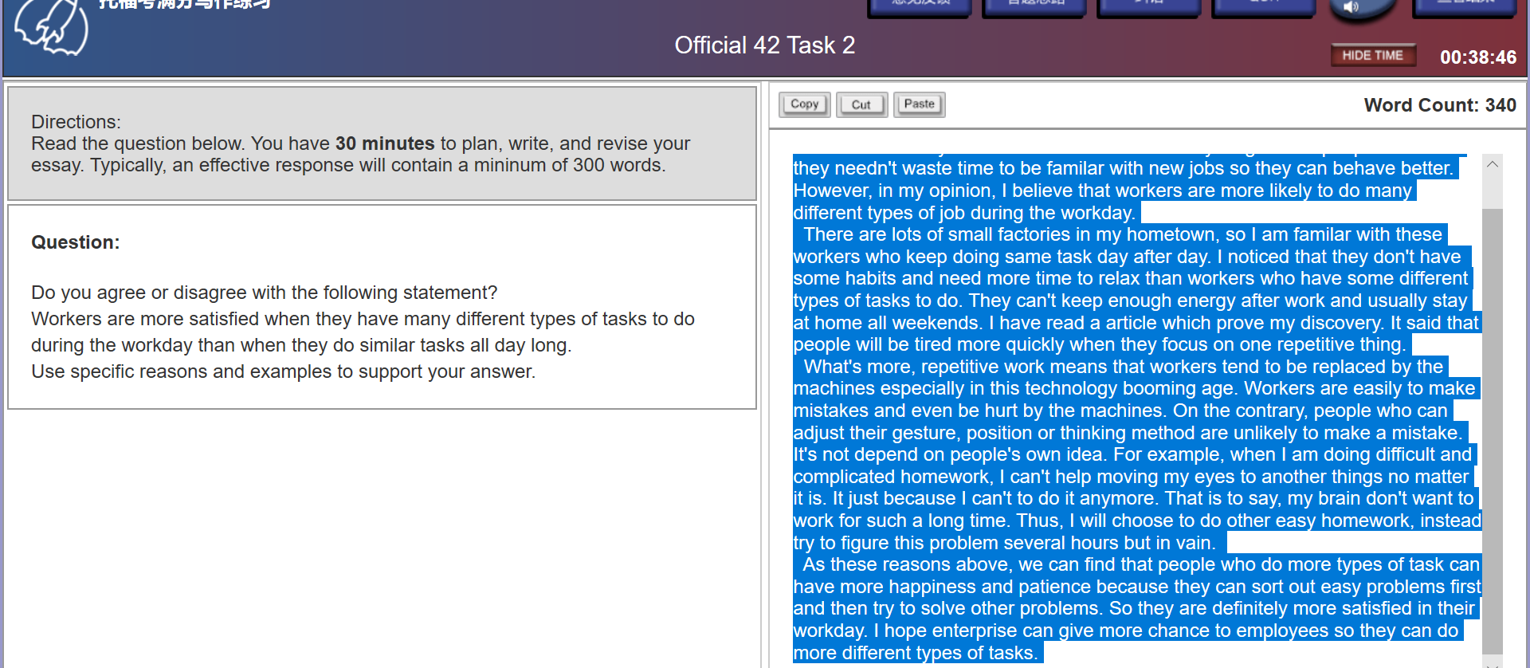
Different workers have different types of tasks. Workers do more specific works than before. Many of them do similar tasks all day long. Some people think that they needn't waste time to be familar with new jobs so they can behave better. However, in my opinion, I believe that workers are more likely to do many different types of job during the workday.
There are lots of small factories in my hometown, so I am famliar with these workers who keep doing same task day after day. I noticed that they don't have some habits and need more time to relax than workers who have some different types of tasks to do. They can't keep enough energy after work and usually stay at home all weekends. I have read an article which prove my discovery. It said that people will be tired more quickly when they focus on one repetitive thing.
What's more, repetitive work means that workers tend to be replaced by the machines especially in this technology booming age. Workers are easily to make mistakes and even be hurt by the machines. On the contrary, people who can adjust their gesture, position or thinking method are unlikely to make a mistake. It's not depend on people's own idea. For example, when I am doing difficult and complicated homework, I can't help moving my eyes to other things no matter it is. It just because I can't to do it anymore. That is to say, my brain don't want to work for such a long time. Thus, I will choose to do other easy homework, instead try to figure this problem several hours but in vain.
As these reasons above, we can find that people who do more types of task can have more happiness and patience because they can sort out easy problems first and then try to solve other problems. So they are definitely more satisfied in their workday. I hope enterprise can give more chance to employees so they can do more different types of tasks.

我好像没写为什么满意，写的有点偏题了！
更多样的工作需要更多的技巧和知识->能促使他们不断学习，完善他们的skillset->他们能在学习和skillset的improvement中fulfill他们的价值收获到满足感 EX：我实习的公司 Product Manager比程序开发者看起来每天更快乐，因为需要每天学习交流技巧，产品热点等等知识
2.更多的工作能接触到更多的人和新鲜事物-》让生活更加丰富，enrich experience-》制造了更多期待和希望-》更多的满足感。 Ex：产品经理每天和不同的人打交道很开心，经历很丰富。

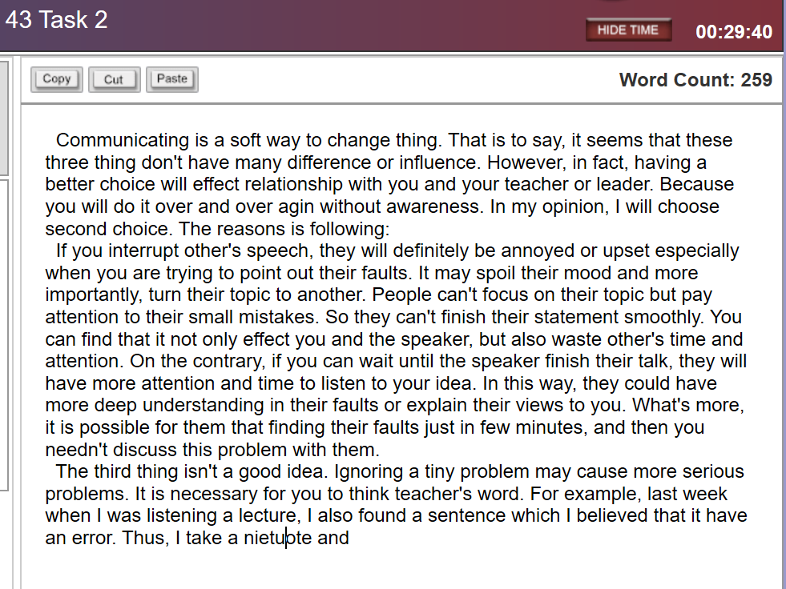

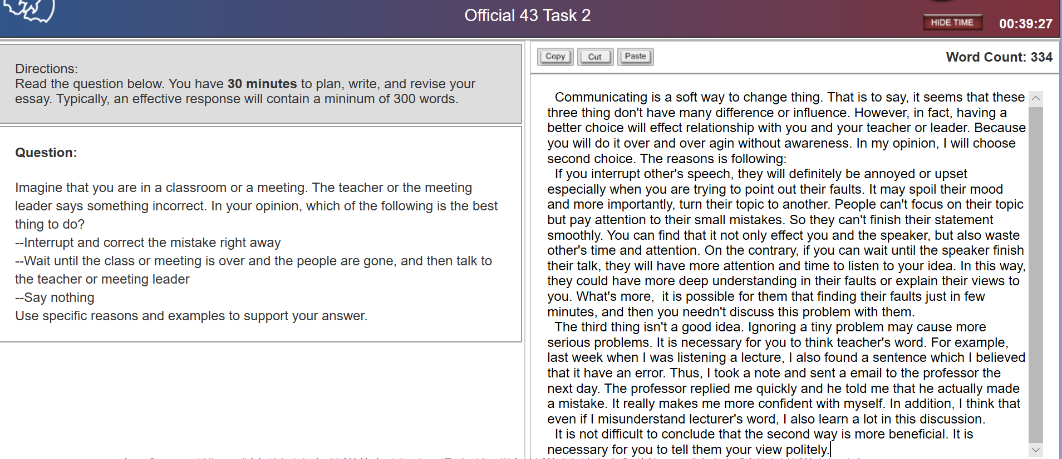
范文：We would encounter the situation where the teacher makes mistakes in a large classroom or you believe that teacher have told something wrong for lots of times during our daliy life我们可以先把内容简单介绍一下

Communicating is a soft way to change thing. That is to say, it seems that these three thing don't have many difference or influence. However, in fact, having a better choice will effect relationship with you and your teacher or leader. Because you will do it over and over again without awareness. In my opinion, I will choose second choice. The reasons is following:
If you interrupt other's speech, they will definitely be annoyed or upset especially when you are trying to point out their faults. It may spoil their mood and more importantly, turn their topic to another. People can't focus on their topic but pay attention to their small mistakes. So they can't finish their statement smoothly. You can find that it not only effect you and the speaker, but also waste other's time and attention. On the contrary, if you can wait until the speaker finish their talk, they will have more attention and time to listen to your idea. In this way, they could have more deep understanding in their faults or explain their views to you. What's more, it is possible for them that finding their faults just in few minutes, and then you needn't discuss this problem with them.
The third thing isn't a good idea. Ignoring a tiny problem may cause more serious problems. It is necessary for you to think teacher's word. For example, last week when I was listening a lecture, I also found a sentence which I believed that it have an error. Thus, I took a note and sent a email to the professor the next day. The professor replied me quickly and he told me that he actually made a mistake. It really makes me more confident with myself. In addition, I think that even if I misunderstand lecturer's word, I also learn a lot in this discussion.
It is not difficult to conclude that the second way is more beneficial. It is necessary for you to tell them your view politely.

范文结尾：In short, I believe that asking the question and correcting for teachers after the class could really benefit both of the professor and all of the students since the class would run as scheduled and everybody would know the truth.
TPO 44
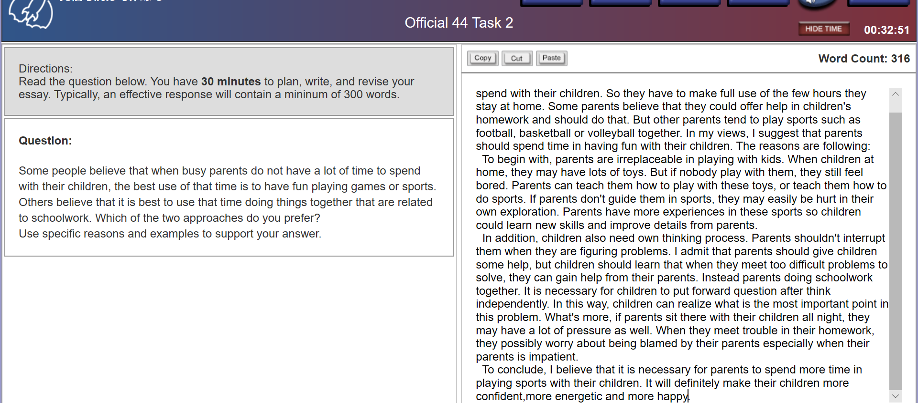
Busy parents often encouter the situation that they don't have plenty of time to spend with their children. So they have to make full use of the few hours they stay at home. Some parents believe that they could offer help in children's homework and should do that. But other parents tend to play sports such as football, basketball or volleyball together. In my views, I suggest that parents should spend time in having fun with their children. The reasons are following:
To begin with, parents are irreplaceable in playing with kids. When children at home, they may have lots of toys. But if nobody play with them, they still feel bored. Parents can teach them how to play with these toys, or teach them how to do sports. If parents don't guide them in sports, they may easily be hurt in their own exploration. Parents have more experiences in these sports so children could learn new skills and improve details from parents.
In addition, children also need own thinking process. Parents shouldn't interrupt them when they are figuring problems. I admit that parents should give children some help, but children should learn that when they meet too difficult problems to solve, they can gain help from their parents. Instead parents doing schoolwork together. It is necessary for children to put forward question after think independently. In this way, children can realize what is the most important point in this problem. What's more, if parents sit there with their children all night, they may have a lot of pressure as well. When they meet trouble in their homework, they possibly worry about being blamed by their parents especially when their parents is impatient.
To conclude, I believe that it is necessary for parents to spend more time in playing sports with their children. It will definitely make their children more confident, more energetic and more happy.

范文: With the development of the society and economy, people are getting busier than past.
Admittedly, sometimes parents should care about the academic behavior of their kids.
Given the reasons above, I would like to reiterate my view of point that parents should spend their time doing fun with their kids.

TPO45
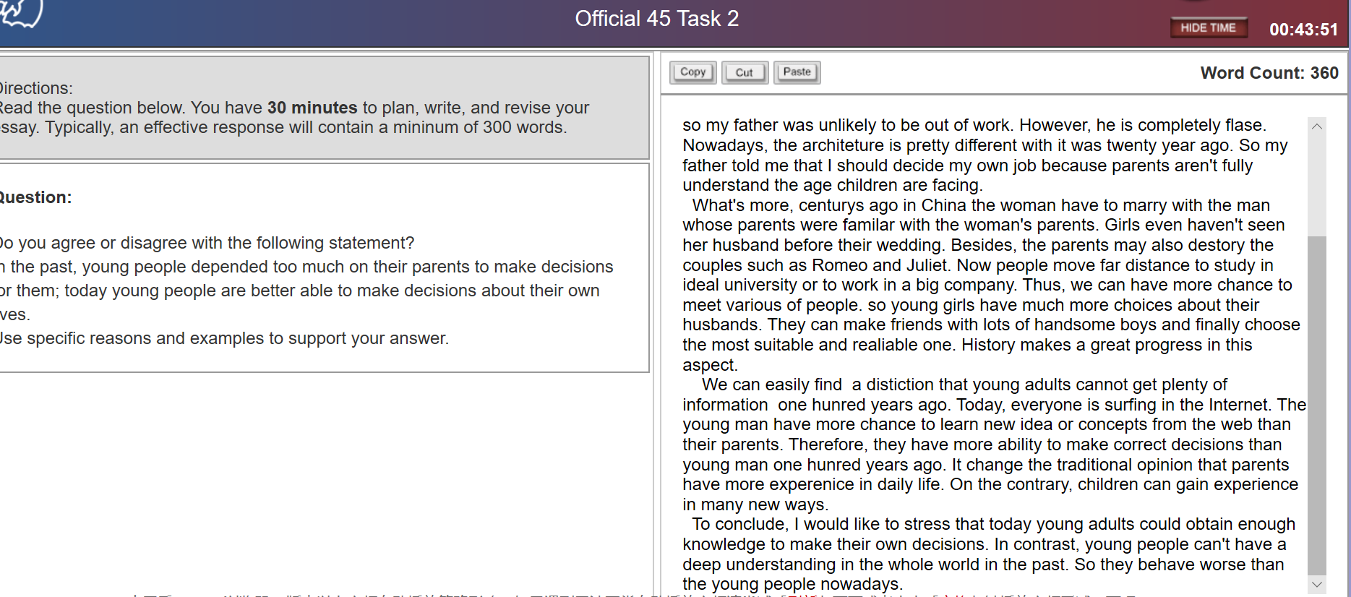

With the development of social economy, traditional culture have a great change. For example, people become more independent than before. So I agree that nowadays young people have more freedom to make decision about their own lives.
Firstly, young adults can choose their favorite work. In the past, parents often gave their children guidance in their job. My father went to learn architetrue because my grandfather believed that architeture was a lifelong and steady job so my father was unlikely to be out of work. However, he is completely flase. Nowadays, the architeture is pretty different with it was twenty year ago. So my father told me that I should decide my own job because parents aren't fully understand the age children are facing.
What's more, centurys ago in China the woman have to marry with the man whose parents were familiar with the woman's parents. Girls even haven't seen her husband before their wedding. Besides, the parents may also destory the couples such as Romeo and Juliet. Now people move far distance to study in ideal university or to work in a big company. Thus, we can have more chance to meet various of people. so young girls have much more choices about their husbands. They can make friends with lots of handsome boys and finally choose the most suitable and realiable one. History makes a great progress in this aspect.
(可以加一句Last but not least, young people are generally more educated than their parents) We can easily find a distiction that young adults cannot get plenty of information one hunred years ago. Today, everyone is surfing in the Internet. The young man have more chance to learn new idea or concepts from the web than their parents. Therefore, they have more ability to make correct decisions than young man one hunred years ago. It change the traditional opinion that parents have more experenice in daily life. On the contrary, children can gain experience in many new ways.
To conclude, I would like to stress that today young adults could obtain enough knowledge to make their own decisions. In contrast, young people can't have a deep understanding in the whole world in the past. So they behave worse than the young people nowadays.
范文:
While the old generation hold old-fashioned and outmoded views, the youngsters today is a generation of the internet, who are proficient in using the internet to search and procure the most helpful and relevant information from immense amount of data online.

Last but not least, young people are generally more educated than their parents

This is because their parents always hold outdated opinions; because the youngsters master the skills in getting the information needed from the internet; and because the young generation have a better judgement result from a better education.

