Revised by:
Maryfe
Date: 10/14/2021

Score and Assessment
Development
Requirements of the task | addresses the topic and task well, though some points may not be fully elaborated
Content
Organization
Organization/Progression | displays unity, progression and coherence though it may contain occasional redundancy, digression or unclear ideas
Paragraphing
Use of cohesive devices
Language Use
Use of lexicons | displays facility in the use of language, demonstrating syntactic variety and range of vocabulary though it will probably have occasional minor errors in structure, word form or use of idiomatic language that do not interfere with meaning
Use of Grammar
Band Score | 4.0- 25  This is the RAW score for one of the two writing test only. To get the overall score (0-30), add the RAW SCORES for integrated and independent writing, then check the scaled TOEFL writing score.

* Note that the computation of score is round down.

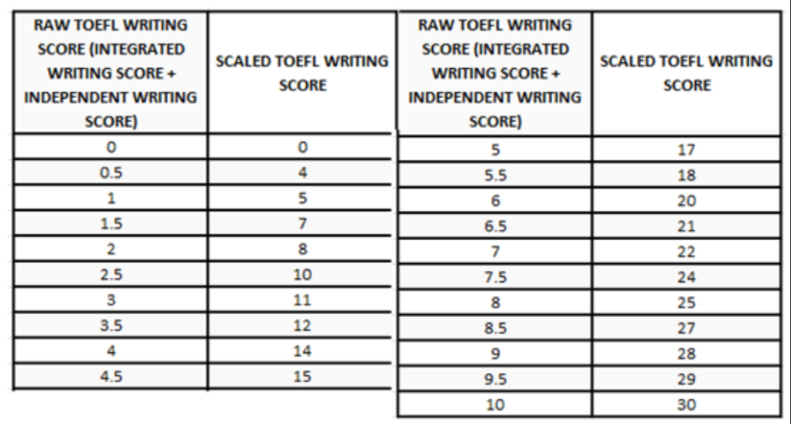

TASK:

Some parents offer their school-age children money for each high grade (mark) they get in school. Do you think this is a good idea?
Use specific reasons and examples to support your answer.

Task Analysis
What the task is asking for | Discuss whether or not it is a good idea for parent to offer their children money for each high grade (mark) they get in school.

Essay:

Is that offering school-age children money for each high grade they get in school so good? As the competition among students is aggravating, many of them, especially parents, are getting anxious; some parents even use money as a stimulus for their young ones to get a high score. It is a hot topic. When it comes to the question, people's views vary from one to another. Some assert that parents should not offer their school-age children money for each high grade, whileNevertheless, otherspeople hold different views about this action. From my perspective, I think that it is unnecessary for parents to offer their school-age children money.
Note: Good job since you were able to state your opinion here clearly,.
Undoubtedly, offering children money for each high mark has some advantages. Just imagine that when kids youngsters get twenty dollars after getting a high grade, they can buy many compelling toys. If they obtain some money from their parents, they will be pre delighted and excited. This can improve their learning motivation. After all, children all love playing games, and buying toys, and so on. Moreover, spending money on these small things also means that children can learn how to correctly use their money to purchase things. It will develop their awareness of spending money in the future. InBy contrast, if children dodidn't not have boughtbuy anything when they arewere young, they will lack this awareness and then incorrectly use their money. To some extent, the argument seems to be perfect. To be specific, when a youngster enters a big mall and he has seen so much appealing foods, toys, or garments such as fried French or superman toy, it is not surprising that if he has enough money to buy these things even if the money couldn’t be better used for some emergency in the future, he could not control himself to reach those things because he has enough money to buy them but doesn’t have the ability of self-control.
However, we have to stress one point, and that is, with the use of money, we are attaching less importance to motivations unrelated to money the true value of education, which can imply simplicity and consequently lead to diverse underlying shortages. Therefore, it is problematic that parents encourage their children to work hard by giving money. From one angle, it suggests that children may not pay attention to the really useful knowledge, but focus on the following reward. Then, the children may not dive into important academic researches since it is inefficient to work for difficult academic problems. It will limit their future career development. Without any exaggeration, even though some young children really like studying, they will not pay close attention to the textbooks unrelated to the high grade. It will cause thatConsequently, they couldn't not enjoy the beauty of knowledge. On the contrary, if some parents encourage their children in other ways, such as go hiking with them or eat a delicious meal in a restaurant, their children will also be motivated to get good grades on the next exam.
Note: Good job since you were able give a reason to justify your opinion, with some inaccuracies noted. Also, I suggest you change the structure to have a better flow of ideas.
Furthermore, young children cannot control themselves easily. They may buy a lot ofmany beautiful toys without further thinking. Thus, they will spend a gigantic amount of money very quickly. What's is more, childrenyoungsters may cheat in the exam for getting high grades. They may learn bad habits or become dishonest in order to get the reward. If their parents or teachers don't not teach them seriously, the money will ruin their lives. It really challenges the children, parents, and teachers. Therefore, giving childrenyoung individuals money directly as a reward isn't not an effective strategy.
Note: Good job since you were able give another reason to warrant your opinion, with some errors in the accuracy of language seen.
Everyone has his own ideas. At the same time, as an old saying goes, "Each coin has two sides" In consequence, I don't absolutely believe that my idea is the best and compel people to reach a consensus on the issue. It is, just for me, I am prone to take the ability to maintain a friendship for long as a priority. To sum up, I do not think the measure of using money as a return for good grade would help youngsters make a true progress in their academic study instead it will just teach them undesirable habits and make them forget the true meaning of studying.
Note: Always include a conclusion for closure, reminding the contents and importance of the essay. The conclusion is your final chance to show how all the paragraphs of your essay add up to a coherent whole. In this part, it is also important for you to reiterate your stand. FORMAT: In conclusion, [RESTATE THE OPINION]. This is because [SUMMARIZE THE POINTS YOU HAVE DISCUSSED IN THE BODY PARAGRAPH].

Suggestions and Improvements
Development | - The stand was supported in the body paragraph, but there was no proper conclusion seen. Also, since some parts are confusing, I suggest that after you’ve finished writing your essay, spend a little bit of time looking it over. Even setting aside 60 seconds can give you enough time for you to skim your essay and catch any spelling or grammar errors or any sentences that aren’t clear. Fixing these little mistakes can help you from losing points when your essays are scored.
Organization | Many TOEFL Independent Writing responses turn out to be disorganized due to a lack of prewriting. Prewriting involves two steps: brainstorming and outlining. In the brainstorming phase, just write down whatever ideas you can think of. Then move onto your outline. This is where you choose the ideas you’ll use in the essay, and you organize them into the right order. The order of your outline should match good TOEFL Independent Essay structure, providing for an introduction, body, and conclusion.  **************  Establishing Coherence  It is important to focus on coherence when writing at the sentence level. However, cohesion smoothens the flow of writing and should be established. There are various ways to ensure coherent writing:  - Write sentences that flow by varying the lengths and structures, the use of correct punctuation, and broadening your word choices  - Use simple transitions, such as “in addition, additionally, furthermore, therefore, thus, on the contrary, by the same token, at the same time, in other words, etc.”  - Repeat your keywords but be careful of excessive repetition  - Repeat sentence structures, which is used as a rhetorical technique rather than cohesion to highlight parallelism between sentences  - Ensure thematic consistency  - Start every sentence or paragraph with information that hints at the content of the next sentence  Academic writing is improved by coherence and cohesion. Without coherence and cohesion, readers will become confused and eventually disinterested in the article. Your ideas then become lost and the primary objective of writing is not achieved.  Tips and Strategies  There are six ways for creating coherence, which you will find useful while polishing your manuscript. Creating coherence is not as difficult as it seems, but you will need the right tools and strategies to achieve it.  - Lexis creates cohesion using synonyms, hyponyms, and superordinates. The use of lexical chains creates variety in writing and avoids monotony.  - Reference creates cohesion by using possessive pronouns (e.g. your, their, etc.), pronouns (e.g. she, me, etc.), and determiners (e.g. those, these, etc.).  - Substitution, which is the use of a different word in place of a previously mentioned word (e.g. “I bought a designer bag today. She did the same.”)  - Ellipsis is the removal or omission of words because their meaning is implied through context (e.g. “He goes to yoga classes in the afternoon. I hope I can too.”)  - Cohesive nouns are also called umbrella nouns because they summarize many words in one.  - Conjunctions include words that list ideas (e.g. first, next, then, lastly, etc.)
Language Use | - Use variation of terms or synonyms to avoid over-repetition of a word. In the test, to receive a higher score for the LANGUAGE, you should be able to utilize less common words appropriately.  - Contractions are a part of informal writing. Thus, avoid contractions in scholarly writing, except for under the following circumstances:  - If you are reproducing a direct quotation that contains a contraction (e.g., a quotation from a research participant), leave the contraction as-is.  - If you are writing about contractions (e.g., in a paper about language), naturally you must be able to use contractions as linguistic examples.  - If you are reproducing an idiom that contains a contraction (e.g., “don’t count your chickens before they hatch”), leave the contraction (no need for “do not count your chickens…”).  - If you are making an off-the-cuff or informal remark within an otherwise formal paper, it is okay to use a contraction as part of your writing voice. You might find this kind of remark in a footnote or a parenthetical statement. Scientific writing should be formal but it doesn’t have to be stuffy. It is okay to have a moment of informality as long as the overall tone is appropriately formal.  - RUN-ON SENTENCES  Problem  A run-on sentence occurs when two or more independent clauses are not joined correctly. An independent clause is a group of words that can stand alone as a sentence, as in, “the dog runs.” Your writing may be confusing or unclear if independent clauses are joined incorrectly.  There are two types of run-on sentences: fused sentences and comma splices. A fused sentence occurs when independent clauses run together with no marks of punctuation or coordinating conjunctions to separate them.  independent clause independent clause  Fused sentence: My professor read my paper she said it was excellent.  A comma splice occurs when two or more independent clauses are joined only by a comma.  Comma splice: My cat meowed angrily, I knew she wanted food.  Solution  REVISE RUN-ON SENTENCES in one of four ways:  - Use a comma and a coordinating conjunction (and, but, yet, so, or, nor, for). When you join two independent clauses with a coordinating conjunction, place a comma before the coordinating conjunction.  Run-on: My professor read my paper she said it was excellent.  Correction: My professor read my paper, and she said it was excellent.  - Use a semicolon (or, in some cases, a colon or a dash). You can use a semicolon alone or with a transitional expression (e.g., however, at any rate, in contrast, as a result, etc.).  Run-on: My cat meowed angrily, I knew she wanted food.  Correction: My cat meowed angrily; I knew she wanted food.  Correction with a transitional expression: My cat meowed angrily; therefore, I knew she wanted food.  - Separate the independent clauses into sentences. This is an especially good technique when one of the independent clauses is very long.  Run-on: It seemed to Wanda that her daughter had more than enough crayons, they were strewn across the bedroom floor and some of them were broken, and, worse still, someone had used the stub of a red crayon to mark a sinister smiley face on the wall.  Correction: It seemed to Wanda that her daughter had more than enough crayons. They were strewn across the bedroom floor, and some of them were broken. Worse still, someone had used the stub of a red crayon to mark a sinister smiley face on the wall.  - Restructure the sentence by subordinating one of the clauses. You can subordinate a clause if one of the independent clauses seems less important than the other. Here are a few examples in which one of the clauses has been subordinated (indicated here by underlining). Note that a subordinated clause is no longer independent—it cannot stand on its own as a sentence.  Run-on: The largest tree by volume in the world is the General Sherman Sequoia, it is a little over 52,500 cubic feet.  Correction: The largest tree by volume in the world is the General Sherman Sequoia, which is a little over 52,500 cubic feet.  Run-on: Toni Morrison is a professor at Princeton University, she wrote the novel The Bluest Eye.  Correction: Toni Morrison, a professor at Princeton University, wrote The Bluest Eye.  Run-on: I told my roommate I would be late, she still locked me out.  Correction: Although I told my roommate I would be late, she still locked me out.  Run-on: I told the children I would read to them they said they wanted to sit by me so they could look at the pictures.  Correction: When I told the children I would read to them, they said they wanted to sit by me so they could look at the pictures.  4. A Brief Guide to Using Commas  1. Use a comma when you link two or more sentences with one of the coordinating conjunctions: F(for)A(and)N(nor)B(but)O(or)Y(yet)S(so).  a. The year was 2081, and everybody was finally equal.  2. Use commas with three or more items in a list.  a. She is a child of her age, of depression, of war, and of fear.  3. Use a comma to separate most OPENING chunks of text from the rest of the sentence.  a. Although I try to avoid eating pizza because I consider it unhealthy, sometimes I  cannot resist having a slice.  b. Certainly, any plan that is enacted must be fair.  c. In other words, we cannot act hastily.  4. Put commas around “interrupters” or words in the MIDDLE of a sentence that are not  essential to the meaning of the sentence.  a. The restaurant, which only serves breakfast and lunch, was closed.  Note that if the information inside the commas is removed, the sentence still makes sense.  5. In most cases, use commas to set off a direct quotation from the identifying tag—the  phrase that identifies the speaker (he said, she answered).  a. The person said to me, “Why don’t alligators like to eat clowns?”  6. Use commas in dates and addresses:  a. On June 4, 2005, a dog walked into a house in Paris, Texas, and ate a pair of  shoes.  7. To separate adjectives that describe the same noun (coordinate adjectives).  a. I drank the sweet, cold lemonade.  b. It felt like the hot, sticky summer would never end.  Note that you can put “and” instead of a comma between the adjectives. (Sweet and cold  lemonade; hot and sticky summer.)  8. Use a comma to set off nouns of direct address:  a. Mom, you’re the best.  b. Be quiet, Toto!  Commas are NOT necessary in the following examples:  • NOT between a subject and a verb  o INCORRECT: The gifts she received from her colleagues, made her realize her  value.  o CORRECT: The gifts she received from her colleagues made her realize her value.  • NOT between a verb and its object or complement  o INCORRECT: The best gifts are, food and clothes  o CORRECT: The best gifts are food and clothes.  • NOT before part of a compound sentence that is not an independent clause  o INCORRECT: She won the trophy, and accepted it gracefully.  o CORRECT: She won the trophy and accepted it gracefully.  • NOT before a clause beginning with “that”  o INCORRECT: They warned us, that the meeting would be difficult.  o CORRECT: They warned us that the meeting would be difficult.  • NOT with a subordinating conjunction (after, before, because, if, since, unless, until,  when)  o INCORRECT: She will continue working for the city, until she has saved enough  for graduate school.  o CORRECT: She will continue working for the city until she has saved enough for  graduate school.  • NOT after “such as”  o INCORRECT: The bought kitchen supplies such as, detergent, paper towels, and  garbage bags.  o CORRECT: They bought kitchen supplies such as detergent, paper towels, and  garbage bags.

