Luke Olsen Tristan Ramos
143552222

- Which programming languages did you choose?
  - For Step 1 I used C++ language which I am most familiar with
  - For Step 2 I chose to use Rust
- How long did it take to write manually vs. with AI?
  - Manually, it took me around 1 hour and 10 minutes to fully complete the program and run it without any problems
  - With AI, it only took me 16 minutes and 22 seconds from installation of required tools to running a complete working port in rust
- Reflections on the experience:
  - Time & Effort: Compare the time and effort for the manual vs. the AI-assisted part. Which felt faster or easier, and why?
  - AI's Strongest Role: Where did the AI help you the most? Was it writing the initial code, explaining how to set up the project, or helping you test/debug?
  - AI's Weakest Role: Where did the AI struggle or give you incorrect information? Did you have to correct its code or instructions?
  - Impact on Learning: Do you feel you learned the basics of the new language, or did the AI act as a "black box" that just gave you the answer? Explain briefly.
For time and effort, AI is 100 percent faster as I just have to copy and paste my code to the chat and tell the model to port it to another language. It also didn’t have any problems with telling me the installation process and the porting process so everything went smoothly without me correcting the code and instructions. BUT, using AI, I just copied the code and told the instructions to port, then pasted the results, there was very little learning. The only thing I learned is the commands to create a new rust project and running the source file, so there wasn’t any learning in terms of syntax and how the code in the language is written.

Output in C++:
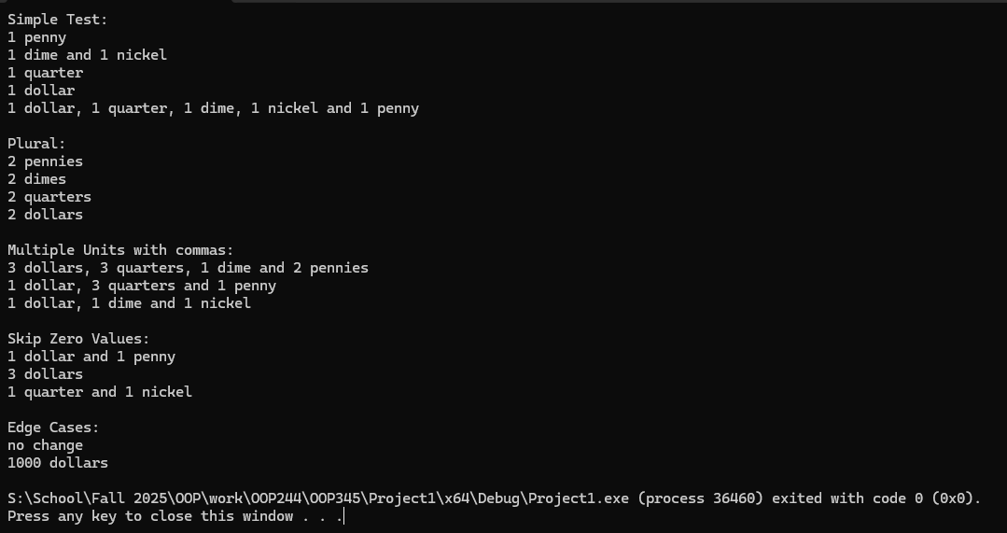

Compilation Process and Output in Rust via Command Prompt:
