# How Biological Neurons Work

When considering how to model **Neural Networks** we take inspiration from biological **Neurons**, specifically those found in animals, concentrating on the parts which are specific to their processing capabilities. In their most basic form **Neurons** work by taking electrical signals, processing them and passing those signals along the chain to other **Neurons**. This ability stems from the **Neurons Membrane**, which supports a variety of electrochemical processes.

**Synapses** are located all over the cell on branches known as **Dendrites**. As the cell receives signals from thousands of other **Neurons** every second it is here where they are summed together in some way, if they exceed a certain threshold the **Neuron** will fire generating a voltage in response. This is then transmitted to other **Neurons** via the **Axon**.  
  
In determining whether or not an impulse should be produced signals can have **Inhibitory** or **Excitatory** effects. The unique processing ability of each **Neuron** supposedly resides within the type and strength of these **Synaptic Connections**.

While each **Neuron** has only one **Axon** they can have many **Dendrites,** the Axon may however branch into a series of **Collaterals** connecting to many **Neurons**.

At equilibrium the **Membrane** maintains an electrical imbalance of negatively and positively charged **Ions**. This creates a difference in **Electric Potential Energy** across the **Membrane** with the inside being negatively **Polarized**.

**Axons** are often found to be surrounded in **Myelin** which serves to enhance conduction of **Action Potentials. Upon reaching the Axon Terminal**, **Synaptic Vesicles** contain **Neurotransmitters** cluster beneath the **Axon Terminal** membrane on the pre-synaptic side. **Axon Terminals** are specialised to release these neurotransmitters across the **Synaptic Cleft** this then chemically binds with receptor sites at the **Post-synaptic Membrane** initiating an electrochemical process that changes the polarisation state of the membrane local to the synapse.

This **Postsynaptic Potential (PSP)** can either depolarise a negative standing membrane towards 0v, encouraging signal production, or hyperpolarise the membrane to a greater negative potential to discourage signal production. This means that positive **PSP’s** are excitatory while those that are negative are inhibitory, while **PSPs** have the same characteristic signal profile and maximum value, they can take on a range of values depending on the efficiency of the synapse in producing electrical signals.   
  
The **PSP** spreads out from the synapse travelling down the associated **Dendrite** towards the **Cell Body (Soma) and** eventually reaching the **Axon Hillock.** This is concurrent with thousands of **PSP’s** arriving at the **Axon Hillock** where they are summed together to produce a **Membrane Potential**. While these may not decay for a period of time (milliseconds) allowing for slightly desynchronised **PSP’s** to interact in the summation process they may not be effective at combining to create **Action Potentials**.

The Integrated **PSP** at the **Axon Hillock** will affect its **Membrane Potential**. If this exceeds a certain threshold an **Action Potential** is generated which then progresses down the **Axon** collaterals reaching **Axon Terminals** and resulting in **Synaptic Events** in neighbouring **Neurons**.

# How We Can Model Neurons

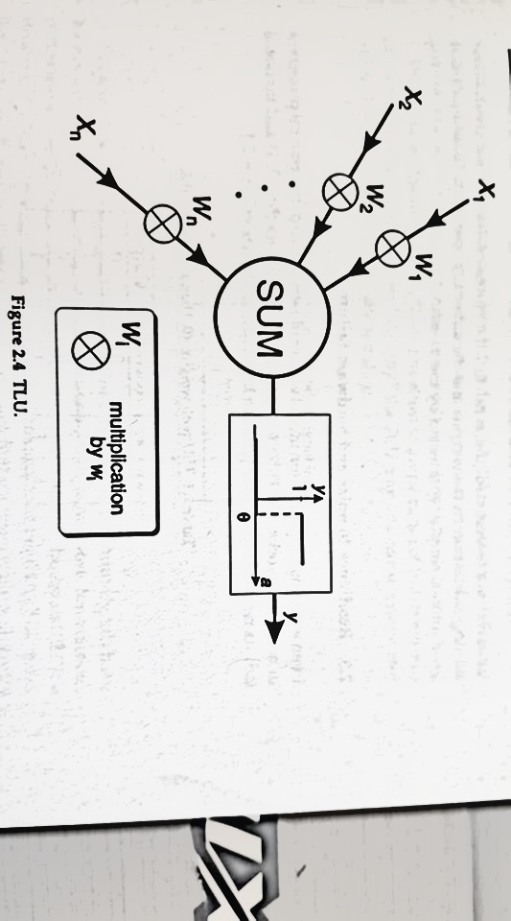

When modelling biological neurons as **Perceptron’s** (Artificial Neurons) we capture the modulatory effect of the synapse by multiplying the incoming signal with a weight value.

Excitatory and inhibitory actions are modelled by the use of positive and negative values respectively.   
  
 Henceforth, we have *n* weights of: *w1x1* + *w2x2* …. + wnxn

Each product is now the analogue of a PSP and has the ability to be either negative or positive dependent on the sign of the weight.   
  
These are next combined in a process to emulate the Axon Hillock with simple summation:

*a* = *w1x1* + *w2x2* + … *wnxn*  
  
Next, we emulate the generation of action potentials using a threshold value of θ (theta) such that if the threshold is equivalent to or greater than θ the output will be “1”, otherwise the output will be a “0”.  
  
This relation is sometimes referred to as a “Step Function” , this type of Perceptron is known as a “Threshold Logic Unit”.  
  
By using symbolic notation we are able to represent our biological neuron in a more compact form:

Here Sigma denotes summation with n and I denoting the upper and lower limits of the summation, here we assume I can be any integer between *1* and *n* these can often be omitted if they have been defined elsewhere.

The threshold relation for obtaining the output *y* may be written as:

It is worth noting that while biological neurons integrate their **PSP’s** over space and time, the TLU integrates instantaneously to its input. Action-potential is generation is represented simply by the threshold function.