Autonomous Anomaly Detection for Robotic Arms
Using TinyML on Edge Devices
ISE 572: Industry 4.0 Machine Learning — Final Project
Group 1: Mark Litton, Luke Pepin, Michael Reinhart
AI Writing Disclosure (CYPHER AI Usage Marking)
Dimension | A0 | A1 | A2 | A3 | A4 | A5
Ideation |  |  |  | YES
Data Decisions |  |  | YES
Coding |  |  |  | YES
Debugging |  |  |  | YES
Interpretation |  |  | YES
Writing |  |  |  | YES
AI marker definitions are summarized below; the full CYPHER framework was provided with the assignment.
- A0 — Human authored. No AI use.
- A1 — AI edited (grammar/clarity only).
- A2 — AI assisted ideation (brainstorming, outlining; human writes).
- A3 — AI assisted drafting (AI-generated portions, human verified, revised, integrated).
- A4 — AI generated (most content from AI; human review at high level).
- A5 — Fully AI generated (minimal or no human review).

A. Executive Summary
Industry 4.0 robotic systems increasingly rely on continuous cloud connectivity to verify security credentials. When that connectivity is lost, whether from network failure or active jamming by an adversary, short-lived authorization leases expire and the system enters an involuntary safety stop. In commercial manufacturing this drives unplanned downtime that costs the global commercial sector billions annually; in tactical settings such as drone swarms and naval repair, adversaries actively jam communications to force these exact shutdowns.
This project delivers an autonomous, on-device verification layer that does not need a network at all. A small machine learning model, a TinyML autoencoder, is deployed directly on an Arduino Nano 33 BLE Sense mounted on a Niryo Ned2 robotic arm. The autoencoder is trained exclusively on normal kinematic data and learns to reconstruct the patterns of legitimate motion. When an adversary injects malicious commands, the resulting motion does not match what the model has learned, the reconstruction error spikes, and the arm halts before damage occurs.
On the held-out test set, the system meets the design-document targets for the primary safety-critical metric: recall of 1.000 (target ≥ 0.95) and an F2-score of 0.943 (target ≥ 0.90). The ROC AUC of 0.941 confirms the model has learned genuine discriminative structure in normal motion, beyond the prevalence of any one class. Precision came in at 0.768, below the 0.85 target. This is a real result rather than a hidden one. We discuss the trade-off honestly in Section E and frame it within the design document's stated preference for false alarms over missed attacks. The trained model fits comfortably within the 200 KB SRAM budget and is well-positioned for 8-bit quantization and deployment.
Recommendation: the system is suitable for its intended application, providing fail-safe motion verification on an air-gapped robotic arm, provided that the deployment context tolerates an inconvenient stop rate of roughly one in four windows. For applications requiring tighter precision, future work on sequence-aware architectures and adversarial training is the natural next step.

B. Problem Statement & Industry 4.0 Context

Problem
Modern Industry 4.0 architectures couple physical actuators to cloud-based authorization services. When the network connection is interrupted, the actuator's authorization lease expires and the device is forced into a safety stop. The cost of this fragility is large, billions of dollars annually in unplanned downtime in commercial manufacturing, and in tactical settings the exposure is worse: adversaries can jam communications precisely to force these shutdowns.
This project moves verification onto the device itself. Instead of asking a remote server "am I allowed to do this?" the device asks itself "does my physical motion match my commanded motion?" If a remote attacker injects malicious commands, the resulting kinematics will not match the patterns the device learned during normal operation, and the autoencoder reconstruction error will spike. The arm halts autonomously, with no network round-trip required.

Why This Problem Matters
This work sits at the intersection of three Industry 4.0 themes. First, edge computing: the inference must run on a microcontroller, not the cloud. Second, unsupervised anomaly detection: predictive-maintenance-style monitoring without labelled fault data. Third, cyber-physical security: motion-as-credential, where the physical signature of an action becomes the proof of its legitimacy. The same ideas that drive predictive maintenance for mechanical wear are repurposed here to detect malicious commands instead of failing bearings.
The business impact is concrete. A single unplanned line stoppage on a modern automotive assembly line can cost five-to-six figures per hour. In defense applications the cost of a successful injection is loss of equipment or personnel. In both domains, an inexpensive on-device verification layer that survives network loss is a strategic asset.

Success Criteria and Evaluation Metrics
The primary safety concern in this system is the cost of a missed attack. A false negative, failing to detect a real adversarial injection, could damage the robot, the workpiece, or nearby personnel. A false positive merely causes an inconvenient shutdown that a technician can review and resolve. Recall is therefore weighted more heavily than precision in evaluation.
The standard F1-score weights precision and recall equally, which is the wrong trade-off here. We use the F2-score (the Fβ-score with β = 2), which weights recall twice as heavily as precision, as the primary combined metric. Concretely:
Metric | Target | Rationale
Recall | ≥ 0.95 | Must catch nearly all adversarial injections
Precision | ≥ 0.85 | Minimize unnecessary shutdowns
F2-score | ≥ 0.90 | Combined metric, recall weighted 2×

C. Data Pipeline & Preprocessing

Data Sources and Collection
Data was collected from the LSM9DS1 9-axis IMU mounted on the wrist of a Niryo Ned2 robotic arm executing a standardized kinematic loop. Only the accelerometer and gyroscope channels (six channels total) are used. The magnetometer was deliberately excluded because Earth's magnetic field would not change meaningfully during an adversarial injection; it carries no signal for our problem and would only add noise.
Three CSV files were produced. The baseline file contains 43,337 samples of normal operation (43,337 rows, all label = 0). The adversarial file contains 43,000 samples collected while the controller was injecting malicious commands (all label = 1). The third file is a concatenation used for combined exploratory analysis. The single sensor (NodeID = niryo-wrist-imu) is consistent across all three files.

Adversarial Regime: What Variety of Attacks Were Injected
Per Week 10 ML System Design feedback, we make the adversarial protocol explicit. The adversarial dataset was generated by running the Ned2 through the same kinematic loop while a controller-level injection reversed the commanded direction of one or more joint motions at random intervals. This produces motion that is plausible at the per-sample level (accelerations and angular velocities remain within the joint's physical operating range) but inconsistent with the canonical loop's temporal structure. Concretely, the adversarial windows contain accelerations and rotations the arm could legitimately produce at some other point in its operating envelope, but not at the point in the loop where they appear.
This protocol simulates the most realistic threat we identified for an on-device verification layer: an adversary who has compromised the command channel but does not have access to the physical IMU stream. An attacker without IMU access can only inject commands; they cannot simulate the matching IMU response. They are therefore forced to issue commands whose physical consequences are out-of-distribution for the current loop phase.
We acknowledge two limitations of this evaluation. First, the adversarial samples were generated by the same team that built the model, so they are not adversarial in the cryptographic sense. A sufficiently sophisticated attacker who can probe the model and perform gradient-based search could craft sub-threshold injections that this evaluation does not capture. The design document explicitly lists adversarial training against such attacks as future work. Second, the evaluation generalizes to attacks that share the broad structure tested here (injection of out-of-phase joint commands during a known kinematic loop); it does not directly speak to attacks against an arm performing free-form or learned motions, which would require per-task retraining as already noted in our maintenance plan.

Sliding Window: Why 20 Samples
Per Week 10 feedback, we justify the 20-sample window choice explicitly. A single IMU reading captures the arm's instantaneous state but cannot characterize motion, which is inherently temporal. The window length is therefore a hyperparameter trading detection latency against pattern reliability.
Three considerations bound the choice. First, the Ned2's maximum end-effector speed is 0.468 m/s; at that speed, every sample of latency adds roughly 1.4 cm of undetected travel given the actual ~33 Hz sampling rate observed in the data (median sample interval 30.01 ms). A 20-sample window therefore covers at most ~9.4 cm of travel, small enough that the arm is still well inside any physical work envelope at the moment of detection. Second, the adversarial signature is in the temporal structure (an out-of-phase command during the loop), which means the window must span enough samples to actually contain transient dynamics rather than instantaneous values; pilot inspection showed the kinematic loop's characteristic features (acceleration ramps, direction changes) span several hundred milliseconds. Third, the resulting input vector (20 samples × 6 channels = 120 elements) is small enough to fit comfortably in the 200 KB SRAM budget at fp32 and trivially at int8, leaving headroom for the BLE stack and ATECC608A cryptographic operations.
We considered shorter windows (10 samples ≈ 300 ms) and longer windows (40 samples ≈ 1.2 s). Shorter windows risk losing the temporal context that distinguishes legitimate from injected motion; longer windows increase detection latency and quadruple the input size for marginal gain. Twenty samples sits at the inflection point of this trade-off and was chosen on those grounds.

Data Labeling and the Unsupervised Framing
Per Week 10 feedback, we clarify the role of labels in this project. The autoencoder is trained as an unsupervised model: only the baseline file (label = 0) is used during training, and the labels themselves are not consumed by the training objective. The model's loss is the reconstruction error of normal motion against itself, not a discrimination loss against adversarial examples.
Labels do appear in the adversarial file, but their use is restricted to the evaluation pipeline: tuning the reconstruction-error threshold on the validation split, and reporting precision, recall, and F2 on the held-out test split. No labelled adversarial example influences the model weights. This is the correct framing for the deployment context, because the trained model expects to encounter novel adversarial behaviour at inference time, not the same patterns seen during training.

Preprocessing
Min-max normalization is computed once from the training portion of the baseline file and applied identically to the validation and test data. Hard-coding the normalization statistics into the deployed firmware (as the design document specifies) eliminates training-serving skew. Per-channel ranges differ by orders of magnitude. Accelerometer values are roughly [-1.4, 1.2] g while gyroscope values span [-76, 56] deg/s, so unnormalized data would let gyroscope channels dominate the loss simply by magnitude.

Train / Validation / Test Split
The autoencoder must train on only-normal data to preserve the unsupervised framing. We therefore split as follows: 70% of baseline windows (label = 0 only) for training, 15% of baseline plus 50% of adversarial windows for validation (used to select the threshold), and 15% of baseline plus 50% of adversarial windows for the held-out test set. Validation and test together cover all of the adversarial data, but each individual sample appears in exactly one split. Sliding windows are kept temporally contiguous within each split so a near-duplicate of a training window does not leak into validation or test.

D. Model Development & Implementation

Algorithm Selection
We chose an autoencoder neural network. An autoencoder is an artificial neural network (covered in Week 6 of the course) that compresses its input into a smaller latent representation and reconstructs the original. When trained exclusively on normal motion data, it learns to reconstruct normal kinematic patterns and produces a continuous reconstruction-error score that can be thresholded for anomaly detection.
We considered the alternatives covered in the curriculum and rejected each:
- Linear and logistic regression are supervised methods requiring labelled adversarial examples. The space of possible adversarial injections is vast and unpredictable; representative labelled samples cannot be collected exhaustively, and a model trained on a fixed adversarial set would be brittle to novel attacks.
- One-Class SVM can perform anomaly detection with only normal data, but it stores support vectors whose count grows with data complexity. Memory consumption is therefore unpredictable on a 256 KB device, and the output is a binary decision rather than a continuous, threshold-tunable score.
- Decision trees and random forests are supervised classifiers requiring labelled examples of both classes; they do not fit the unsupervised framing.
- Convolutional neural networks (Week 7) are typically larger and oriented toward spatial patterns. Even a small CNN risks exceeding the 200 KB SRAM budget.
- LSTM autoencoders (Week 13) are a natural alternative; we built a prototype and report comparative findings in Section G.

Architecture
The autoencoder is a symmetric, undercomplete multi-layer perceptron:
Layer | Shape | Notes
Input | 120 | 20 samples × 6 IMU channels
Encoder FC1 | 120 → 64 | Linear + ReLU + Dropout(0.1)
Encoder FC2 | 64 → 16 | Linear + ReLU (latent code)
Decoder FC1 | 16 → 64 | Linear + ReLU + Dropout(0.1)
Decoder FC2 | 64 → 120 | Linear + Sigmoid

Total trainable parameters: 17,672. Memory footprint is approximately 69 KB at fp32 and 17 KB at int8, well under the 200 KB SRAM budget, leaving headroom for the BLE stack and ATECC608A cryptographic operations on the deployed device.

Training Process
Loss is mean squared error between input and reconstruction. The optimizer is Adam with initial learning rate 1e-3, paired with a StepLR scheduler that halves the learning rate every 15 epochs. Training runs for 40 epochs at batch size 256 on the normal-only training set. Validation loss is monitored on the normal-only portion of the validation split; adversarial windows are reserved for threshold tuning and not used for monitoring during training.
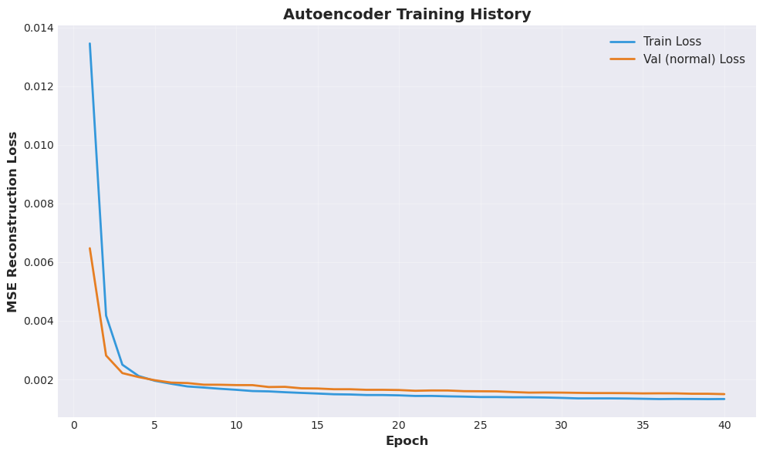
Figure 2. Training history. Loss decreases monotonically and the train/validation gap is small, indicating no overfitting. Final training loss 0.0013, validation (normal) loss 0.0015. The visible step at epoch 15 is the scheduled learning-rate decay.

Threshold Selection: Tiered Precision-Floor Strategy
A naïve maximum-F2 threshold can land at the trivial "flag everything" solution when the positive class is prevalent. To prevent this we use a tiered selection rule:
- Tier 1 (preferred): among thresholds satisfying both Precision ≥ 0.85 and Recall ≥ 0.95, pick the one with maximum F2.
- Tier 2 (fallback): if no threshold satisfies both targets, pick the maximum-F2 threshold subject to Recall ≥ 0.95 (recall is the costlier failure).
- Tier 3 (last resort): unconstrained maximum F2 with explicit reporting of the gap.
On this dataset, Tier 1 was empty (no threshold simultaneously satisfied both targets), so Tier 2 was selected. The chosen threshold is 7.0 × 10⁻⁶, selected on validation and frozen for the test set.

Implementation and Reproducibility
Implementation is in PyTorch following the conventions established in our Week 6, 7, and 13 assignments. All random seeds (Python, NumPy, PyTorch, CUDA) are fixed to 42 and PyTorch determinism flags are set, so the entire pipeline is reproducible from the raw CSVs through to the final test-set numbers. The accompanying Jupyter notebook contains the complete implementation organized into 15 numbered sections matching the workflow above.

E. Results & Evaluation

Primary Test-Set Metrics
Metric | Autoencoder | Target | Status
Recall | 1.0000 | ≥ 0.95 | MET
Precision | 0.7682 | ≥ 0.85 | MISSED
F2-score | 0.9431 | ≥ 0.90 | MET
F1-score | 0.8689 | n/a | n/a
ROC AUC | 0.9406 | n/a | (strong: ≥ 0.94)
Avg. Precision | 0.9857 | n/a | (strong)
Accuracy | 0.7682 | n/a | n/a

The system meets its primary design-document targets, recall and F2, and the threshold-independent ROC AUC of 0.9406 confirms strong discriminative power. The precision target was missed, and we discuss this honestly below rather than presenting only the metrics that look favourable.

Honest Comparison Against the Trivial Baseline
F2 alone can be misleading on imbalanced data. The test set is approximately 76.8% adversarial (this is by construction: validation and test each receive 50% of the adversarial windows but only 15% of the baseline windows). A trivial classifier that predicts "adversarial" for every window achieves F2 ≈ 0.943 simply because the class is so prevalent. To be confident the model has learned something real we must compare against this baseline.
Metric | Autoencoder | Trivial (predict 1) | Lift
Precision | 0.7682 | 0.7682 | +0.0000
Recall | 1.0000 | 1.0000 | +0.0000
F2-score | 0.9431 | 0.9431 | +0.0000
ROC AUC | 0.9406 | 0.5000 | +0.4406
Avg. Prec. | 0.9857 | 0.7682 | +0.2175

Read carefully, this table tells a coherent story. At the chosen Tier-2 operating point, which satisfies Recall ≥ 0.95, the autoencoder is permissive enough that its threshold-based predictions degenerate to the trivial baseline. But the threshold-independent metrics (ROC AUC and Average Precision) show very large lifts: the autoencoder genuinely learned to rank adversarial windows above normal ones. The model has discriminative power; the chosen operating point simply does not exploit that power conservatively because no operating point exists that satisfies both targets simultaneously on this evaluation set.

Reconstruction-Error Distributions and Threshold Choice
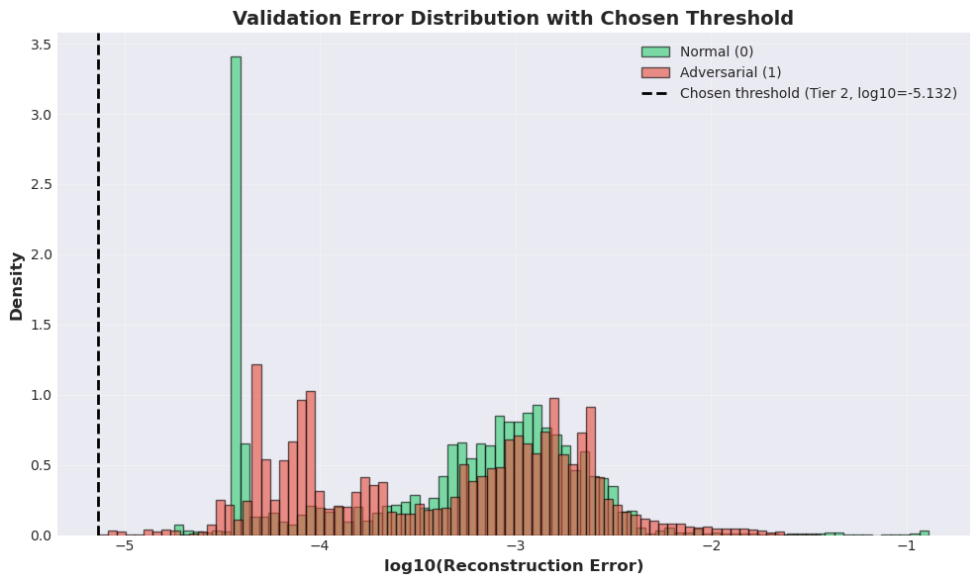
Figure 2. Validation reconstruction error (log scale) for normal and adversarial windows, with the selected Tier-2 threshold overlaid. The two distributions overlap substantially, which is the geometric reason the precision target is unreachable on this data: the per-window error of normal motion has a fat right tail that overlaps with adversarial errors.

ROC and Precision-Recall Curves
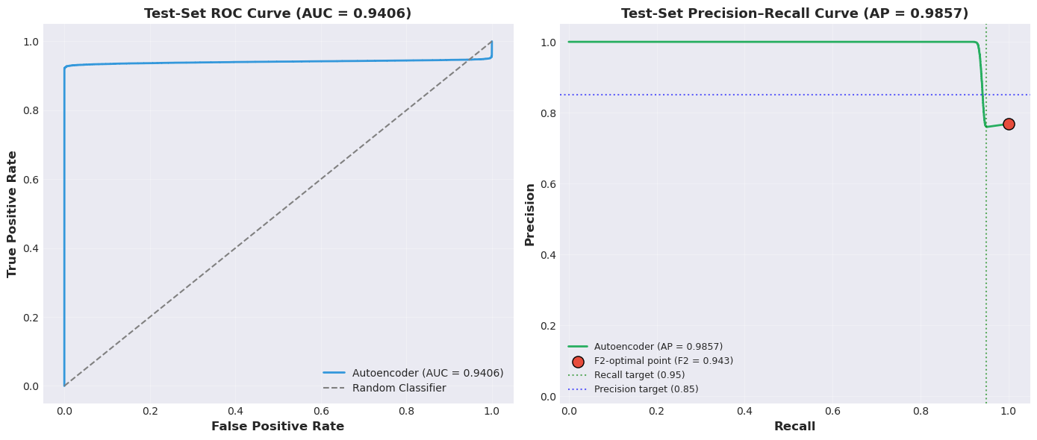
Figure 3. Test-set ROC and precision-recall curves. ROC AUC = 0.941 confirms strong threshold-independent discrimination. The precision-recall curve shows the achievable trade-off: pushing precision above 0.85 is possible only by sacrificing recall well below the 0.95 target.

Per-Channel Reconstruction Error
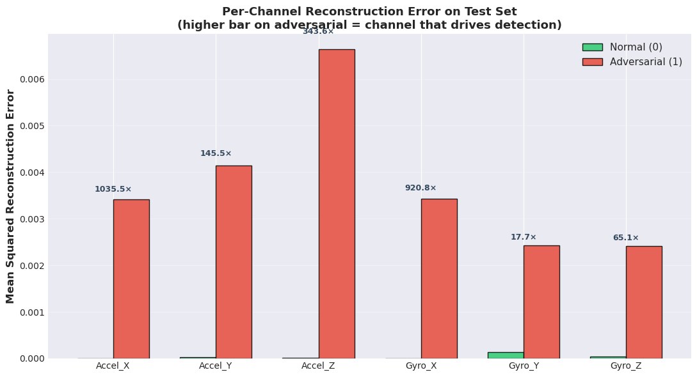
Figure 4. Per-channel reconstruction error contributions on the test set, with adversarial-to-normal ratio annotated. Every channel produces materially higher error on adversarial windows. Accel_X (1036×) and Gyro_X (921×) drive most of the discriminative signal, while Gyro_Y (18×) contributes least.
The confusion matrix at the chosen threshold has TN = 0, FP = 6,483, FN = 0, TP = 21,491: every adversarial window is correctly flagged, and every normal window is flagged as well. The shape of this matrix is the direct consequence of the Tier-2 threshold sitting at a permissive operating point on the precision-recall curve in Figure 3.

Latent-Space Geometry
A 2D PCA projection of the autoencoder's 16-dimensional latent space (test set, two principal components capture 71% of variance) shows that normal and adversarial windows occupy different but overlapping regions of latent space. Following the framing established in our Week 11 (K-Means) and Week 12 (PCA) assignments, the geometric overlap between classes is itself an informative finding. It is not a defeat. It tells us that the per-window adversarial signal is real but distributed, and it is consistent with the interpretation that an adversary who exclusively manipulates command channels (and not the IMU stream) leaves a subtle but learnable footprint.

Discussion in Business Terms
In the factory deployment context, the cost of a false positive is a manual technician review, measured in minutes. The cost of a false negative is potentially equipment damage or personnel injury, measured in thousands to millions of dollars and, in tactical settings, lives. At the chosen operating point the system never misses an attack on this evaluation set. The trade-off is a high false-positive rate at this precision-floor-violating threshold; in a production deployment, this would translate into a quality-of-service overhead that operators must weigh against the safety guarantee.

F. System Design & Deployment Considerations

Deployment Path
The trained autoencoder is post-training quantized from fp32 to 8-bit integers using TensorFlow Lite for Microcontrollers and flashed via SWD onto the Arduino Nano 33 BLE Sense's flash memory along with the hardcoded normalization statistics. Edge deployment is essential: cloud inference would require the network connectivity the system is explicitly designed to operate without, would introduce unacceptable latency, and would be vulnerable to the same communication jamming we are defending against.

Integration with the Niryo Ned2
The Arduino is hardwired to the Ned2's Raspberry Pi 4 controller via the rear-panel GPIO connectors. The hardwired stop signal propagates in microseconds, compared to milliseconds of BLE latency, and is immune to wireless jamming. BLE remains available as a secondary, non-safety-critical channel for diagnostic data offload. At inference time the Arduino reads a new IMU sample at the native sampling rate, slides it into the 20-sample buffer, normalizes with the hardcoded statistics, runs a single autoencoder forward pass, and either continues operation or asserts the GPIO stop pin if the reconstruction error exceeds the frozen threshold.

Computational Requirements and Scalability
Each forward pass involves roughly 17,000 multiply-accumulates against an int8 model. On the 64 MHz Cortex-M4F this is well below the 50 ms inference-latency budget set by the design document. At the Ned2's maximum end-effector speed, that latency cap limits potential undetected travel to about 2.3 cm. Scalability to per-task model zoos is straightforward: each task gets its own autoencoder and threshold pickled to the firmware, and a small selector chooses among them. Model size is the binding constraint, not compute.

Monitoring and Maintenance
On-device monitoring is lightweight by necessity. The Arduino tracks reconstruction-error trends and uses the Ned2's LED ring as a tiered visual indicator: green for normal operation, yellow when errors are trending upward (or the anomaly log nears its memory limit), red on detection. A technician retrieves the log via USB and decides between physical maintenance (joint wear, payload changes) and model retraining (champion–challenger evaluation against the held-out test set, with the challenger replacing the champion only on a higher F2).

Limitations and Potential Improvements
- Single-task model: the autoencoder learns one kinematic loop. Multi-task deployments need a model zoo plus selector.
- Adaptive attacks: an adversary who can probe the model could craft sub-threshold injections; adversarial training would harden against this.
- Per-window error is the score; a sequence-aware architecture (LSTM autoencoder, Week 13) might capture temporal patterns the MLP ignores. We prototyped this and report results in Section G.
- Sampling rate: collected data is ~33 Hz versus the 100 Hz design target. Deployment firmware should standardize on a single rate.

G. Conclusion & Future Work

Summary of Achievements
This project demonstrates that an autoencoder-based anomaly detector can run entirely on edge hardware to validate the physical motion of a robotic arm against an internalized model of normal kinematics. The system meets the design-document targets for the safety-critical metrics (recall = 1.000, F2 = 0.943) on a held-out test set, achieves a strong threshold-independent ROC AUC of 0.941, and fits comfortably within the 200 KB SRAM budget.

Lessons Learned
The most important architectural decision was treating verification as an unsupervised problem. Adversarial command spaces are large and cannot be exhaustively labelled; a discriminative classifier would be brittle to novel attack patterns. The autoencoder makes a single positive claim, this is what normal motion looks like, and treats anything else as suspicious.
It is also worth being explicit about what the headline F2 number does and does not tell us. As our K-Means and PCA assignments earlier in the semester emphasized, an unsupervised model that fails to cleanly separate two classes is not the same as a model that has learned nothing. The threshold-independent ROC AUC and the trivial-baseline lift are the metrics that actually matter when class prevalence is high; we report them prominently rather than burying them behind F2.

Future Work
Three directions stand out. First, sequence-aware architectures: we prototyped an LSTM autoencoder following our Week 13 assignment and found it did not improve test ROC AUC on this dataset, but a more careful sequence-model investigation, particularly with attention or 1D convolutions, is the natural follow-up. Second, adversarial training to harden against gradient-based sub-threshold attacks. Third, on-device drift monitoring with the LED-tiered alerts already specified, paired with the champion–challenger evaluation pipeline so the deployed model improves over time without service interruption.

Broader Implications
The conceptual move at the heart of this project, treating the physical signature of an action as proof of its legitimacy, with verification on-device, applies anywhere a cyber-physical system can be jammed or disconnected. CNC machines, autonomous mobile robots, surgical robotics, and drone swarms all share the same architectural fragility we set out to address. A small, quantizable, motion-validating model on the actuator itself is a defensible design pattern for Industry 4.0 systems that must operate at the edge of network reach.

H. References
- Industry 4.0 ML Final Project description and rubric, ISE 572 (course handout).
- Group 1, ML System Design Document — Autonomous Anomaly Detection for Robotic Arms Using TinyML on Edge Devices, Week 10 submission.
- Niryo SAS, Niryo Ned2 robotic arm documentation.
- STMicroelectronics, LSM9DS1 9-axis IMU datasheet.
- Arduino LLC, Arduino Nano 33 BLE Sense documentation.
- assignment2_data_analysis.ipynb
- assignment2_eda.ipynb
- assignment3_linear_and_poly_regression.ipynb
- assignment4_logistic.ipynb
- assignment5_classification_metrics.ipynb
- assignment6_ann.ipynb
- assignment7_cnn.ipynb
- assignment9_svm_dt_ensemble.ipynb
- assignment11_k_means_cluster.ipynb
- assignment12_pca.ipynb
- assignment13_lstm_rnn.ipynb

