Machine Learning to Quantum Machine Learning

Extended Abstract

Luke Power - March 2024

# 1 Introduction

Machine Learning (ML) is a subset of computer science that uses algorithms to detect patterns in the data and to fit a statistical model. The model aims to make accurate predictions based on new data. [1] Quantum Machine Learning (QML) expands what is capable of classical computers by exploiting phenomena that are observed in quantum physics, such as superposition and entanglement. wineA graph of different colored lines

# 2 The Qubit

The qubit is to quantum computing is what the bit is to classical computing.

The qubit differs from the classical bit, which is constrained to the states of 0 or 1; a qubit can be simultaneously in states 0 *and* 1 in a state known as super position. [2] Quantum computing heavily relies on linear algebra and matrix transformations to describe the transformation of information. Qubits’ states are represented as vectors where $\overset{⃑}{0} = \begin{matrix}1 \\ 0\end{matrix}$ and $\overset{⃑}{1} = \begin{matrix}0 \\ 1\end{matrix}$.

These vectors are represented in Dirac notation where a vertex .

A super-positioned qubit is represented with $\left|ψ\right\rangle$. This particular state is represented as a linear combination of the foundational states $\left|0\right\rangle$ and $\left|1\right\rangle$; $α\left|0\right\rangle +β\left|1\right\rangle$, where $α$ and $β$ are complex numbers whose squares' magnitudes represent the probabilities of the qubit being observed in the respective states. This mathematical formula underpins the qubit's capability to embody quantum superposition, illustrating the departure from classical bits that are confined to the definitive states of 0 or 1.

Figure 1: The Bloch Sphere 3D representation of a qubits’ possible states.

[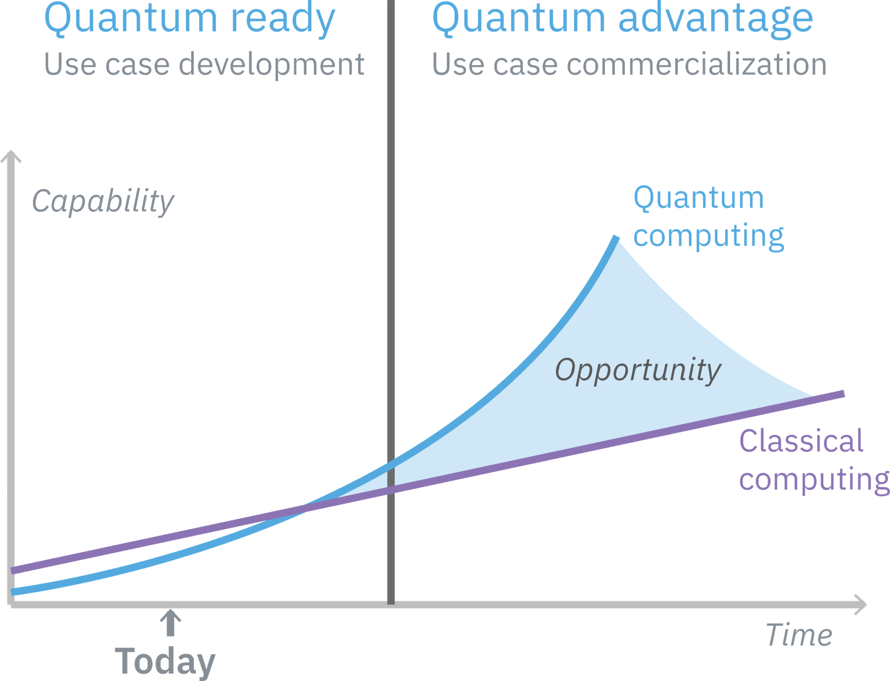](https://www.ibm.com/thought-leadership/institute-business-value/public/static/images/Quantum-Report/Figure3.svg)The core advantage of quantum computing lies in its ability to process information in ways that classical systems cannot match, offering exponential speed-ups for certain types of problems. For example, quantum algorithms have been demonstrated to outperform classical counterparts in oracle-based problems, showing that a significant quantum advantage emerges even in existing noisy systems. [3]Furthermore, quantum technology can revolutionize how we learn from experiments, as shown in a study where quantum machines learned from exponentially fewer experiments than required by conventional means, leading to dramatic reductions in the number of necessary experiments. [4] Quantum machine learning also benefits from the ability to process atypical patterns produced by quantum systems, offering potential speed-ups in learning tasks [5]. Additionally, the use of quantum-enhanced feature spaces in machine learning can provide advantages in solving classification problems where classical feature spaces become computationally prohibitive [6]. These advancements underscore the transformative potential of quantum computing and quantum machine learning across various fields, from drug discovery to optimization problems, by leveraging quantum mechanics' unique properties.

Figure 2 Source: [IBM](https://www.ibm.com/thought-leadership/institute-business-value/public/static/images/Quantum-Report/Figure3.svg)

# 4 The QML Model – Variational Quantum Classifier

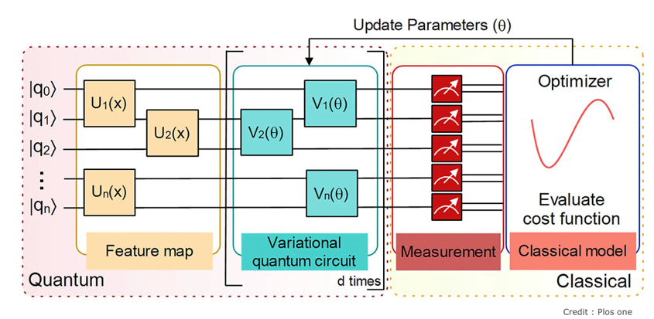For this project, I decided to use the Variational Quantum Classifier (VQC). VQCs are a type of hybrid quantum machine learning algorithm that can be used to solve a wide variety of classification problems. VQCs combine the power of quantum computing with the flexibility of classical machine learning algorithms to achieve state-of-the-art performance on many tasks. The steps involved in implementing a VQC with classical data is transforming the classical data to a quantum state with a feature map. [7] [8]

# 4 Real-World Example of VQC Usage

An application of a VQC was done in the field of dementia prediction. While the study showcases VQC outperforming classical SVM models in dementia prediction by efficiently handling various feature sets, it acknowledges that QML has not yet reached a point where it can entirely replace state-of-the-art techniques for such applications. However, the promising results from VQC indicate a bright future for QML in healthcare, suggesting that with further development and enhancement of quantum computing capabilities, QML methods like VQC will become increasingly valuable in addressing the needs of the healthcare system. [9]

# 5 Inference via Feature Importance

I intend to make inferences about data by evaluating feature importance in the QML models, by running the model multiple times and ranking the feature importance by their effects on the model’s prediction accuracy. The only other paper I could find which attempted a similar approach; applied on the real-world dataset ESPN Fantasy Football data, utilising Qiskit’s statevector simulators and IBM quantum hardware. [10]The architecture enables the calculation of feature importance values from classical algorithms for QML models, aiming to bridge the gap between quantum and classical machine learning by enhancing the interpretability and performance of QML models through focused data pre-processing and feature engineering techniques.

# 6 Conclusion

This project should investigate what changes in the inferences that can be drawn from Classical ML when compared to an equivalent QML model, emphasizing the quantum advantage in computation through superposition and entanglement. This should help to uncover new information about the data that could otherwise not be found via classical machine learning techniques.

# Bibliography

|  |  |
| --- | --- |
| [1] | A. Burkov, The hundred-page machine learning book, 2019. |
| [2] | J. D. Martín-Guerrero and L. Lamata, “Quantum Machine Learning: A tutorial,” *Neurocomputing,* 2022. |
| [3] | D. Diego, M. P. da Silva, C. A. Ryan, A. W. Cross, A. D. Córcoles, J. A. Smolin, J. M. Gambetta, M. J. Chow and B. R. Johnson, “Demonstration of quantum advantage in machine learning,” *npj Quantum Information,* vol. 3, no. 1, 2017. |
| [4] | H.-Y. Huang, M. Broughton, J. C. S. Chen, J. Li, M. Mohseni, H. Neven, R. Babbush, R. Kueng, J. Preskill and J. R. McClean, “Quantum Advantage in learning from experiments,” *Science,* vol. 376, no. 6598, 2022. |
| [5] | J. Biamonte, P. Peter, N. Pancotti, P. Rebentrost, N. Wiebe and S. Lloyd, “Quantum Machine Learning,” *Nature,* vol. 549, no. 7671. |
| [6] | V. Havlíček, A. D. Córcoles, K. Temme, A. W. Harrow, A. Kandala, J. M. Chow and J. M. Gambetta, “Supervised learning with quantum-enhanced feature spaces,” *Nature,* vol. 567, no. 7747, 2019. |
| [7] | Qiskit, “IBM Quantum Documentation,” [Online]. Available: https://docs.quantum.ibm.com/api/qiskit/qiskit.circuit.library.ZZFeatureMap. |
| [8] | Qiskit, 2021. [Online]. Available: https://medium.com/qiskit/building-a-quantum-variational-classifier-using-real-world-data-809c59eb17c2. |
| [9] | D. Sierra-Sosa, J. Arcila-Moreno, B. Garcia-Zapirain, C. Castillo-Olea and A. Elmaghraby, “Dementia Prediction Applying Variational Quantum Classifier,” 2020. |

