BALCONY SCREEN BUILD GUIDE
506 mm bench · five free-standing modules · 1820 mm high
Five modules: four 600 mm wide and one 900 mm in the centre. Each is a two-tier plant bench with a lattice panel fixed to its back. Build one at a time; roughly 25 to 35 hours in total, 6 to 8 hours for the first module and 3 to 4 for each one after.
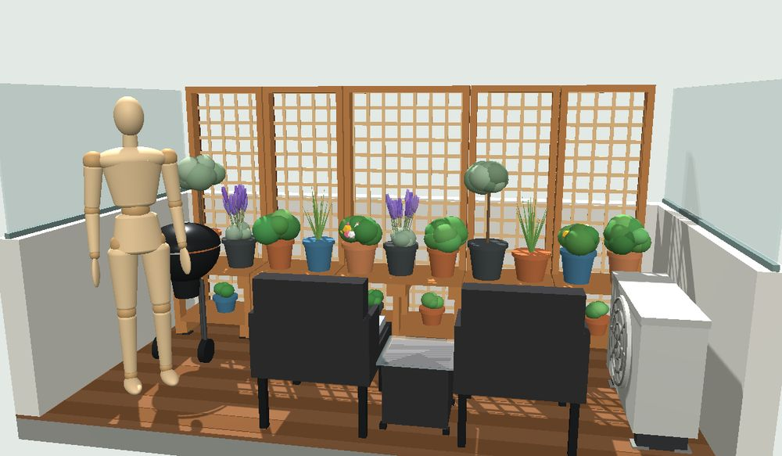
Before you start
- Tools: mitre saw, drill and impact driver, 11 mm auger or spade bit, 3.5 mm pilot bit and countersink, 17 mm spanner or socket, four clamps, square, tape.
- Consumables: end-grain preservative, pigmented decking oil, spare driver bits.
- Safety: glasses, ear protection, dust mask. Sweep up treated pine dust; do not burn offcuts.
Parts for one 600 module (506 mm bench)
Qty | Length | Material | Part
2 | 1810 | 90x45 H3 | Posts
2 | 468 | 90x45 H3 | Front legs
4 | 465 | 90x45 H3 | Bearers, two per frame
1 | 510 | 90x45 H3 | Top rail
2 | 510 | 90x22 H3 | Bottom and mid rails, both flush
1 | 510 | 90x22 H3 | Front shelf piece, between the legs
7 | 600 | 90x22 H3 | Boards: 4 top, 3 full-width shelf
2 | 1800 | 42x19 merbau | Vertical cover strips
1 | 516 | 42x19 merbau | Top cover strip
1 | 1800 x 600 | Lattice | Screen panel
Fixings per module: 16 M10x120 bolts with washers, 32 x 50 mm screws, 17 x 65 mm screws, 12 x 100 mm screws, 4 plastic foot packers.

01 Cut and seal
- Work through the Cutting Plan one stock length at a time; use a stop block for the repeats.
- Pencil the mark letter on every piece as it comes off the saw.
- Seal every cut end, especially the post tops.
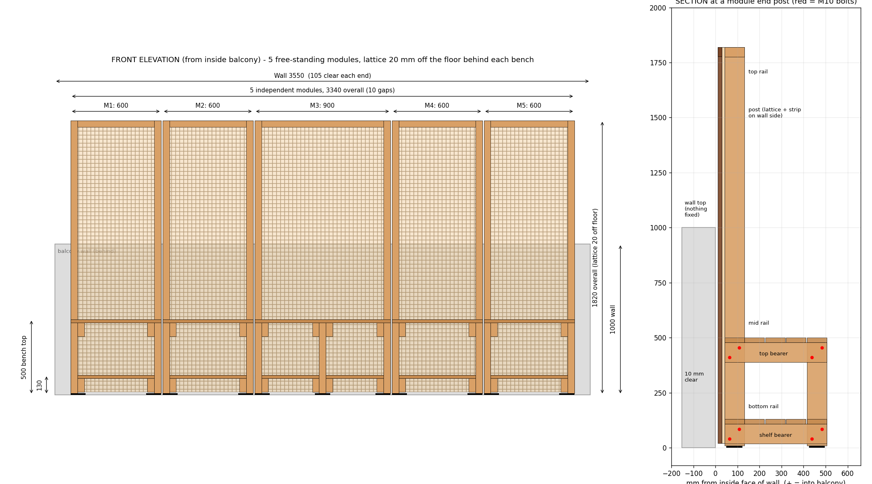
02 Drill the bolt holes
- 11 mm holes, not 10 mm.
- Two bolts per joint on the diagonal, each 22.5 mm in from both edges of the lap.
- Clamp both pieces and drill through together; back the exit side with an offcut.
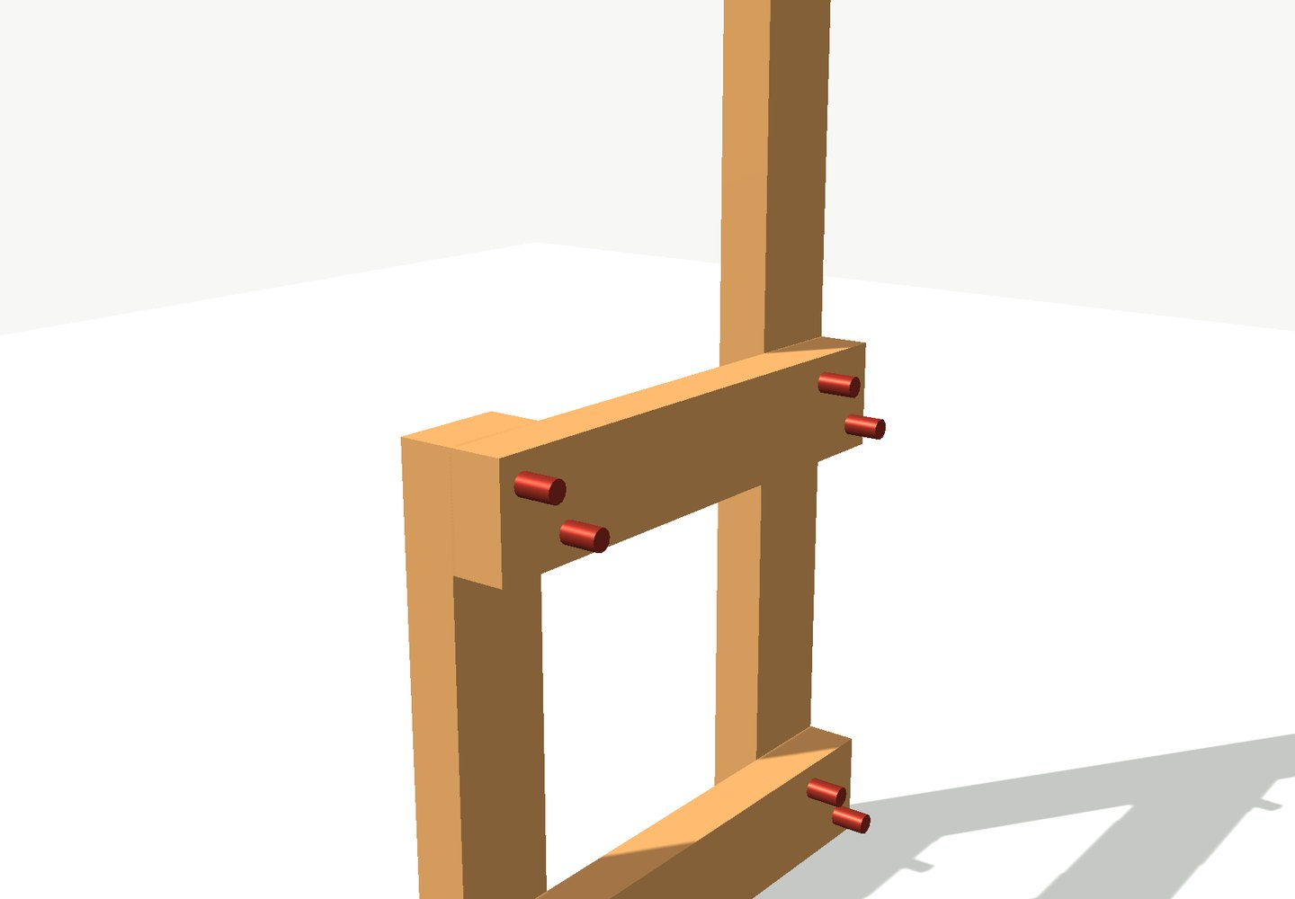
03 Bolt up the cross-frames
- One frame is a post, a front leg and two bearers.
- 600 modules take two frames. The 900 module takes three: its middle frame is built now too, using a 468 mm rear leg in place of the post, and a second bearer at each level. See the 900 mm section for that frame.
- Bearers lap on the side facing the middle of the module.
- Shelf bearer top at 108, bench bearer top at 478, measured from the bottom of the post or rear leg.
- Nip the bolts up, check the diagonals match, then tighten.
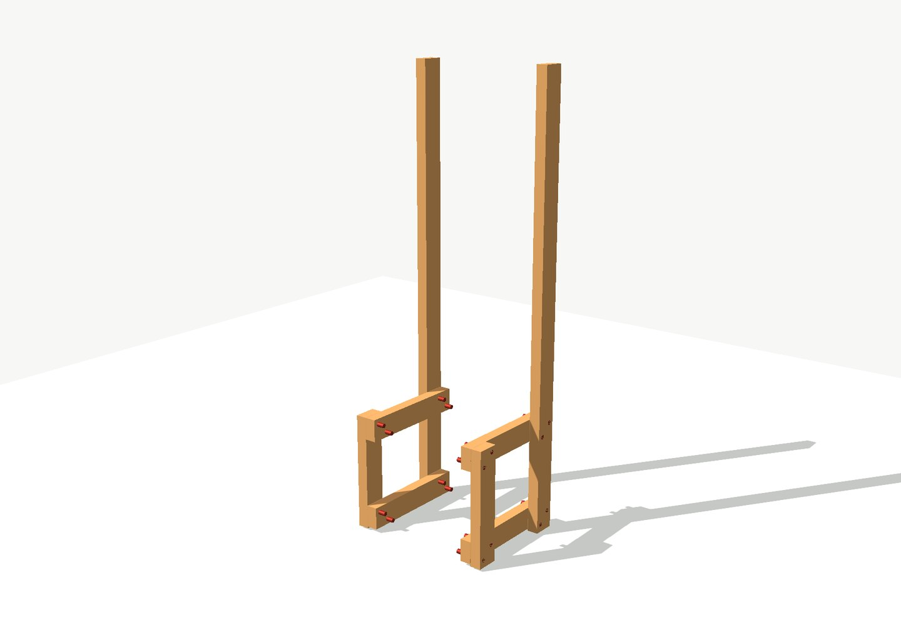

04 Fit the boards
- Rear top board first: it sets the frame spacing.
- Then the rest of the 4 top boards with 5 mm gaps, and 4 shelf boards.
- The front shelf board is cut to fit between the legs, so the shelf reaches the front.
- Two screws per board at every bearer it crosses; 32 screws in all. Pre-drill within 50 mm of a board end.
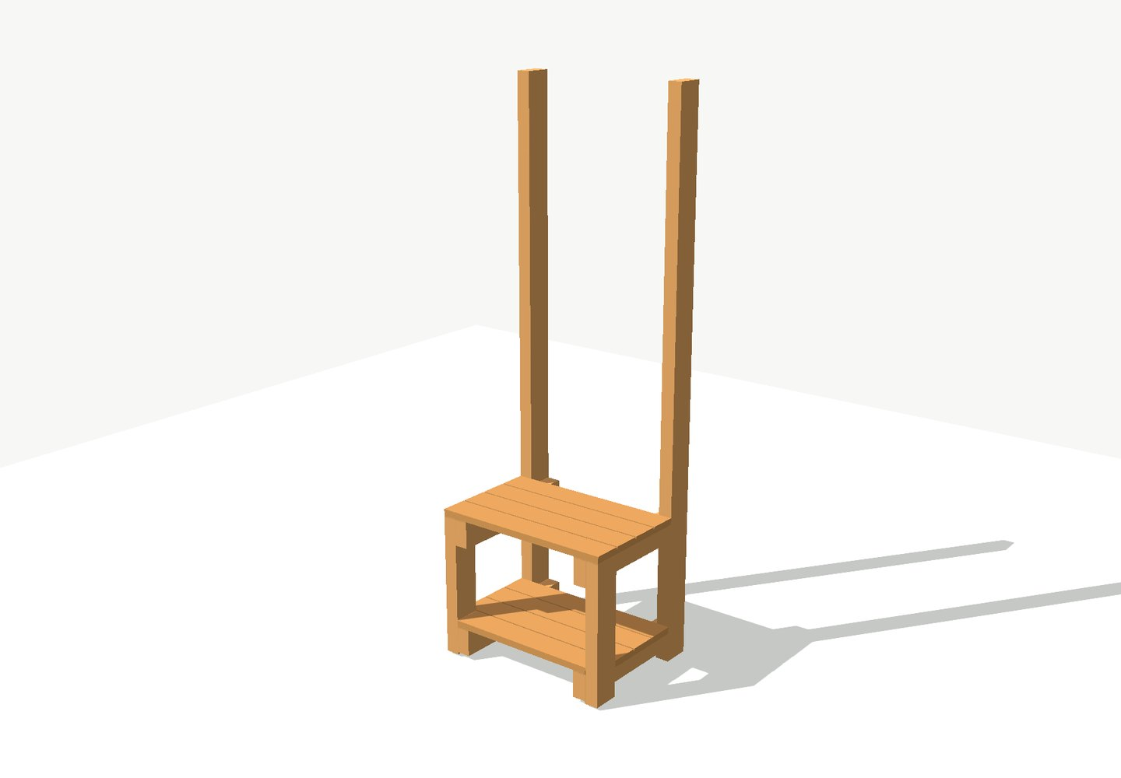
05 Three rails between the posts
- Bottom rail, 90x22, sits on the shelf bearers and finishes flush at 130.
- Mid rail, 90x22, sits on the bench bearers and finishes flush at 500.
- Top rail, 90x45, is flush with the post tops at 1820.
- Screw straight down into the bearers, or straight through the posts from outside. No angled screws.
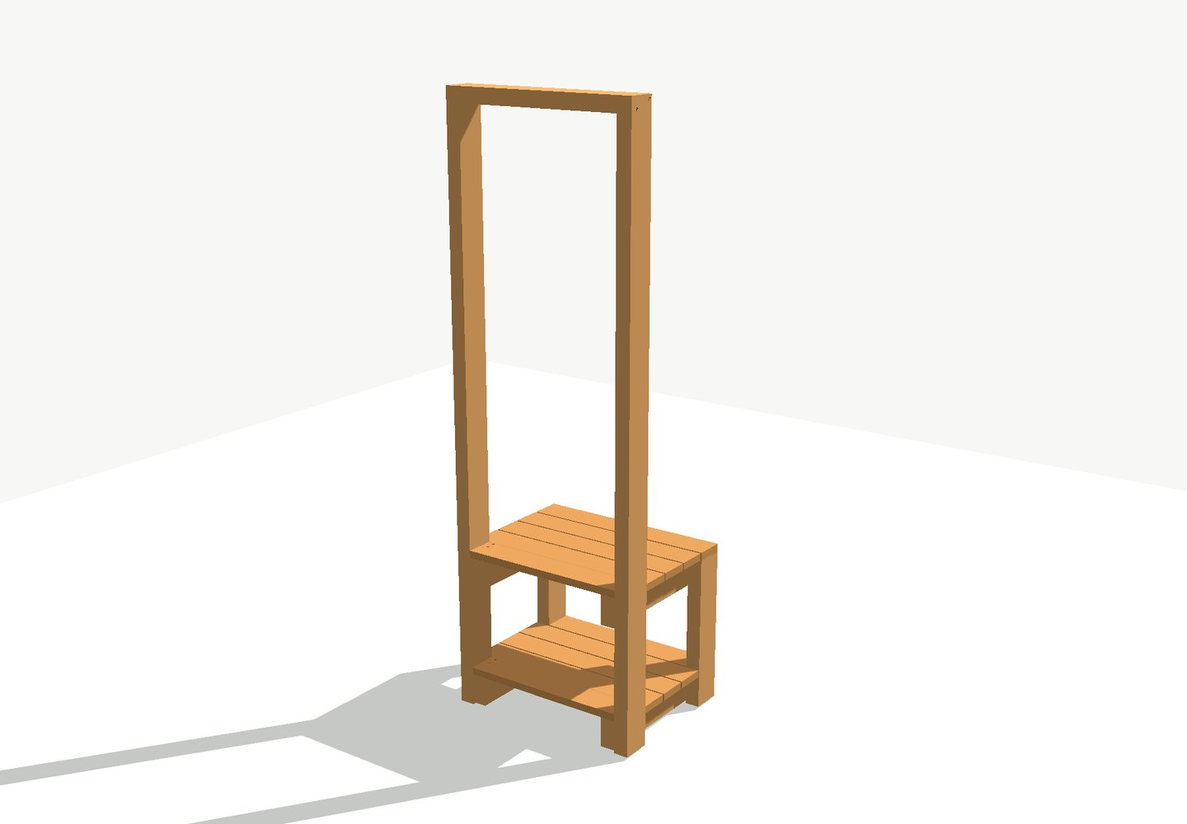

06 Lattice and cover strips
- Lay the module on its front, bench side down.
- Lattice on the posts, 20 mm up from the floor line.
- A vertical strip over each post and one along the top: the lattice is clamped around its perimeter. The rails behind carry no strips.
- Screws at roughly 300 mm centres, 17 in all. Pre-drill and countersink every merbau screw.
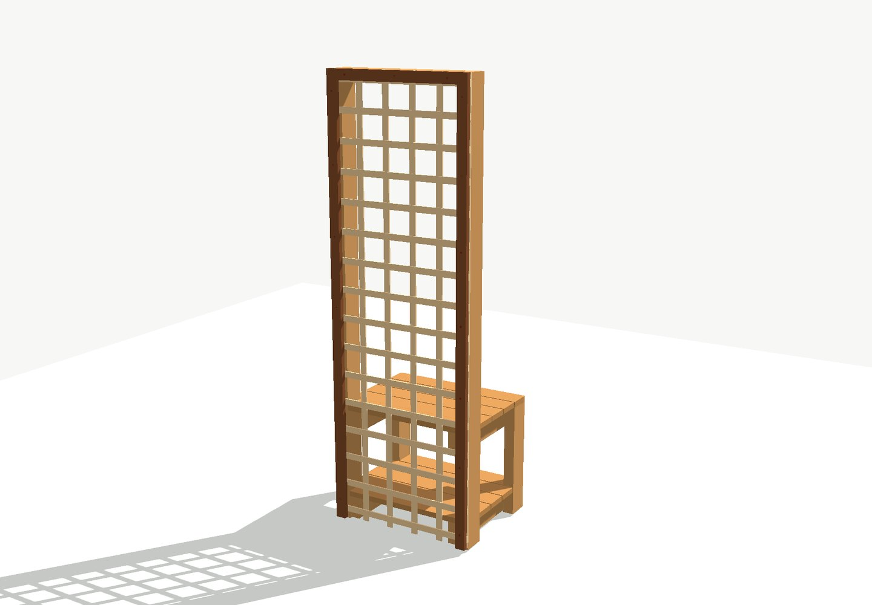
07 Carry out, pack and place
- 26 kg for a 600 module; it fits through a doorway upright.
- A plastic packer under each of the four legs.
- 10 mm clear of the wall, 10 mm to its neighbour, then level it across and front to back.
- Load the pots on before you leave it: empty, a module tips forward with about 4.6 kg of pull at the top.
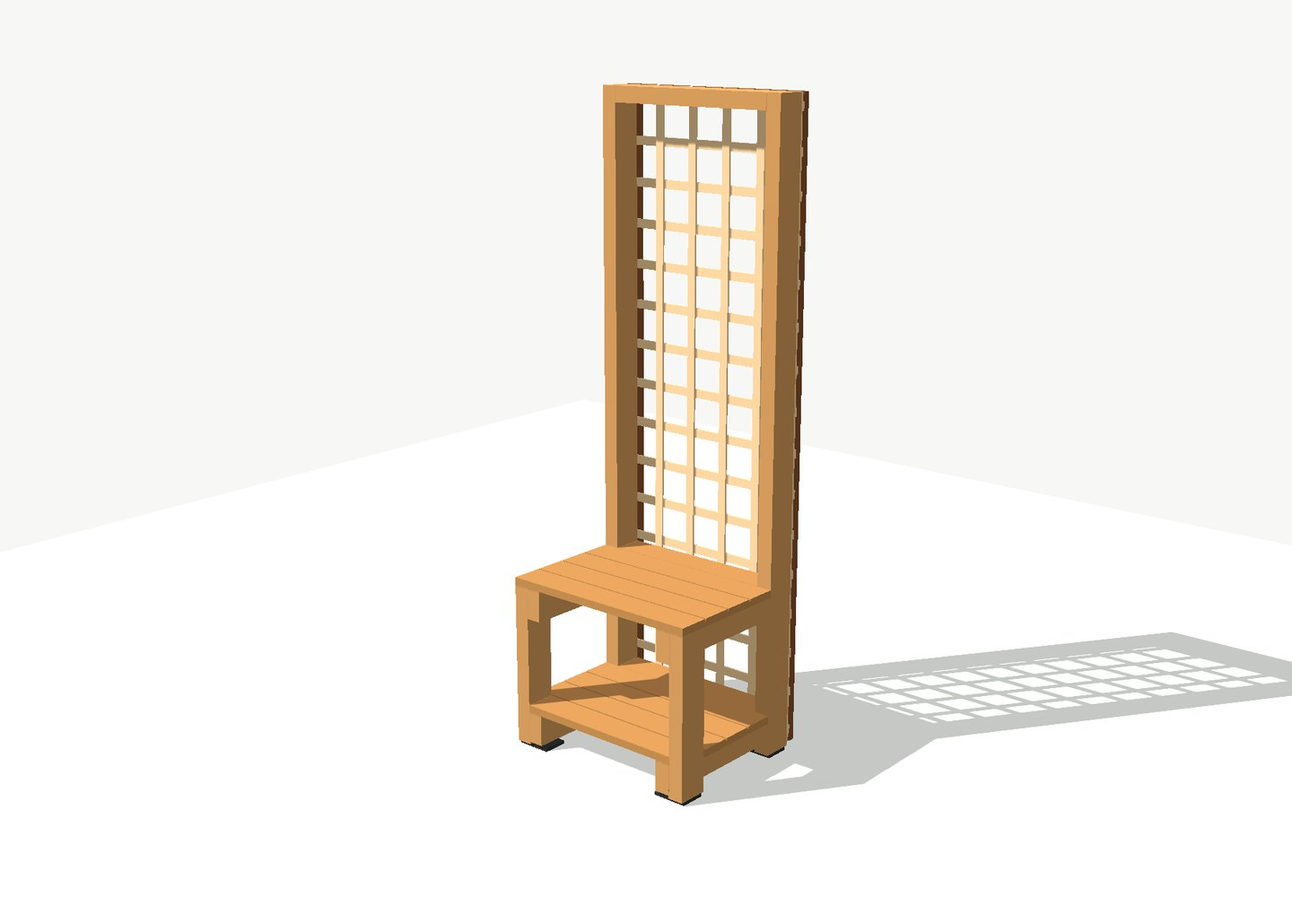

The 900 mm centre module
- Three cross-frames instead of two.
- The middle frame is a full leg pair: a rear leg and a front leg, both 468 long to 478, so the back of the bench top is carried at mid-span. The rear leg stops at bench height so it does not foul the lattice.
- Second bearers on the far side of the middle frame at both levels, carrying the boards either side of it.
- Those four joints bolt through 45 + 45 + 45, so they take M10x150 bolts.
- 16 x M10x120 plus 8 x M10x150, and 64 fifty-mm screws.
- The bottom rail is two 382 mm pieces. Fit the left piece and screw through the middle leg into its end first, then the right piece. 37 kg before pots.
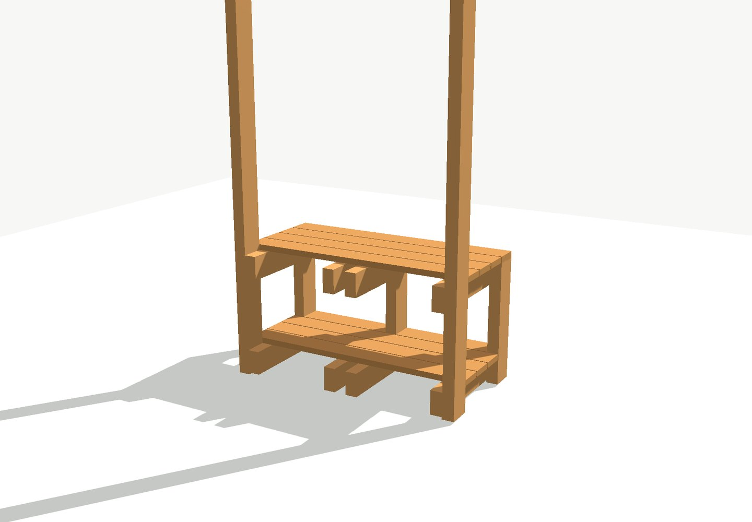
Seen from the wall side: the middle frame's rear leg runs to the underside of the bench top.
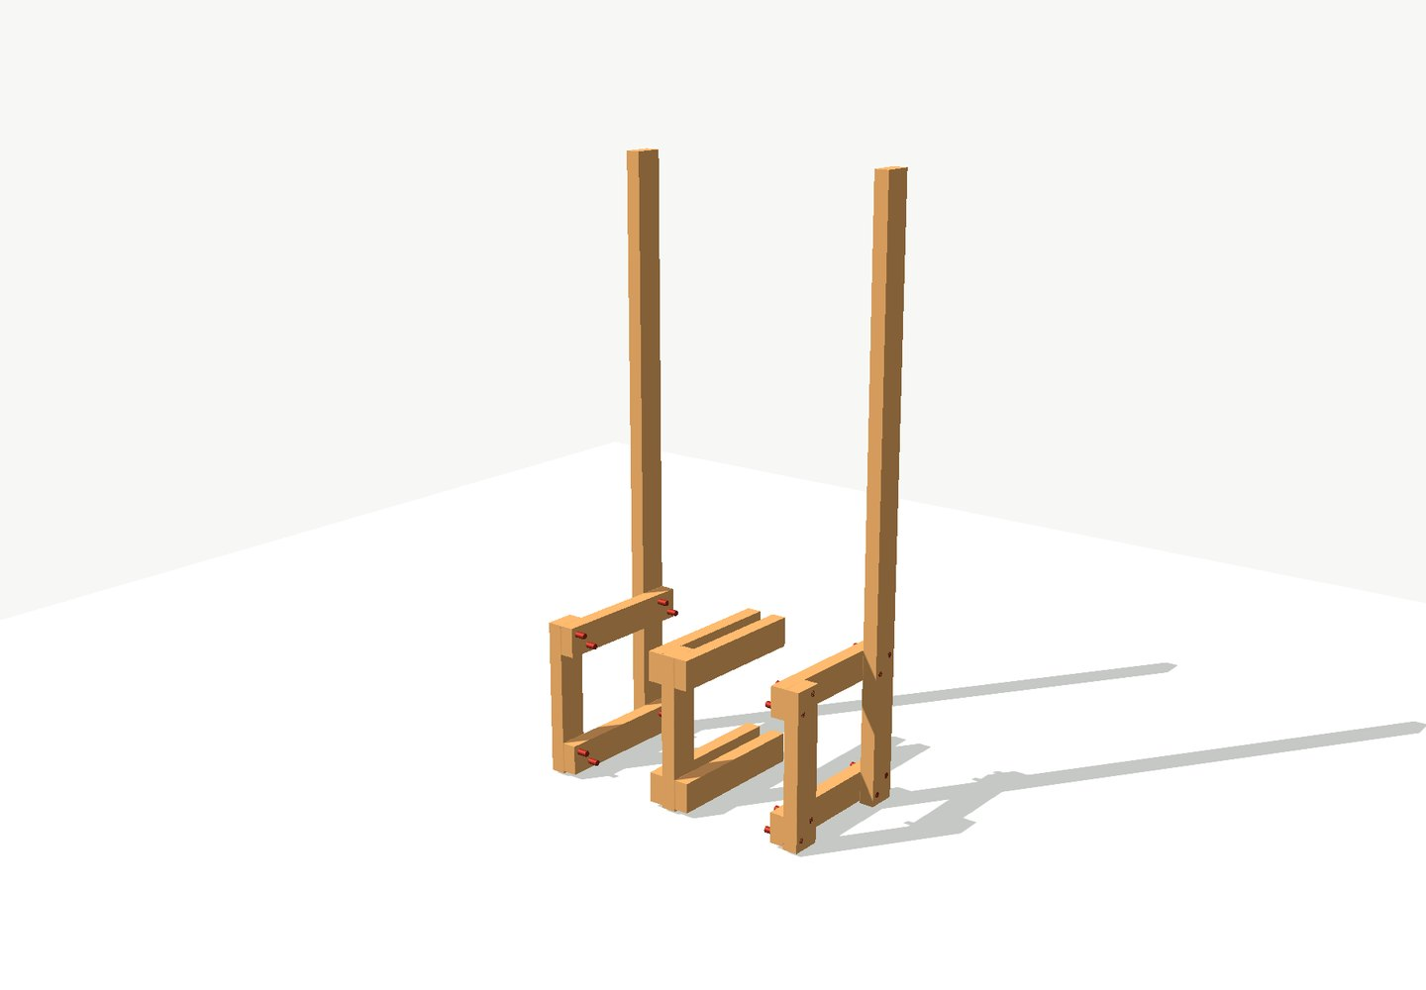
The same module from the front, with all three frames standing.
Finishing and first-year care
- H3 treatment handles rot; oil is for looks and to slow surface checking. Use a pigmented oil, since clear gives almost no UV protection.
- Coat parts before assembly where you can, and spray or dip the lattice rather than brushing it.
- Re-tighten every M10 nut after about a month, then check each spring.
- Keep the pots on: they are what hold the modules down. Keep children off; the lattice is not a barrier.
Slide version of this guide: https://claude.ai/artifact/VX7RYzKuyGwnUHXprddLsv

