WORKS APPLICATION - SUPPORTING ATTACHMENTS
Balcony privacy screen and plant benches
Owner | Luke Jamieson
Lot number | 7
Property address | 37 Cambridge Road, Mooroolbark VIC 3138
Email | luke.jamieson@gmail.com
Location of works | Balcony (first floor); timber cut in the garage. Final assembly on the balcony. Both within the lot.
Preferred dates | Start [dd/mm/yy] - End [dd/mm/yy] (approx. 6 week window)

1. Brief description of intended works
Five free-standing timber modules will be placed on the balcony, standing against the inside of the balcony wall. Each module is a two-tier plant bench with a lattice panel fixed to its back, providing privacy and support for climbing plants. Potted plants sit on the bench top and the lower shelf. Each module is 506 mm deep. The balcony is about 1800 mm deep, so this leaves roughly 1294 mm of clear walkway.
The modules are items of furniture. They stand on the existing timber deck boards on plastic packers, which spread their weight across several boards, and can be lifted out at any time. They are not fixed to each other.

Nothing is fixed to the building
- No drilling, fixing, clamping or adhesive to the balcony wall, the deck boards, the side walls, the glass balustrade, or any common property.
- Nothing is placed on top of, or overhangs, the balcony wall. All parts sit within the lot, 10 mm clear of the wall face.
- Nothing is fixed through the decking. The deck boards, and the drainage gutter beneath them, are not penetrated, lifted, coated or altered in any way, and nothing is stored in the gutter.
- No plumbing, electrical, air-conditioning or wall penetration work of any kind.
- Nothing is attached to the existing air-conditioning outdoor unit, and clearance around it is maintained.

Assembly and impact on other residents
- Timber is cut to length in my own garage using a mitre saw. Sub-assemblies are then carried up in sections small enough to handle, and the final screwing together is done on the balcony with a cordless drill. All work happens within the lot. No trades or contractors are engaged.
- No cutting is done on the balcony. Work there is hand assembly only: driving screws with a cordless drill, which is no louder than hanging a picture.
- Cutting is batched into a small number of sessions rather than spread across many days. Saw use is intermittent and confined to the garage, with the door open only as needed. Offcuts and sawdust are swept up and removed; nothing is cut on common property or on the balcony.
- Because this is hobby work done outside business hours, cutting and assembly would fall on weekends. Approval is requested for work between 9.00am and 5.00pm on Saturdays and Sundays, in addition to the standard 8.00am - 5.00pm weekday hours.
- No building materials or skip bins are stored on common property. Materials are carried in through the lot.
- Access to other lots and common property is not obstructed at any time.
- The five modules are built one at a time over several weekends within the approved window, rather than in a single continuous period. Roughly 25 - 35 hours of work in total. Each module is complete and in place before the next is started, so the balcony is never left as a work site.

2. Rough plan and diagram
Dimensioned front elevation and a section through one module (all dimensions in millimetres):
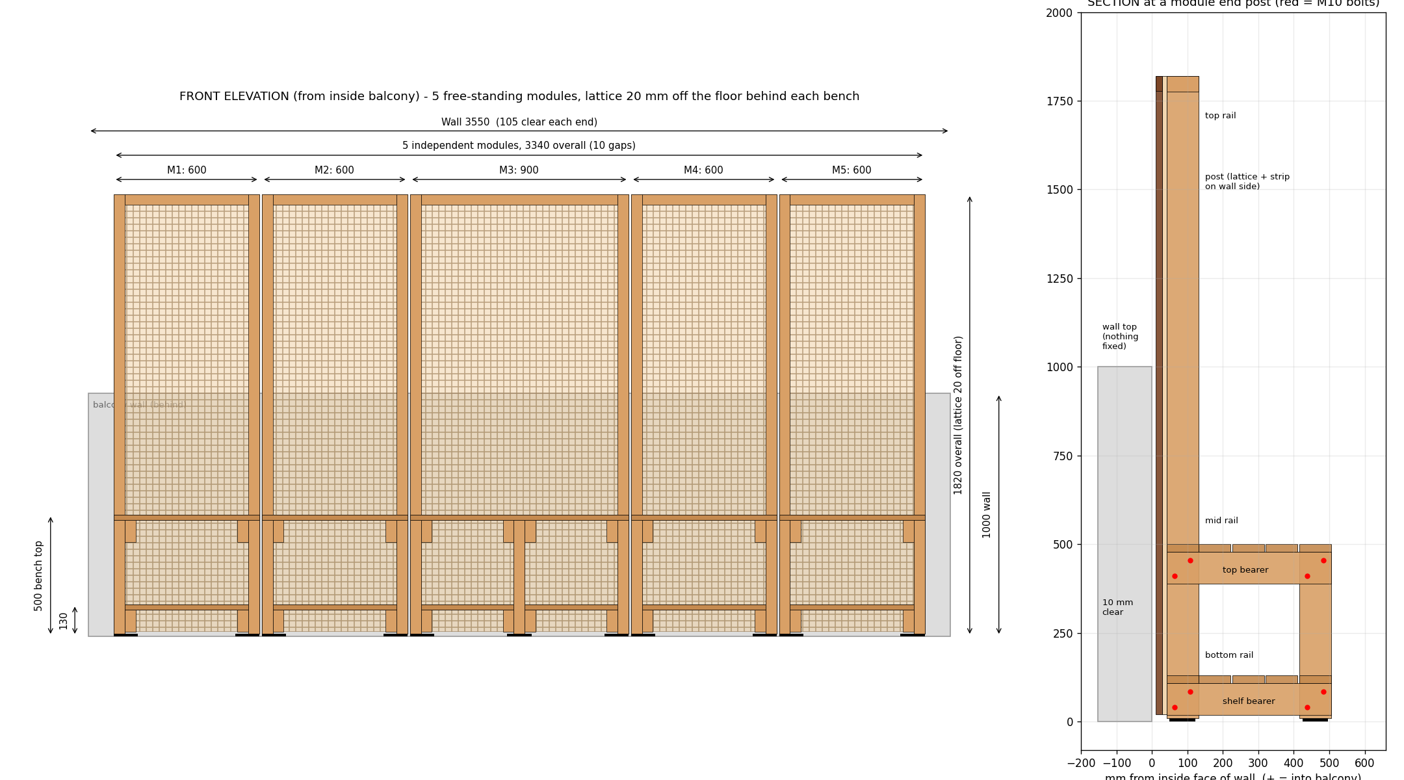
An interactive 3D model of the proposal is available at the link below. It can be opened on a phone or computer, rotated and zoomed, and includes views from inside the balcony, from the driveway below, from above, and a close-up of one module.
https://lukerjamieson.github.io/balcony-screen/

Key dimensions
Item | Detail
Number of modules | 5, free-standing (600 / 600 / 900 / 600 / 600 mm wide)
Overall length | 3340 mm along a 3550 mm balcony wall (105 mm clear at each end)
Overall height | 1820 mm above the balcony floor (820 mm above the top of the wall)
Depth from wall | 506 mm
Bench top / lower shelf | 500 mm / 130 mm above floor
Weight per module | 26 kg (600 mm modules), 37 kg (900 mm module), before pots
Clearance to wall | 10 mm, on plastic packers

3. Proposed products and materials
All materials are standard outdoor-rated products from Bunnings. Specifications and photographs are available on the product pages at bunnings.com.au.
Qty | Product | Used for
17 | 90 x 45mm Outdoor Framing H3 Treated Pine (MGP10), 2.4 m | Posts, bench frames, rails
14 | 90 x 22mm Decking H3 Treated Pine, 2.4 m | Bench tops (4 boards) and lower shelves (4 boards)
11 | SpecRite 42 x 19mm Merbau Pre-Oiled Solid Screening, 2.7 m | Lattice cover strips
4 | Lattice Makers 1800 x 600mm Economy Lattice | Screen panels
1 | Lattice Makers 1800 x 900mm Economy Lattice | Screen panel
93 | Zenith M10 x 120mm hot dip galvanised cup head bolts, nuts and washers | Frame joints
9 pk | Zenith galvanised countersunk timber screws (50 / 65 / 100 mm) | Boards, strips, rails
24 | Titan 10 x 72 x 100mm black shim packing | Packers under each leg
Finish: natural timber. H3 treated pine is rated for outdoor above-ground use; the merbau screening is pre-oiled. All fixings are hot dip galvanised or galvanised for corrosion resistance.

4. Signed indemnity form
The Owner Indemnity page of the Works Application Form is signed and attached.
Item 5 (waterproofers / tilers / builders warranty for sealing of the balcony floor): not applicable. No waterproofing, sealing, tiling, decking or drainage works are proposed. The deck boards stay as they are and nothing beneath them is touched.

5. Structural certificate
Not required. The works consist of free-standing furniture standing on the existing deck boards. There is no fixing to the building, no load applied to the balustrade or walls, and no structural alteration of any kind.

Reinstatement
The modules can be removed at any time by lifting them out, leaving the decking exactly as it is now. No making good would be required.
If the works are not finished within the approved window, an extension will be requested before continuing.
Prepared by Luke Jamieson, owner of Lot 7, 37 Cambridge Road, Mooroolbark VIC 3138.

