**Aoni To IV patch**

|  |  |  |
| --- | --- | --- |
| Historical version | date | [Uploader](https://fanyi.baidu.com/#en/zh/Uploader) |
| Aoni_To_IV_20190327_PATCH | 2019/3/27 | **Luke** |

**Aoni_To_IV_20190327_PATCH:**

We will upload a compressed package to github.

The package’s name is Aoni_To_IV_20190327_PATCH.zip.

When decompressed, we will get six files.

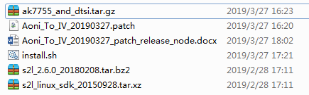

We just need to run install.sh.

**Note that after running install.sh, the compressed packages and patches will be deleted. Please pay attention to backup.**

Updated functions:

1. Fixed the problem of WiFi driver not loading
2. Update audio driver
3. Add ircut mode settings

**Icut mode test:**

Test source code in ambarella/oryx/image_quality/unit_test/ aoni_ircut_mode_test.cpp.

Test command :

**aoni_ircut_mode_test mode (mode :0/1/2)**

**Enable Day mode: aoni_ircut_mode_test 0**

**Enable Night mode: aoni_ircut_mode_test 1**

**Enable Auto moe: aoni_ircut_mode_test 2**