Robert Shay

COM S 319

24 February 2019

HW3 Report

For this homework we were tasked with making a snake game. It was not too difficult to make. Once I figured out how the setInterval function worked, I was able to get the game running fast. I used a switch case in the function that painted on the canvas to determine which direction spaces needed to be added to the snake. For the left and right buttons, I also used switch cases to determine which way the snake needed to be turned. For the hw3.js file, we had to make the program perform different functions on inputted numbers. Some examples can be found below.

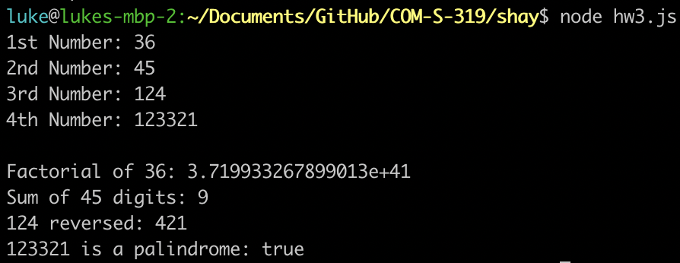

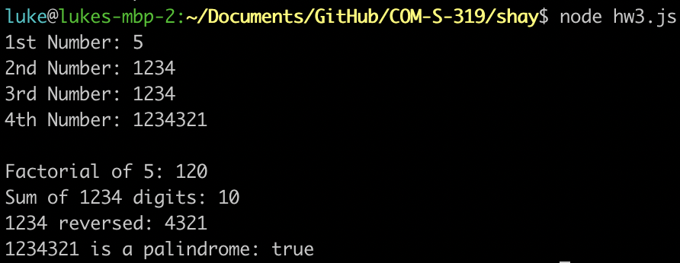

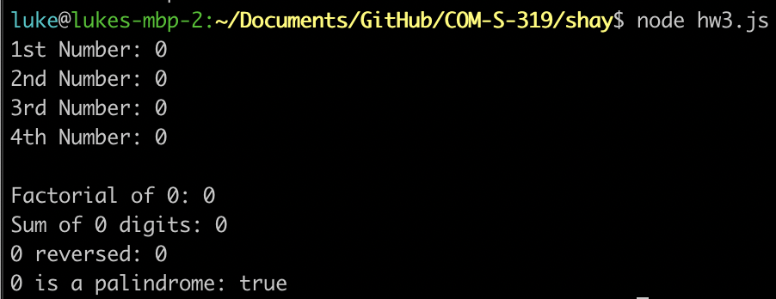

Here is a picture of the snake game before it is started:

