HW1 Report

For this project we had to create a messaging application on localhost that was entirely text based. I first started by making a server class. How the server class works is it opens a server socket on a given socket, which is on the localhost and the port 5000. This class accepts the incoming connection requests by clients and stores them in a vector. The vector consists of the type ClientThread. ClientThread is a handler the clients that are trying to connect. In this class, it will receive a message from the client, then print it to the server, then out to all of the other clients that are connected. If the client types “quit”, this class will close its socket connection, input stream and output stream. Each client has its own instance of ClientThread. The client class is the one that the user runs if they want to connect to the messaging server. When you run this program, it first asks you to enter your name, then it gives you some instructions on how to use the messaging system. Here is a screenshot of the output:

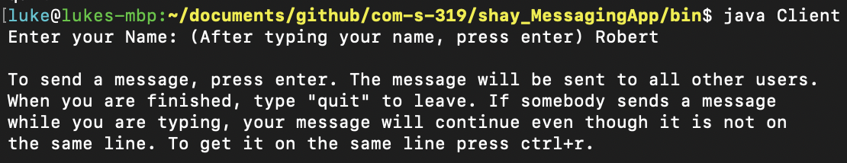

After this you can start sending messages. When other users connect and disconnect, the server sends a message to itself and all other users. The server also prints when a new client has been accepted and when it’s data streams have been created. An example of what the chat looks like for three clients and the server is shown below:

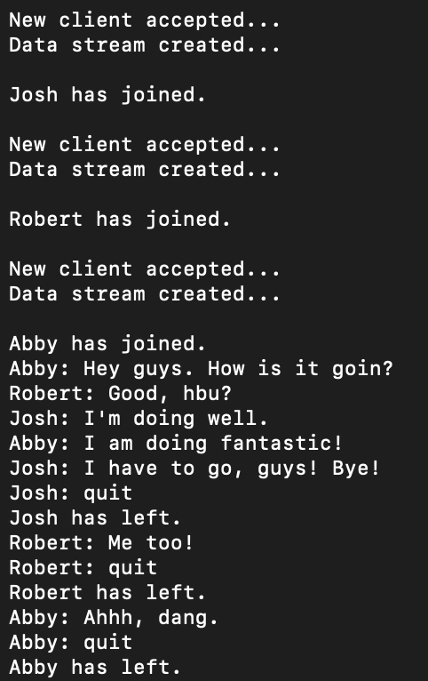

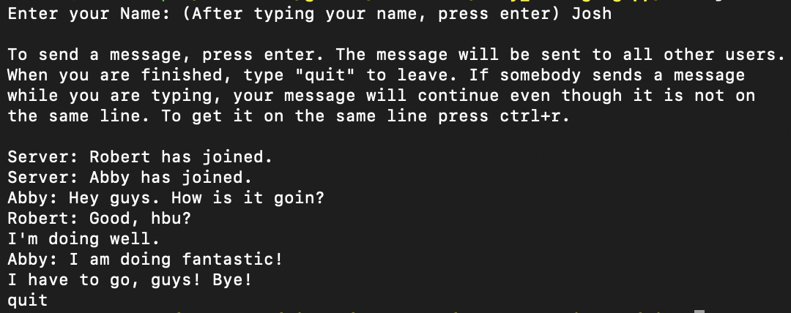

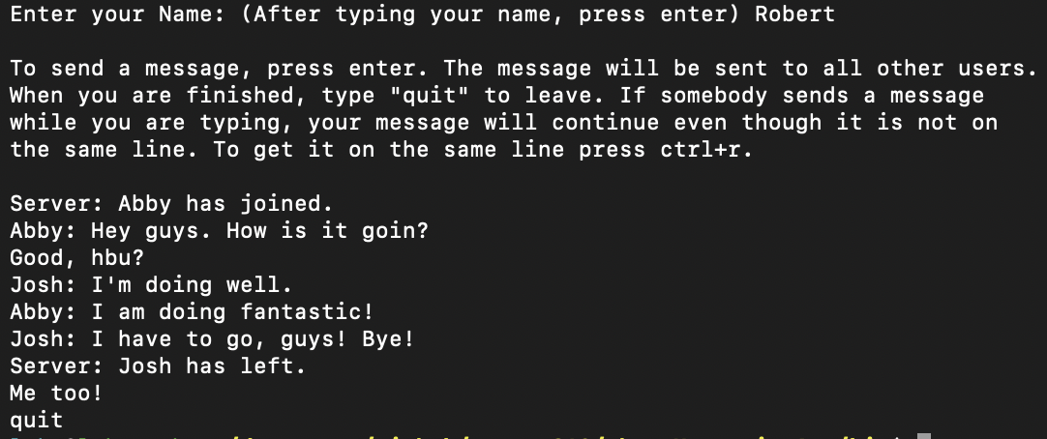

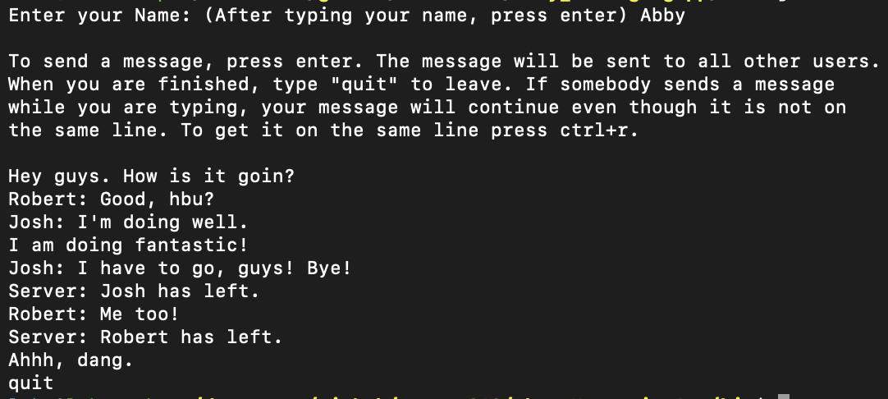

One error that I found when testing is the server will through errors repeatedly if the client gets terminated without the user typing “quit” first.