Robert Shay

COM S 319

10 February 2019

HW2 Report

For this homework, I did it very similar to the examples given in the .zip file. They were a really good resource to use to create this homework. I used the same basic process for both of the parts. I first created the .html file for both of them which included the spots to put in all of the data and the drop downs. I used the example files to understand how to do this. I then created the JavaScript code to work with the .html files. I borrowed some of the code from the examples, like the image picker as well as the email validator. The other code I wrote myself. It was not too difficult to write the code for validation. The hardest one was validating the phone number mainly because I was not to familiar with JavaScript. I ran different tests by putting in input until I figured out how to make the code work. The results can be seen below.

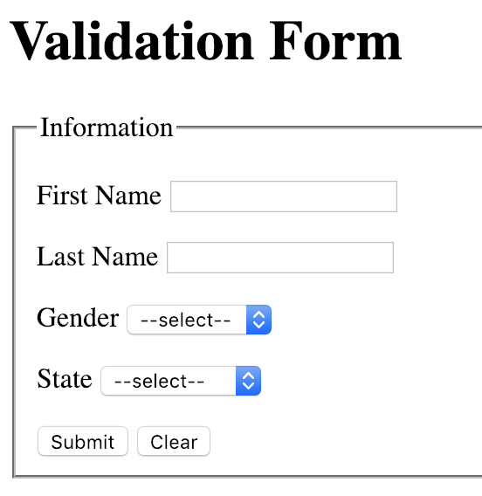

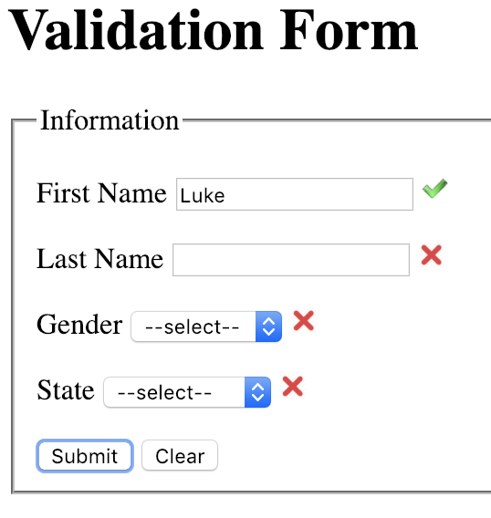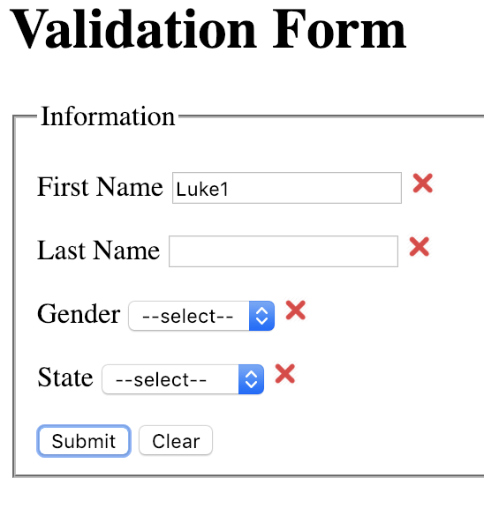

**\*\*NOTE Last Name works the same as first name\*\***

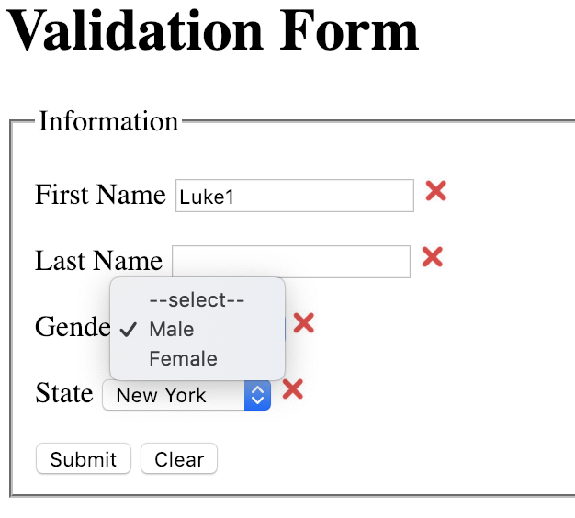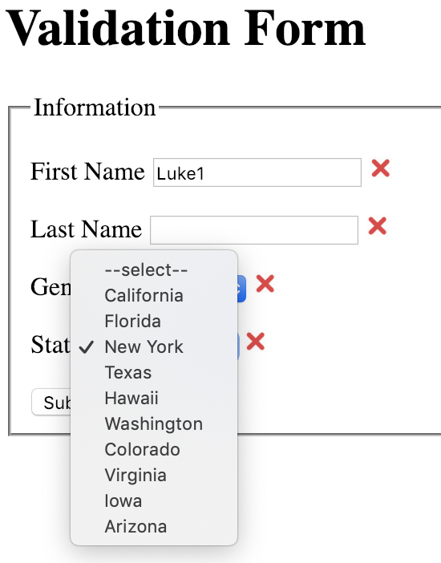

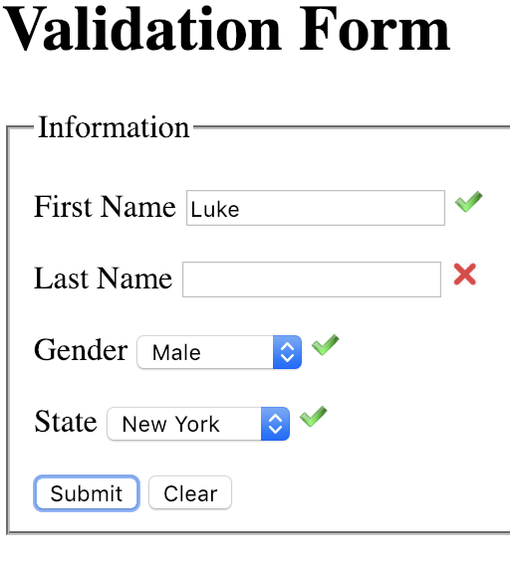

**\*\*NOTE when they are all correct it goes to the next page\*\***

