S1) Is serializable because the graph is cycle free. Goes from T1 to T2 and does not go back.

Equivalent:

|  |  |
| --- | --- |
| T1 | T2 |
| lock A |  |
| lock B |  |
| lock C |  |
| unlock A |  |
| unlock B |  |
| unlock C |  |
|  | lock A |
|  | lock C |
|  | unlock A |
|  | unlock C |

S2) Is not serializable because the graph goes from T4 to T3 then back to T4. Therefore there is a cycle.

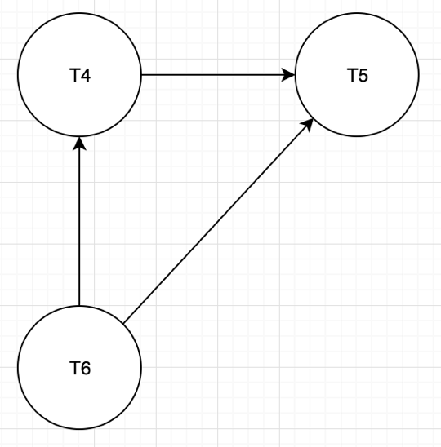S3) Is serializable because the graph is cycle free.

|  |  |  |  |
| --- | --- | --- | --- |
| T6: wlock A |  | R | W |
| T6: unlock A |  | T4: rlock A |  |
| T4: rlock A |  | T5: rlock A |  |
| T6: wlock B |  | T5: rlock B |  |
| T5: rlock A |  |  |  |
| T6: unlock B |  | W | W |
| T4: wlock B |  | T6: wlock A |  |
| T5: unlock A |  | T6: wlock B | T4: wlock B |
| T4: unlock A |  |  |  |
| T4: unlock B |  | W | R |
| T5: rlock B |  | T4: rlock A | T6: wlock A |
| T5: unlock B |  | T5: rlock A | T6: wlock A |
|  |  | T5: rlock B | T6: wlock B |
|  |  | T5: rlock B | T4: wlock B |

Equivalent:

|  |  |  |
| --- | --- | --- |
| T4 | T5 | T6 |
|  |  | wlock A |
|  |  | unlock A |
|  |  | wlock B |
| rlock A |  |  |
|  | rlock A |  |
|  |  | unlock B |
|  | wlock B |  |
|  | unlock A |  |
| unlock B |  |  |
| unlock A |  |  |
|  | rlock B |  |
|  | unlock B |  |

S4) Is not serializable because there is a cycle in the graph.

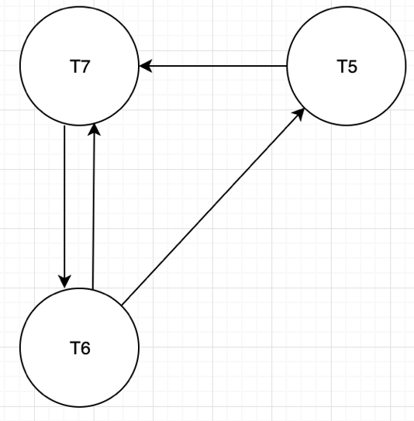

|  |  |  |  |
| --- | --- | --- | --- |
| T6: wlock A |  | R | W |
| T7: rlock B |  | T7: rlock B | T6: wlock B |
| T6: unlock A |  | T5: rlock A | T7: wlock A |
| T7: unlock B |  | T5: rlock B |  |
| T6: wlock B |  |  |  |
| T5: rlock A |  | W | W |
| T6: unlock B |  | T6: wlock A | T7: wlock A |
| T5: unlock A |  | T6: wlock B |  |
| T7: wlock A |  |  |  |
| T5: rlock B |  | R | W |
| T7: unlock A |  | T5: rlock A | T6: wlock A |
| T5: unlock B |  | T5: rlock B | T6: wlock B |
|  |  |  | T7: wlock A |