**Space data processing: making sense of experimental data**

**Exam, May 24, 2016**

1. You have experimental data about a dynamical process. What do you start with to study   
   the regularities of process?

Regularities (cycle, min, max etc)

* 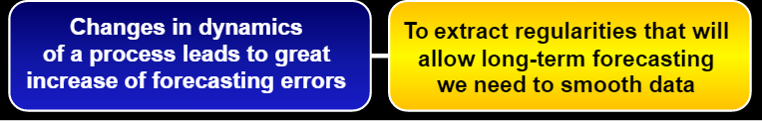
* Try to find characteristics of dynamic process, such as trajectory (there will be big estimation error if parabolic line would be considered as linear) – than optimal method if dynamic is known

1. What is the difference between optimal and quasi-optimal estimation methods?

In optimal method characteristics of dynamic process is known, more accurate predictions.

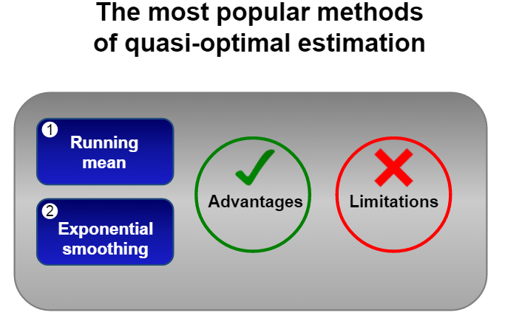 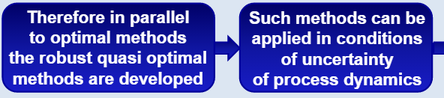

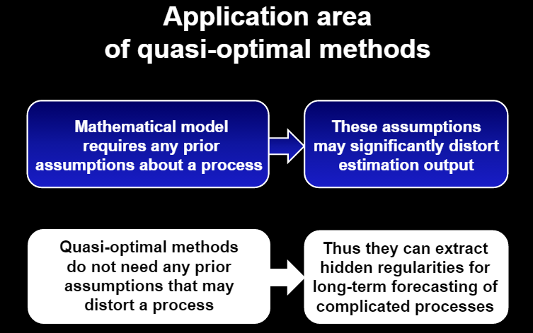

1. Describe advantages and disadvantages of optimal and quasi-optimal estimation methods.

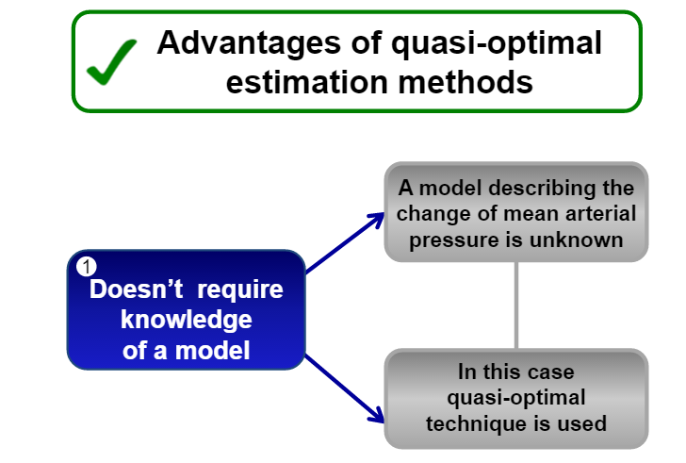 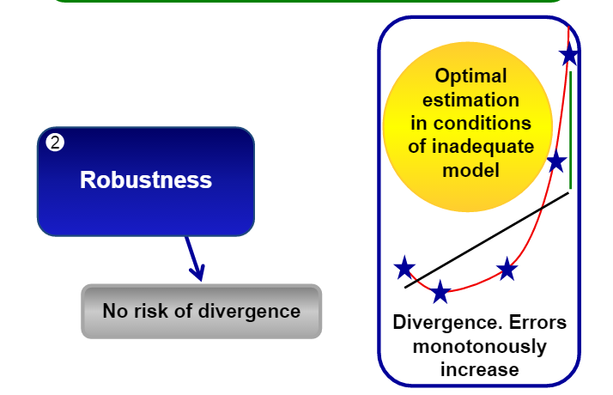

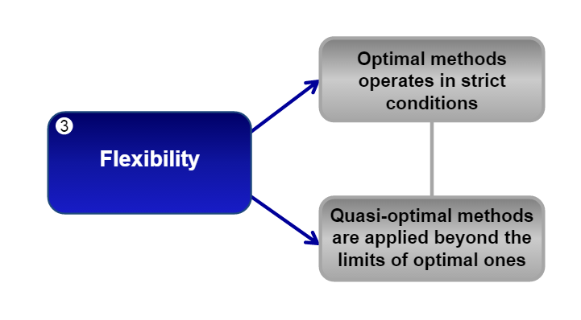

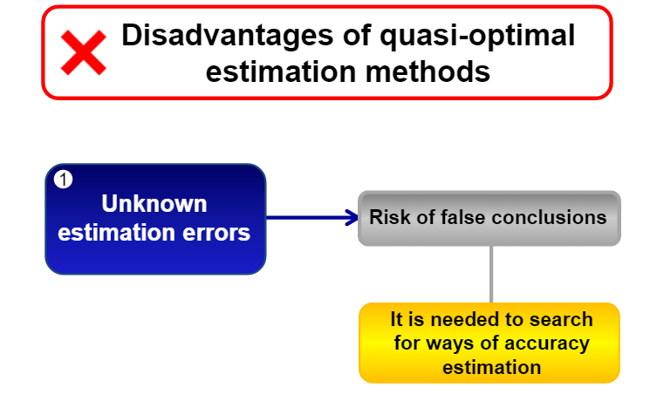

1. How do you analyze the reliability of obtained estimation results and potential success   
   of processing? **(?)**
2. Which conditions are more preferable to apply running mean than exponential mean?

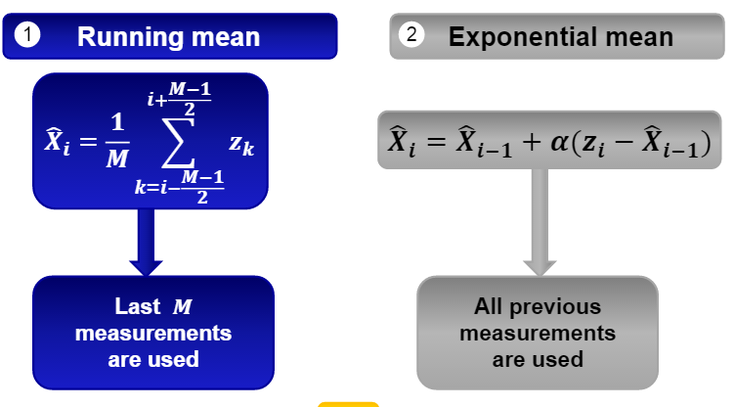



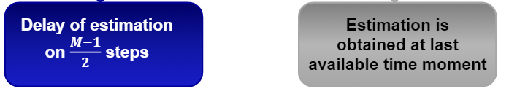

In running mean in order to smooth data we need to wait following measurements and if it is months or years it is inconvenient to wait, than we will not have smoothing of last points.

For exponential mean, the graph is shifted to the right, because only previous measurements were taken in account, in running mean, there is no shift.

Errors for running mean is greater than in exponential.

It is critical to choose M and alfa for those methods. If process is almost constant than it is necessary to reduce as much noise as possible, in this case big window M is suitable. For exponential, it is needed small alfa, because the smaller it is the less we rely on next measurements, to this noise.

1. What are results of running mean if the width of running window is the same or greater   
   than period of variations?

If running mean applied for width of running mean equal to period of variations, than process is completely distorted. Graph is linear.

If it is greater, than inverse oscillation occurs.

1. Processing methods are based on finding a balance between the maximal noise reduction   
   and the minimal distortion of true process. Which parameters determine this balance?

А. In Kalman filter – **Ki**

B. In running mean - **M**

C. In exponential mean - **alfa**

D. In smoothing algorithm based on complex minimization of deviation and variability indicator? **Betta**

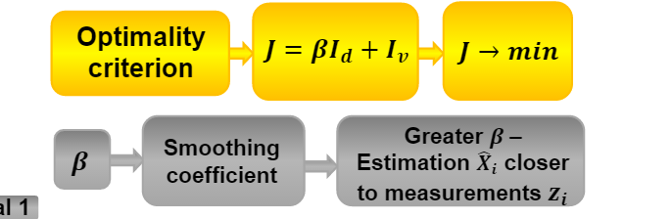

1. What is the main difference between classical least-square method and Kalman filter?

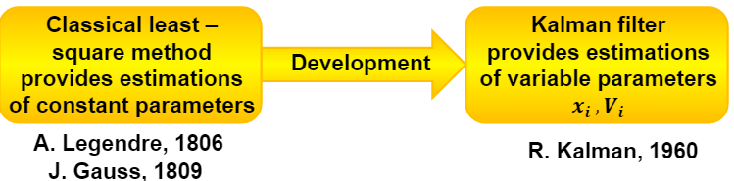

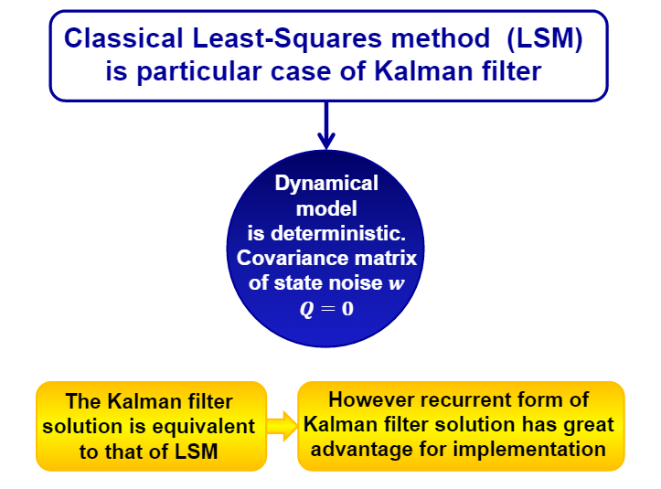

1. How a theoretical model of process can be adjusted on the basis of available experimental data? How errors of measurements can be estimated?

**Through state space model**

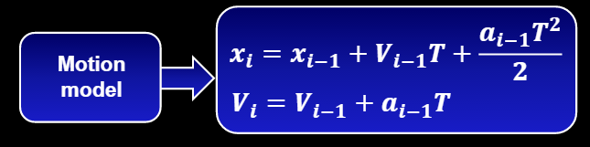

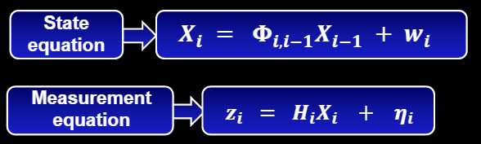

1. Is it possible to estimate directly unmeasured parameters using **(not sure)**A. Classical least-square method? - **NO**

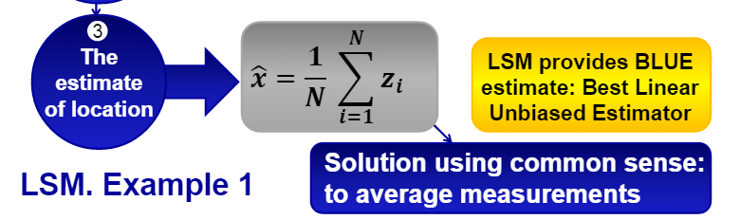   
B. Kalman filter? – **YES**

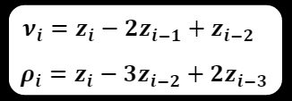  
C. Quasi-optimal estimation methods? – **NO** (measurements constantly is needed)

1. How to estimate the accuracy of forecast *m* steps ahead using Kalman filter?

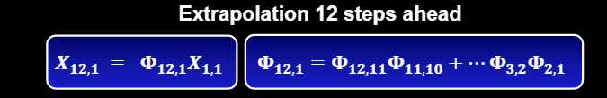

1. Does Extended Kalman filter provide optimal estimation? Why?   
   Under which conditions it comes to divergence even if all the parameters are known?
2. Which methods considered in the course can be widely applied in

A. Navigation?  
B. Space weather?

C. Biomedicine (running – mean)

14. What is the most important thing you learned in this course?