Development Testing

|  |  |  |
| --- | --- | --- |
| Tested: | Expected: | Result: |
| Player Input: Up | Characters moves and rotates up | Characters moves and rotates up |
| Mute Button | Enables check icon, Sets volume slider and value to 0 | First click did not enable check icon but would mute the game. |
| Collecting Coin | UI updated, Coin object disabled | UI Gets updated, Coin object disabled |
| Resetting | Character position reset, Coins activated, UI updated, Gates position reset | Character position reset, Coins activated, UI updated, Gates position reset |
| Activate player switch | Characters switch color, swaps characters horizontal input | Characters switch color, swaps characters horizontal input |
| UI links | UI activate appropriate menus | Options button activates options menu, back button closes options menu. |

Outcome of testing:

Changed the layout order of the mute script to allow the mute button to function as intended.

Optimisation opportunities:

Caching Components- In order to speed up the program, references to components of objects are made on start up instead of every time they are needed.

Batching Draws- Having limited moving objects in the game can help to increase the draw speed by setting everything that is not intended on moving to static.

Performance Profiling- Using Unity’s in-built profiling tool, we can determine which parts of code are using more memory than other parts and where performance drops off.

Feedback:

Extra level in camera view. Small characters that are hard to see. Make levels smaller. Grid. character entrance for the first level. Having only 1 axis inverted felt off.

Outcome of feedback:

Reduced the level scale to increase the amount of the current level that is being shown and makes the characters more visible. Changed the character controls so that both axis’ were being mirrored by the non-active character. To make the characters more noticable, a disk was put at the characters feet to show which one was active.

|  |  |
| --- | --- |
| Name: | FeedBack: |
| Thomas | The controls of possessing both characters at the same time are not necessarily intuitive. The fact the inactive player goes opposite for the left and right is unorthodox and jarring. Possessing 1 character at a time or not inverting the controls of only one axis may benefit the game. |
| Millie | The main menu looks nice, but the controls were incorrect. Make more levels and add terrain to the scene to make it look more eye-catching.  Change character model. |
| Class | Add grid to the ground. Add indicator under the character |

Changing the map assets to give the game more color.

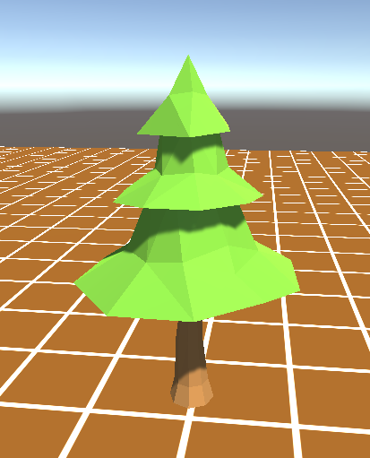

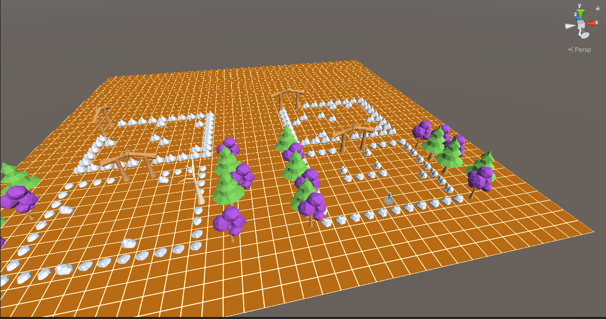

Created an icon below the player to highlight the characters. Added grid to the ground.

