**Luke Stanbridge**

Game Developer

**Phone:** 0488 119 493 **Email:** [stickdriftsoftware@gmail.com](mailto:stickdriftsoftware@gmail.com) **Location:** Adelaide, SA

**LinkedIn:** <https://www.linkedin.com/in/luke-stanbridge-75b328194/>

**GitHub:** <https://github.com/LukeStanbridge?tab=repositories>

| **SUMMARY**  I am currently studying game programming at AIE. Previously I was an Electrician since 2011. I completed my Certificate III in Information Technology in July of 2022. Completed my Diploma of Information Technology (Game Programming) and Diploma of Screen and Media in December of 2022. I like to research areas outside of my studies that I think are important and undertake extra courses and tutorials to broaden my knowledge and target gaps I believe are important. Comfortable working independently and in a team environment.  **PROFESSIONAL EXPERIENCE**  AIE Game Production - The final 3 months of my Diploma was dedicated to a full Game Production Project. The environment simulated for production is designed to be as accurate to real world game development as possible. I worked with other programmers, game designers and artists through the whole project. Each profession had their individual responsibilities. As a programmer I was responsible for the Technical Design Document, developing the player controller, UI systems, Audio System and Testing/Troubleshooting the game.    AIE Diploma Content - C#, C++, Maths, Version Control, Game Business Studies, Code Design & Data Structures, AI for Games, UI Programming, Cross Platform Development, Production Planning and Game Production.  **EDUCATION**  Academy of Interactive Entertainment   * Cert III in Information Technology * Diploma of Information Technology * Diploma of Screen and Media |  | **SKILLS**  C#  C++  Unity  Microsoft Office Suite  Visual Studio 2022  Visual Studio Code  Game Development 3D/2D  Raylib  Github  Problem-Solving  Time Management  Communication  UI Design  Character Combat  Level Design  **STRENGTHS**  Interpersonal Skills  Results Orientated  Knowledge Hungry  Hard Working  Resourceful  Team Player  **ACHIEVEMENTS**  AIE Game Production Project  Diploma Completion  Cert III in IT completion  **GAME INTERESTS**  Battlefield  Dead Cells  Elden Ring  Nier Automata  Wolfenstein |
| --- | --- | --- |

* **Add Referees (Nick and John)**
* **Create this below**

**https://www.kickresume.com/en/help-center/game-programmer-resume-sample/**

Self-Promotional Material #1 - Github Repositories

<https://github.com/LukeStanbridge?tab=repositories>

Self-Promotional Material #2 - aMaze Game UI System

-upload video to a twitter account or somewhere

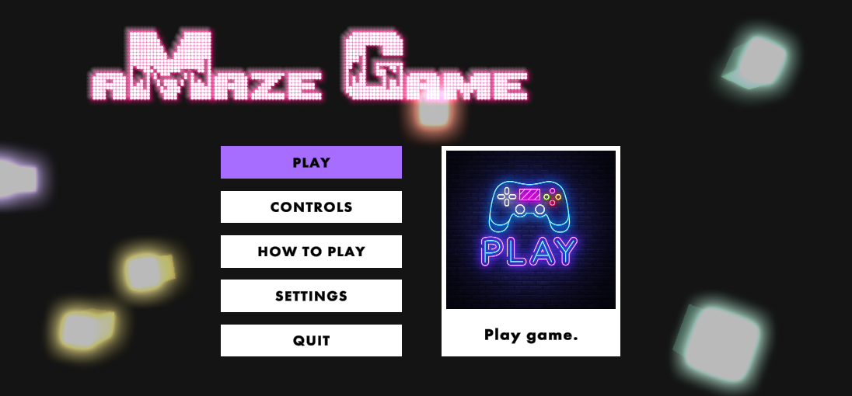

**ToDo for job**

**Website - demonstrating games and things I developed**

**Resume**

**GitHub**

**LinkedIn**