San Francisco Bay University

MATH201 - Calculus I

Luke Gregory G. Pamaos

Homework Assignment #4

Due Date: 11/17/2024

1.)

(a) Use Excel to graph the function within the window (-2pi, 2pi) by (-4, 4). What is the slope at the origin?

- Graph (f(x)) in the specified window.

- The slope at the origin is 1.

(b) Adjust the view to (-0.4, 0.4) by (-0.25, 0.25) in Excel. Does your new estimate align with part (a)?

- The slope remains 1 at the origin, consistent with part (a).

(c) Zoom further to the window (-0.008, 0.008) by (-0.005, 0.005). Do you wish to revise your slope estimate?

- At the origin, the slope is 0. Therefore, I revise my earlier estimate.

2.)

Graph Analysis:

Graph (f(x)) in Excel and zoom in near the points ((-1, 0)) and the origin. How does the graph behave at these points?

- At ((-1, 0)), the graph appears linear, so (f(x)) is differentiable at (x = -1).

- At the origin ((x = 0)), the graph has a sharp corner, indicating that (f(x)) is not differentiable at (x = 0).

3.)

Differentiability Test:

If (f(x)) is differentiable, the left-hand derivative ((f'_-(a))) and right-hand derivative ((f'_+(a))) must exist and be equal:

f'_-(a) = lim_h to 0^- f(a+h) - f(a)h

f'_+(a) = lim_h to 0^+ f(a+h) - f(a)h

For (f(x)), calculate (f'_-(4)) and (f'_+(4)):

- Left-hand derivative at (x = -4):

Given (f(x) = 5 - x) for (0 < x < 4),

f'_-(4) = -1

- Right-hand derivative at (x = 4):

f'_+(4) = 1

Conclusion: (f(x)) is not differentiable at (x = 4) since the derivatives are not equal.

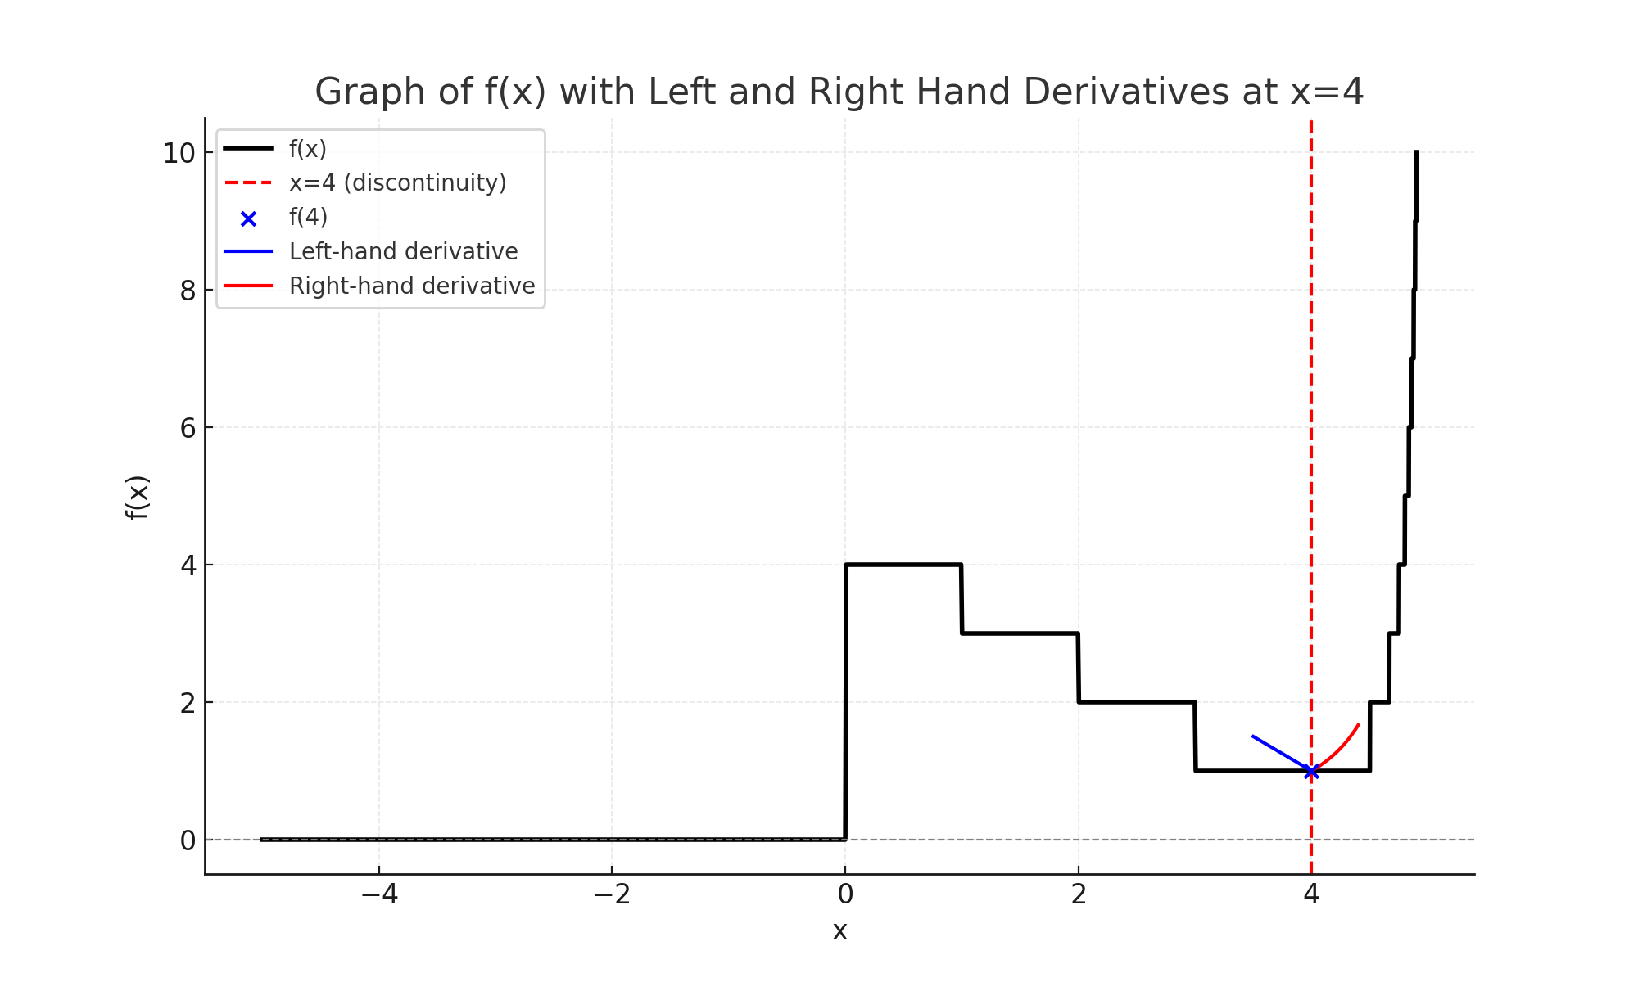

Discontinuities and Non-Differentiability:

- (f(x)) is discontinuous at (x = 0) and (x = 5).

- (f(x)) is not differentiable at (x = 0) and (x = 4).

4.)

Derivative Proof:

If (g(x) = x f(x)), prove (g'(x) = x f'(x) + f(x)):

g'(x) = lim_h to 0 g(x+h) - g(x)h = lim_h to 0 (x+h)f(x+h) - xf(x)h

Simplifying each term confirms:

g'(x) = x f'(x) + f(x)

5.)

Boyle’s Law:

For a gas sample compressed at constant temperature, (PV = C). Given (P = 50 kPa), (V = 0.106 m^3):

C = P x V = 5.3 m^3 kPa

The volume as a function of pressure is:

V(P) = 5.3P

Interpretation of Derivative:

The derivative (dV/dP) measures the rate of change of volume for pressure.

6.)

Tire Pressure and Life:

Using the provided data, model tire life (L(P)) as a quadratic function:

L(P) = -0.275P^2 + 19.75P - 273.55

Evaluate (dL/dP) at (P = 30) and (P = 40):

- (P = 30): (dL/dP = 3.25 thousands of miles per lb/in^2)

- (P = 40): (dL/dP = -2.25 thousands of miles per lb/in^2)

The derivative shows the rate of change of tire life with pressure. Positive values indicate tire life is increasing, while negative values indicate a decrease.