Luke Gregory G. Pamaos
20104

Question 1: Blood Alcohol Concentration (BAC) Over Time
Step 1: Input the provided time and BAC values into Excel.
Step 2: The graph shows that BAC rises sharply at first, peaking around 0.5 hours, then slowly decreases as the body metabolizes alcohol over time. This illustrates the quick absorption and slow processing of alcohol by the body.
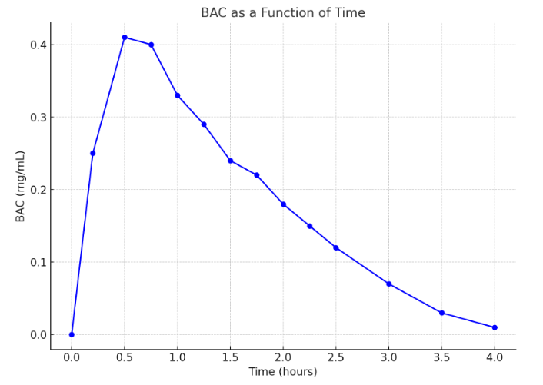

Question 2: Equation of a Circle
The equation (x^2 + (y - 2)^4 = 4) describes a circle centered at (0, 2) with a radius of 2. Solve for (y) to find the top half of the circle.

y – 2 = √4 - x^2
y = 2 + √4 - x^2
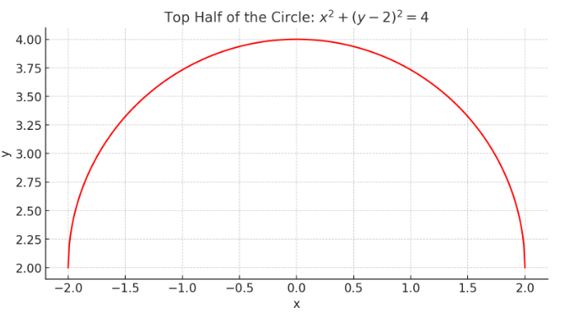

Question 3: Tax Rates and Calculations
Tax Rate:
- Income (I leq 10,000): tax rate (R = 0).
- (10,000 < I leq 20,000): tax rate (R = 0.1).
- (I > 20,000): tax rate (R = 0.15).
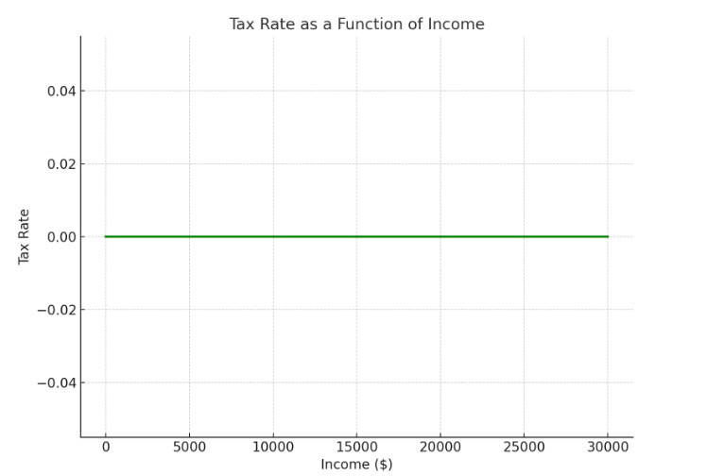
Income of $14,000, tax = ((14,000 - 10,000) times 0.1 = 400).
Income of $26,000, tax = (10,000 times 0.1 + (26,000 - 20,000) times 0.15 = 1,900).

Question 4: Graph Patterns
- Graph (a) can be modeled by a quadratic function (y = ax^2 + bx + c).
- Graph (b) could be represented by an exponential decay function (y = a cdot e^{-bx}).

Testing these in Excel confirms that these models match the shapes of the graphs.
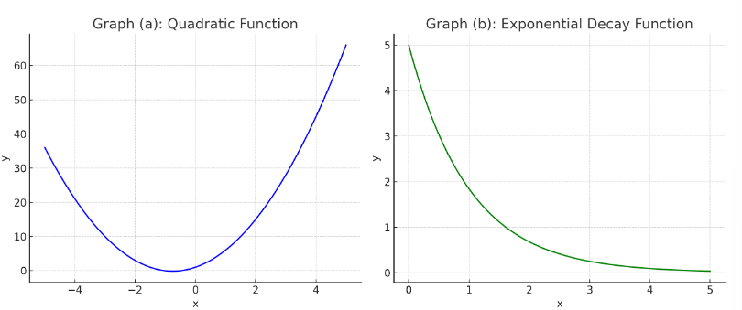
Question 5: Scatter Plot and Linear Regression
The scatter plot shows the relationship between femur length and height with a linear regression line. For a femur of 53 cm, the estimated height is approximately 182.33 cm.
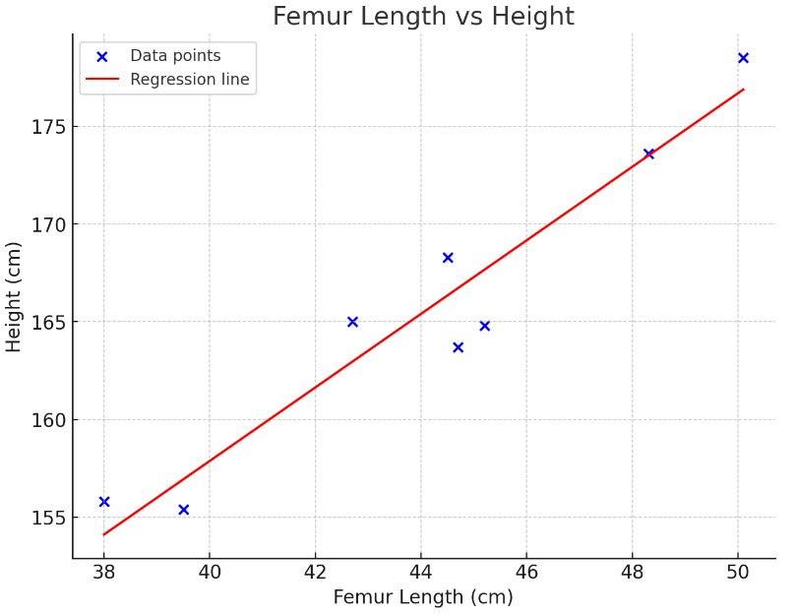
Question 6: Graph of (y = f(|x|))
The graph of (f(|x|)) reflects the original function across the y-axis.
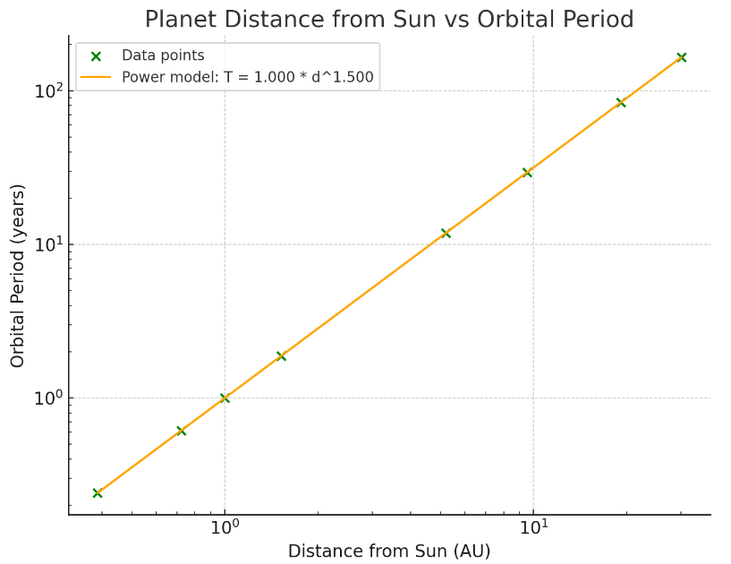
Kepler's Third Law
The model (T = 1.000 times d^{1.500}) aligns with Kepler’s Third Law, confirming that (T^2) is proportional to (d^3). The data supports the relationship.

Question 7: Graphing Transformations
- The graph of (y = sin(|x|)) mirrors the sine function across the y-axis.
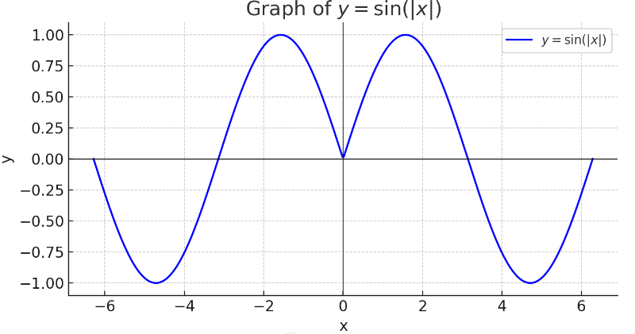
- A V-shaped graph is formed when applying the square root function to absolute values, reflecting over the y-axis.

Question 8: Composite Functions
For the given composite functions:
- ((g circ f)(6)) is undefined since (f(6)) is outside the domain.
- ((g circ g)(-2)) equals 3 based on the graph.
- ((f circ f)(4)) equals 1.

