Luke Gregory G. Pamaos

Calculus I Homework Assignment 2:

Problem 1:

A.) Average Velocity

**Average Velocity Calculations**

The formula for average velocity over a time interval is:

Average velocity = (y_final - y_initial) / (t_final - t_initial)

Where y(t) = 10t - 1.86t^2.

**Interval [1, 2]:** Average velocity = (y(2) - y(1)) / (2 - 1)  
= [(10 × 2 - 1.86 × 2^2) - (10 × 1 - 1.86 × 1^2)] / 1  
= (20 - 7.44 - 10 + 1.86) / 1  
= 4.42 m/s

**Interval [1, 1.5]:** Average velocity = (y(1.5) - y(1)) / (1.5 - 1)  
= [(10 × 1.5 - 1.86 × 1.5^2) - (10 × 1 - 1.86 × 1^2)] / 0.5  
= (15 - 4.185 - 10 + 1.86) / 0.5  
= 5.35 m/s

**Interval [1, 1.1]:** Average velocity = (y(1.1) - y(1)) / (1.1 - 1)  
= [(10 × 1.1 - 1.86 × 1.1^2) - (10 × 1 - 1.86 × 1^2)] / 0.1  
= (11 - 2.2506 - 10 + 1.86) / 0.1  
= 6.094 m/s

**Interval [1, 1.01]:** Average velocity = (y(1.01) - y(1)) / (1.01 - 1)  
= [(10 × 1.01 - 1.86 × 1.01^2) - (10 × 1 - 1.86 × 1^2)] / 0.01  
= 6.28 m/s

**Interval [1, 1.001]:** Average velocity = (y(1.001) - y(1)) / (1.001 - 1)  
= [(10 × 1.001 - 1.86 × 1.001^2) - (10 × 1 - 1.86 × 1^2)] / 0.001  
= 6.2781 m/s

(i)4.42m/s, (ii)5.35m/s, (iii) 6.094m/s, (iv) 6.2614, (v) 6.27814

B.) 10 – 3.72(1) = 6.28m/s

**Instantaneous Velocity at t = 1**

The position function is y(t) = 10t - 1.86t^2.  
The derivative of y(t) is:

dy/dt = 10 - 2 × 1.86t

At t = 1:

dy/dt = 10 - 2 × 1.86 × 1  
dy/dt = 10 - 3.72  
dy/dt = 6.28 m/s

**Answer:** The instantaneous velocity at t = 1 is 6.28 m/s.

The graph represents the instantaneous velocity of a rock thrown upward on Mars as a function of time, based on the equation y=10t−1.86t^2. It illustrates how the velocity changes over time, with the slope at t=1 corresponding to the instantaneous velocity at that moment. By finding the derivative of y, the instantaneous velocity at t=1 is calculated to be approximately 6.28 m/s, which aligns with the value observed on the graph. The steepness of the curve around t=1 highlights how rapidly the velocity decreases as the rock approaches its peak height.

Problem 2:

**A) Average Velocity Calculations**

The formula for average velocity is:

Average Velocity = (s(b) - s(a)) / (b - a)

The displacement function is s(t) = 2sin(πt) + 3cos(πt).

**Interval [1, 2]:**  
s(2) = 2sin(2π) + 3cos(2π) = 3  
s(1) = 2sin(π) + 3cos(π) = -3  
Average Velocity = (3 - (-3)) / (2 - 1) = 6 cm/s

**Interval [1, 1.1]:**  
s(1.1) ≈ 0.4743  
s(1) = -3

Average Velocity = (0.4743 - (-3)) / (1.1 - 1) = -4.71m/s

**Interval [1, 1.01]:**  
s(1.01) ≈ 0.06183  
s(1) = -3  
Average Velocity = (0.06183 - (-3)) / (1.01 - 1) = -6.13 cm/s

**Interval [1, 1.001]:**  
s(1.001) ≈ 0.006183  
s(1) = -3  
Average Velocity = (0.006183 - (-3)) / (1.001 - 1) = -6.27 cm/s

**B) Instantaneous Velocity at t = 1**

The instantaneous velocity is the derivative of s(t):  
s'(t) = 2πcos(πt) - 3πsin(πt)

At t = 1:  
s'(1) = 2πcos(π) - 3πsin(π)  
s'(1) = 2π(-1) - 3π(0) = -2π  
s'(1) ≈ -6.283 cm/s

Problem 3:

**A.)** sinx/(sin pi x) = 0.32

The graph of f(x) = sin(x)/sin(pi*x) is periodic with vertical asymptotes at integer values of x, where sin(pi*x) = 0 makes the denominator undefined. Between these asymptotes, the graph oscillates like a sine wave, with increasing amplitude as it approaches the asymptotes. The function approaches zero as x approaches 0, with a limit of approximately 0.32. Near x = 0, the limit is approximately 1/pi, as sin(x) and sin(pi*x) both approach zero, but their ratio converges to a constant. This explains the behavior of the function near x = 0.

**B)**

lim (x → 0) [sin(x) / sin(πx)]

**Step-by-Step:**

1. Rewrite the function:  
   sin(x) / sin(πx) = (sin(x) / x) × (x / πx) × (πx / sin(πx))
2. Evaluate each part:

lim (x → 0) [sin(x) / x] = 1

lim (x → 0) [x / πx] = 1 / π

lim (x → 0) [πx / sin(πx)] = 1

1. Combine the results:  
   lim (x → 0) [sin(x) / sin(πx)] = 1 × (1 / π) × 1 = 1 / π
2. Approximate the result:  
   1 / π ≈ 0.31831

**Final Answer:**  
The limit of the function as x → 0 is approximately 0.31831.

The graph shows the function f(x) = sin(pi * x) as x approaches 0. It approaches approximately 1/pi (around 0.31831), matching the calculated limit in part 3(b). The periodic nature and undefined points at multiples of x = 1 confirm the expected behavior near x = 0.

Problem 4:

**A)**

We want to evaluate:

lim (x → 0) (1 + x)^(1/x)

**Step-by-Step:**

1. Expand (1 + x)^(1/x) using a binomial expansion:  
   (1 + x)^(1/x) = 1 + x(1/x) - (x^2 / 2!)(1/x) + (x^3 / 3!)(1/x) + …
2. Simplify terms:  
   (1 + x)^(1/x) = 1 + 1 - (1 / 2!) + (1 / 3!) + (1 / 4!) + …
3. Take the limit as x → 0:  
   lim (x → 0) (1 + x)^(1/x) = 1 + 1 + (1 / 2!) + (1 / 3!) + (1 / 4!) + …
4. Recognize the series:  
   This infinite sum is the definition of Euler’s number, e:  
   e = 1 + 1 + (1 / 2!) + (1 / 3!) + (1 / 4!) + …
5. Approximate the result:  
   e ≈ 2.71828

The number equals to Euler’s number, 2.72

**B.)**

The graph of the function y = (1 + x)^(1/x) shows how the expression behaves as x changes. As x approaches 0, y approaches the familiar number e (approximately 2.71828), which is the limit of the expression. As x increases, y gradually decreases and approaches 1, reflecting the diminishing effect of the term (1 + x)^(1/x) as x grows larger. The graph highlights the rapid rise near x = 0 and the asymptotic behavior as y approaches 1 for large x, confirming the result from part (a) that e is the limit as x → 0.

Problem 5:

**A)** Nope, the graph does not accurately represent the function f(x)=ex+ln∣x−4∣. Here’s why:

1. **Discontinuity at x=4:** The term ln∣x−4∣ is undefined at x=4 because ln(0) is undefined. This creates a vertical asymptote or point of discontinuity at x=4, which is not clearly shown in the graph.
2. **Behavior Around x=4:** As x gets closer to 4, ln∣x−4∣ makes the function approach negative infinity from the left and positive infinity from the right. This sharp change is not reflected in a typical graph, where the function might appear smooth.
3. **Detailed View Near x=4:** A zoomed-in graph near x=4 is necessary to clearly show the sharp changes and vertical asymptote. Without this, the graph may give a misleading impression.

In conclusion, while the graph provides a general idea of the function, it does not accurately show the critical behavior and discontinuity at x=4.

**B)** To accurately represent f(x)=ex+ln∣x−4∣, the graph should focus on the behavior near x=4, where the function is undefined. Here are some ways to improve it:

1. **Zoom in Near x=4:** A closer view around x=4x=4 would highlight the sharp drop and the vertical asymptote caused by ln∣x−4∣. This is crucial to show how the function approaches infinity as xx gets closer to 4 from both sides.
2. **Refine the Scale:** Using a finer scale near x=4, with smaller increments in x-values, would better capture the steep changes in the function, providing more detail.
3. **Indicate the Discontinuity:** Marking the vertical asymptote at x=4 and indicating that the function is undefined at this point would improve the graph’s accuracy and prevent it from appearing misleadingly continuous

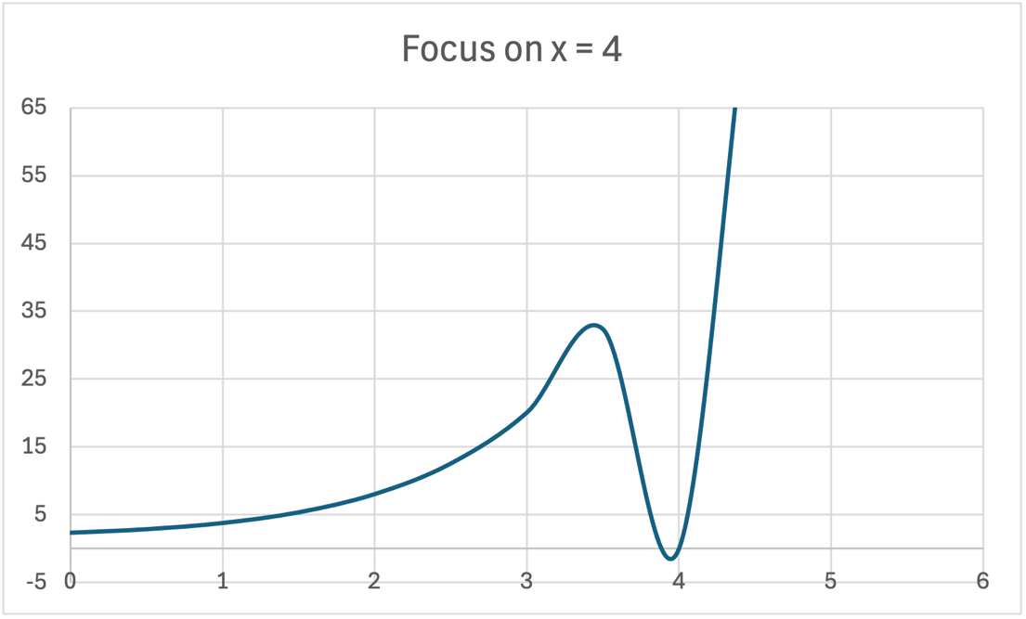

Problem 6:

**A.)**

**B.)**

For the function f(x)=(x3−1)/(x−1)f(x)=(x3−1)/(x​−1) to be within 0.5 of its limit as x→1x→1, xx must satisfy 0.9314<x<1.06490.9314<x<1.0649, excluding x=1x=1, where the function is undefined. The limit of the function as x→1x→1 is 6, so the inequality ∣f(x)−6∣<0.5∣f(x)−6∣<0.5 ensures that the function stays within 0.5 from the limit. Therefore, xx must lie in this interval to meet the requirement.