Luke Trujillo
CS 4342

Homework 2

For all implementations of MSE, I used the “half MSE” method.

1A. Table showing the MSE for the training and testing set using the analytical solution
 | Training Set | Testing Set
Mean Squared Error | 39.2469 | 206.8378

1B. Table showing the MSE for the training and testing set using Gradient Descent
 | Training Set | Testing Set
Mean Squared Error | 83.5723 | 93.1206

1C. Table showing the MSE for the training and testing set using Gradient Descent with Regularization
 | Training Set | Testing Set
Mean Squared Error | 83.5518 | 93.1033

1D.
The RMSE for the testing set of method 3 (Gradient Descent with Regularization) is 9.65 years.
 | Image | Guess | Actual
Image 1 | 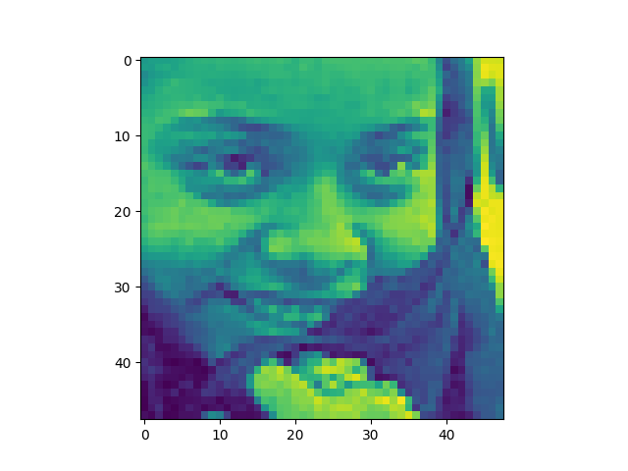 | 59.96 | 10
Image 2 | 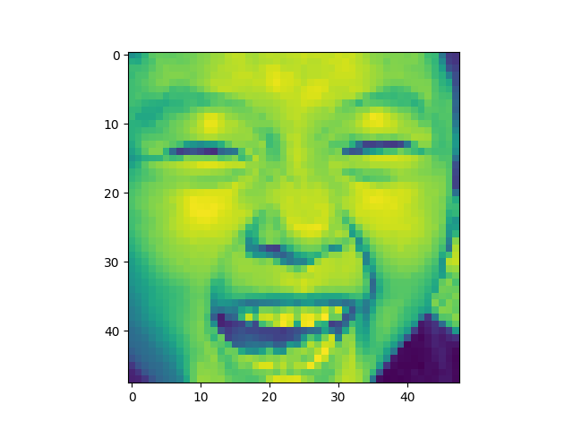 | 52.4357 | 4
Image 3 | 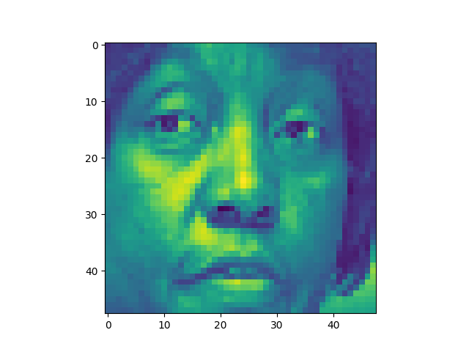 | 41.6052 | 89
Image 4 | 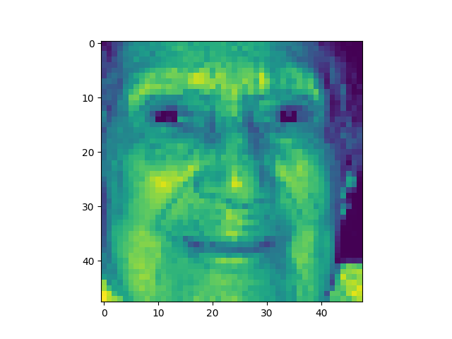 | 33.3303 | 80
Image 5 | 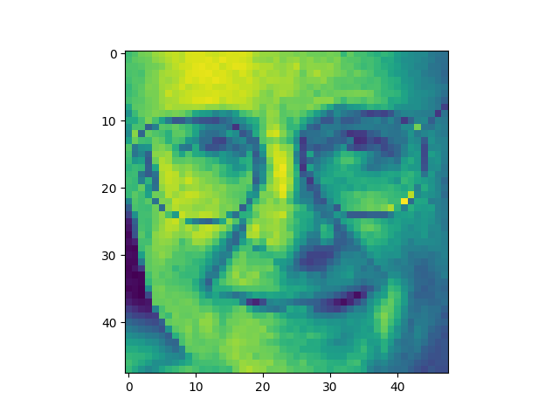 | 53.54 | 8

Analytical Solution | Gradient Descent | Gradient Descent with Regularization
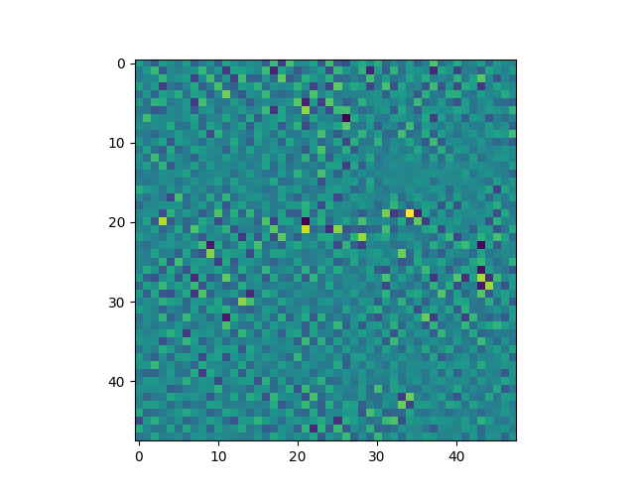 | 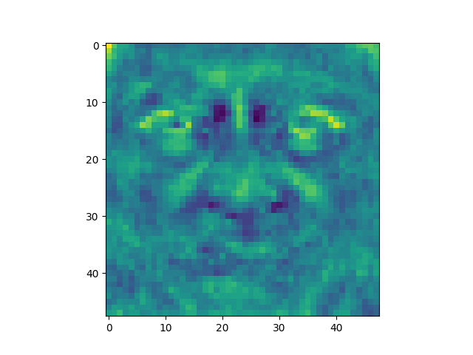 | 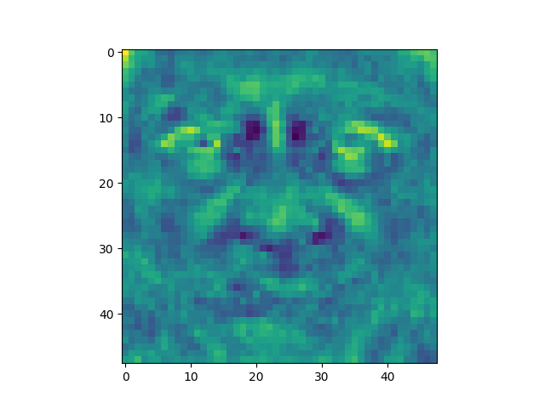
The weight vectors are very different depending upon the method used. In each image, you can see the features of a face getting more defined. With the analytical solution, it is just a very light outline of the face. With the gradient descent solution it is more defined but when using regularization it becomes much more clear.

