

Network Security Analytics. BSC Year 4, 2025/2026
(Assignment 1 - 50%)

Assignment 1: T-Pot: A Multi-Honeypot Platform

Submitted by:
Luke Waterhouse, B00152290

Submission date
25/11/2025

Declaration

I herby certify that this material, which I now submit for assessment on the programme of study leading to the award of Ordinary Degree in Computing in the Institute of Technology Blanchardstown, is entirely my own work except where otherwise stated.

Author: Luke Waterhouse Dated: 25/11/2025

Table of Contents
Setup 4
Platform comparison 4
Credits 4
Billing info 4
Specs and OS 4
Connecting to instance 4
Networking rules 4
Most Active Honeypots 5
Interesting findings 6
Honeytrap 6
Mumbai 6
Israel 7
Cowrie 8
CPU info 8
Cron 8
.s 8
Busybox 9
ADBhoney 10
UFO.miner 10
Trinity 10
H0neytr4p 11
CVE-2017-984 11
GitHub repository disclosure 11
Phpinfo 11
Conclusion 12
Attacker behaviour 12
Summary 13
References 14
Tpot Kibana dashboards 16

Setup
To collect data for this assignment I set up eight Tpot instances. Six on Google cloud and two on AWS. Choosing the location for each instance came down to current global politics and conflicts. I placed two instances(one Google Cloud one AWS) in India due to the tensions with Pakistan (Hussain, 2025), two in Israel(one standard and one lite) due to conflict in the area (Burke, J, 2025), one in Honk-Kong and one Taiwan due to tensions with China (Chen, X. , 2025) (Maizland, L, 2025), one in Frankfurt as it is a hub for Internet traffic (DE-CIX)and one in Ireland as a control of sorts. Overall, these instances amassed over 2 million attacks over the testing period. These instances were all restarted daily to ensure proper system performance, logging and attack activity. There was a huge outage on AWS on the 20th of October which took out the US-EAST-1 region (Taylor, J. 2025), my instances were located elsewhere so they were unaffected, but it did highlight the importance of keeping a check on the status of all the instances.

Platform comparison
In testing I created instances on two cloud providers AWS and Google Cloud. Majority of instances were set up on Google Cloud for a few reasons that differed from AWS:
Credits: upon creating a free account I was given ~€250 to power the instances whereas on AWS I received ~€100. The extra credits allowed me to power more powerful instances and for longer. I had to shut down my AWS instances earlier to keep some credits for my data collection and report. Some interesting data might have been missed with the shorter span that the AWS instances were up.
Billing info: when configuring the specs of each instance on Google Cloud I was given clear monthly costs of each instance, AWS did not display this clearly meaning I under utilised the specs of the instances to keep the cost down.
Specs and OS: Debian was recommended for Tpot setup, on AWS the Debain OS came with limited ram that was under the recommended. Google cloud allowed me to create as much ram as needed regardless of the OS I selected. With more ram on the instance, it helps to prevent any system crashes as it becomes overloaded by attacks.
Connecting to instance: When connecting to the instances on AWS you must connect by ssh via your own device. I’m using a Windows device, so I had to use PuTTY to connect making the connection longer and far more painstaking. Google Cloud provides an online ssh client on the main VM instance dashboard, this is seamless when having to reboot and reconnect to the instance multiple times especially when setting up Tpot or troubleshooting.
Networking rules: AWS by default creates a new security group for each instance and allows for a simple and precise rules a lot quicker. Google cloud by default creates a network group for all instances in a project, creating rules takes longer as it enters a new page each time. Quickly creating, modifying or deleting rules is essential on setup as we configure the ports needed to allow attackers to interact with honeypots but still protect the instance itself.

Most Active Honeypots
On the standard or hive Tpot setup, which was used on seven of the instances, there are four main honeypots that stand out as most active. These are Dionaea, Honeytrap, Sentrypeer and Cowrie.
- Dionaea’s main goal is to trap malware that is injected into the system to exploit vulnerabilities. This allows us to see what files were injected into the system and any other actions taken (Dinotools, 2015).
- Honeytrap observes attacks from TCP or UDP services. This pot pretends to be a well-known service fooling attackers into sending responses. The pot parses the arriving data and can retrieve any files attackers attempted to download (Armedpot, 2006).
- Cowrie logs all info created by attempted brute force attacks by ssh. When attackers gain entry it also tracks the commands used (Cowrie, 2015).
- Sentrypeer prevents VoIP attacks and VoIP fraud attempts which then blacklists those Ips (SentryPeer, 2025).

Interesting findings
Below are some data or attacker behaviour I found interesting due to either relation to international events or specific motivations that influence the attacks carried out by malicious users.

Honeytrap

Mumbai
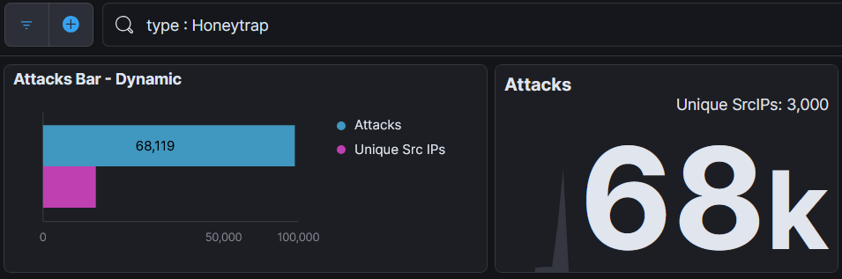

My AWS instance in Mumbai had 68 thousand attacks on the Honeytrap pot.
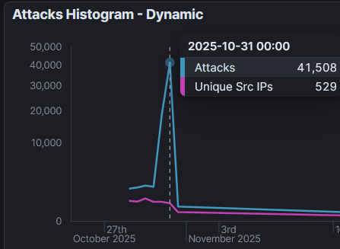
The part I found most interesting while looking through this data is that I saw the largest spike happened on the 31st of October. I searched to see if there was any event on this day that might have triggered that. That day a man who kidnapped 17 children was shot dead by police (India Today, 2025). I was more interested to see if there was an international event, what I found was a 10-year defence pact with the US to enhance information sharing and technology cooperation, this news was amid the US tariffs (Mollan, C. 2025). This pact and cooperation could cause higher attacks from neighbouring countries who disagree with the teaming of the two countries. There is a very high attack to unique IP ratio, in the picture above there is ~78 attackers per unique IP

Israel
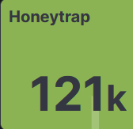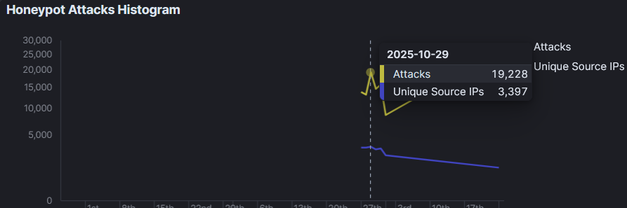

Like the last honeytrap finding I saw a noticeable boost of activity on the 29th of October. I decided to do some research about events that day. I found that Israel had carried out strikes on the Gaza strip that day and during the night before killing a total of 106 people (Tondo, L. 2025). This sparked outrage worldwide alongside the already raging controversy surrounding the conflict. Seeing this news would possibly cause a spike in attacks by hacktivists attempting to disrupt Israeli systems as well as the usual traffic that is expected. By dividing the number of attacks with the unique IPs (19,228 / 3397) we can see that each unique IP attacked around 5 – 6 times each this is relatively high again showing these attackers were motivated to gain access or cause disruption.

Cowrie
I found some interesting behaviour within Cowrie pots by analysing the recorded commands that were inputted by attackers. These are shown below:

CPU info
From analysing this command, we can see that attackers were looking for the CPU name, this could be for reasons like modifying malware to lower the processing power to remain undetected and looking for vulnerabilities in the CPU. Head -n 1 prints out the first 10 lines of the file. AWK is a Linux tool for text-processing tasks (Geeks for Geeks, 2025). and in this command the attacker is looking for fields 4, 5, 6, 7, 8 and 9. To link in with another command found below, attackers may look for CPU information to decide whether they can run crypto mining software without sapping too much processing power.

Cron
Cron is a tool used for automating tasks on Linux devices (Linas, L. 2025). Attackers may use Cron to create a startup task that envelopes malware. They may also use Cron to view Cronjobs potentially to see if a device is already infected.

.s
 This command is interesting, it tells us that the attacker may have downloaded a file named .s and now deleted it. This file would be hidden from the user as . files are not shown. This seems to be a method used many times by attackers to remain undetected. .s is the file extension for source code written in Assembly so this could also be a technique to hide the file.
Following on I also found this command which tries three different techniques to read the file. The appearance of this command lead me to believe the attacker used to file and removed it then afterwards.

Busybox
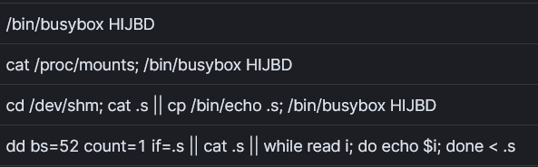
Busybox is a suite containing common Linux utilities into a single program (AIRCORRIDOR. 2025). Busybox allows code to be shared through multiple applications without requiring a library meaning if malware can find its way in it can spread across a device at speed. The word HIJBD appears a lot in these commands I could not find any information on it being a command so we can assume that it could be a placeholder for another string. We again see attempts to read a .s file as previously mentioned this would be hidden, dd also means the attacker may be trying to write some parts of the file and using read as a fallback. The attacker collects environment information evaluating the attack surface.

ADBhoney
ADBhoney mimics an ADB service over TCP and logs suspicious activity. Specifically, this tool analyses attacks on Android devices (CybersecTools, 2025).

UFO.miner
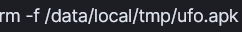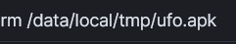
This list of commands is especially unique. They each reference the word UFO and/or miner. With a bit of searching I found this out to be a crypto miner, this UFO miner is used highly when it comes to attacks on devices that may be rarely monitored and always on (Brandt, A. 2019). This miner is small enough to not cause disruption that would prompt an investigation. These devices are incredibly attractive for crypto miners as they are similar in operation to a crypto farm which consists of multiple computers to constantly solve mathematical problems which in short creates the crypto coins. To summarise these commands: attacker downloads ufo.apk, checks path to apk, starts the miner, removes application. We can assume the application did not work prompting the attacker to delete the miner.

Trinity
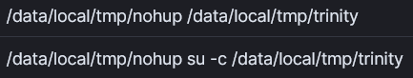
From what information is available it seems that Trinity is the botnet that infects devices with the previously mentioned UFO.miner, it then uses the device to find ways to spread to other devices. Multiple sources mention Trinity as a huge botnet infecting unprotected android devices likely through services like P2P (Cirlig, G. 2020). I have found these commands and/or the presence of UFO.miner on multiple of my instances showing that its spreading across the globe. The articles mentioning the Trinity botnet also mentioned a botnet called Fbot that seemed to be rivalling it I have yet to see the presence of this botnet within my instances, from the data I have it seems that Trinity is more effective (Cyware, 2018).

H0neytr4p
H0neytr4p is specified to protect against web recon and exploits. The honeypot takes each attempted logs it, places it in a folder called /traps and restarts preparing for the next attack (Pbssubhash, 2021).

CVE-2017-984
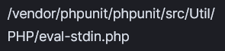 This command seems to be an attempt to exploit the php remote execution CVE-2017-984 (MITRE, 2017). This is a known attack on sites with an exposed /vendor folder. The presence of this line shows the attacker knows this weakness and is either acting on it or probing to check whether the vulnerability is present.

GitHub repository disclosure
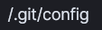 This line is an attempt of git repository disclosure attack. Attackers do this to try download any source code which may reveal credentials or vulnerabilities (Smolnik, O. 2025). With the source that could be extracted attackers can rebuild the site and test their attacks to see the effect without the risk is of generating any alerts that would raise suspicion on the original site.

Phpinfo
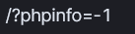 Phpinfo.php displays information about the current state of php on the site for example: version, server info, and environment (PHP). This information can provide attackers with an attack surface to find vulnerabilities. This command is an attempt to input unexpected values to see whether the system will produce an error and show the attacker the information they’re looking for.

Conclusion
Through this research assignment I found and learned many interesting things. The purpose of honeypots for research of attacker behaviour, malware analysis, global incidents and they’re effect on attacker activity and how to correctly setup software like this.

Attacker behaviour
Through my findings above we can see the presence of three possible types of threat actors:
- Hacktivists – hacktivists are threat actors that carry out attacks motivated by political causes (IBM, 2025). Upon looking at the data on the instance located in Tel Aviv, Israel we see an increased rate of attack along the dates where airstrikes were carried out killing over 100 Palestinians, although we cannot say for certain this is the cause of increased attacks it’s an indicator that hacktivists may be the main threat actor present.
- Cybercriminals – Cybercriminals are users that carry out attackers mostly for financial gain (IBM, 2025). The Trinity botnet could be classed as a subclass of this threat actor as it deploys crypto miners within unsuspecting IoT devices to mine cryptocurrency and send it back to its source thus its purpose being for financial gain. Crypto has exploded in the criminal world as due to the high level of anonymity associated with it, cryptocurrency is not managed by banks meaning its harder to trace, it can be transferred nearly instantaneously to different wallets (Chiang, S. 2024). Mining crypto is highly demanding and requires high computing power, instead of criminals setting up a large and expensive crypto farm they instead create botnets like this to sap computing power from a large network (Bitget, 2024). This allows criminals to shift all operational costs onto unsuspecting victims while generating huge profits.
- Script kiddies – Script kiddies generally attack systems without much understanding of the systems vulnerabilities. Script kiddies are known to try and deface websites, we had a large amount URL manipulation that could be related to this type of threat actors as some were not well crafted and had little to no success. Brute-forcing attacks on ssh is another attack that’s simple to pull off as there is so many tools out there so script kiddies will use tools like Hydra with wordlists that may or may not be related to the protocol or function in question (Malwarebytes, 2025).

Summary
I’ve learned so much from using Tpot (telekom-security, 2015) in this assignment. Observing how real attackers behave and move within systems can be extremely valuable when preparing for penetration testing. The specialised honeypots like Conpot (industrial system honeypot), Medpot (medical systems honeypot) and CiscoASA (cisco security appliance honeypot) offer a deeper understanding of attacks on specific industry systems. These honeypots allow cybersecurity teams in those sectors to study attacker techniques and uncover new malware to develop stronger and targeted defences.
These honeypots also show us any downloads. Digital forensics teams can use these downloads as almost a template of files as targets to identify during an investigation and any directories attackers moved to or showed any interest in. By analysing the input commands incident responders can learn of new filenames for hidden files meaning they can discover and destroy said file.
Other than the honeypots themselves Tpot provides a great monitoring system in the form of Kibana. This is where we can view attacks on honeypots, any inputs from attackers, attacker IPs and which ports were attacked. This allowed me to gather the information needed to write this report and find any interesting data.

References
Hussain, H. (2025) Commentary: Is another Pakistan-India flare-up inevitable?.Channel News Asia. URL: https://www.channelnewsasia.com/commentary/pakistan-india-conflict-kashmir-attack-terrorism-5482541
Burke, J. , Tondo, L. (2025) Israel and Hamas trade accusations as tensions rise over hostages’ remains. The Guardian. URL: https://www.theguardian.com/world/2025/oct/16/hamas-hostage-bodies-recovered-amid-israel-gaza-fighting-ceasefire-deal
Chen, X. , Woo, R. (2025) China's Xi tells Trump Taiwan's 'return' key to post-war order, Xinhua reports. Reuters. URL: https://www.reuters.com/world/china/chinas-xi-holds-phone-call-with-trump-xinhua-reports-2025-11-24/
Maizland, L. Fong, C. (2025) Hong Kong’s Freedoms: What China Promised and How It’s Cracking Down. Council on Foreign Relations. URL: https://www.cfr.org/backgrounder/hong-kong-freedoms-democracy-protests-china-crackdown
DE-CIX, (2025) frankfurt Connect to the world's leading IX. DE CIX. URL: https://www.de-cix.net/en/locations/frankfurt
Brandt, A. (2019) Automated Android attacks deliver “UFO” cryptominer Trojan. Sophos. URL: https://news.sophos.com/en-us/2019/02/26/automated-android-attacks-deliver-ufo-cryptominer-trojan/
CybersecTools. (2025) ADBHoney. Cybersectools. URL: https://cybersectools.com/tools/adbhoney
IBM(2024). Input and output files. IBM. URL:https://www.ibm.com/docs/en/open-xl-c-cpp-zos/2.1.0?topic=guide-input-output-files
Linas, L. Valentinas, C. (2025). What is a cron job: understanding cron syntax and how to configure cron jobs. Hostinger. URL:https://www.hostinger.com/tutorials/cron-job
Geeks for Geeks (2025). AWK command in Unix/Linux with examples. GeeksForGeeks. URL: https://www.geeksforgeeks.org/linux-unix/awk-command-unixlinux-examples/
India Today(2025). Top news headlines for school assembly: October 31. IndiaToday. URl: https://www.indiatoday.in/education-today/news/story/top-news-headlines-for-school-assembly-october-31-2811080-2025-10-31
Mollan, C. (2025). India-US sign 10-year defence pact amid tariff turmoil. BBC. URL: https://www.bbc.com/news/articles/c5y0qz701xeo
Tondo, L., Christou, W., Tantesh, S.(2025). The Guardian. URL: https://www.theguardian.com/world/2025/oct/29/israeli-strikes-in-gaza-overnight-as-ceasefire-looks-increasingly-fragile
SentryPeer(2025). Fraud Detection for VoIP . SentryPeer. URL: https://sentrypeer.com/
Cyware(2018). Fbot vs Trinity: Two IoT botnets battle for supremacy for control over thousands of vulnerable Android devices. Cyware Social. URL: https://social.cyware.com/news/fbot-vs-trinity-two-iot-botnets-battle-for-supremacy-for-control-over-thousands-of-vulnerable-android-devices-0bf00771
Cirlig, G.(2020). Trinity—P2P Malware Over ADB. Keysight. URL: https://www.keysight.com/blogs/en/tech/nwvs/2020/11/22/trinityp2p-malware-over-adb
IBM. (2025). What is a threat actor? IBM. URL: https://www.ibm.com/think/topics/threat-actor
Bitget. (2024). What is Crypto Farming and Staking. Bitget. URL: https://www.bitget.com/wiki/what-is-crypto-farming-and-staking
Chiang, S. (2024). Money launderers are increasingly turning to crypto to conceal flow of funds, Chainalysis says. CNBC. URL: https://www.cnbc.com/2024/07/16/crypto-is-increasingly-being-used-for-money-laundering-chainalysis-says.html
Phpinfo. PHP. URL: https://www.php.net/manual/en/function.phpinfo.php
Smolnik, O. (2025). They’re Out to Git You: How to Find Exposed Repos Before Attackers Do. Pentera. URL: https://pentera.io/blog/git-repo-security-exposed-secrets/
MITRE. (2017). PHPUnit Util/PHP/eval-stdin.php Remote Code Execution via Malicious POST Data in Exposed Vendor Folder. CVEdetails.com. URL: https://www.cvedetails.com/cve/CVE-2017-9841/
Pbssubhash. (2021). H0neytr4p. GitHub. URL: https://github.com/pbssubhash/h0neytr4p
Cowrie. (2015). Cowrie. GitHub. URL: https://github.com/cowrie/cowrie
Dinotools. (2015). Dionaea. GitHub. URL: https://github.com/DinoTools/dionaea/blob/master/doc/source/index.rst
Telekom-security. (2015). Tpot. GitHub. URL: https://github.com/telekom-security/tpotce?tab=readme-ov-file
Armedpot. (2006). Honeytrap. GitHub. URL: https://github.com/armedpot/honeytrap/
AIRCORRIDOR. (2025). IoT Embedded Linux: BusyBox, the Most Widely Used Linux in IoT. Hackers Arise. URL: https://hackers-arise.com/busybox-the-swiss-army-knife-of-embedded-linux/
Malwarebytes. (2025). What is a script kiddie?. Malwarebytes. URL: https://www.malwarebytes.com/cybersecurity/basics/script-kiddie
Taylor, J. (2025). Amazon reveals cause of AWS outage that took everything from banks to smart beds offline. theGuardian. URL: https://www.theguardian.com/technology/2025/oct/24/amazon-reveals-cause-of-aws-outage

Tpot Kibana dashboards
Google Cloud Delhi:
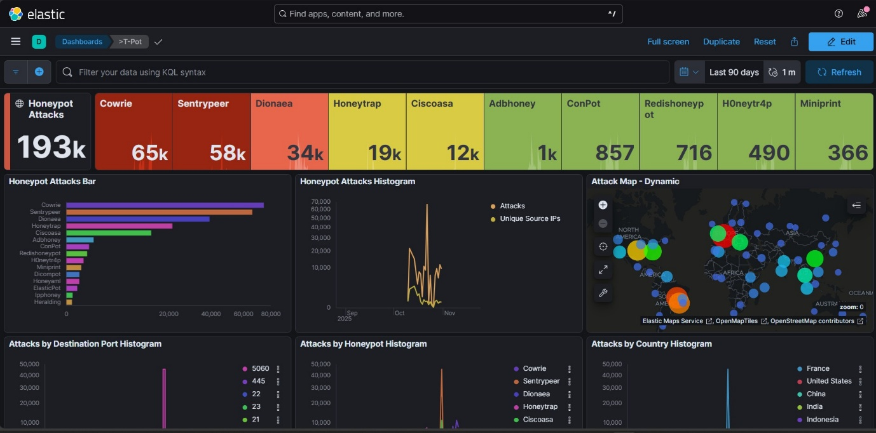
AWS Mumbai:
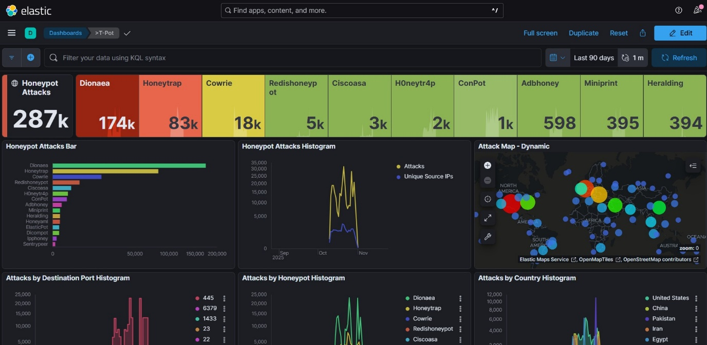

AWS Ireland
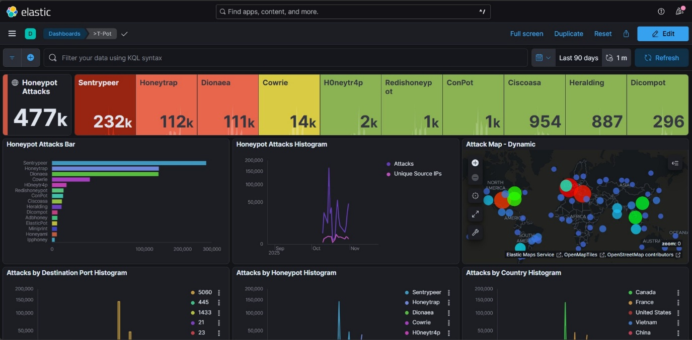
Google Cloud Frankfurt:
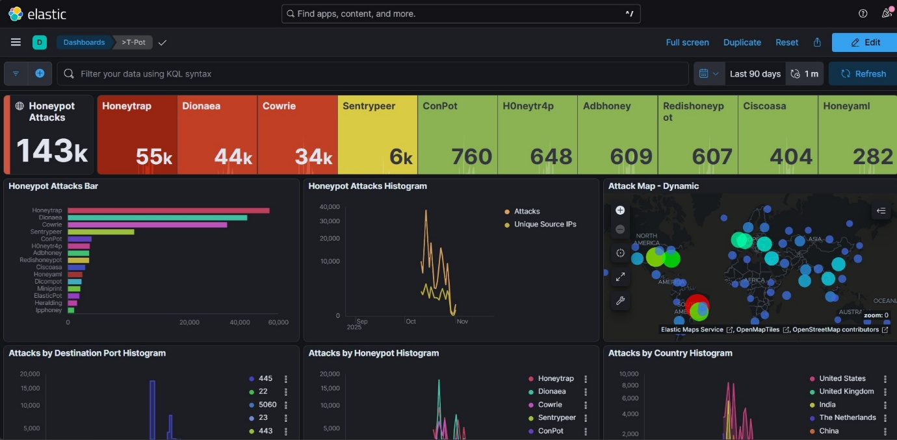
Google Cloud Honk-Kong: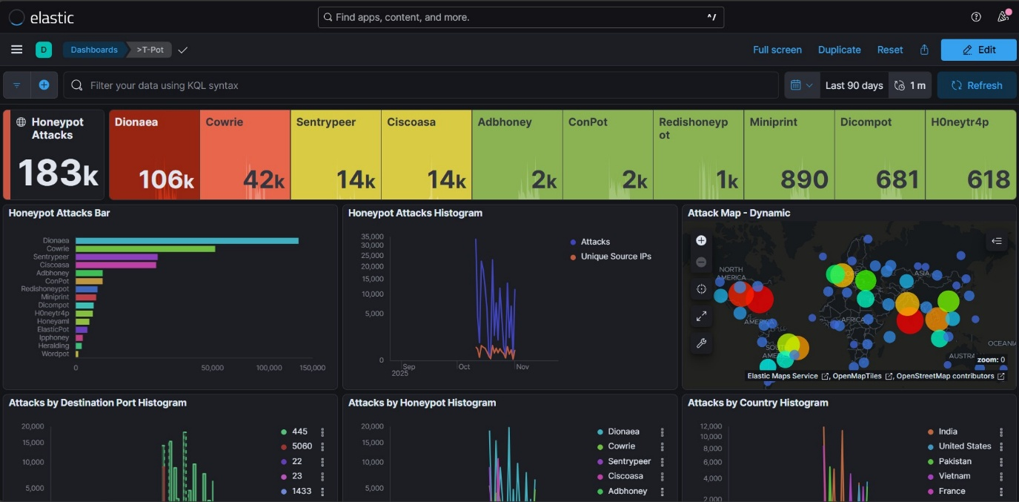
Google Cloud Israel standard:
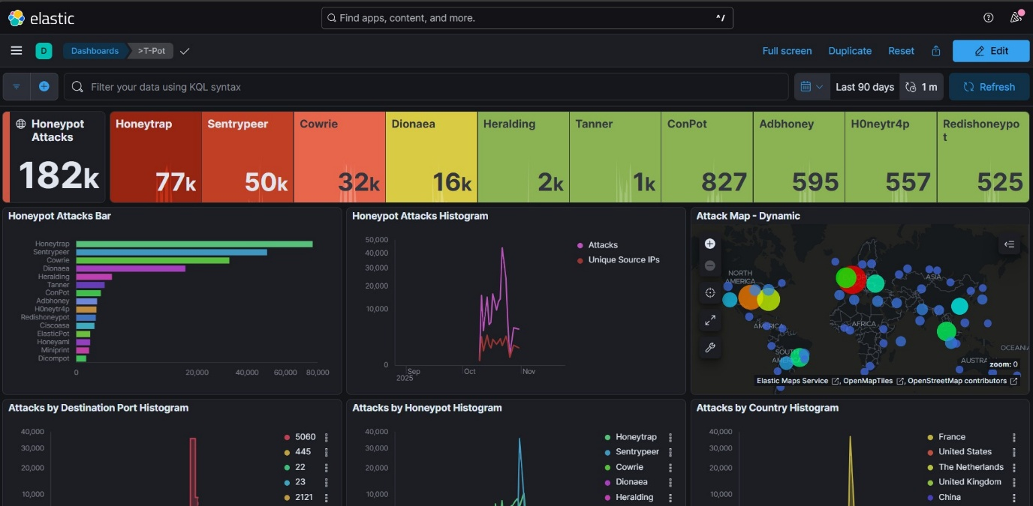
Google Cloud Israel lite: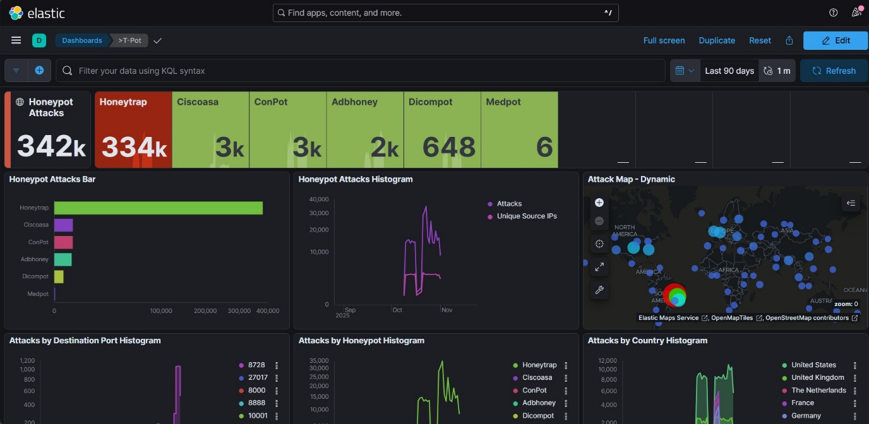
Google Cloud Taiwan:
