**549 – AT2 TEST CASES (for Gold Coast E-Sports V2)**

1. ADD NEW EVENT

No event name --- to produce error message pop-up

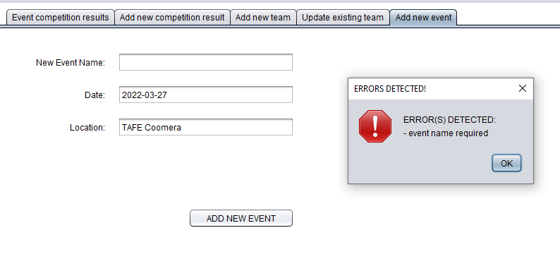

2. ADD NEW EVENT

With event name that already exists in the event table --- to produce error message pop-up

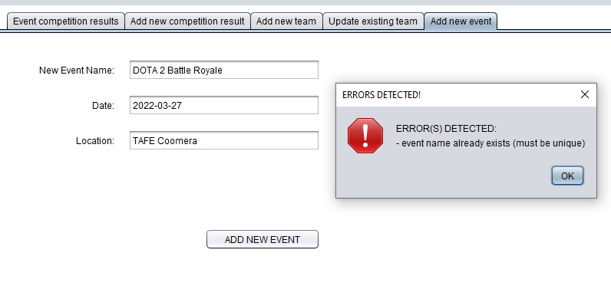

3. ADD NEW EVENT

With unique event name --- to produce prompt message pop-up to continue YES | NO

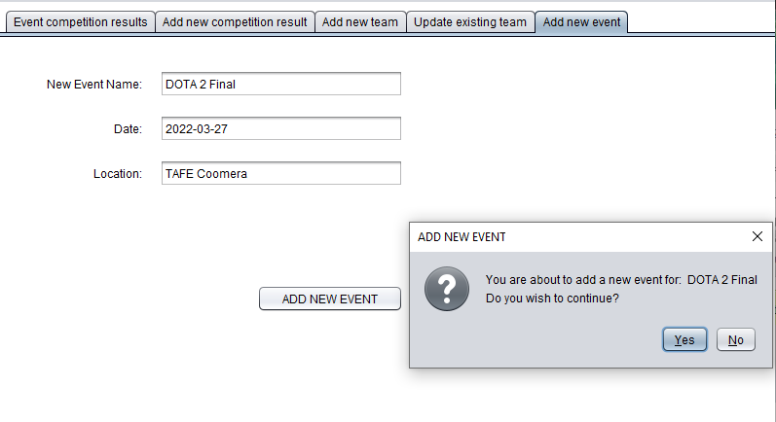

New event added to EVENT COMBO-BOX in EVENT COMPETITION RESULTS tab panel.

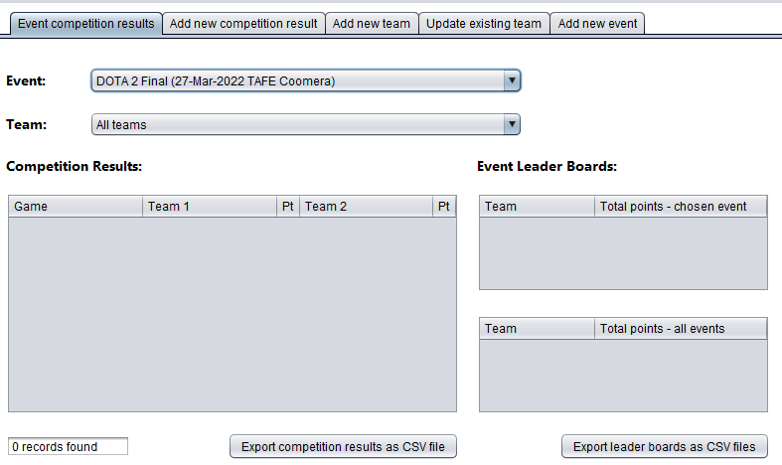

New event added to EVENT COMBO-BOX in ADD NEW COMPETITION RESULT tab panel.

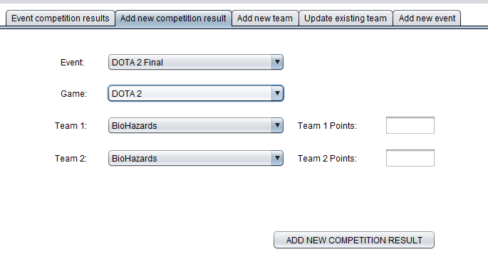

New event added to the event table in the goldcoast_esports database

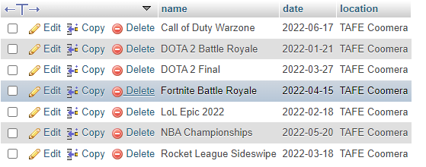

4. ADD NEW TEAM

No fields entered --- to produce error message pop-up

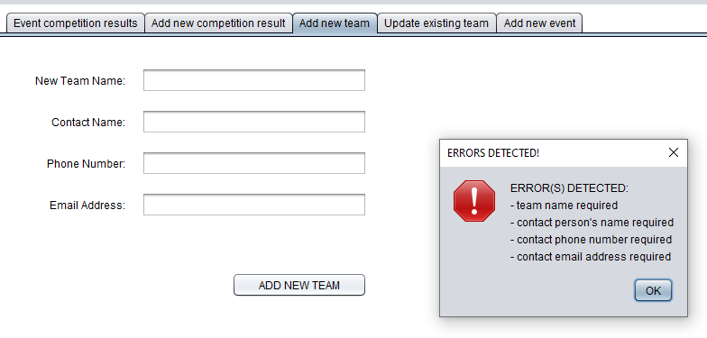

5. ADD NEW TEAM

All details entered --- to produce prompt message pop-up to continue YES | NO

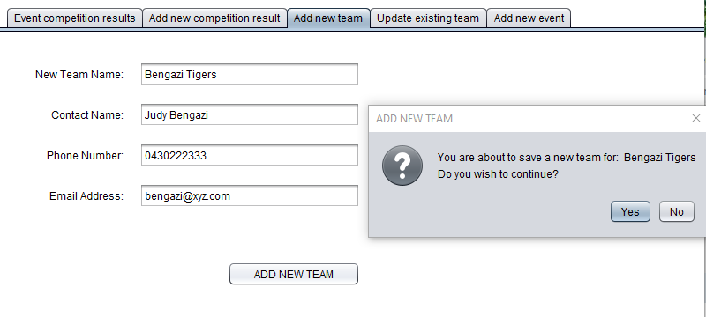

New team added to EVENT COMBO-BOX in EVENT COMPETITION RESULTS tab panel.

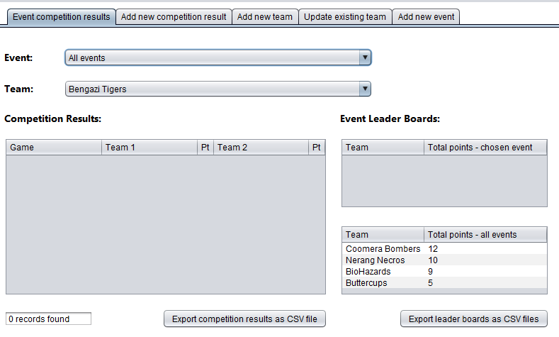

New team added to both Team 1 and Team 2 combo boxes in the ADD NEW COMPETITION RESULT tab panel

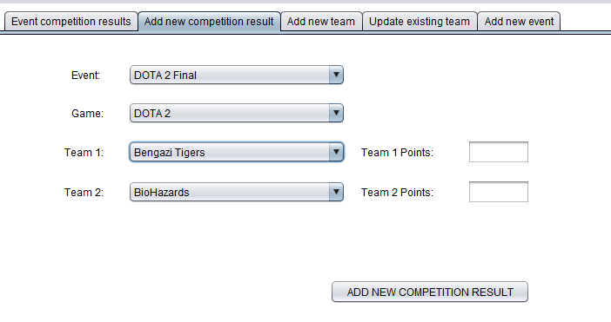

New team added to Team Name combo box in the UPDATE EXISTING TEAM tab panel.

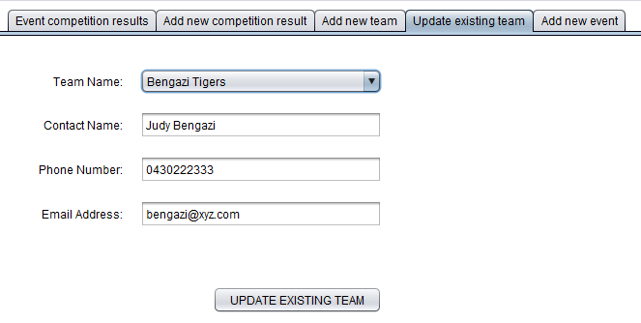

New team added to the team table in the goldcoast_esports database

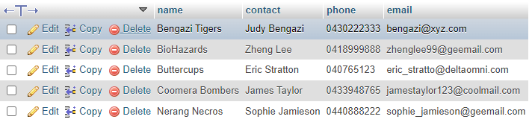

6. UPDATE AN EXISTING TEAM

All details entered --- to produce prompt message pop-up to continue YES | NO

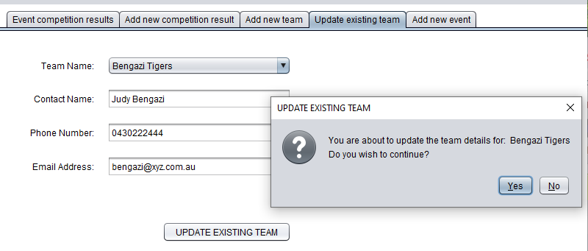

Updated team details made to the team table in the goldcoast_esports database



7. ADD NEW COMPETITION RESULT

All event, game, team 1 and team 2 options correctly selected/entered (refer screen shot below)

--- to produce prompt message pop-up to continue YES | NO

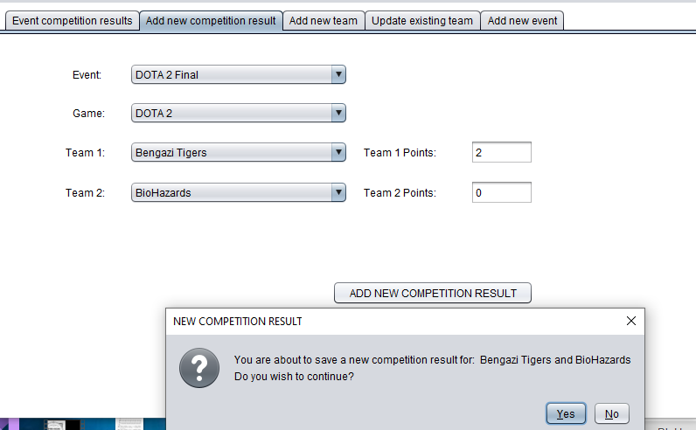

New competition result confirmed in the EVENT COMPETITION RESULTS tab panel.

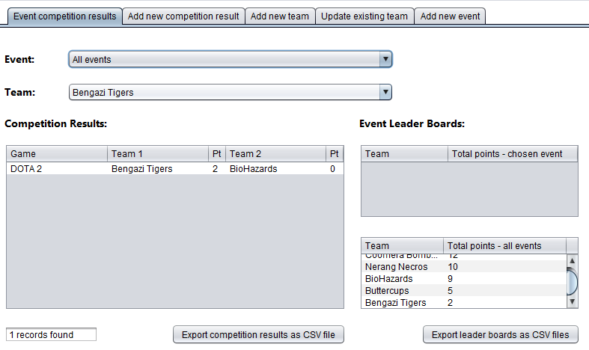

New competition result inserted into the competition table in the goldcoast_esports database.



8. ADD NEW COMPETITION RESULT

Team 1 and Team 2 selections are the same team --- to produce error message

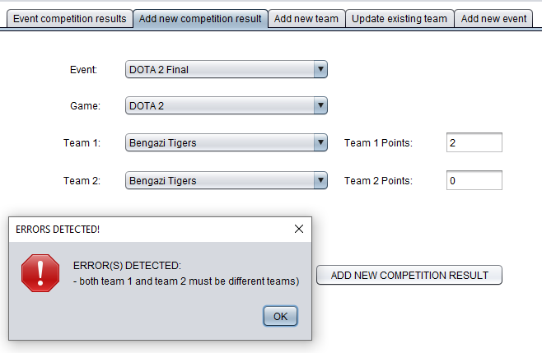

9. ADD NEW COMPETITION RESULT

Point scores do not add up to a total of 2 --- to produce error message

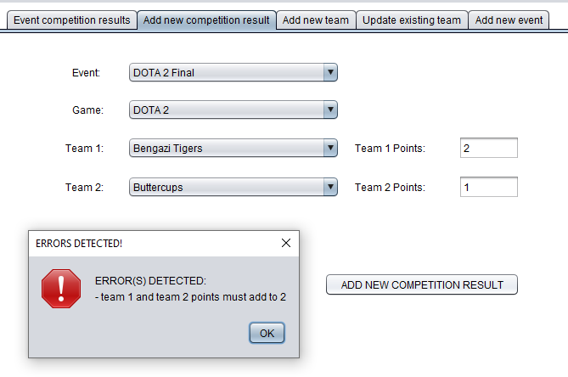

10. EVENT COMPETITION RESULTS

Previously added competition result (Bengazi Tigers – 2 points versus BioHazards – 0 points) should produce the all events leader-board displaying all teams and accumulated scores displayed below.

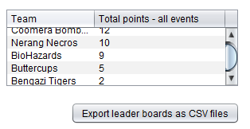

Clicking the EXPORT LEADER BOARDS AS CSV FILES should write the following to the external file:

