Number Theory\_\_\_\_\_\_\_\_\_\_\_\_\_\_\_\_\_\_\_\_\_\_

Modular Arithmetic\_\_\_\_\_\_\_\_\_\_\_\_\_\_\_\_\_\_\_\_\_\_\_\_\_\_\_\_\_\_\_

Euler’s Totient Function

|  |
| --- |
| The totient function phi(n), also called Euler's totient function, is defined as the number of [positive integers](http://mathworld.wolfram.com/PositiveInteger.html) <=n that are [relatively prime](http://mathworld.wolfram.com/RelativelyPrime.html) to (i.e., do not contain any factor in common with) n, where 1 is counted as being [relatively prime](http://mathworld.wolfram.com/RelativelyPrime.html) to all numbers. Since a number less than or equal to and [relatively prime](http://mathworld.wolfram.com/RelativelyPrime.html) to a given number is called a [totative](http://mathworld.wolfram.com/Totative.html), the totient function phi(n) can be simply defined as the number of [totatives](http://mathworld.wolfram.com/Totative.html) of n. For example, there are eight [totatives](http://mathworld.wolfram.com/Totative.html) of 24 (1, 5, 7, 11, 13, 17, 19, and 23), so phi(24)=8. |

Φ(n) = n(1-1/P1) (1-1/P2) (1-1/P3)…

    Where P1, P2 … are the unique prime factors of **n** (don’t count the duplicates, could include n if n is prime).

|  |
| --- |
| Examples:  Φ(24) = 24(1-1/2)(1-1/3) = 8  Φ(13) = 13(1-1/13) = 12 |

|  |
| --- |
| Review coprime:  In **number** theory, two integers a and b are said to be **relatively prime**, mutually prime, or **coprime** (also spelled **co-prime**) if the only positive integer that divides both of them is 1. That is, the only common positive factor of the two **numbers** is 1 |

|  |
| --- |
| Review prime factor:  In [number theory](https://en.wikipedia.org/wiki/Number_theory), the **prime factors** of a positive [integer](https://en.wikipedia.org/wiki/Integer) are the [prime numbers](https://en.wikipedia.org/wiki/Prime_number) that divide that integer exactly. 1 is not a prime number |

Euler’s Totient Theorem

    Any positive integer **a** **coprime to n** satisfies this theorem.

https://lh6.googleusercontent.com/i19F46YEuhS8ECirejwJav_KB5y5w1cmnfwuk4n-kq4LSz7CYmDaNcAGKxmmhS0wUt9fjDvpbBV_hdLRcnf6CqdedDJfbCxFUYx7yWtXNbLFuKnYF4j81X8ES-BwhivhD3BRcbvM

Chinese Remainder Theorem

    Given an integer **n** which satisfies multiple modulo congruencies

https://lh6.googleusercontent.com/K2F7xkwjWfKe2mwLUd0BToxKaZCFy9AzMrAwF_yntHd32-1PHDAjlZEwncVZMImMeUMTKzMnKfb_NAEyk-uFB8tNbbPTVS52Uf1_vZNXOfSZDShImZRWgZBPE0Lmu606OrRxpW27

**n** can be determined through the following formula

https://lh4.googleusercontent.com/UtCygSGkr7riwtMlVWz-032sdyviDyJTIGAVO0XvhYY5Dx_KAZnmkDm3O6HQbiHe-4rkxT6QIkzMethfNCYlSbOrfpFIQN-jpc-9gHs1wEZD4mgekBhwAEz3UdFDnr387_MA6T58

    Where **b** is defined as

https://lh3.googleusercontent.com/esAZG-g82tUKeUsWQQQC5L48qiYsIPSU8BFEx2jzgB5O7KKjIIuPsNkYvdnT8nttXST3WX-4VIOLF_H0f6GMeuHbXhF3A3pMVcXlj3h_ViWtbbEZW-GH0b_4hQ_jHxx4CcXJqXbX

    And **M** is

https://lh5.googleusercontent.com/IJaGG2QRnzyVk_7fNZvoRRPFSWxhrhMb2iPlNzy92r6Jjo4staQCnP1uwXDio1z3oePTIoEyRwjOFeuH61t8Tguo1ao3EiGoRm1XWnqwQg0Rs6n7NTCeL68wr0pr1OunFJMF7ou-

**An example problem using Chinese Reminder therom and Euler’s totient:**

|  |
| --- |
| Find redminder of 2345 when divided by 400.  M = 400 = m1  m2  = 16 x 25  a1 = 2345 Mod(16) = 0  a2 = 2345 Mod(25), to find this we can use euler’s totient.  Φ (25) = 25 ( 1 – 1/5) = 20, so 220 = 1 Mod(25), thus 2345 Mod(25) = 25 Mod(25) = 7  b1: 25b1 = 1 Mod(16), so b1 = 9 (in fact we don’t need to find this because a1 is 0)  b2: 16b2 = 1Mod(25), b2 = 11  result = (a2 x b2 x 16) Mod(400) = (7 x 11 x 16) Mod(400) = 32 Mod(400) |

|  |
| --- |
| The way to find out 16b2 = 1Mod(25)  Add 25 to the right: 16b2 = 26Mod(25)  Divided by 2: 8b2 = 13Mod(25)  Add 25 again: 8b2 = 38Mod(25)  Divide by 2: 4b2 = 19Mod(25)  …………… b2 = 11Mod(25) |

Bijection:

|  |
| --- |
| Review Injection:  Injection (1-1): Let *f* : *A* *B* . If for each *y* *f* (*A*) there exists a unique  (pre-image) *x* *A* such that *f*  *x*  *y* , the function *f* is called an injection (or  simply one-to-one1). |

|  |
| --- |
| Review Surjection:  Surjection (onto): Let *f* : *A**B* . If the set of images *f* (*A*) is equal to the  codomain *B* (i.e. *f*  *A*  *B* ) the function *f* is called a surjection (or simply  onto) and we say “ *f* is from *A* onto B .” In other words, for each *y**B* there  exists an *x* *A* (called a pre-image of *y* ) such that *f* (*x*)  *y* |

|  |
| --- |
| Review Bijection  (1-1 correspondence): If *f* : *A* *B* is both an injection and  surjection, then *f* is called a bijection (or one-to-one correspondence).    Bijection is actually both Surjection and Injection. |

|  |
| --- |
| Example 1:  **2006 AIME II Problem 4**  **Problem**  Let $(a_1,a_2,a_3,\ldots,a_{12})$be a permutation of $(1,2,3,\ldots,12)$for which  $a_1>a_2>a_3>a_4>a_5>a_6 \mathrm{\  and \ } a_6<a_7<a_8<a_9<a_{10}<a_{11}<a_{12}.$  An example of such a permutation is $(6,5,4,3,2,1,7,8,9,10,11,12).$Find the number of such permutations.  Example 2: 2001 AIME I Problem 6Problem A fair die is rolled four times. The [probability](https://www.artofproblemsolving.com/wiki/index.php?title=Probability) that each of the final three rolls is at least as large as the roll preceding it may be expressed in the form $\frac{m}{n}$where $m$ and $n$ are [relatively prime](https://www.artofproblemsolving.com/wiki/index.php?title=Relatively_prime) [positive](https://www.artofproblemsolving.com/wiki/index.php?title=Positive) [integers](https://www.artofproblemsolving.com/wiki/index.php?title=Integer). Find $m + n$. |

Block Walking:

There are m steps and each step could have one of n values, each step must be at least as big as previous step.

[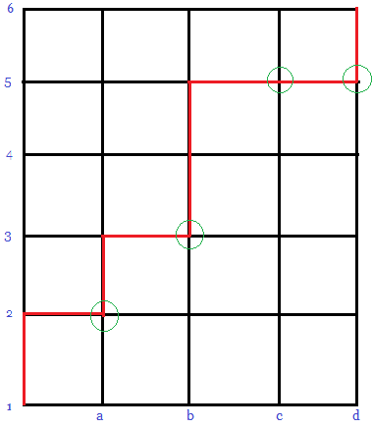](https://wiki-images.artofproblemsolving.com/2/26/AIME01IN6.png)

Here we have 4 steps and 6 values. The number of paths are:

(steps + values – 1) choose (steps or [values – 1])

|  |
| --- |
|  |

Combinatorial identity (see problem from block walking)

Vandermonde's Identity:

Vandermonde's Identity states that 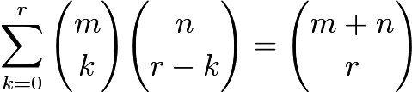, which can be proven combinatorially by noting that any combination of $r$objects from a group of $m+n$objects must have some $0\le k\le r$objects from group $m$and the remaining from group $n$

Hockey-Stick Identity:

For 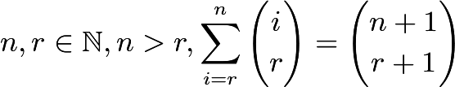.

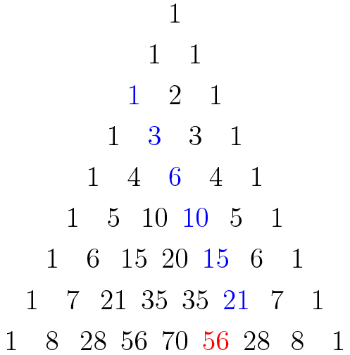

This identity is known as the *hockey-stick* identity because, on Pascal's triangle, when the addends represented in the summation and the sum itself are highlighted, a hockey-stick shape is revealed.

Another Identity:

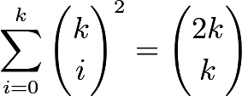

### Hat Proof

We have $2k$different hats. We split them into two groups, each with k hats: then we choose $i$hats from the first group and $k-i$hats from the second group. This may be done in 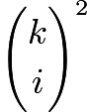ways. Evidently, to generate all possible choices of $k$hats from the $2k$hats, we must choose $i=0,1,\cdots,k$hats from the first $k$and the remaining $k-i$hats from the second $k$; the sum over all such $i$is the number of ways of choosing $k$hats from $2k$. Therefore 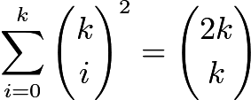, as desired.

### Proof 2

This is a special case of Vandermonde's identity, in which we set $m=n$and $r=m$.

|  |
| --- |
| Examples:  (1)The polynomial $1-x+x^2-x^3+\cdots+x^{16}-x^{17}$may be written in the form $a_0+a_1y+a_2y^2+\cdots +a_{16}y^{16}+a_{17}y^{17}$, where $y=x+1$and thet $a_i$'s are constants. Find the value of $a_2$. (1986 AIME P2)  (2)Given that  $\frac 1{2!17!}+\frac 1{3!16!}+\frac 1{4!15!}+\frac 1{5!14!}+\frac 1{6!13!}+\frac 1{7!12!}+\frac 1{8!11!}+\frac 1{9!10!}=\frac N{1!18!}$  find the greatest integer that is less than $\frac N{100}$.(2000 AIME ii P7)  (3) Consider all 1000-element subsets of the set {1, 2, 3, ... , 2015}. From each such subset choose the least element. The arithmetic mean of all of these least elements is $\frac{p}{q}$, where $p$and $q$are relatively prime positive integers. Find $p + q$.(2015 AIME I p12) |

Accuracy and Precision

When taking measurements, it is important to realize that the larger the sample size, the more precise and necessarily accurate the measurements are.

This is true because the bell curve of standard deviation will be narrowed but the percentage will remain the same.

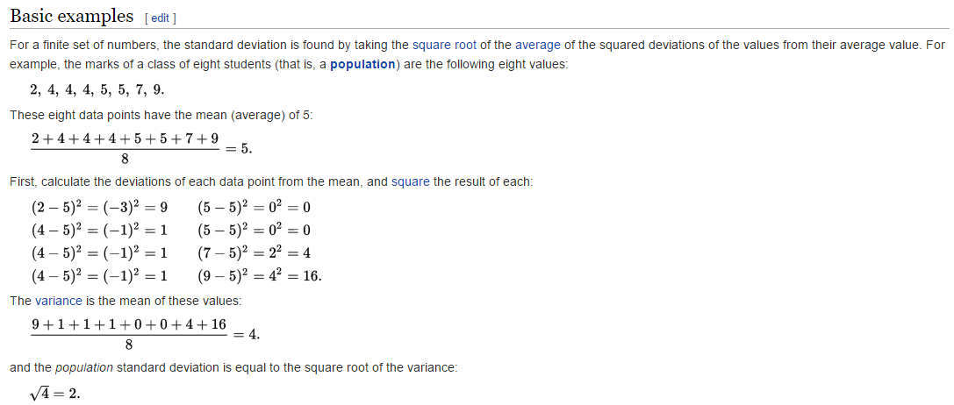

As your data set increases, variance, and therefore standard deviation, and THEREFORE Margin of Error also decreases.