How many ordered triples $(x,y,z)$ of positive integers satisfy $\text{lcm}(x,y) = 72, \text{lcm}(x,z) = 600$ and $\text{lcm}(y,z)=900$?

$\textbf{(A)}\ 15\qquad\textbf{(B)}\ 16\qquad\textbf{(C)}\ 24\qquad\textbf{(D)}\ 27\qquad\textbf{(E)}\ 64$

We prime factorize $72,600,$ and $900$. The prime factorizations are

$2^3\times 3^2$

, $2^3\times 3\times 5^2$

 and $2^2\times 3^2\times 5^2$, respectively.

Let $x=2^a\times 3^b\times 5^c$,

$y=2^d\times 3^e\times 5^f$ and

$z=2^g\times 3^h\times 5^i$. We know that

\[\max(a,d)=3\]

\[\max(b,e)=2\]

\[\max(a,g)=3\]

\[\max(b,h)=1\]

\[\max(c,i)=2\]

\[\max(d,g)=2\]

\[\max(e,h)=2\]

From here we can see a few things. Note that since the max of d and g is 2, a must equal 3. Because the max of b and h is 1, e must equal 2. From here, we only care about

\[\max(b,h)=1\]

\[\max(d,g)=2\]

Running a casework on both of them, we have the first has 3, and second 5, so 3 \* 5 = 15.

A quadrilateral is inscribed in a circle of radius $200\sqrt{2}$. Three of the sides of this quadrilateral have length $200$. What is the length of the fourth side?

$\textbf{(A) }200\qquad \textbf{(B) }200\sqrt{2}\qquad\textbf{(C) }200\sqrt{3}\qquad\textbf{(D) }300\sqrt{2}\qquad\textbf{(E) } 500$

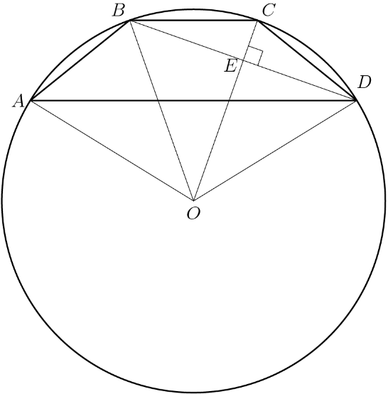

Let us divide everything by 200 and multiply that later, so the side lengths are all 1 and the radius √2.

Let BE = ED = x, so CE = √(12-x2) and OE = √(√22-x2). We also know CE + OE = √2.

We can then find x, then use Ptolemy’s theorem to solve for AD = 500.

The number $5^{867}$ is between $2^{2013}$ and $2^{2014}$. How many pairs of integers $(m,n)$ are there such that $1\leq m\leq 2012$ and\[5^n<2^m<2^{m+2}<5^{n+1}?\]$\textbf{(A) }278\qquad \textbf{(B) }279\qquad \textbf{(C) }280\qquad \textbf{(D) }281\qquad \textbf{(E) }282\qquad$

Between each consecutive power of 5, there are either 2 or 3 powers of two. This is because 22 = 4, and if a power of 2 is say 1 greater than a power of 5, then if we multiply that power of 2 by 22 it will still be less than the next power of 5, therefore there are 3 in this interval.

We know that up to 5867 there are 2013 powers of 2, so let x be the number of intervals with 2 powers of 2, and y with 3 powers of 2.

x + y = 867

2x + 3y = 2013.

Solve and y = 279

In a small pond there are eleven lily pads in a row labeled $0$ through $10$. A frog is sitting on pad $1$. When the frog is on pad $N$, $0<N<10$, it will jump to pad $N-1$ with probability $\frac{N}{10}$ and to pad $N+1$ with probability 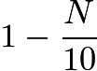. Each jump is independent of the previous jumps. If the frog reaches pad $0$ it will be eaten by a patiently waiting snake. If the frog reaches pad $10$ it will exit the pond, never to return. What is the probability that the frog will escape being eaten by the snake?



The probability is ½ at Lili pad 5. If we let Pk be the probability the frog will escape at pad k, then we obtain the following equations.

P1 = 9/10 P2

P2 = 1/5 P1 + 4/5 P3

P3 = 3/10 P2 + 7/10 P4

P4 = 2/5 P3 + 3/5 P5

We can then plug in P5  and solve P1 = 63/146

Let $a$, $b$, and $c$ be positive integers with $a\ge$ $b\ge$ $c$ such that $a^2-b^2-c^2+ab=2011$ and $a^2+3b^2+3c^2-3ab-2ac-2bc=-1997$.

What is $a$?

$\textbf{(A)}\ 249\qquad\textbf{(B)}\ 250\qquad\textbf{(C)}\ 251\qquad\textbf{(D)}\ 252\qquad\textbf{(E)}\ 253$

Adding the two equations, we get

2a2 + 2b2+ 2c2 – 2ab -2ac -2bc = 14

This can be factored into

(a-b)2 + (a-c)2 + (b-c)2 = 14

They are all integers, so note 14 = 9 + 4 + 1, or 32  + 22 + 12

We know that a-c is the largest, so a-c = 3.

We then do casework on a-b = 1 or 2, and solve for a in either case, and find a = 253.

In base $10$, the number $2013$ ends in the digit $3$. In base $9$, on the other hand, the same number is written as $(2676)_{9}$ and ends in the digit $6$. For how many positive integers $b$ does the base-$b$-representation of $2013$ end in the digit $3$?

$\textbf{(A)}\ 6\qquad\textbf{(B)}\ 9\qquad\textbf{(C)}\ 13\qquad\textbf{(D)}\ 16\qquad\textbf{(E)}\ 18$

We are essentially looking for numbers such that 2013modb = 3, in other words factors of 2010.

2010 has 16 factors, but we cannot use 1 2 or 3 because their base representations cannot contain the digit 3, so we have a total of 13.

The number $2013$ is expressed in the form 

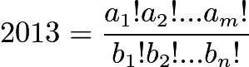,

where $a_1 \ge a_2 \ge \cdots \ge a_m$ and $b_1 \ge b_2 \ge \cdots \ge b_n$ are positive integers and $a_1 + b_1$ is as small as possible. What is $|a_1 - b_1|$?

$\textbf{(A)}\ 1 \qquad \textbf{(B)}\ 2 \qquad \textbf{(C)}\ 3 \qquad \textbf{(D)}\ 4 \qquad \textbf{(E)}\ 5$

2013 = 61 \* 11 \* 3. Because of this, a1 = 61 since we need a factor of 61 at the top and it also is the smallest possible.

The denominator needs to cancel every prime other than 11 and 3 that is less than 61, and the next prime is 59. Therefore, b1 = 59. So the answer is 2.