AP Chemistry For Dummies Cheat Sheet

From [**AP Chemistry For Dummies**](http://www.dummies.com/store/product/AP-Chemistry-For-Dummies.productCd-0470389761.html)

By [**Peter J. Mikulecky,**](http://www.dummies.com/?s=&a=peter-j-mikulecky) [**Michelle Rose Gilman,**](http://www.dummies.com/?s=&a=michelle-rose-gilman) [**Kate Brutlag**](http://www.dummies.com/?s=&a=kate-brutlag)

Taking the AP Chemistry exam doesn’t have to be stressful if you review some key material. Help yourself prepare for the AP Chemistry exam by knowing your way around chemistry lab equipment and reviewing common polyatomic ions and rules for significant figures.

Common Polyatomic Ions to Know for the AP Chemistry Exam

*Polyatomic ions* are ions that consist of more than one kind of atom. (*Ions* form when an atom either gains or loses valence electrons in pursuit of filling its valence shell.) The following table lists the most common polyatomic ions, grouped by ionic charge. They’ll pop up frequently and annoy you until you simply buckle down and memorize them.

|  |  |  |  |
| --- | --- | --- | --- |
| Common Polyatomic Ions | | | |
| **–1 Charge** | **–2 Charge** | **–3 Charge** | **+1 Charge** |
| Dihydrogen phosphate (H2PO4–) | Hydrogen phosphate (HPO42–) | Phosphite (PO33–) | Ammonium (NH4+) |
| Acetate (C2H3O2–) | Oxalate (C2O42–) | Phosphate (PO43–) |  |
| Hydrogen sulfite (HSO3–) | Sulfite (SO32–) |  |  |
| Hydrogen sulfate (HSO4–) | Sulfate (SO42–) |  |  |
| Hydrogen carbonate (HCO3–) | Carbonate (CO32–) |  |  |
| Nitrite (NO2–) | Chromate (CrO42–) |  |  |
| Nitrate (NO3–) | Dichromate (Cr2O72–) |  |  |
| Cyanide (CN–) | Silicate (SiO32–) |  |  |
| Hydroxide (OH–) |  |  |  |
| Permanganate (MnO4–) |  |  |  |
| Hypochlorite (ClO–) |  |  |  |
| Chlorite (ClO2–) |  |  |  |
| Chlorate (ClO3–) |  |  |  |
| Perchlorate (ClO4–) |  |  |  |

AP Chemistry: Rules for Significant Figures

After you get an answer on the AP Chemistry exam, make sure that you provide the correct number of significant figures in your answer. Here is a summary of the rules for assigning significant figures:

ADVERTISING

* **Any nonzero digit is significant.** Thus, 6.42 seconds (s) contains three significant figures.
* **Zeros sandwiched between nonzero digits are significant.** Thus, 3.07 s contains three significant figures.
* **Zeros on the left side of the first nonzero digit are *not* significant.** Thus, 0.0642 s and 0.00307 s each contain three significant figures.
* **When a number is greater than 1, all digits to the right of the decimal point are understood to be significant.** Thus, 1.76 s has three significant figures, while 1.760 s has four significant figures. We understand that the *6* is uncertain in the first measurement, but is certain in the second measurement.
* **When a number has no decimal point, any zeros after the last nonzero digit *may or may not* be significant.** Thus, in a measurement reported as 1370 s, we cannot be certain if the “0” is a certain value, or if it is merely a placeholder. Be a good chemist. Report your measurements in scientific notation to avoid such annoying ambiguities.
* **Numbers resulting from *counting* (for example, one kangaroo, two kangaroos, three kangaroos . . .) or from *defined quantities* (for example, 60 seconds per 1 minute) are considered completely certain.** These values are understood to have an unlimited number of significant figures, consistent with their complete certainty.
* **When taking the log of a number, as when calculating pH or pOH from [H+] or [OH–], only the decimal portion of the answer applies toward the significant figure count (not the preceding integer).** For example, if [H+] = 0.0100*M* and pH = –log[H+], then pH = 2.000. Why? 0.0100 contains three significant figures. Therefore, the decimal portion of the log answer (the mantissa) contains three significant figures. The preceding integer (the characteristic “2” in this case) does not count toward the significant figure total.

The final thing to burn into your brain about significant figures is that your final answer should always be rounded to the same number of significant figures as the least-precise number you were given in the problem. However, do not round any of the numbers you are given until the very end after you have plugged them into your equations in their full, precise glory.

AP Chemistry: An Overview of Common Lab Equipment

You won’t be directly tested on your knowledge of lab equipment, however the AP chemistry exam will often describe and/or diagram experimental setups so you will need to be able to recognize and understand the purpose of each of the pieces of equipment below. The following figure shows all of the lab equipment that an AP chemistry test-taker will need to be familiar with.

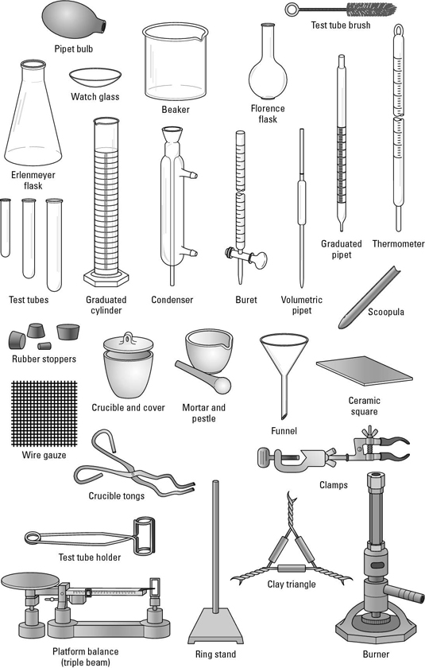<img src="http://d2r5da613aq50s.cloudfront.net/wp-content/uploads/416518.image0.jpg" width="535" height="840" alt="Diagram of common lab equipment, such as an Erlenmeyer flask, beaker and condenser, among others."/>

This list tells you how each piece of lab equipment functions:

* **Balance:** Used for obtaining the masses of solid and liquid samples
* **Beaker:** A flat-bottomed, cylindrical piece of glassware used for mixing and heating compounds
* **Bunsen burner:** Attached to a gas line and lit to provide heat for your experiments
* **Buret:** An extremely accurate device with a stopcock at the bottom used to measure volumes of reagents
* **Ceramic square:** Used to avoid burning the surface of your lab bench and incurring your chemistry teacher’s wrath
* **Clamps:** Used to hold a variety of things in place, particularly test tubes
* **Clay triangle:** Used to hold a crucible while it is being heated
* **Condenser:** Used to collect vapors by condensing them into liquid as they contact the liquid-cooled inner surface of the condenser
* **Crucible:** A cup-shaped container capable of sustaining high temperatures. It is used to heat chemicals.
* **Crucible tongs:** Used to handle the hot crucible
* **Erlenmeyer flask:** Used to hold liquids. The small upper opening slows evaporation, so for some volatile liquids, a flask is a better choice than a beaker. The shape also makes it suitable for mixing and swirling liquids during a titration.
* **Florence flask:** A type of flask, generally round-bottomed, usually suspended and heated from below. Its shape makes it easy to swirl and mix liquids inside of it.
* **Funnel:** Used together with filter paper to filter precipitates out of solutions
* **Graduated cylinder:** Used to precisely measure volumes
* **Metal spatula:** Used to measure out solid substances
* **Mortar and pestle:** Used to grind sesame seeds for cooking and chemical compounds for chemistry experiments, though we recommend using a different set for each
* **Pipette bulb:** Used to transfer accurately measured amounts of liquid from one container to another
* **Rubber stoppers:** Used to close flasks or test tubes to prevent evaporation of liquids or escape of gases
* **Scoopula:** Another instrument used to transfer solids from one place to another
* **Test tube:** Cylindrical open-topped piece of glassware that comes in varying sizes
* **Thermometer:** Used to measure temperatures. Thermometers generally contain liquid mercury.
* **Watch glass:** A piece of glassware in the shape of a large contact lens used for evaporating liquids
* **Wire gauze:** Generally used as a surface for a beaker or flask to rest when being heated by a Bunsen burner