# Three Newton's laws

1. Newton's First Law states that an object will remain at rest or in uniform motion in a straight line unless acted upon by an external force. It may be seen as a statement about inertia, that objects will remain in their state of motion unless a force acts to change the motion. Any change in motion involves an acceleration, and then [Newton's Second Law](http://hyperphysics.phy-astr.gsu.edu/hbase/newt.html#nt2cn) applies; in fact, the First Law is just a special case of the Second Law for which the net external force is zero.

Newton's First Law contains implications about the fundamental symmetry of the universe in that a state of motion in a straight line must be just as "natural" as being at rest. If an object is at rest in one frame of reference, it will appear to be moving in a straight line to an observer in a reference frame which is moving by the object. There is no way to say which reference frame is "special", so all constant velocity reference frames must be equivalent

1. Newton's Second Law as stated below applies to a wide range of physical phenomena, but it is not a fundamental principle like the [Conservation Laws](http://hyperphysics.phy-astr.gsu.edu/hbase/conser.html#cons). It is applicable only if the [force](http://hyperphysics.phy-astr.gsu.edu/hbase/force.html#defor) is the net external force. It does not apply directly to situations where the mass is changing, either from loss or gain of material, or because the object is traveling close to the speed of light where relativistic effects must be included. It does not apply directly on the very small scale of the atom where quantum mechanics must be used.

Data can be entered into any of the boxes below. Specifying any two of the quantities determines the third. After you have entered values for two, click on the text representing to third to calculate its value.

1. Newton's third law: All forces in the universe occur in equal but oppositely directed pairs. There are no isolated forces; for every external force that acts on an object there is a force of equal magnitude but opposite direction which acts back on the object which exerted that external force. In the case of internal forces, a force on one part of a system will be countered by a reaction force on another part of the system so that an isolated system cannot by any means exert a net force on the system as a whole. A system cannot "bootstrap" itself into motion with purely internal forces - to achieve a net force and an acceleration, it must interact with an object external to itself.

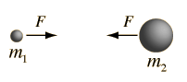

Without specifying the nature or origin of the forces on the two masses, Newton's 3rd law states that if they arise from the two masses themselves, they must be equal in magnitude but opposite in direction so that no net force arises from purely internal forces.

Newton's third law is one of the fundamental symmetry principles of the universe. Since we have no examples of it being violated in nature, it is a useful tool for analyzing situations which are somewhat counter-intuitive. For example, when a small truck collides head-on with a large truck, your intuition might tell you that the force on the small truck is larger. Not so!

# Law of conservations

In physics, a **conservation law** states that a particular measurable property of an isolated physical system does not change as the system evolves over time. Exact **conservation laws** include **conservation** of energy, **conservation** of linear momentum, **conservation** of angular momentum, and **conservation** of electric charge.

* **law of conservation of energy:** In physics, the **law of conservation of energy** states that the total [energy](https://en.wikipedia.org/wiki/Energy) of an [isolated system](https://en.wikipedia.org/wiki/Isolated_system) remains constant—it is said to be [*conserved*](https://en.wikipedia.org/wiki/Conservation_law) over time.[[1]](https://en.wikipedia.org/wiki/Conservation_of_energy#cite_note-Feynman2Ch1S2-1) Energy can neither be created nor destroyed; rather, it transforms from one form to another or from one place to another. For instance, [chemical energy](https://en.wikipedia.org/wiki/Chemical_energy) can be [converted](https://en.wikipedia.org/wiki/Energy_conversion) to [kinetic energy](https://en.wikipedia.org/wiki/Kinetic_energy) in the explosion of a stick of [dynamite](https://en.wikipedia.org/wiki/Dynamite).

A consequence of the [law](https://en.wikipedia.org/wiki/Laws_of_science) of conservation of energy is that a [perpetual motion machine of the first kind](https://en.wikipedia.org/wiki/Perpetual_motion#Classification) cannot exist. That is to say, no system without an external energy supply can deliver an unlimited amount of energy to its surroundings

# Conservation of Linear Momentum: The conservation of linear momentum is based on the principle of Newton’s first law of motion. It implies that for an isolated system, i.e., for a system with no external force, the momentum remains a constant quantity. It also implies the Newton’s third law of motion, i.e., the law of reciprocal actions which states that the force acting between systems is opposite in sign and equal to each other.

* **conservation** of angular momentum: In physics, **angular momentum** (rarely, moment of **momentum** or rotational **momentum**) is the rotational analog of linear **momentum**. It is an important quantity in physics because it is a conserved quantity – the **angular momentum** of a system remains constant unless acted on by an external torque

# Newton's law of universal gravitivity

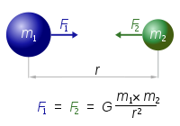

*G* is the [gravitational constant](https://en.wikipedia.org/wiki/Gravitational_constant) (6.674×10−11 N **·** (m/kg)2);

Gravitational potential energy is 0 when infinite far, and negative for all of the rest, the closer the objects, the more negative the potential energy. U(r) = -GMm/r

# Hooke's law

**Hooke's law** is a principle of [physics](https://en.wikipedia.org/wiki/Physics) that states that the [force](https://en.wikipedia.org/wiki/Force) *F* needed to extend or compress a [spring](https://en.wikipedia.org/wiki/Spring_(mechanics)) by some distance *X* is proportional to that distance. That is: *F* = *kX*, where *k* is a constant factor characteristic of the spring: its [stiffness](https://en.wikipedia.org/wiki/Stiffness), and *X* is small compared to the total possible deformation of the spring

# Important concepts

1. Cross product (vector product): AxB. Both A and B are vectors. The angle is between 0 and 180 degree.
   1. Magnitude: ||a|| x ||b|| x sin(*θ)*
   2. Direction: use right hand rule 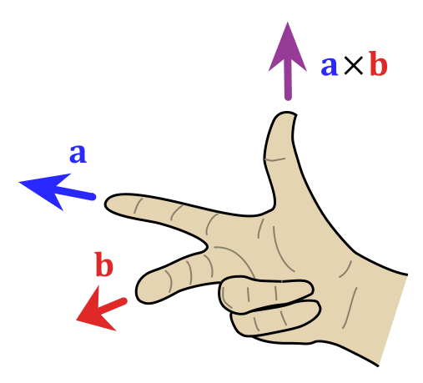
2. Angular momentum: **L = r x p** where **p** is momentum **p =** m**v** 
   1. Unlike momentum, angular momentum does depend on where the origin is chosen, since the particle's position is measured from it
3. Angular speed: ω = θ/t. θ is angles traveled in radians(not degrees). t is time.
4. Angular acceleration = a_t(Tangential acceleration)/r
5. Moment of inertia (**angular mass** or **rotational inertia): I =** r2m. For a continuous body, integration should be used: Complete list at <https://en.wikipedia.org/wiki/List_of_moments_of_inertia>. Following are the common ones: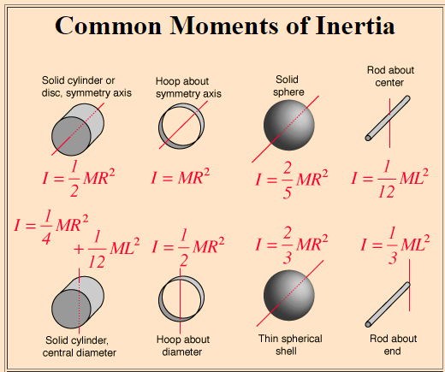
6. Rotational energy: (½)Iω2
7. Center of mass.
8. Potential energy: the energy possessed by a body by virtue of its position relative to others, stresses within itself, electric charge, and other factors

Buoyancy and Pressure

Buoyancy arises from the fact that [fluid pressure](http://hyperphysics.phy-astr.gsu.edu/hbase/pflu.html#fp) increases with depth and from the fact that the increased pressure is exerted in all directions ([Pascal's principle](http://hyperphysics.phy-astr.gsu.edu/hbase/pasc.html#pp)) so that there is an unbalanced upward force on the bottom of a submerged object.

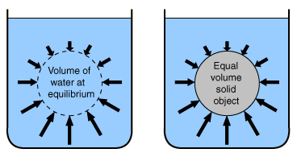

Tensile Strength

**Tensile strength** is a measurement of the [force](https://simple.wikipedia.org/wiki/Force_%28physics%29) required to pull something such as [rope](https://simple.wikipedia.org/wiki/Rope), [wire](https://simple.wikipedia.org/wiki/Wire), or a structural beam to the point where it breaks. It is commonly referred to with symbol https://latex.codecogs.com/gif.latex?%5Csigma, or sigma.

A string will break if tension exceeds Ahttps://latex.codecogs.com/gif.latex?%5Csigma, where a is the cross-sectional area.

In other words

https://latex.codecogs.com/gif.latex?T%20%3E%20A%5Csigma

Potential Energy and Force

http://hyperphysics.phy-astr.gsu.edu/hbase/images/pefuna.gif

Dx however can be modified to fit whatever direction we want it to. Simply factor out whatever factors from inside dx to fit your needs, and multiply that F(x) by that factor. Note this results in a different magnitude of force, but however there is always only one force. Think of it kind of as resolving forces, where one force viewed from another angle looks like a different force or forces, but internally it is not.

Center of mass

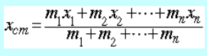 position

https://i.gyazo.com/40b7145e1e863163b8f7988761848122.pngvelocity

Centripetal Acceleration/Force

mrw^2, or mv^2/r

it is the net force needed for a rotating object

all forces acting on the rotating object must add up to this

Gravity Stuffs

Escape Velocity would be when the kinetic energy is equal to the potential energy.

½ mv^2 = GMm/r

V = sqrt(2GM/r)

Vis-Viva Equation



Used to determine the speed of an object in orbit.

Springs Oscillations

The oscillation of a spring be the oscillation of a point moving at constant angular velocity around a circle with radius of the maximum displacement of the spring, and the projection of this point onto the diameter. The frequency of this oscillation is w/2pi, if w is the angular velocity.