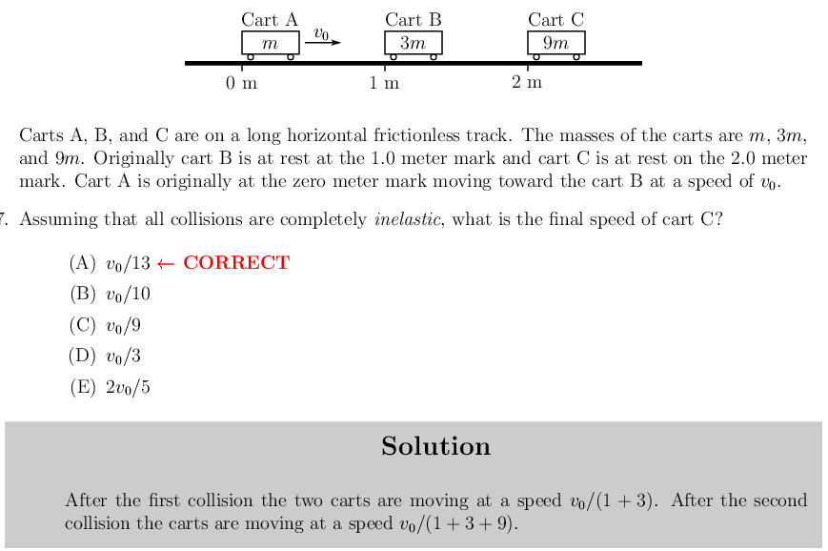

Using conservation of momentum. Since mass cancels, the new velocities are just ratios of the mass to the first velocity. mv0 = (am + bm + cm ….)v1

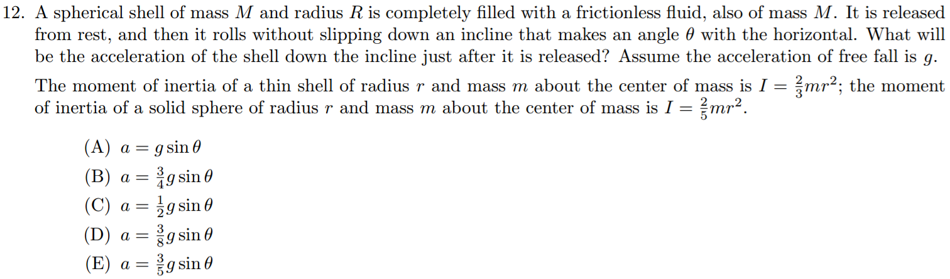  
  
Torque acts as a friction here, countering the force of gravity of the sphere rolling down. Note that the water in the sphere does not rotate, so when considering the moment of inertia, we use the inertia of the empty shell. So the force of the sphere rolling down, 2MA is the result of the frictional torque, 2/3 MA subtracted from the force of gravity, 2Mgsin@.

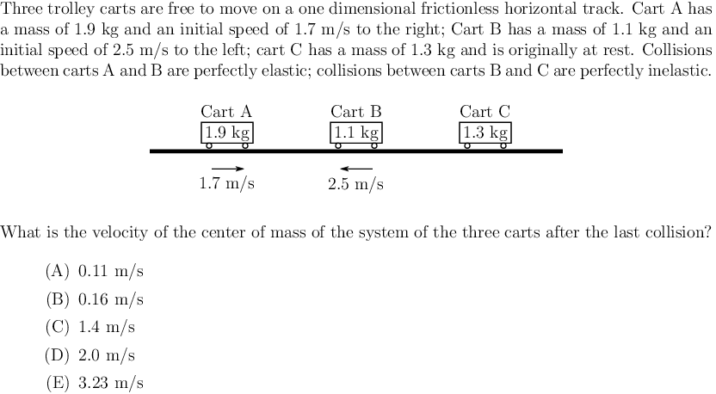

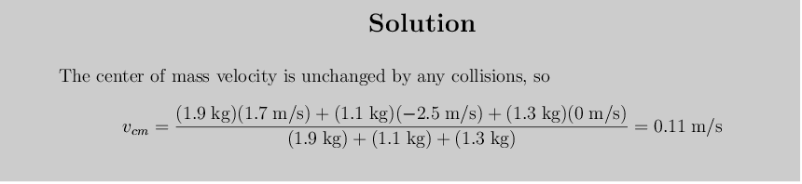

If momentum is conserved, then the velocity of the center of mass never changes. More on this in CCof Physics.

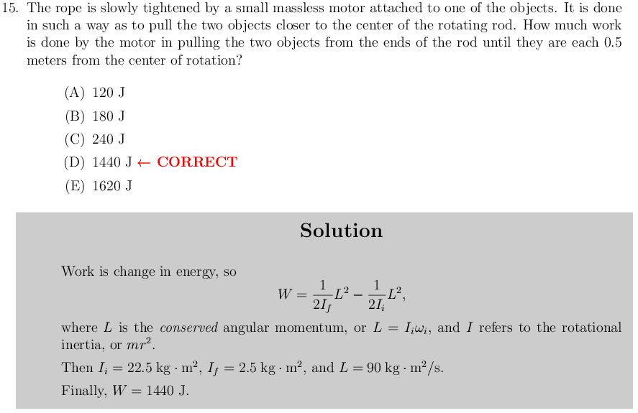

We cannot use ½ Iw^2 here. The conserved angular momentum must be used instead.   
  
   

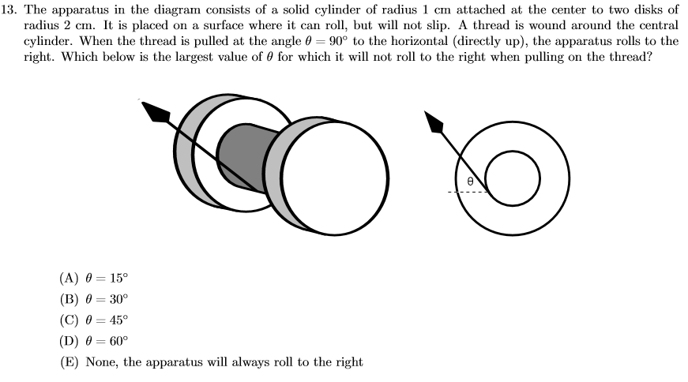

Torques and forced need to be balanced. As the apparatus clearly does not rotate and does not slide in any direction, we must balance both the two torques (from friction and the applied force) and the two forces (same).

For the two torques, we have from friction .2f and from applied force .1F. Since these two act in opposite directions, they need to be equal : .2f = F

The two horizontal forces also cancel, this is from the applied force’s horizontal component Fcos0 and the force of friction f.

Fcos0 = f;

Solving for 0 we get 0 = 60.

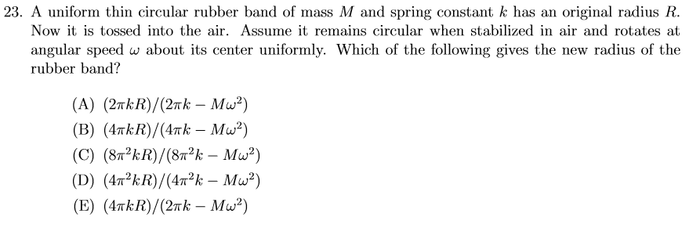

If we look at this, there is only one force acting upon the rubber band as it rises and that is the spring tension force.

To properly analyze this force, we use energy.

-dU/dx = F

-d(1/2k(2pir – 2piR))/d(2pir – 2piR) = F, where r is the new radius.

However, this gives us the force along the circumference of the circle, not towards the center (which is what centripetal force is directed as). To mitigate this, we simply pull out a 2pi from the bottom to change to radial spring force, and the energy remains unchanged (as energy is an existence).

From this, we get that 2piF = mrw^2, where F = 2kpi(r – R).

And there is our solution D.

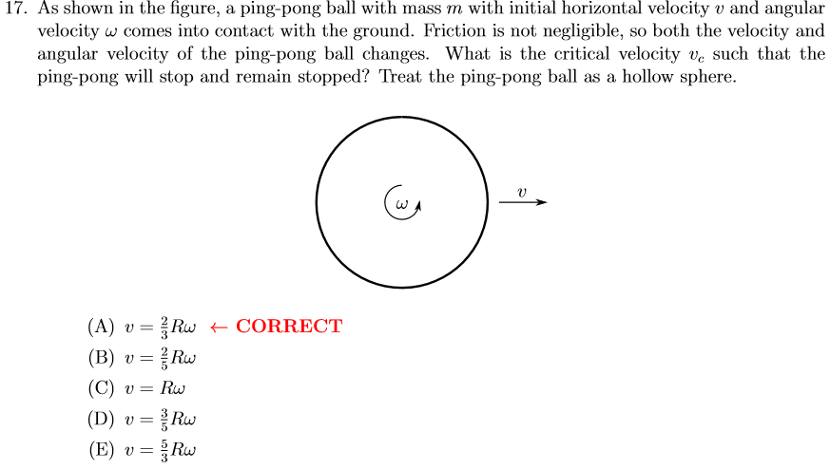

When the ball hits the ground, two things occur, the momentum changing to 0 and the angular momentum doing the same.

Starts with momentum mv and moment of angular momentum Iw which is 2/3mr^2w.

So the change in momentum from frictional force F = mv, and change in angular momentum from torque is Fr = 2/3mr^2w.

Therefore 2/3mrw = mv, and v = 2/3rw

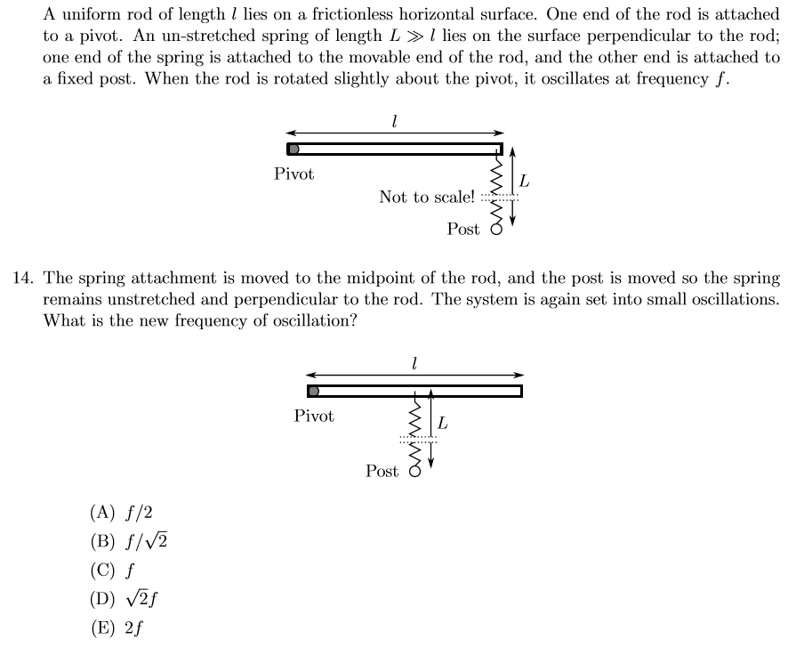

We want to find a general formula for the frequency of this rod at any point. We will use energy to solve this problem.

Let’s say that the maximum stretch of the spring is a distance x. So at the maximum point, we have

1/2kx^2 as the spring potential energy. Now once it returns to equilibrium, we only have rotational velocity, so

1/2kx^2 = 1/2Iw^2 (that is the capital letter i for moment of inertia)

So we know that w = sqrt(k/l)x

From here, we want to find the frequency. Note that frequency of a spring can be analogized to the frequency of a point moving at a constant velocity around a circle and its projection to the diameter. This is the frequency of oscillation with which we wish to observe, with frequency w/2pi where w is the rotational velocity of the point moving about the circle, in other words the rate of oscillation for the spring.

However, the w in our previous equation is not that same w as the one we want to solve for here. So we want to find a relation between these two. Looking at it, the w in our equation follows the path of a larger circle, of radius l (lowercase L), and the w of the spring a circle of radius x. So we have that the ratio between the two w’s is l/x.

So we have w(spring) = l/x w(rod)

Plugging this in, we have that f = l/x w(spring) / 2pi which would equal l \* sqrt(k/i). So the frequency is completely dependent on l, the distance the spring is from the pivot.