1. Sign up
2. Log in
3. Amazon cloud---single node---sandbox 5GB
4. Name “Coursera_zips”
5. Create new MongoDB deployment
6. Create new database user
7. Create

Tools ---- JSON



Setting MONGOLAB_URI

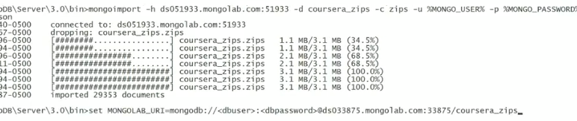

Testing

