require './gridfs_loader'

GridfsLoader.mongo_client

//Connection to database

os_file = File.open("./image3.jpg")

//load file

grid_file = Mongo::Grid::File.new(os_file.read)

//create gridfs object

grid_file.methods

//methods that can be called

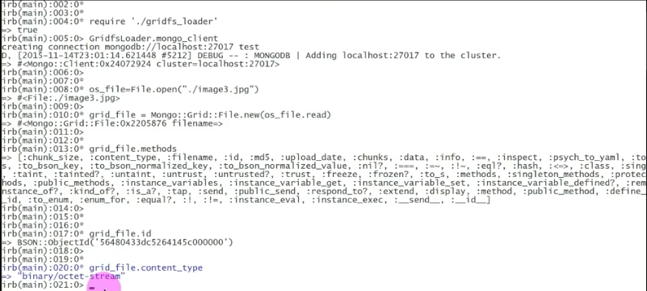

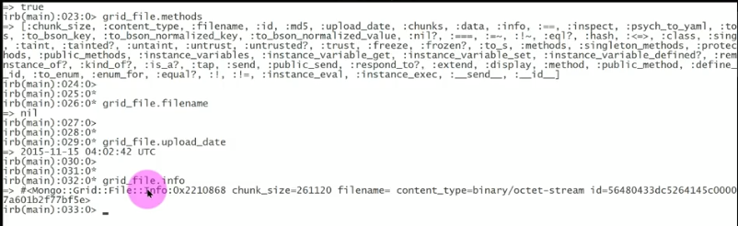





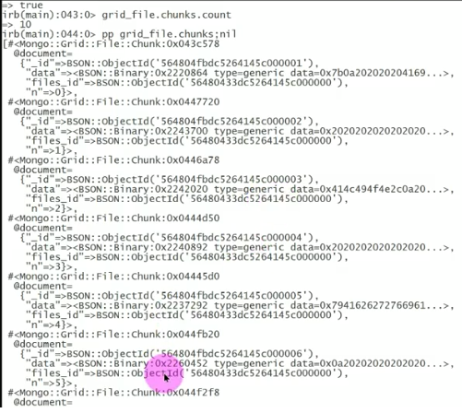

C = GridfsLoader.mongo_client //create a connection

R=c.database.fs.insert_one(grid_file)//insert data

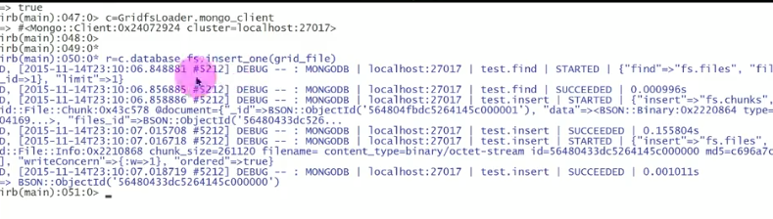

Export:

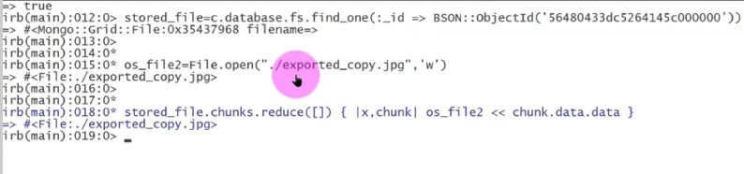

Add description:

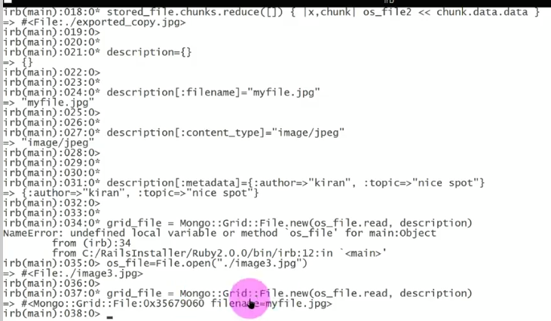

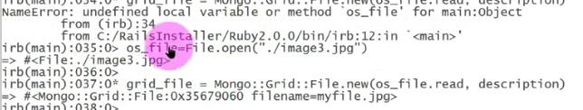

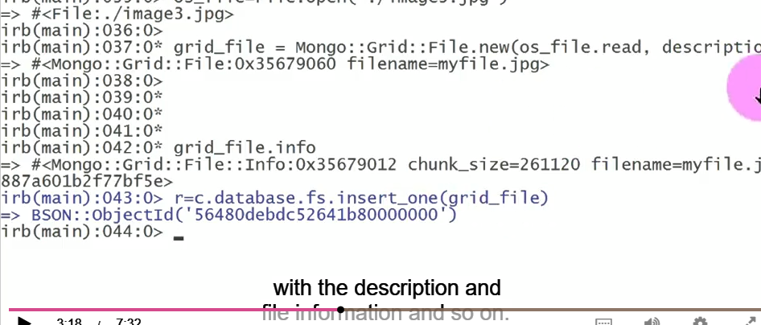

Find:

c.database.fs.find_one(;contentType=>’image/jpeg’, :filename=> ‘myfile.jpg’)

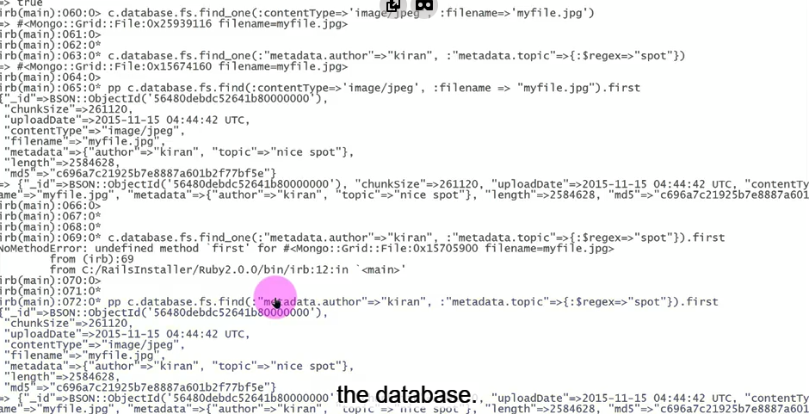

Delete:

Id = c.database.fs.find(:”metadata.author” => “kiran”).first[:_id]

R = c.database.fs.find(:_id=>id).delete_one

r.deleted_count

=>1

r=c.database.fs.find.delete_many//delete all files

[{“ok”=>1,”n”=>3}]