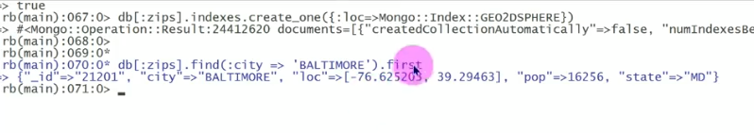

2dsphere Queries

db[:zips].find(:city => 'BALTIMORE').first

**Output**: {"_id"=>"21201", "city"=>"BALTIMORE", "loc"=>[-76.625203, 39.29463], "pop"=>16256, "state"=>"MD"}

Let’s find some cities close to Baltimore using $nearusing $minDistanceand $maxDistance

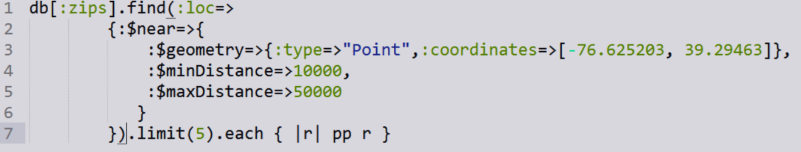

In meter

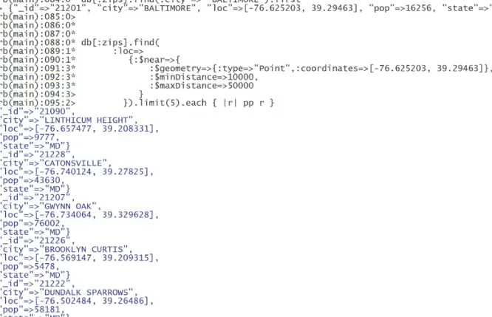

Geospatial Demo

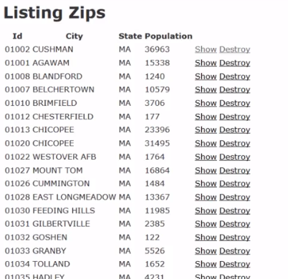

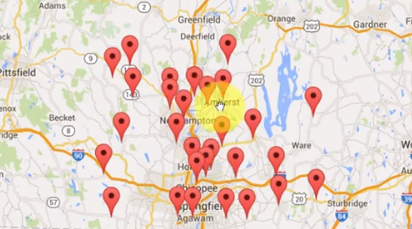

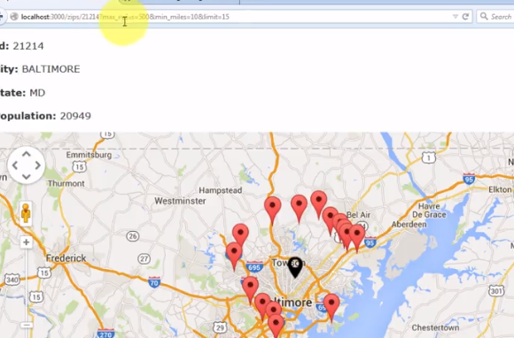

Zip.collection.indexes.create_one({:loc=>Mongo::Index::GEO2DSPHERE})

