In this lecture, we will discuss…

2 How to seed the database with some preliminary data

load schema from other pc:

Rake db:schema:load

Rake db:seed //populate database

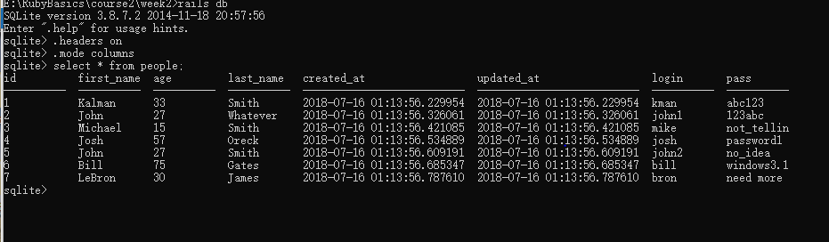

In this lecture, we will discuss…

2 Including SQL fragments in Active Record queries

2 The dangers of SQL injection

In this lecture, we will discuss…

2 Two alternatives to directly specifying SQL literals

• Array Condition Syntax

• Hash Condition Syntax

So remember how the hacker provided his own raw SQL, and

he was able to do that because he escaped his own string with a single quote.

So Array syntax takes care of that and cleans that out for you,

so you can't do that any more.

In this lecture, we will discuss…

2 Relational aspect of RDBMS

2 One-to-One Association/Relation

Array Syntax

2 Lets you specify SQL fragment with ? followed by

values (parameters)

2 “Automagically” performs conversions on the input

values and escapes strings in the SQL

2 Immune to SQL injection

2 Similar to a PreparedStatement in Java

