RETAIL SALES ANALYSIS
A Data-Driven Analysis of Regional, Category, and Product Performance

Prepared by : Lukesh M
Date : August 2026

  - Business Problem
A retail company operates across multiple regions, product categories, and customer segments, generating thousands of orders each year.
While overall sales appear healthy, leadership lacks visibility into which regions, categories, and products are actually driving profit versus simply generating revenue.
Certain product lines may be selling well but losing money after discounts and costs are accounted for, and some regions may be underperforming despite reasonable sales volume.
This analysis examines order-level data to uncover where the business is genuinely profitable, where it is not, and what actions could improve overall margin.

  - Objectives
- Calculate core business KPIs: total revenue, profit, orders, customers, and average order value.
- Identify which regions and product categories drive the most revenue, and which are actually the most profitable.
- Determine which specific products and sub-categories are losing money, and why.
- Understand how discounting affects profit margin.
- Provide actionable recommendations based on the findings.

  - Dataset Overview

The dataset used for this analysis is a retail order-level dataset containing 1,000 transaction records across 21 fields, including order and shipping dates, customer segment, geographic region, product category and sub-category, sales revenue, profit, discount rate, shipping cost, and order priority.
The data spans orders placed between 2011 and 2014 across multiple global markets and regions.
Column | Meaning
order_date / ship_date | Date the order was placed / shipped
region / market | Geographic location of the order
category / sub_category | Product classification
sales / profit | Revenue and profit generated per line item
discount | Discount rate applied to the order

  - Methodology

Before analysis, the dataset required cleaning to address several data quality issues found during initial inspection:
- The sales column contained comma-formatted values (e.g., "1,244") in some rows, which needed to be stripped and converted to numeric type.
- Order and ship dates were recorded in two inconsistent formats (M/D/YYYY and DD-MM-YYYY) within the same column, requiring conditional parsing to correctly interpret each date.
- Text encoding issues affected some international city names, resolved by reading the source file as UTF-8.

Once cleaned, the same dataset was analyzed independently across four tools to validate consistency:
- Microsoft Excel (pivot tables and KPI formulas)
- MySQL (aggregate queries and window functions)
- Power BI (interactive dashboard with DAX measures)
- Python (pandas for analysis, matplotlib for visualization)
All four approaches produced matching results — $262,795 in total revenue and $29,562.37 in total profit — confirming the reliability of the findings presented in this report.

  - KPI Results
The table below summarizes the core business metrics calculated from the cleaned dataset.
Metric | Value
Total Revenue | $262,795.00
Total Profit | $29,562.37
Overall Profit Margin | 11.2%
Total Orders | 987
Total Customers | 556
Average Order Value | $266.26

  - Dashboard Screenshots
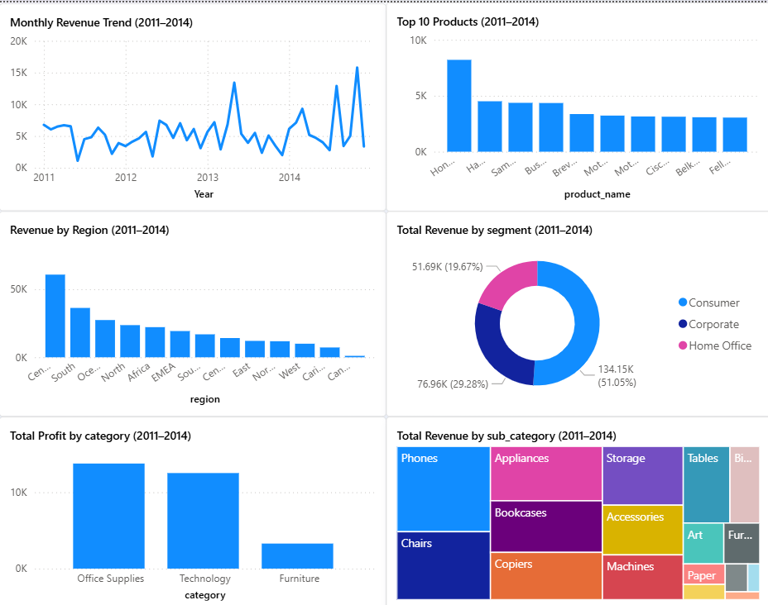
Figure 1- KPIs - PowerBI
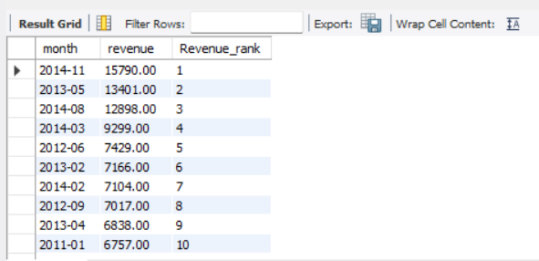
Figure 2 – Ranking Month by Revenue - MySQL
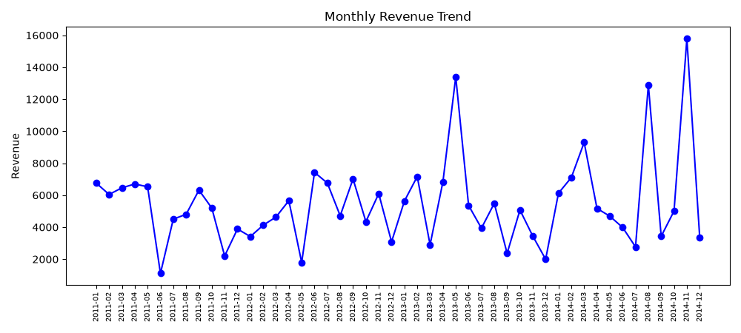
Figure 3 - Monthly Sales Trend – Python

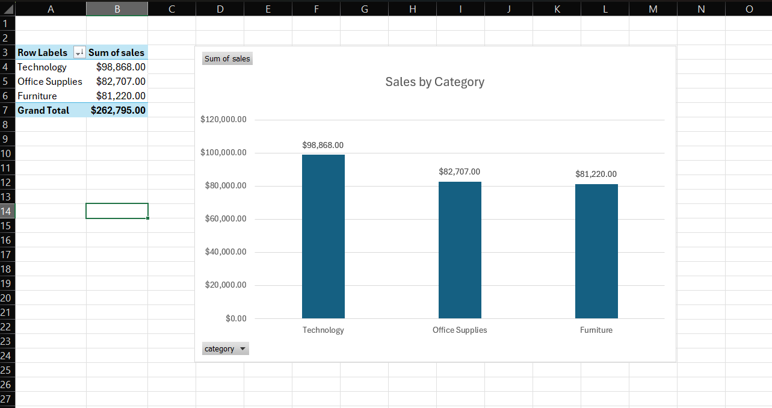
Figure 4 - Sales by Category -Excel

Key Insights

Central Region Leads Revenue, But Africa Is More Profitable
Central generates the highest revenue of any region ($60,804), but Africa converts sales into profit more efficiently, posting a stronger profit-to-sales ratio despite far lower volume ($22,162 in sales, $4,925 in profit). This suggests Central's scale is valuable, but Africa's operating model may be worth studying and replicating elsewhere.

Southeast Asia Is Losing Money
Southeast Asia is the only region operating at a net loss, generating $16,882 in sales but -$401 in profit. Despite reasonable sales volume, something in this region's cost structure, discounting, or shipping is eroding margin entirely.

Furniture Revenue Looks Healthy, But Profit Tells a Different Story
Furniture generates $81,220 in revenue, nearly matching Office Supplies ($82,707) — but only produces $3,280 in profit, a fraction of Office Supplies' $13,764. Technology and Office Supplies both convert revenue to profit at a far healthier rate.

Tables Are the Root Cause
Within Furniture, the Tables sub-category is actively unprofitable, losing $2,015 overall despite generating $16,901 in revenue. This single sub-category is the primary reason Furniture underperforms as a category — removing Tables from the equation, Furniture's remaining profit margin looks much closer to the company average.

Discounting Above 20% Erodes Profit
Average profit per order declines steadily as discount rate increases, turning negative once discounts exceed approximately 20%. Orders discounted between 0-10% remain the healthiest, both in volume and profitability.

  - Business Recommendations
- Review pricing and supplier costs for Tables and other loss-making sub-categories to determine whether the issue is cost, pricing, or excessive discounting.
- Cap standard discounting at approximately 10-15%, reserving deeper discounts for specific, deliberate promotional campaigns rather than routine practice.
- Investigate Southeast Asia's regional cost structure — particularly shipping costs and
discount levels — to identify the specific driver of its losses.
- Study Africa's and Office Supplies' operating models as potential benchmarks for improving margin elsewhere in the business.
- Consider reallocating marketing or inventory investment toward high-margin categories and regions rather than distributing it evenly.

CONCLUSION
This analysis set out to determine which regions, categories, and products genuinely drive profit for the business, rather than relying on revenue alone as a measure of success.
The findings show that strong sales figures do not always translate to strong profitability — Furniture and Southeast Asia both illustrate this clearly, generating meaningful revenue while underperforming or losing money on the bottom line.
The root causes were traceable to specific, addressable factors: a single underperforming sub-category (Tables) within Furniture, and excessive discounting eroding margin across the business.

These findings were validated independently across four analytical tools — Excel, SQL, Power BI, and Python — with consistent results throughout, giving confidence that the insights presented here reflect the underlying data accurately.
The recommendations outlined in this report offer a starting point for the business to protect and improve its profit margin without necessarily needing to grow revenue further, by focusing instead on where existing revenue is being converted into profit least efficiently.

