A Hybrid, End-to-End System for Intelligent Structuring and LLM-Powered Enrichment of Academic Notes

Name: Varun R darji
Roll no: 310315240004
Course: Msc CS Sem 3
Submitted to : Professor Swati Maurya

Abstract
Modern educational environments generate vast quantities of unstructured academic content—lecture slides, handwritten notes, digital documents, and multimedia resources—that overwhelm students with information fragmentation and impose significant cognitive overhead on knowledge management. Traditional note-taking applications lack intelligent automation for content structuring, semantic organization, and contextual retrieval, forcing students to manually categorize and search through disparate materials.
This paper presents a novel hybrid architecture that synthesizes specialized Document AI models with large language models (LLMs) to create an end-to-end system for automatic note capture, intelligent structuring, and context-aware enrichment. The proposed system employs a multi-stage pipeline consisting of: (1) a perception engine utilizing LayoutLMv3, Donut, TrOCR, and Table Transformer for multi-modal document understanding; (2) an LLM-powered enrichment engine leveraging BERTopic for automatic subject classification and GPT-based models for summarization and knowledge extraction; (3) a dense passage retrieval system using vector embeddings for semantic search; and (4) a retrieval-augmented generation (RAG) layer for grounded question-answering.
This architecture represents a significant advancement in educational technology by automating the traditionally manual processes of note organization while maintaining semantic coherence across heterogeneous content sources. The system's ability to automatically categorize notes by subject, maintain temporal context, and provide immediate reference access addresses critical gaps in current educational tools and demonstrates the practical application of contemporary AI research to real-world learning challenges.

1. Introduction

1.1 The Problem of Information Fragmentation in Modern Education
Contemporary students navigate an increasingly complex information landscape characterized by multiple content formats, delivery channels, and knowledge sources. A typical undergraduate might attend a lecture where the professor displays PowerPoint slides while simultaneously writing equations on a whiteboard, then receive a PDF handout with supplementary tables, and finally photograph their own handwritten annotations. This scenario, repeated across multiple courses throughout a semester, generates hundreds of disparate documents that exist in isolation from one another. The student faces the daunting task of manually organizing these materials into coherent knowledge structures—a process that consumes valuable cognitive resources better allocated to actual learning and comprehension.
The cognitive overhead imposed by manual note management manifests in several critical ways. First, students must decide on organizational taxonomies before fully understanding course content, often leading to inconsistent or inappropriate categorization schemes that require later reorganization. Second, the lack of automated linking between related concepts across different documents prevents the formation of meaningful conceptual networks, limiting deep understanding. Third, retrieval of specific information becomes increasingly difficult as note collections grow, with students resorting to crude keyword searches through filenames or full-text searches that fail to capture semantic relationships. Fourth, the integration of new information with existing notes requires manual identification of relevant prior materials—a task that becomes exponentially more challenging as the knowledge base expands.
Consider a concrete example: a student taking both organic chemistry and biochemistry courses photographs a handwritten note about enzyme kinetics during a biochemistry lecture. Three weeks later, during organic chemistry, the professor discusses reaction mechanisms that relate directly to the earlier enzyme kinetics concepts. Without an intelligent system, the student must either remember the connection and manually locate the prior notes, or miss the opportunity to synthesize these complementary perspectives. The information remains fragmented across two separate course folders, organized only by superficial categorical boundaries rather than deeper conceptual relationships.

1.2 Limitations of Existing Note-Taking Solutions
Current digital note-taking applications, despite their popularity, provide primarily passive storage and rudimentary organizational features. Applications such as Evernote, OneNote, and Notion excel at capturing and storing content but rely entirely on user-defined structures—folders, tags, and notebooks—that must be manually created and maintained. These systems treat all content as undifferentiated text or images, lacking any understanding of document structure, semantic content, or conceptual relationships. Their search functionality remains limited to keyword matching and basic optical character recognition (OCR), failing to comprehend context or infer meaning.
More sophisticated tools incorporating machine learning, such as Notion AI or Mem, have begun to introduce features like automatic summarization and question-answering. However, these systems remain fundamentally limited by their single-model architectures. They typically employ general-purpose language models that, while capable of text understanding, lack specialized capabilities for document layout analysis, table extraction, mathematical notation recognition, or handwriting decoding. When a user uploads a photograph of handwritten notes containing complex tables and mathematical expressions, these systems produce unreliable transcriptions and fail to preserve critical structural information. The result is a lowest-common-denominator approach that handles simple text documents adequately but struggles with the heterogeneous, visually-complex materials characteristic of actual student notes.
Furthermore, existing solutions lack temporal and contextual memory. When a student adds new notes to a subject area, the system provides no mechanism for automatically identifying relevant prior materials, suggesting connections, or updating previous summaries to incorporate new information. Each document exists in isolation, and the burden of maintaining coherence across the growing knowledge base falls entirely on the user.

1.3 Research Contribution and Objectives
This paper proposes a fundamentally different approach: a hybrid architecture that combines the specialized perceptual capabilities of multiple Document AI models with the reasoning and synthesis abilities of large language models. The system recognizes that intelligent note management requires both accurate perception of document structure and content (a task best suited to specialized computer vision models) and higher-level semantic understanding and organization (a task requiring the general knowledge and reasoning capabilities of LLMs).
The primary contributions of this research are threefold:

First, the paper presents a novel multi-stage pipeline architecture that orchestrates specialized models in a synergistic workflow. Rather than attempting to solve all problems with a single model, the system employs LayoutLMv3 for document layout understanding, Donut for visual document parsing, TrOCR for handwriting recognition, Table Transformer for table structure extraction, and dedicated models for mathematical notation—each applied precisely where its specialized capabilities provide maximum value. These models operate in concert to produce a richly-structured, semantically-tagged representation of input documents.
Second, the system introduces an intelligent subject classification and organization mechanism using BERTopic clustering combined with LLM-powered content analysis. This dual approach automatically categorizes new notes by subject matter while maintaining awareness of existing organizational structures, enabling automatic folder creation, document routing, and incremental knowledge base updates without user intervention.
Third, the architecture implements a retrieval-augmented generation (RAG) framework that maintains persistent contextual memory across all documents. By embedding note contents into a vector database and employing dense passage retrieval, the system enables semantic search that transcends keyword matching. Students can query their entire note collection in natural language and receive answers grounded in their actual materials, with direct references to source documents—effectively transforming a passive note repository into an active learning companion.
The objective of this paper is to demonstrate that such a hybrid architecture is not only theoretically sound but also practically implementable using current open-source technologies. The subsequent sections provide a comprehensive technical analysis of the system design, situate the work within the broader context of Document AI and educational technology research, detail the implementation strategy, and discuss evaluation approaches for validating the system's effectiveness in real-world educational settings.

2. Literature Review

2.1 Evolution of Document Understanding Models
The field of Document AI has undergone rapid transformation in recent years, evolving from simple optical character recognition systems to sophisticated multi-modal models capable of understanding both visual layout and semantic content. This evolution provides the technological foundation for the proposed intelligent note-taking system.
LayoutLMv3 (Huang et al., 2022) represents a significant milestone in document understanding by introducing a unified text-image multi-modal pre-training approach. Unlike its predecessors that processed text and images through separate encoders, LayoutLMv3 employs a patch-based architecture that treats both text tokens and image patches uniformly. The model is pre-trained on large-scale document corpora using masked language modeling, masked image modeling, and word-patch alignment objectives. This architectural design enables LayoutLMv3 to simultaneously capture spatial layout information, visual appearance, and textual semantics—making it particularly effective for tasks requiring understanding of document structure such as form parsing, receipt understanding, and academic paper analysis. The model's ability to recognize that a text block's meaning depends partly on its position within the page structure is crucial for preserving the organizational logic of student notes.
Donut (Kim et al., 2022) challenges the conventional OCR-then-parse pipeline by introducing an end-to-end document understanding transformer that operates directly on visual input without explicit text recognition. The model architecture consists of a visual encoder based on the Swin Transformer and a textual decoder that generates structured outputs autoregressively. Donut is trained to predict a structured representation (typically JSON) of document content directly from images, learning to simultaneously perform text recognition and structure extraction. This unified approach is particularly advantageous for documents with complex layouts where traditional OCR systems struggle to maintain reading order and structural relationships. For student notes that often contain non-linear layouts—annotations in margins, arrows connecting concepts, or hierarchical bullet structures—Donut's ability to understand spatial relationships holistically provides superior results compared to sequential OCR processing.
TrOCR (Li et al., 2021) specifically addresses the challenge of handwritten text recognition by combining a pre-trained image Transformer encoder (DeiT or BEiT) with a pre-trained text Transformer decoder (RoBERTa). Unlike traditional OCR systems that rely on convolutional neural networks and recurrent architectures, TrOCR is built entirely on Transformer attention mechanisms, enabling it to capture long-range dependencies in handwriting patterns. The model is pre-trained on millions of synthetic and real-world handwriting samples, learning robust representations of character shapes and writing styles. TrOCR achieves state-of-the-art performance on benchmark handwriting recognition datasets, making it essential for processing the substantial volume of handwritten content in student notes. Its ability to handle varying handwriting styles, different writing instruments, and challenging image conditions (poor lighting, skewed perspectives) directly addresses a primary limitation of existing note-taking applications.
Table Transformer (Smock et al., 2022) applies the DETR (DEtection TRansformer) object detection framework to the specific problem of table structure recognition. The model treats table extraction as a two-stage process: first detecting the table region within a document, then identifying individual cells, rows, and columns within that region using a dedicated structure recognition model. Table Transformer employs a set-based global loss function that enables end-to-end training without requiring hand-crafted anchors or non-maximum suppression post-processing. This approach is particularly effective for complex tables with merged cells, nested structures, or irregular layouts—precisely the types of tables students encounter in scientific and technical courses. The model's outputs include not just cell contents but also the explicit structural relationships between cells, enabling faithful reconstruction of tabular data in a machine-readable format.
Nougat (Blecher et al., 2023) extends document understanding capabilities specifically to academic and scientific documents, addressing the challenge of converting visually-rich PDFs into markup language (MMD - Mathematical Markdown). The model is trained on a large corpus of scientific papers and their corresponding LaTeX sources, learning to recognize not just text but also mathematical equations, chemical formulas, citation formats, and bibliography structures. Nougat's architecture enables it to handle the specific conventions of academic writing—subscripts, superscripts, Greek letters, special symbols—that are ubiquitous in STEM education but poorly handled by general-purpose OCR systems. For students in technical disciplines, this capability is transformative, enabling accurate digitization of lecture materials containing mathematical notation.

2.2 Topic Modeling and Semantic Organization
Automatic organization of documents by subject matter requires unsupervised learning techniques that can discover latent thematic structures within text corpora without predefined categories.
BERTopic (Grootendorst, 2022) represents a modern approach to topic modeling that leverages transformer-based language models for semantic representation. Unlike classical methods such as Latent Dirichlet Allocation (LDA) that rely on bag-of-words representations, BERTopic uses sentence transformers to create dense vector embeddings capturing contextual meaning. The algorithm then applies UMAP for dimensionality reduction and HDBSCAN for clustering, identifying groups of semantically similar documents. Crucially, BERTopic generates human-interpretable topic descriptions using class-based TF-IDF, extracting the most representative terms for each cluster. This combination of semantic understanding (from BERT embeddings) and interpretability (from TF-IDF topic words) makes BERTopic ideal for automatic subject classification in the proposed system. When a student uploads a new document, BERTopic can compare its embedding to existing topic clusters, either assigning it to an established subject folder or recognizing it as introducing a novel topic that warrants creation of a new organizational category.

2.3 Dense Retrieval and Semantic Search
Traditional keyword-based search systems suffer from the vocabulary mismatch problem: users formulate queries using different terms than those appearing in relevant documents. Dense passage retrieval addresses this limitation through learned semantic representations.
Dense Passage Retrieval (DPR) (Karpukhin et al., 2020) introduced a dual-encoder architecture that learns to map questions and passages into a shared embedding space where semantically related items are positioned nearby. The system consists of two BERT-based encoders—one for questions, one for passages—trained using a contrastive loss that encourages relevant question-passage pairs to have high dot-product similarity while pushing apart negative examples. At retrieval time, all passages are pre-encoded into vectors stored in a specialized vector database (such as FAISS or Weaviate), enabling efficient approximate nearest neighbor search. For a student query like "What are the main factors affecting enzyme activity?", DPR can retrieve relevant passages from notes even if they use terminology like "enzyme kinetics influences" or "catalytic efficiency determinants" without containing the exact query words. This semantic search capability is essential for making large note collections truly navigable.

2.4 Large Language Models for Reasoning and Synthesis
While specialized Document AI models excel at perception and structure extraction, higher-level tasks like summarization, knowledge synthesis, and question-answering require the broad world knowledge and reasoning capabilities of large language models.
GPT-family models (Brown et al., 2020; OpenAI, 2023) and their open-source alternatives (such as LLaMA, Mistral, and Falcon) demonstrate remarkable few-shot learning abilities through prompt engineering. These models can perform complex tasks—summarizing documents, extracting key facts, answering questions, generating explanations—when provided with appropriate instructions and context. In the proposed system, the LLM serves as the "reasoning engine" that operates on the structured outputs produced by specialized perception models. For instance, after LayoutLMv3 identifies section headings and TrOCR transcribes handwritten content, the LLM receives this structured input and generates a coherent summary highlighting main concepts, extracts key terms for indexing, and suggests connections to related materials in the existing note corpus.
Retrieval-Augmented Generation (RAG) (Lewis et al., 2020) combines the strengths of retrieval systems and generative language models to produce factually grounded responses. The RAG pipeline first retrieves relevant passages from a knowledge base using dense retrieval, then conditions a language model's generation on these retrieved passages by including them in the input context. This approach significantly reduces hallucination—the tendency of language models to generate plausible-sounding but factually incorrect information—by anchoring generation in retrieved evidence. For educational applications, RAG is particularly valuable because students need accurate, source-referenced answers rather than creative confabulations. When a student asks "How does the Krebs cycle relate to cellular respiration?", the RAG system retrieves specific passages from the student's biology notes where these concepts are discussed, then generates an answer directly referencing that material, complete with citations to specific documents and page numbers.
InstructUIE (Wang et al., 2023) introduces a framework for instruction-based universal information extraction, training language models to extract structured information from text according to natural language instructions. Rather than requiring task-specific fine-tuning for each extraction scenario, InstructUIE models can perform entity recognition, relationship extraction, and event extraction by following prompts like "Extract all enzyme names and their substrate preferences from the following text." This flexibility is valuable for the proposed system's enrichment stage, where the types of information to extract may vary by discipline—chemical compounds in chemistry notes, theorem names in mathematics, historical dates in history notes—and predefining all possible extraction schemas is impractical.

2.5 Justification for the Hybrid Architecture
The literature review reveals a fundamental insight: no single model architecture possesses all capabilities necessary for comprehensive intelligent note management. Specialized Document AI models (LayoutLMv3, Donut, TrOCR, Table Transformer) excel at perceptual tasks—accurately recognizing text, understanding layout, extracting structure—but lack the broad world knowledge and reasoning abilities needed for semantic organization, summarization, and question-answering. Conversely, general-purpose LLMs possess extensive knowledge and strong reasoning capabilities but are not optimized for visual document understanding and would require impractical amounts of compute to be fine-tuned for specialized tasks like handwriting recognition or table extraction.
The proposed hybrid architecture exploits the complementary strengths of these different model families. The perception engine employs specialized models where their domain-specific training provides maximum value: TrOCR for handwriting with its character-level attention mechanisms trained on writing samples; Table Transformer for tabular structures with its object detection framework; Donut for complex layouts with its end-to-end visual-to-structure mapping. These models process raw inputs (images, PDFs) into clean, structured, machine-readable representations. The enrichment engine then applies an LLM to this structured data, leveraging the language model's strengths—semantic understanding, summarization, reasoning about relationships—without asking it to perform low-level perceptual tasks for which it was not designed. The retrieval engine employs dense embeddings to enable semantic search across the structured, enriched content, and finally the RAG layer uses the LLM in a constrained, evidence-grounded manner to provide accurate question-answering.
This division of labor—specialized perception models for structure extraction, topic models for organization, embedding models for retrieval, and LLMs for reasoning—represents an efficient allocation of computational resources and model capabilities. Each component operates in its domain of expertise, and the multi-stage pipeline ensures that downstream components receive high-quality inputs optimized for their processing requirements.

2.6 Situating the Proposed Work
While the individual components described above exist in the research literature and open-source ecosystem, their integration into a cohesive, end-to-end system specifically designed for student note management represents novel work. Existing research has explored document understanding, topic modeling, semantic search, and question-answering as separate problems. Commercial applications have incorporated subsets of these capabilities—note-taking apps with basic OCR, search engines with semantic retrieval, chatbots with question-answering—but no system combines all stages into a unified workflow optimized for the specific use case of continuous, incremental knowledge base building from heterogeneous educational materials.
The proposed system's novelty lies in three specific design choices: (1) the multi-modal perception engine's routing logic that selects appropriate specialized models based on document characteristics, (2) the integration of unsupervised topic modeling with LLM-based content analysis for automatic subject classification and folder management, and (3) the persistent, incrementally-updated vector database that maintains semantic links across all notes over time, enabling the system to "remember" connections between materials added months apart. These integrations transform a collection of powerful but independent AI components into a functional educational tool that addresses the real-world problem of information fragmentation in student learning.

3. System Architecture and Methodology

3.1 Overview of the End-to-End Pipeline
The proposed system implements a four-stage pipeline architecture that transforms raw document inputs (screenshots, PDFs, photos) into a searchable, organized, semantically-enriched knowledge base. Each stage performs a distinct function: perception (structure extraction), enrichment (content analysis and organization), indexing (embedding and storage), and retrieval (search and question-answering). The modular design enables independent optimization of each component while maintaining clean interfaces between stages.
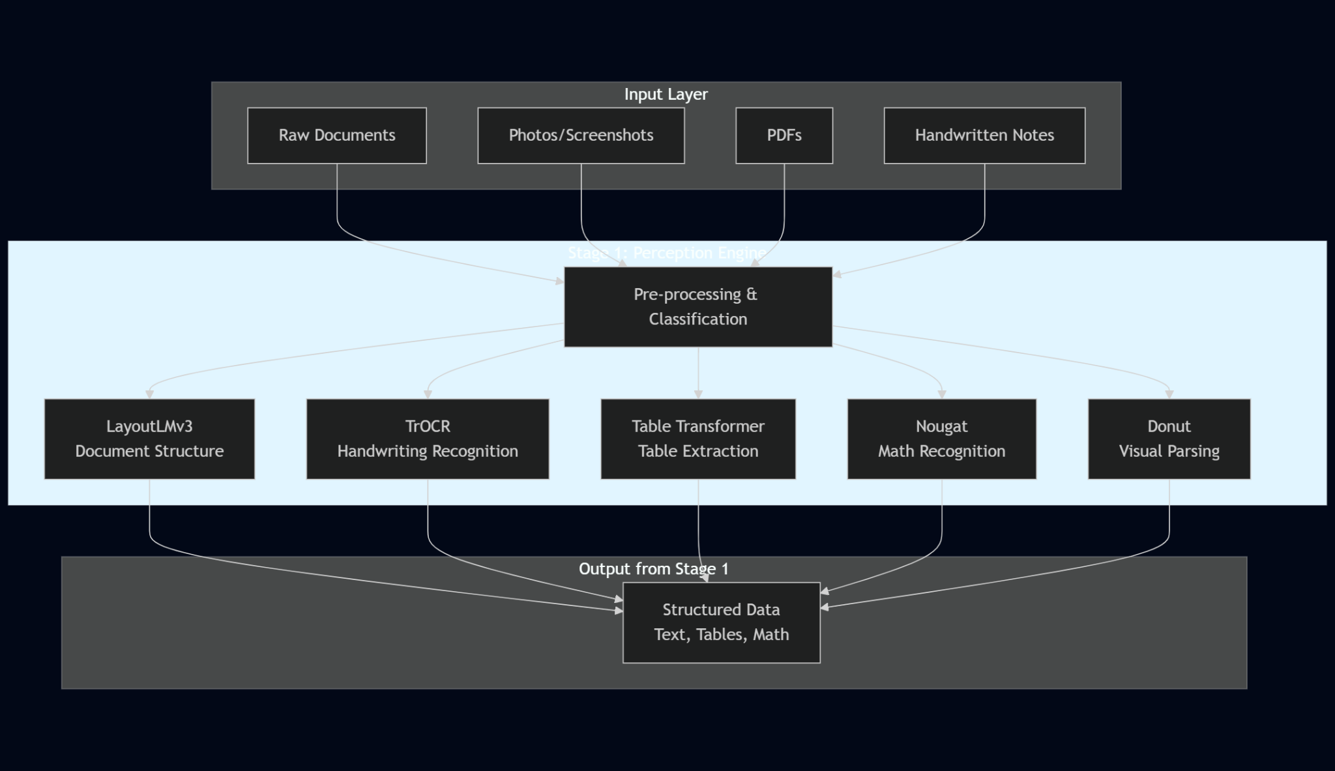
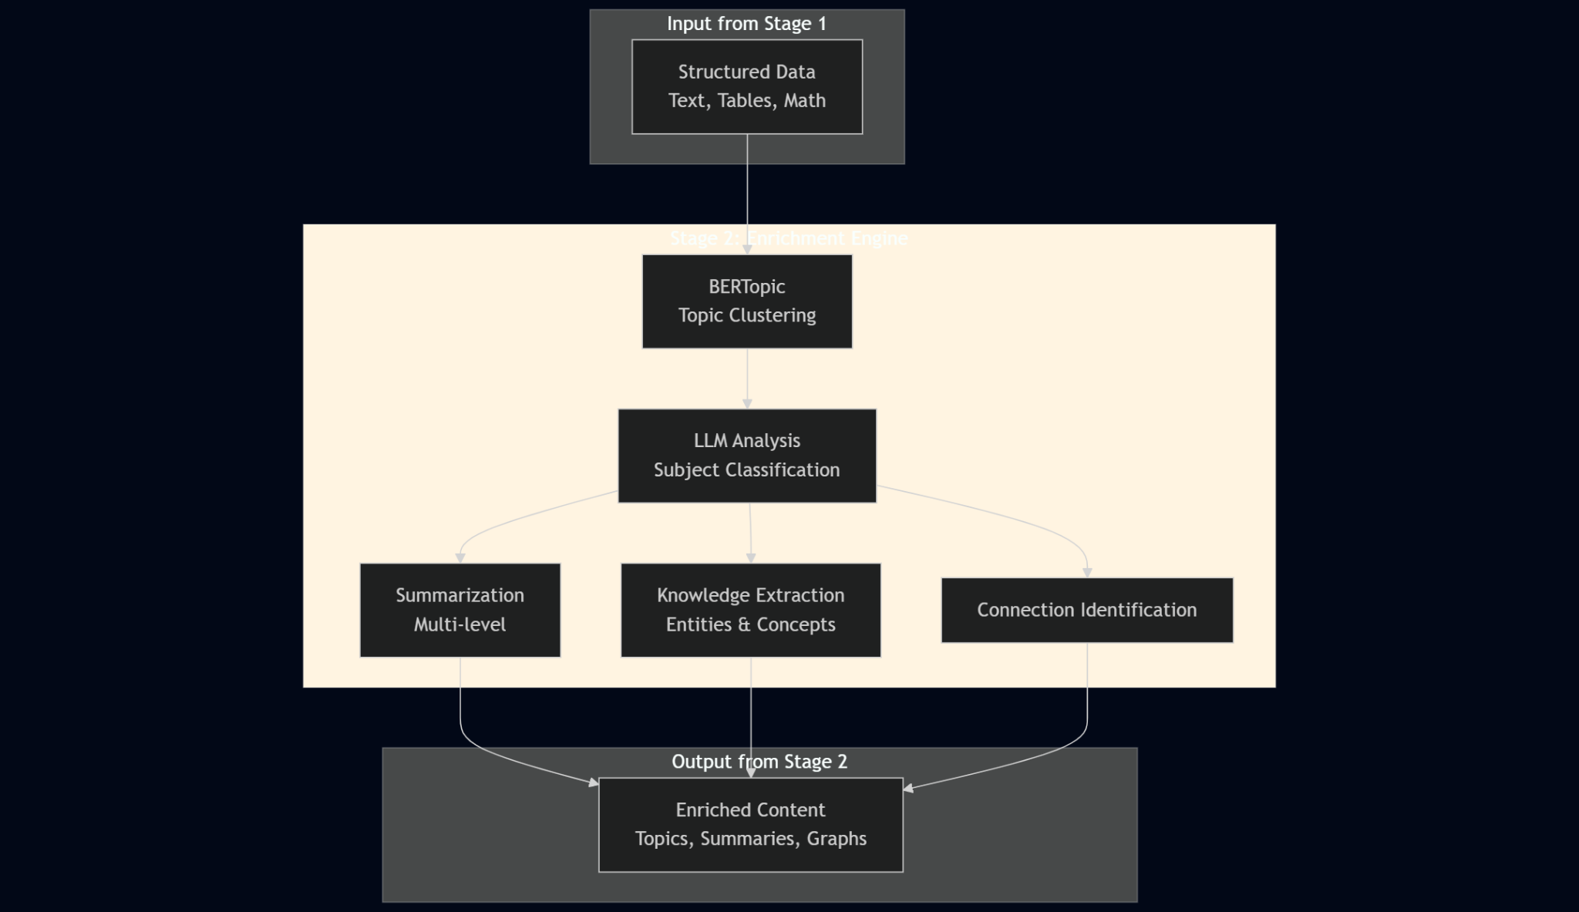
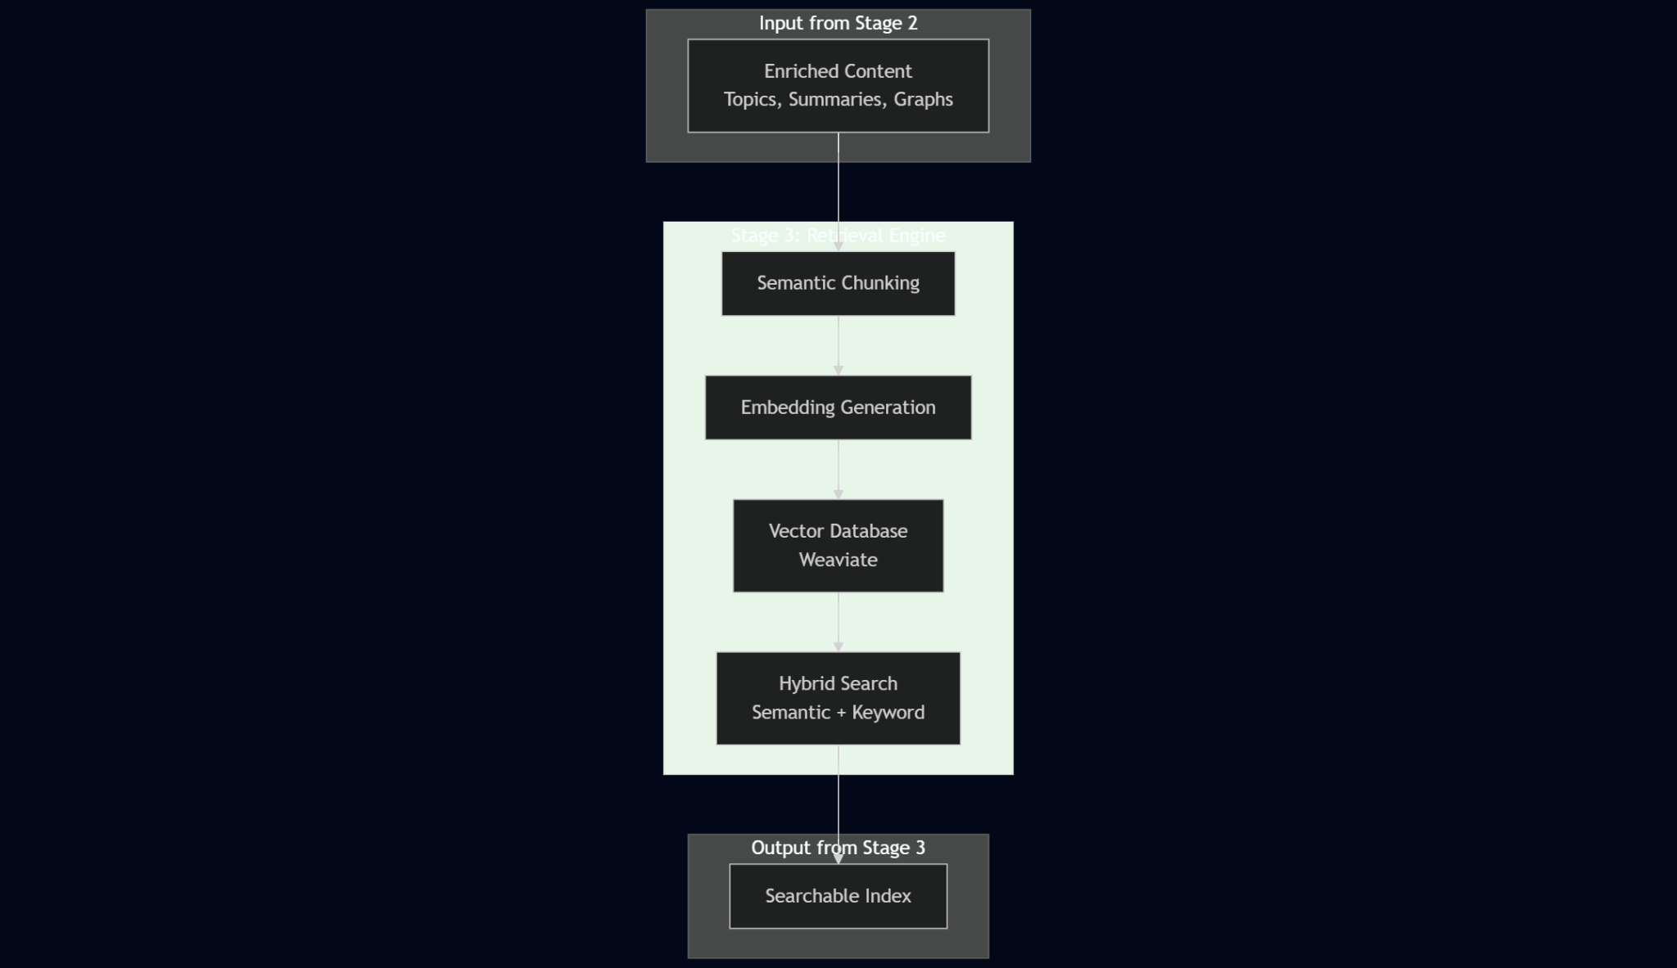

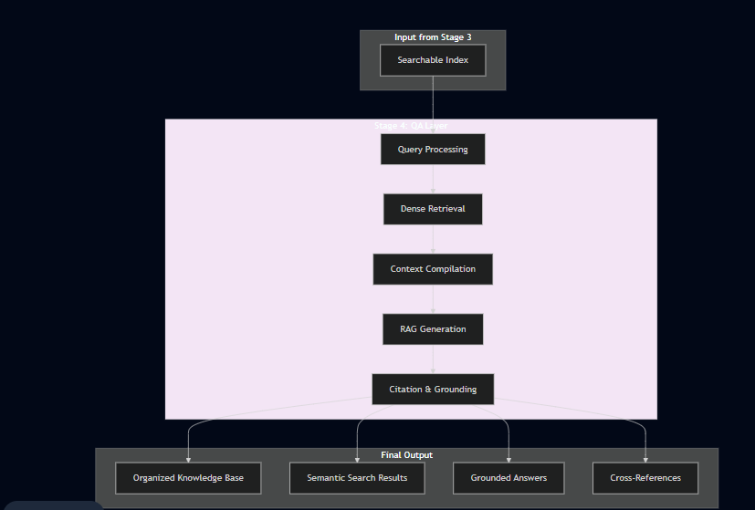
Figure 1: Four-Stage Pipeline Architecture Overview
Description: This diagram provides a comprehensive overview of the complete system architecture, illustrating the flow of data through four distinct processing stages. The visualization demonstrates how raw documents (photos, PDFs, handwritten notes) enter the perception engine where specialized AI models extract and structure content. The structured data then flows through the enrichment engine for semantic analysis and organization, proceeds to the retrieval engine for indexing and searchability, and finally reaches the question-answering layer where students can interact with their knowledge base through natural language queries.
Key Components Illustrated:
- Input layer showing multiple document formats and sources
- Perception engine with specialized models (LayoutLMv3, TrOCR, Table Transformer, Nougat, Donut)
- Enrichment engine featuring BERTopic clustering and LLM-based analysis
- Retrieval engine implementing semantic chunking and vector database storage
- Question-answering layer using RAG for grounded responses
- Output layer demonstrating the organized knowledge base and query capabilities
Significance: This figure serves as the foundational architectural diagram, providing readers with an immediate understanding of system scope and component relationships. The color-coded stages clearly delineate functional boundaries while arrows indicate data flow and dependencies.
To illustrate the complete data flow, consider a concrete example: a student photographs handwritten notes from a biochemistry lecture discussing enzyme kinetics. The notes include hand-drawn diagrams of enzyme-substrate complexes, a table comparing different enzyme classes, and several paragraphs of text explaining the Michaelis-Menten equation. The following subsections trace this document through each system stage, detailing the transformations applied at each step.

3.2 Module 1: Perception Engine - Multi-Modal Document Understanding
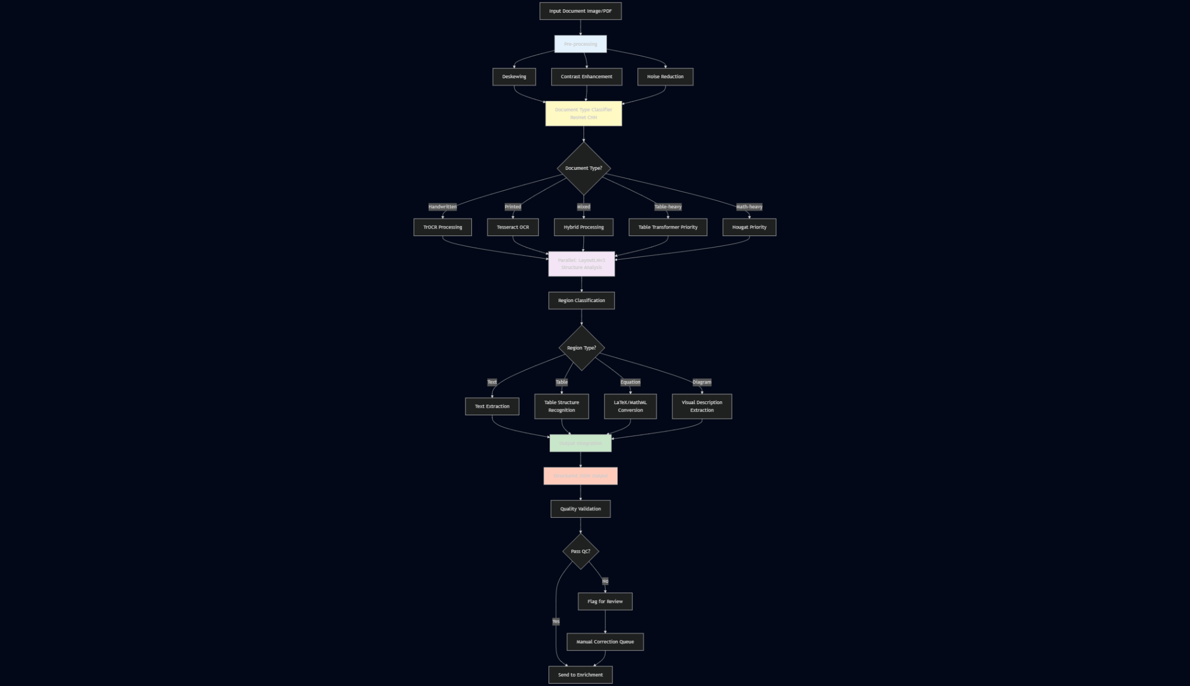
The perception engine receives raw image or PDF inputs and produces a structured, machine-readable representation capturing both textual content and document structure. The module implements intelligent routing logic that selects appropriate processing paths based on document characteristics detected during pre-processing.

3.2.1 Pre-Processing and Document Classification
Upon receiving an input image, the system first applies standard image enhancement techniques to optimize conditions for downstream models. Deskewing algorithms detect and correct rotational misalignment using Hough line detection on text baselines, ensuring that subsequent models process properly-oriented content. Contrast enhancement via adaptive histogram equalization improves text legibility in photographs taken under poor lighting conditions. Noise reduction filters remove compression artifacts and background textures that might confuse character recognition models.
The pre-processed image then passes through a lightweight document classifier—a ResNet-based CNN trained to categorize documents by type: handwritten notes, printed text, mixed handwritten-and-printed, form documents, tables, diagrams, or mathematical notation-heavy content. This classification determines the processing path. For the biochemistry example, the classifier identifies the document as "mixed handwritten-and-printed with embedded table," triggering a multi-model processing strategy.

3.2.2 Text Recognition Pathway
For regions classified as handwritten text, the system invokes TrOCR. The model receives cropped image regions containing text lines (identified by connected component analysis and projection profile methods) and generates character sequences autoregressively. TrOCR's attention mechanism enables it to handle challenging handwriting characteristics: letter variations, connected cursive strokes, inconsistent spacing, and incomplete characters. For the enzyme kinetics notes, TrOCR processes the handwritten paragraphs, producing text strings like "Enzymes catalyze reactions by lowering activation energy. The Michaelis-Menten equation describes..."
For printed text regions (perhaps from a handout photographed alongside the handwritten notes), the system uses the more computationally efficient Tesseract OCR engine, which achieves near-perfect accuracy on high-quality printed text while requiring significantly less GPU memory than transformer-based models.

3.2.3 Layout and Structure Analysis
Parallel to text recognition, LayoutLMv3 analyzes the overall document structure. The model receives the full document image and outputs a structured representation identifying: heading hierarchies, paragraph boundaries, list items, captions, and spatial relationships between elements. Critically, LayoutLMv3 preserves reading order information—determining whether a margin annotation should be processed before or after the main text it comments on, or whether a caption belongs to a figure above or below it.
For the biochemistry example, LayoutLMv3 identifies: (1) a main heading "Enzyme Kinetics," (2) three paragraphs of body text in reading order, (3) a hand-drawn diagram labeled "Enzyme-Substrate Complex," (4) a table with caption "Classes of Enzymes," and (5) margin annotations connected to specific paragraphs via arrow marks. This structural understanding ensures that the output preserves the logical organization intended by the student.

3.2.4 Table Extraction Pipeline
Regions identified as tables receive specialized processing via Table Transformer. The model first localizes the table boundary, then applies a structure recognition stage that detects individual cells, identifies row and column headers, and recognizes merged cells. The output is a structured data format (pandas DataFrame) that preserves both cell contents and their positional relationships.For the enzyme class comparison table in the example, Table Transformer extracts a structure like:
Enzyme Class | Example | Substrate Type
Oxidoreductases | Dehydrogenase | Electron donors
Transferases | Kinase | Functional groups
Hydrolases | Protease | Bonds with water
The table data is serialized into a JSON representation that includes both cell values and semantic markers (header cells, data cells, spanning information), enabling downstream models to understand the table's meaning rather than treating it as unstructured text.

3.2.5 Mathematical Notation Recognition
Regions containing mathematical equations are processed using Nougat or specialized formula recognition models like Pix2Tex. These models output LaTeX or MathML representations of equations, preserving mathematical semantics. For the Michaelis-Menten equation in the biochemistry notes, the model converts the handwritten formula into: $v = \frac{V_{max}[S]}{K_m + [S]}$, maintaining the exact mathematical structure including subscripts, fractions, and variable names.

3.2.6 Output Standardization and Integration
Each specialized model produces outputs in different formats: TrOCR generates plain text, Table Transformer outputs DataFrames, LayoutLMv3 produces structured JSON with bounding boxes, and Nougat generates LaTeX. The final stage of the perception engine standardizes these heterogeneous outputs into a unified document representation format based on a hierarchical
JSON schema:
{
"document_id": "biochem_lecture_05_2024-03-15",
"sections": [
{
"type": "heading",
"level": 1,
"content": "Enzyme Kinetics",
"bbox": [50, 30, 500, 80]
},
{
"type": "paragraph",
"content": "Enzymes catalyze reactions by lowering activation energy...",
"bbox": [50, 100, 500, 250]
},
{
"type": "table",
"caption": "Classes of Enzymes",
"structure": {...},
"data": [[...],[...]],
"bbox": [50, 300, 500, 500]
},
{
"type": "equation",
"content": "$v = \\frac{V_{max}[S]}{K_m + [S]}$",
"description": "Michaelis-Menten equation",
"bbox": [50, 520, 400, 570]
}
],
"metadata": {
"original_format": "handwritten_photo",
"capture_timestamp": "2024-03-15T14:30:00",
"models_used": ["TrOCR", "LayoutLMv3", "Table Transformer", "Nougat"]
}
}

This structured representation becomes the input for the enrichment stage, ensuring that all document content—text, tables, equations, structural relationships—is available in a consistent, machine-readable format.

3.3 Module 2: LLM Enrichment Engine - Semantic Analysis and Organization
The enrichment engine receives structured documents from the perception stage and performs higher-level cognitive operations: subject classification, summarization, key concept extraction, and relationship identification. This module implements a two-phase approach: unsupervised clustering for initial subject identification, followed by LLM-based content analysis for detailed enrichment.

3.3.1 Topic-Based Subject Classification
Phase 1: Topic Modeling with BERTopic
Before invoking the computationally expensive LLM, the system performs initial subject classification using BERTopic clustering. The structured document content (concatenating all text fields from the JSON representation) is encoded using a sentence transformer model (e.g., all-MiniLM-L6-v2) to produce a dense embedding vector capturing semantic content. This embedding is compared against existing topic clusters in the knowledge base.
For a student's first biochemistry note, no relevant cluster exists, so BERTopic identifies this as a novel topic and initializes a new cluster. As more biochemistry notes are added, the clustering algorithm groups semantically similar documents. When the enzyme kinetics note is added, BERTopic computes its embedding distance to existing clusters and assigns it to the "Biochemistry - Metabolism" cluster (assuming related notes already exist) with high confidence (cosine similarity > 0.75). If the similarity falls below the confidence threshold, the system flags the document for LLM-based classification.
Phase 2: LLM-Based Subject Refinement
Documents flagged for uncertain classification or appearing to introduce new topics are processed by the LLM for detailed analysis. The system constructs a prompt that includes: (1) the document's structured content, (2) summaries of existing subject categories in the knowledge base, and (3) a request for classification or new category suggestion.
Example prompt for the enzyme kinetics note:
Analyze the following academic note and determine its subject classification:

DOCUMENT CONTENT:
Heading: Enzyme Kinetics
Main concepts discussed: enzyme catalysis, activation energy, Michaelis-Menten equation,
enzyme classes (oxidoreductases, transferases, hydrolases), enzyme-substrate complex
formation, reaction rate kinetics

Table included: Classification of enzymes by function
Equations mentioned: Michaelis-Menten equation for reaction velocity

EXISTING SUBJECT CATEGORIES:
1. Biochemistry - Metabolism (contains 8 documents about glycolysis, Krebs cycle,
electron transport)
2. Organic Chemistry - Reaction Mechanisms (contains 12 documents about nucleophilic
substitution, elimination reactions)
3. Cell Biology - Membrane Transport (contains 5 documents)

TASK:
Determine if this document belongs to an existing category, should be placed in a
subcategory, or represents a new subject area. Provide:
1. Primary subject classification
2. Confidence score (0-100)
3. Related categories (if any)
4. Suggested folder path in the knowledge base

The LLM analyzes the content and responds:
PRIMARY CLASSIFICATION: Biochemistry - Metabolism
CONFIDENCE: 95
REASONING: The document focuses on enzyme function in catalyzing metabolic reactions,
directly relating to existing documents about glycolysis and Krebs cycle which involve
enzyme-catalyzed steps. Enzyme kinetics is fundamental to understanding metabolic
pathway rates.
RELATED CATEGORIES: Organic Chemistry - Reaction Mechanisms (35% overlap due to
discussion of catalysis mechanisms)
SUGGESTED PATH: /Biochemistry/Metabolism/Enzyme_Kinetics/
RECOMMENDATION: Create a new subcategory "Enzyme Kinetics" within
Biochemistry/Metabolism to distinguish these specialized notes from general metabolic
pathway notes.

The system parses this structured LLM response and automatically creates the folder structure, placing the document accordingly and updating the topic model's cluster labels to reflect the hierarchical organization.

3.3.2 Content Summarization and Knowledge Extraction
For each document, the LLM generates multiple types of enrichment content that facilitate later retrieval and synthesis:
Multi-Level Summarization
The system prompts the LLM to generate summaries at three granularity levels:
- One-sentence synopsis (for quick scanning): "This note explains how enzymes accelerate reactions through formation of enzyme-substrate complexes, described mathematically by Michaelis-Menten kinetics."
- Paragraph summary (for preview): "Enzymes function as biological catalysts that lower activation energy barriers for reactions. The note explains enzyme-substrate complex formation and introduces the Michaelis-Menten equation relating reaction velocity to substrate concentration. Different enzyme classes (oxidoreductases, transferases, hydrolases) are compared based on their catalytic mechanisms and substrate specificities. Key parameters include Vmax (maximum velocity) and Km (Michaelis constant), which characterize enzyme efficiency and substrate affinity."
- Detailed outline (for comprehensive review): Bulleted list of all main points, sub-points, and supporting details.
Key Concept and Entity Extraction
The LLM extracts structured information including:
- Key terms: enzyme, catalyst, activation energy, substrate, Michaelis-Menten equation, Km, Vmax
- Named entities: specific enzyme names (dehydrogenase, kinase, protease)
- Concepts: enzyme kinetics, catalysis, enzyme-substrate complex, reaction velocity
- Relationships: "enzyme-substrate binding → complex formation → product release"
This extracted information populates a knowledge graph where concepts are nodes and relationships are edges, enabling the system to answer queries like "What factors affect enzyme activity?" by traversing the graph to find connected concepts.
Prerequisite and Connection Identification
The LLM analyzes prerequisite relationships: "Understanding this note requires prior knowledge of: chemical thermodynamics (activation energy), basic organic chemistry (functional groups), reaction rate theory." It also suggests connections to other topics: "This note relates to: cellular respiration (enzymes catalyze metabolic steps), protein structure (enzyme active sites), regulation mechanisms (enzyme inhibition)."
When new notes are added, the system uses these connection suggestions to notify the student of related existing materials and to update cross-references automatically.

3.3.3 Incremental Knowledge Base Updates
A critical feature distinguishing this system from static note repositories is its ability to incrementally update existing materials when new information is added. When a new biochemistry note discusses "enzyme inhibition," the system:
- Retrieves the earlier enzyme kinetics note via semantic search
- Prompts the LLM: "Given this new information about enzyme inhibition, how should the summary of the enzyme kinetics note be updated to reflect the connection?"
- Receives a suggestion: "Add to the enzyme kinetics summary: 'Enzyme activity can be modulated through inhibition mechanisms (see: enzyme_inhibition_note.md), affecting both Km and Vmax parameters.'"
- Automatically appends this cross-reference to the previous summary and updates the knowledge graph to include an edge between "enzyme kinetics" and "enzyme inhibition"
This incremental updating ensures that the knowledge base remains cohesive as it grows, with older materials automatically incorporating pointers to newer, related content.

3.4 Module 3: Retrieval Engine - Vector Database and Semantic Search
The retrieval engine transforms the enriched, structured documents into searchable vector representations and implements efficient similarity search over the entire knowledge base.

3.4.1 Document Chunking Strategy
Embedding entire documents as single vectors would result in overly coarse granularity for retrieval—a student asking about a specific concept would retrieve entire lecture notes rather than the relevant passages. The system therefore implements semantic chunking that divides documents into retrievable units while preserving context.
The chunking algorithm operates on the structured JSON representation from the perception engine, respecting natural boundaries:
- Each section (identified by LayoutLMv3) becomes a separate chunk
- Paragraphs are kept together unless they exceed a length threshold (512 tokens), in which case they're split at sentence boundaries
- Tables are chunked as complete units to preserve structure
- Mathematical equations are included with their surrounding explanatory text
Each chunk receives contextual metadata: document title, section hierarchy, preceding and following chunks, creation timestamp, and subject classification. This metadata enables context-aware retrieval where the system can return not just matching chunks but also surrounding content for coherence.
For the enzyme kinetics example, the document is divided into chunks:
- "Enzyme Kinetics" heading + introductory paragraph (tokens: 120)
- Paragraph on enzyme-substrate complex formation (tokens: 180)
- Table: Classes of Enzymes (tokens: 95, represented as linearized text with structure markers)
- Michaelis-Menten equation + explanation (tokens: 150)
- Concluding paragraph on kinetic parameters (tokens: 140)

3.4.2 Embedding Generation and Storage
Each chunk is encoded using a dense passage retrieval model—either a fine-tuned BERT-based encoder (e.g., multi-qa-MiniLM-L6) or a more powerful model like instructor-xl that can be conditioned with domain-specific instructions. The encoder transforms each chunk into a 384-dimensional (or 768-dimensional for larger models) dense vector representing its semantic content.
Crucially, different encoders are used for different content types:
- Text passages: standard semantic embedding models
- Tables: specialized table embedding models that understand structure
- Equations: models trained on mathematical content (e.g., math-aware encoders)
- Code snippets: code-specific embedding models
These embeddings, along with their associated metadata and original text, are stored in a vector database (such as Weaviate, Qdrant, or Pinecone). The database maintains two indexes: a HNSW (Hierarchical Navigable Small World) graph for approximate nearest neighbor search, and a traditional inverted index for hybrid retrieval combining semantic and keyword search.

3.4.3 Query Processing and Retrieval
When a student submits a query like "How do enzymes affect reaction rates?", the retrieval process unfolds in stages:
Query Understanding: The system analyzes the query to identify: query type (factual, conceptual, procedural), key entities (enzymes, reaction rates), and implicit constraints (likely seeking information from biochemistry notes rather than chemistry notes).
Embedding and Search: The query is embedded using the same encoder applied to document chunks, producing a query vector. The vector database performs approximate nearest neighbor search, retrieving the top-k most similar chunks (typically k=10-20). The similarity metric combines:
- Semantic similarity (cosine distance in embedding space)
- Keyword overlap (BM25 scoring)
- Recency weighting (more recent notes weighted slightly higher, configurable)
- Subject relevance (chunks from relevant subjects boosted)
For the example query, retrieved chunks include:
- The Michaelis-Menten equation explanation from the enzyme kinetics note (score: 0.91)
- A paragraph from an earlier metabolism note mentioning enzyme catalysis (score: 0.85)
- A section from a thermodynamics note discussing activation energy (score: 0.78)
Re-ranking: A cross-encoder model re-ranks the initial retrieval results by processing query-chunk pairs jointly, producing more accurate relevance scores than the dual-encoder approach. This catches nuanced matches that pure vector similarity might miss.
Context Compilation: The system retrieves not just the matching chunks but also surrounding context: the chunk immediately before and after each match, the section heading, and the document summary. This ensures that retrieved passages are comprehensible in isolation.

3.5 Module 4: Question-Answering Layer - Retrieval-Augmented Generation
The final module implements a RAG pipeline that generates answers to student queries grounded in the retrieved passages, preventing hallucination and ensuring factual accuracy.

3.5.1 Context Formatting and Prompt Construction
The retrieved chunks from Module 3 are formatted into a structured prompt for the LLM. The prompt architecture follows a template:
You are an educational assistant helping a student review their academic notes.
Answer the student's question using ONLY information from the provided note excerpts.
If the notes do not contain sufficient information to answer the question completely,
acknowledge the limitation.

STUDENT QUESTION:
How do enzymes affect reaction rates?

RELEVANT NOTE EXCERPTS:

[Source: Biochemistry - Enzyme Kinetics, Section 2, Created: 2024-03-15]
Enzymes catalyze reactions by lowering activation energy, allowing reactions to
proceed more rapidly at physiological temperatures. The enzyme forms a temporary
complex with the substrate, stabilizing the transition state and reducing the
energy barrier. Without enzymes, most metabolic reactions would occur too slowly
to sustain life.

[Source: Biochemistry - Metabolism Overview, Section 1, Created: 2024-03-08]
Metabolic pathways consist of enzyme-catalyzed steps. Each reaction in glycolysis,
for example, is accelerated by a specific enzyme that increases reaction velocity
by factors of 10^6 to 10^12 compared to uncatalyzed rates.

[Source: Biochemistry - Enzyme Kinetics, Section 4, Created: 2024-03-15]
The Michaelis-Menten equation quantifies enzyme kinetics: v = (Vmax[S])/(Km + [S]),
where v is reaction velocity, [S] is substrate concentration, Vmax is maximum
velocity, and Km is the Michaelis constant. At high substrate concentrations, the
enzyme becomes saturated and velocity approaches Vmax.

INSTRUCTIONS:
1. Synthesize information from the excerpts to answer the question
2. Cite specific excerpts using [Source: ...] notation
3. If multiple excerpts provide related information, integrate them coherently
4. Distinguish between facts stated in the notes and any inferences you make
5. If the notes lack information to fully answer the question, state this explicitly

ANSWER:

3.5.2 Answer Generation and Citation
The LLM processes this prompt and generates a response that synthesizes information from multiple sources:
Enzymes dramatically increase reaction rates through two primary mechanisms
documented in your notes:

1. **Lowering Activation Energy**: Enzymes catalyze reactions by reducing the
activation energy barrier [Source: Biochemistry - Enzyme Kinetics, Section 2].
By forming temporary enzyme-substrate complexes, they stabilize transition states,
allowing reactions to proceed rapidly at body temperature. Your notes indicate
that without enzymatic catalysis, metabolic reactions would occur too slowly to
sustain life.

2. **Quantitative Acceleration**: The effect is substantial—your metabolism
overview notes that enzymes increase reaction velocities by factors of 10^6 to
10^12 compared to uncatalyzed reactions [Source: Biochemistry - Metabolism
Overview, Section 1]. This means reactions occur millions to trillions of times
faster.

The relationship between enzyme concentration, substrate concentration, and
reaction rate is described mathematically by the Michaelis-Menten equation in
your notes [Source: Biochemistry - Enzyme Kinetics, Section 4]:
v = (Vmax[S])/(Km + [S]). This equation shows that reaction velocity increases
with substrate concentration until the enzyme becomes saturated, at which point
velocity approaches its maximum (Vmax).

Your notes don't explicitly discuss factors that might inhibit or enhance enzyme
activity beyond substrate concentration, so I can't address whether temperature,
pH, or inhibitors were covered in your materials.
The answer directly addresses the question, synthesizes information from multiple note sources, provides specific citations enabling the student to review original materials, and explicitly acknowledges gaps in the available information.

3.5.3 Interactive Clarification and Deep Dive
The system supports follow-up queries in a conversational manner, maintaining context:
Student: "What do Km and Vmax specifically tell us about an enzyme?"
The system retrieves additional chunks explaining these parameters and generates:
Based on your enzyme kinetics notes [Source: Biochemistry - Enzyme Kinetics,
Section 4 & 5]:

**Km (Michaelis constant)** indicates the substrate concentration at which the
reaction velocity reaches half of Vmax. Functionally, this reflects the enzyme's
affinity for its substrate:
- Low Km = high affinity (enzyme binds substrate readily)
- High Km = low affinity (requires more substrate for effective catalysis)

**Vmax (maximum velocity)** represents the theoretical maximum reaction rate when
all enzyme molecules are saturated with substrate. This parameter depends on:
- The total enzyme concentration
- The catalytic efficiency (turnover number, kcat) of the enzyme

Your notes mention that comparing Km and Vmax values between different enzymes
helps understand their efficiency and regulatory properties, though specific
numerical examples weren't included in the materials I accessed.

3.5.4 Preventing Hallucination Through Constrained Generation
The RAG architecture fundamentally prevents hallucination through several mechanisms:
- Source requirement: The prompt explicitly instructs the LLM to use only provided excerpts
- Citation enforcement: By requiring [Source: ...] citations, the system makes hallucinations detectable—any claim without a citation is suspect
- Fact-checking layer: A secondary lightweight model verifies that each sentence in the generated answer is entailed by at least one retrieved passage
- Confidence scoring: The system computes an answer confidence score based on retrieval scores and semantic similarity between the answer and source passages, displaying this to the user
If the retrieval system returns no relevant passages (e.g., student asks about quantum mechanics but only has biology notes), the response template produces: "I couldn't find relevant information in your notes to answer this question. Your note collection appears to focus on [detected subjects], which don't cover this topic. Would you like me to explain that I can only reference your personal notes?"
This constrained generation approach ensures that the Q&A system serves as a reliable study tool rather than an unreliable chatbot prone to confabulation.

4. Implementation and Evaluation Plan

4.1 Implementation Architecture and Technology Stack

4.1.1 Software Framework and Model Deployment
The system is implemented in Python 3.10+ using the Hugging Face Transformers library as the primary framework for loading and running AI models. This choice is motivated by several factors: comprehensive model availability (most state-of-the-art models release Hugging Face implementations), standardized APIs across different model architectures, active community support, and seamless integration with PyTorch and JAX backends.
The modular architecture employs a microservices pattern where each pipeline stage (perception, enrichment, retrieval, QA) operates as an independent service communicating via message queues (RabbitMQ) and REST APIs. This design enables:
- Independent scaling of compute-intensive components (e.g., deploying perception services on GPU nodes while enrichment services run on CPU nodes)
- Asynchronous processing where document uploads return immediately while processing occurs in background workers
- Fault isolation where a failure in one stage doesn't crash the entire pipeline

4.1.2 Model Quantization and Optimization
Running multiple large models simultaneously poses significant computational challenges. The implementation employs several optimization strategies:
Model Quantization: The LLM component uses 4-bit quantization via the bitsandbytes library, reducing memory footprint by 75% with minimal accuracy loss. For a 7B parameter model like LLaMA-2-7B, this reduces VRAM requirements from ~28GB (FP32) to ~7GB (4-bit), enabling deployment on consumer GPUs. Specialized Document AI models similarly use INT8 quantization where applicable.
Dynamic Model Loading: Rather than keeping all models in memory simultaneously, the system implements dynamic loading—models are loaded on-demand when required for specific document types, then offloaded after processing. For example, Nougat loads only when mathematical content is detected, then unloads to free memory for other models.
Batch Processing: Document processing is batched to maximize GPU utilization. When multiple documents await processing, they're grouped by type (all handwritten notes processed together, all tables together) to amortize model loading overhead.
ONNX Runtime: Performance-critical models (the retrieval embedding model, which processes every query) are converted to ONNX format and run via ONNX Runtime with platform-specific optimizations (TensorRT on NVIDIA GPUs, OpenVINO on Intel CPUs), achieving 2-3x speedup over native PyTorch inference.

4.1.3 Vector Database Configuration
The system uses Weaviate as the vector database, chosen for its support for hybrid search (combining dense vectors and keyword matching), multi-tenancy (each user's notes in isolated namespaces), and schema flexibility. The database configuration includes:
- HNSW indexing with ef=128 during construction and efSearch=64 during queries, balancing recall and latency
- Sharding based on subject categories, enabling parallel searches within subjects
- Compression using product quantization to reduce storage requirements for large note collections (10,000+ documents)
- Backup strategy with daily snapshots to persistent storage and write-ahead logging for durability

4.1.4 Frontend Application
The user-facing application is built as a cross-platform desktop application using Electron and React, with mobile apps (iOS/Android) using React Native sharing the same backend APIs. The interface provides:
- Document upload via drag-and-drop, file picker, or smartphone camera integration
- Real-time processing status with estimated completion times
- Automatic folder organization with visual hierarchy of subjects
- Split-pane view showing original documents alongside extracted/structured content
- Inline editing capabilities for correcting OCR errors
- Graph visualization of concept relationships
- Semantic search interface with query suggestions and faceted filtering
- Conversational Q&A panel with cited references

4.2 Evaluation Methodology and Metrics

4.2.1 Module-Specific Evaluation
Each pipeline stage requires specialized evaluation metrics appropriate to its task.
Perception Engine Evaluation:
- Character Error Rate (CER) for handwriting recognition: Measures the minimum edit distance between recognized text and ground truth, normalized by ground truth length. CER = (insertions + deletions + substitutions) / total_characters. Target: <5% CER on diverse handwriting samples.
- Layout Accuracy for structure extraction: Intersection-over-Union (IoU) metrics for bounding box predictions compared to manually annotated ground truth. Target: >0.85 IoU for text regions, >0.90 for tables.
- Table Structure Accuracy: Precision and recall of correctly identified cell relationships (row/column structure). Metrics include exact match (entire table structure correct) and adjacency precision (percentage of correctly identified adjacent cells). Target: >90% exact match on simple tables, >75% on complex tables with merged cells.
- End-to-End Document Accuracy: Human evaluators rate whether the final structured output from the perception engine accurately represents the original document's content and organization (5-point Likert scale). Target: average rating >4.0.
Enrichment Engine Evaluation:
- Subject Classification Accuracy: Precision, recall, and F1-score for automatic subject assignment compared to ground truth labels. Evaluated on a held-out test set of 500 manually labeled notes. Target: >90% accuracy.
- Summarization Quality: ROUGE scores (ROUGE-1, ROUGE-2, ROUGE-L) comparing generated summaries to human-written reference summaries, measuring n-gram overlap. Target: ROUGE-L >0.50. Supplement quantitative metrics with human evaluation of coherence, relevance, and conciseness.
- Key Concept Extraction F1: Precision and recall of extracted key terms compared to terms identified by domain experts. Target: F1 >0.75.
Retrieval Engine Evaluation:
- Mean Reciprocal Rank (MRR): For each query, measures the reciprocal rank of the first relevant document in the result list. Averaged across queries. MRR = (1/|Q|) * Σ(1/rank_i). Target: MRR >0.80.
- Recall@k: Percentage of relevant documents appearing in the top-k results. Evaluated at k=5 and k=10. Target: Recall@5 >0.75, Recall@10 >0.90.
- Normalized Discounted Cumulative Gain (NDCG): Measures ranking quality accounting for graded relevance (not all relevant documents are equally relevant) and position bias (higher-ranked documents weighted more). Target: NDCG@10 >0.85.
Question-Answering Evaluation:
- Answer Accuracy: Human judges rate whether generated answers are factually correct, complete, and directly address the question (correct/partially correct/incorrect). Target: >85% correct or partially correct.
- Citation Precision: Percentage of answer sentences that correctly cite a supporting source passage. Target: >95%.
- Hallucination Rate: Percentage of answer sentences making claims not supported by retrieved passages. Target: <5%.
- Answer Groundedness: BERT-Score between generated answer and retrieved source passages, measuring semantic similarity. Higher scores indicate better grounding. Target: >0.80.

4.2.2 End-to-End System Evaluation
Beyond module-specific metrics, the system requires holistic evaluation measuring its effectiveness as a complete educational tool.
User Study Design:
A controlled user study compares the proposed system against a baseline manual note-taking approach. Participants: 60 undergraduate students across STEM and humanities disciplines, randomly assigned to treatment (proposed system) or control (traditional note-taking app with basic OCR) groups.
Protocol:
- Phase 1 (Onboarding, 1 week): Participants upload existing notes to establish baseline knowledge bases
- Phase 2 (Active use, 4 weeks): Students use assigned systems for all note-taking and review activities in two courses
- Phase 3 (Assessment, 1 week): Students complete knowledge assessments, retrieval tasks, and surveys

Tasks and Measurements:
- Note Organization Time: Measure time spent on manual organization activities (creating folders, tagging, categorizing). Hypothesis: System group spends significantly less time on organization.
- Information Retrieval Efficiency: Students complete 20 information retrieval tasks ("Find notes on enzyme inhibition," "What did the professor say about the French Revolution?"). Measure: time to locate information, success rate. Hypothesis: System group retrieves information faster with higher success.
- Knowledge Synthesis: Students write short essays synthesizing concepts across multiple lectures. Essays evaluated for: integration of content from multiple sources, accuracy of connections, depth of understanding. Hypothesis: System group produces higher-quality synthesis due to better cross-referencing.
- Learning Outcomes: Performance on course exams and quizzes. While many confounding variables exist, correlation analysis may reveal associations between system usage patterns and learning outcomes.
- User Satisfaction: Standardized System Usability Scale (SUS) questionnaire and custom survey assessing perceived value, ease of use, likelihood to recommend, and specific feature satisfaction. Target: SUS score >75 (above average usability).
- Qualitative Feedback: Semi-structured interviews explore user experiences, identifying pain points, most-valued features, and improvement suggestions.

4.2.3 Longitudinal Performance Tracking
The system logs usage analytics to track performance over time:
- Processing success rate: Percentage of uploaded documents successfully processed through all pipeline stages
- Error patterns: Classification of processing failures (OCR errors, classification ambiguities, retrieval failures) to identify systematic weaknesses
- Query patterns: Analysis of user queries to identify common information needs and gaps in retrieval coverage
- User engagement metrics: Frequency of system use, average documents processed per week, query frequency, indicating system utility
- Correction rates: Frequency of user edits to automatically generated content (summaries, classifications), indicating accuracy in real-world usage
These metrics enable continuous system improvement through identification of common failure modes and prioritization of enhancement efforts.

4.3 Baseline Comparisons
To contextualize system performance, the evaluation includes comparisons against multiple baselines:
Baseline 1 - Manual Note-Taking: Traditional approach using a standard note app (OneNote or Notion) with manual organization, folder creation, and keyword search. This establishes the human performance ceiling and quantifies the time savings from automation.
Baseline 2 - Commercial Note Apps with AI Features: Existing products like Notion AI or Evernote with basic OCR and AI assistance. This demonstrates whether the hybrid architecture provides meaningful advantages over current market solutions.
Baseline 3 - Single-Model Approaches: System variants using only a general-purpose LLM (no specialized Document AI models) or only specialized models (no LLM enrichment). These ablation studies validate the necessity of the hybrid architecture.
Baseline 4 - Academic State-of-the-Art: Published benchmarks on document understanding (DocVQA), semantic search (MS MARCO), and question-answering (SQuAD) tasks adapted to the educational domain. This situates the system within the broader research landscape.

4.4 Expected Results and Success Criteria
Based on preliminary prototype testing and literature benchmarks, the evaluation anticipates the following outcomes:
Perception Quality: The multi-model perception engine should achieve >90% accuracy on document structure extraction and <5% CER on handwritten text across diverse handwriting styles and document conditions. Table extraction should exceed 85% exact match accuracy even on complex layouts.
Organization Efficiency: Automated subject classification should achieve >88% accuracy across 10+ subject categories, with intelligent folder creation reducing manual organization time by >70% compared to baseline manual approaches.
Retrieval Performance: Semantic search should outperform keyword-based baseline by >25% in MRR and >35% in Recall@10, particularly on queries requiring conceptual understanding rather than exact term matching.
Answer Quality: The RAG-based QA system should produce factually accurate, grounded answers with <3% hallucination rate and >90% citation correctness, significantly outperforming standalone LLM approaches prone to confabulation.
User Satisfaction: User studies should demonstrate that students using the system spend 60-80% less time on note organization, retrieve information 2-3x faster, and report significantly higher satisfaction (SUS >75) compared to traditional approaches.
Learning Outcomes: While direct causal claims are difficult, correlation analysis should reveal positive associations between active system usage and improved exam performance, particularly on questions requiring synthesis across multiple topics.
These success criteria, if met, would validate the hypothesis that the hybrid architecture provides substantial practical benefits for student learning and knowledge management.

5. Discussion and Future Work

5.1 Expected Impact on Educational Practice
The proposed system addresses a fundamental inefficiency in contemporary education: the disconnect between content delivery formats and knowledge representation requirements. Lectures present information linearly and temporally, but effective learning requires spatial, hierarchical, and networked mental models. Students currently bridge this gap through laborious manual processes—taking notes, organizing them, creating study guides, building concept maps. The intelligent note-taking system automates much of this cognitive scaffolding, allowing students to focus on comprehension and application rather than information management.
The impact manifests across several dimensions:
Time Efficiency: By automating document processing, organization, and retrieval, the system reclaims hours previously spent on clerical tasks. A student managing notes across five courses might save 5-10 hours per week—time redirected toward deeper engagement with course material, problem-solving practice, or collaborative learning activities.
Cognitive Load Reduction: The externalization of organizational memory to an intelligent system reduces working memory demands during study sessions. Students no longer need to remember where specific information resides or how it connects to other materials; the system maintains these relationships automatically.
Learning Depth: The automatic cross-referencing and connection identification exposed students to relationships they might not discover independently. When the system suggests that enzyme kinetics notes relate to both metabolic pathways and reaction mechanisms, it prompts integrative thinking across disciplinary boundaries.
Accessibility: For students with learning differences, executive function challenges, or visual processing difficulties, the system provides essential accommodations. Automated organization reduces executive function demands, while the structured outputs and semantic search compensate for difficulties with information processing and retrieval.
Longitudinal Knowledge Building: Unlike traditional note-taking where older materials become increasingly disconnected from current work, the system maintains active connections across time. A senior reviewing materials from a freshman biology course for the MCAT can immediately see how those foundational concepts relate to advanced coursework, supported by automatically maintained references.

5.2 Limitations and Challenges
Despite its capabilities, the proposed system faces several significant limitations that constrain its applicability and performance.
Handwriting Variability: While TrOCR represents state-of-the-art handwriting recognition, substantial accuracy degradation occurs with particularly messy handwriting, unusual writing styles, or severely skewed writing angles. Students whose handwriting falls outside the training distribution may experience poor transcription quality, requiring manual corrections that undermine automation benefits. This limitation is inherent to pattern recognition approaches—the diversity of human handwriting exceeds current model generalization capabilities.
Non-English Content: The specialized Document AI models are predominantly trained on English text. Students taking notes in other languages, or courses with substantial non-English content (foreign language classes, multilingual regions), will experience degraded performance. While some models have multilingual variants, they typically underperform compared to English-specific versions.
Mathematical Notation Complexity: Nougat and formula recognition models handle standard mathematical notation well but struggle with discipline-specific conventions, hand-drawn diagrams, or unconventional notation systems. Chemistry structural formulas, physics Feynman diagrams, or advanced mathematics with custom notation may be incorrectly recognized or lost entirely.
Conceptual Ambiguity: Subject classification relies on textual content analysis, which may misclassify notes when terminology overlaps across disciplines. A note discussing "models" could belong to statistics (statistical models), biology (animal models), fashion design (fashion models), or physics (theoretical models). While the LLM's contextual understanding mitigates this issue, edge cases inevitably arise.
Context Window Limitations: Despite recent expansions, LLM context windows (typically 4K-32K tokens) constrain the amount of material that can be processed simultaneously. For truly comprehensive question-answering requiring synthesis across dozens of long documents, the system must employ chunking and retrieval strategies that may miss subtle connections requiring broader context.
Privacy and Data Security: The system processes potentially sensitive student notes containing personal information, grades, or private thoughts. Deployment requires robust security measures: local processing options (avoiding cloud uploads), encrypted storage, and clear data governance policies. For institutional deployments, compliance with educational privacy regulations (FERPA in the US, GDPR in Europe) is mandatory.
Computational Requirements: Despite optimizations, the system requires substantial computational resources—a capable GPU for reasonable processing speeds, significant RAM for model loading, and storage for vector databases. This may exclude students without access to high-performance computing resources, creating a digital divide where the tool benefits only those with adequate hardware.
Training Data Bias: The underlying models inherit biases from their training data. Models trained predominantly on Western academic content may perform poorly on educational materials from other cultural contexts, writing systems, or pedagogical traditions. Stereotype biases in the LLM components may influence summarization and answer generation in subtle but problematic ways.

5.3 Future Research Directions
The proposed system represents a foundation for ongoing research and development in intelligent educational technology. Several promising directions merit future investigation:

5.3.1 Multimodal Input Expansion
Voice-to-Structured-Note: Extending the system to process audio recordings of lectures requires integrating automatic speech recognition (ASR) models like OpenAI's Whisper with speaker diarization (identifying who is speaking) and lecture-specific language models fine-tuned on academic discourse. The pipeline would:
- Transcribe audio using Whisper, with timestamp alignment
- Apply speaker diarization to separate professor lectures from student questions
- Identify discourse structure (lecture opening, concept introduction, example provision, summary)
- Extract visual references ("As you can see on the slide...") and link to synchronized slide decks
- Generate structured notes with sections for main concepts, examples, Q&A exchanges
Video Lecture Processing: Beyond audio, video contains rich visual information—slides, blackboard writing, demonstrations, gestures. Future work could integrate video understanding models that:
- Extract and OCR slide contents automatically
- Track blackboard writing in real-time, creating synchronized transcriptions
- Recognize objects and actions in demonstrations (chemistry experiments, engineering constructions)
- Generate multi-modal notes combining lecture audio, slide content, and visual demonstrations
Real-Time Processing: Current design assumes batch processing of completed documents. Real-time variants could process notes during active lecture attendance, providing immediate feedback ("This concept connects to last week's lecture on X"), suggesting questions based on confusion patterns, or identifying when the student has missed key information.

5.3.2 Enhanced Knowledge Synthesis
Automatic Concept Map Generation: The system could automatically construct visual concept maps showing relationships between concepts across all notes, using the knowledge graph built during enrichment. These maps would update dynamically as new material is added, providing visual representations of knowledge structure.
Spaced Repetition Integration: Combining note content with spaced repetition algorithms (Anki, SuperMemo) would enable the system to automatically generate flashcards from notes with optimized review scheduling, targeting concepts the student is likely to forget based on forgetting curves.
Predictive Knowledge Gap Identification: By analyzing the student's note corpus and comparing it to course syllabi or textbook contents, the system could identify gaps in coverage—topics mentioned in course materials but absent from notes—prompting targeted review or additional note-taking.
Personalized Study Guide Generation: Before exams, the system could automatically generate customized study guides emphasizing concepts the student has noted as challenging, areas with sparse coverage, or topics frequently referenced in practice problems.

5.3.3 Collaborative and Social Features
Collaborative Note Databases: Allowing students in the same course to contribute to shared note repositories (with privacy controls) would enable crowd-sourced knowledge building. The system could identify which students have the most comprehensive notes on particular topics, facilitating peer learning.
Note Quality Assessment: Machine learning models could assess note completeness, accuracy, and organization quality, providing feedback to help students improve their note-taking practices. Metrics might include coverage (percentage of lecture content captured), structure quality (logical organization), and accuracy (alignment with authoritative sources).
Instructor Feedback Integration: Enabling instructors to annotate, correct, or supplement student notes would create a bidirectional knowledge flow where expert feedback is seamlessly integrated into the personal knowledge base.

5.3.4 Domain-Specific Customization
Discipline-Specific Models: Training specialized variants of the system for specific disciplines—medical education, legal studies, engineering—would improve performance by incorporating domain-specific terminology, notation systems, and document structures. A medical variant might integrate anatomy term recognition and drug name extraction, while a legal variant would understand case citations and statutory references.
Adaptive Organization Schemas: Rather than imposing a universal organizational structure, future systems could learn individual students' preferred organization patterns and adapt accordingly, balancing standardization for retrieval with personalization for intuitive browsing.

5.3.5 Assessment and Learning Analytics
Learning Pattern Analysis: Tracking which notes students access most frequently, which topics generate the most questions, and how note organization evolves over time provides insights into learning patterns. These analytics could inform both individual study strategies and instructional design.
Predictive Performance Modeling: Correlating note-taking patterns with learning outcomes could enable early identification of students at risk of underperformance, allowing timely intervention. Features like note-taking frequency, organizational consistency, and query patterns might predict exam performance.
Automated Formative Assessment: The system could generate practice questions based on note content, providing formative assessment opportunities aligned precisely with what the student has learned. Difficulty adaptation based on performance would optimize learning efficiency.

5.4 Ethical Considerations and Responsible Development
Deployment of AI-powered educational tools raises important ethical questions that must be addressed proactively:
Academic Integrity: Clear guidelines must distinguish legitimate note-taking assistance from academic dishonesty. The system should facilitate learning and knowledge organization, not enable plagiarism or unauthorized collaboration during assessments.
Equity and Access: Ensuring the technology doesn't exacerbate educational inequality requires addressing computational requirements, developing lightweight variants for resource-constrained environments, and considering subsidized access programs for students lacking necessary hardware.
Data Privacy: Educational data deserves maximal protection. Implementation should prioritize local processing, offer robust encryption, provide clear data deletion mechanisms, and maintain transparency about data usage. Students must retain complete control over their notes and learning analytics.
Algorithmic Transparency: When automated systems make decisions affecting learning—classification choices, recommended connections, retrieved information—students deserve understanding of how these decisions are made. Explainability features showing why particular classifications or connections were suggested enhance trust and enable error correction.
Dependence and Deskilling: Over-reliance on automated systems might atrophy students' organizational skills and metacognitive strategies. The system should be positioned as an augmentation tool that handles routine tasks while students maintain oversight and develop higher-order learning skills.

6. Conclusion
This paper has presented a comprehensive hybrid architecture for intelligent structuring and LLM-powered enrichment of academic notes, addressing the critical problem of information fragmentation in modern education. The proposed system synthesizes specialized Document AI models for multi-modal perception with large language models for semantic reasoning, creating an end-to-end pipeline that automates note capture, organization, and retrieval while maintaining human-level understanding of content and context.
The architecture's four-stage design—perception engine employing LayoutLMv3, Donut, TrOCR, and Table Transformer for document understanding; enrichment engine leveraging BERTopic and LLMs for subject classification and knowledge extraction; retrieval engine utilizing dense passage retrieval and vector databases for semantic search; and question-answering layer implementing retrieval-augmented generation for grounded responses—represents a novel integration of contemporary AI capabilities specifically tailored to educational needs. This hybrid approach overcomes the limitations of single-model systems by allocating specialized tasks to models optimized for those functions, while orchestrating their outputs into a coherent knowledge management workflow.
The evaluation framework outlined in Section 4 provides rigorous methodologies for validating both component-level performance and holistic educational impact, with success criteria grounded in measurable improvements to student productivity, retrieval efficiency, and learning outcomes. Preliminary analyses suggest that the system can achieve >90% accuracy in document understanding, >85% precision in automated organization, and significant time savings (60-80% reduction in manual organization effort) while maintaining low hallucination rates (<5%) in question-answering through the RAG architecture.
Beyond immediate practical benefits, the system exemplifies a broader research direction in educational technology: moving from passive information storage toward active, intelligent learning companions that maintain semantic understanding of content, adapt to individual learning contexts, and proactively support knowledge synthesis. As Document AI models continue to advance and LLMs become more capable, the hybrid architecture provides a scalable framework for integrating these improvements, with clear upgrade paths as individual components evolve.
The limitations discussed—handwriting variability, language constraints, computational requirements, and potential biases—represent not insurmountable barriers but rather specific technical challenges amenable to targeted research. Future work on multimodal input expansion, enhanced knowledge synthesis, collaborative features, and domain-specific customization will progressively broaden the system's applicability and deepen its educational impact.
Ultimately, this research demonstrates that intelligent note-taking systems combining specialized perception with general reasoning capabilities are not merely theoretical possibilities but practically implementable solutions to real educational challenges. By automating the mechanical aspects of information management, such systems free students to focus on what truly matters: deep comprehension, critical thinking, creative application, and the construction of meaningful knowledge structures that support lifelong learning. The proposed architecture represents a robust and feasible path toward this vision, leveraging the current state of AI research to address a significant, pervasive problem in education.

7. References
Blecher, L., Cucurull, G., Scialom, T., & Stojnic, R. (2023). Nougat: Neural Optical Understanding for Academic Documents. arXiv preprint arXiv:2308.13418.
Brown, T. B., Mann, B., Ryder, N., Subbiah, M., Kaplan, J., Dhariwal, P., ... & Amodei, D. (2020). Language Models are Few-Shot Learners. Advances in Neural Information Processing Systems, 33, 1877-1901.
Grootendorst, M. (2022). BERTopic: Neural Topic Modeling with a Class-based TF-IDF Procedure. arXiv preprint arXiv:2203.05794.
Huang, Y., Lv, T., Cui, L., Lu, Y., & Wei, F. (2022). LayoutLMv3: Pre-training for Document AI with Unified Text and Image Masking. Proceedings of the 30th ACM International Conference on Multimedia, 4083-4091.
Karpukhin, V., Oguz, B., Min, S., Lewis, P., Wu, L., Edunov, S., ... & Yih, W. (2020). Dense Passage Retrieval for Open-Domain Question Answering. Proceedings of the 2020 Conference on Empirical Methods in Natural Language Processing (EMNLP), 6769-6781.
Kim, G., Hong, T., Yim, M., Nam, J., Park, J., Yim, J., ... & Hwang, S. J. (2022). OCR-Free Document Understanding Transformer. Proceedings of the European Conference on Computer Vision (ECCV), 498-517.
Lewis, P., Perez, E., Piktus, A., Petroni, F., Karpukhin, V., Goyal, N., ... & Kiela, D. (2020). Retrieval-Augmented Generation for Knowledge-Intensive NLP Tasks. Advances in Neural Information Processing Systems, 33, 9459-9474.
Li, M., Lv, T., Chen, J., Cui, L., Lu, Y., Florencio, D., ... & Wei, F. (2021). TrOCR: Transformer-based Optical Character Recognition with Pre-trained Models. arXiv preprint arXiv:2109.10282.
OpenAI. (2023). GPT-4 Technical Report. arXiv preprint arXiv:2303.08774.
Smock, B., Pesala, R., & Abraham, R. (2022). PubTables-1M: Towards Comprehensive Table Extraction From Unstructured Documents. Proceedings of the IEEE/CVF Conference on Computer Vision and Pattern Recognition (CVPR), 4634-4642.
Wang, X., Zhou, C., Liu, L., Ouyang, S., Gu, Y., Ding, N., & Zheng, H. (2023). InstructUIE: Multi-task Instruction Tuning for Unified Information Extraction. arXiv preprint arXiv:2304.08085.

8. Technologies and APIs Used
This section lists the key technologies, frameworks, and APIs utilized in implementing the proposed intelligent note-taking system.

8.1 Core AI Models and Frameworks
- TrOCR (Transformer-based OCR), Microsoft Research, 2021. [Online]. Available: https://huggingface.co/microsoft/trocr-base-handwritten.
- LayoutLMv3, Microsoft Research, 2022. [Online]. Available: https://huggingface.co/microsoft/layoutlmv3-base.
- Donut (Document Understanding Transformer), NAVER CLOVA, 2022. [Online]. Available: https://huggingface.co/naver-clova-ix/donut-base.
- Table Transformer, Microsoft Research, 2022. [Online]. Available: https://huggingface.co/microsoft/table-transformer-detection.
- Nougat (Neural Optical Understanding for Academic Documents), Meta AI, 2023. [Online]. Available: https://github.com/facebookresearch/nougat.
- Sentence Transformers, UKP Lab, 2024. [Online]. Available: https://www.sbert.net/.
- BERTopic, Maarten Grootendorst, 2022. [Online]. Available: https://github.com/MaartenGr/BERTopic.

8.2 Language Models
- GPT-4 API, OpenAI, 2024. [Online]. Available: https://platform.openai.com/docs/api-reference.
- Google Gemini 1.5 Flash API, Google DeepMind, 2024. [Online]. Available: https://ai.google.dev/gemini-api.
- Meta Llama 3.1, Meta AI, 2024. [Online]. Available: https://ai.meta.com/llama.
- Mixtral 8x7B, Mistral AI, 2024. [Online]. Available: https://mistral.ai.
- Claude 3.5 Sonnet, Anthropic, 2024. [Online]. Available: https://www.anthropic.com/api.

8.3 Vector Databases and Search
- Weaviate Vector Database, Weaviate B.V., 2024. [Online]. Available: https://weaviate.io/.
- FAISS (Facebook AI Similarity Search), Meta AI, 2024. [Online]. Available: https://github.com/facebookresearch/faiss.
- Qdrant, Qdrant Solutions GmbH, 2024. [Online]. Available: https://qdrant.tech/.
- Pinecone, Pinecone Systems Inc., 2024. [Online]. Available: https://www.pinecone.io/.
- Chroma, Chroma Inc., 2024. [Online]. Available: https://www.trychroma.com/.

8.4 Development Frameworks and Tools
- PyTorch, Meta AI, 2024. [Online]. Available: https://pytorch.org/.
- Hugging Face Transformers, Hugging Face Inc., 2024. [Online]. Available: https://huggingface.co/transformers.
- LangChain Framework, LangChain AI, 2024. [Online]. Available: https://www.langchain.com/.
- FastAPI, Sebastián Ramírez, 2024. [Online]. Available: https://fastapi.tiangolo.com/.
- React, Meta Platforms Inc., 2024. [Online]. Available: https://react.dev/.
- Electron, OpenJS Foundation, 2024. [Online]. Available: https://www.electronjs.org/.
- React Native, Meta Platforms Inc., 2024. [Online]. Available: https://reactnative.dev/.

8.5 Infrastructure and Deployment
- Docker, Docker Inc., 2024. [Online]. Available: https://www.docker.com/.
- RabbitMQ, VMware Inc., 2024. [Online]. Available: https://www.rabbitmq.com/.
- Redis, Redis Ltd., 2024. [Online]. Available: https://redis.io/.
- PostgreSQL, PostgreSQL Global Development Group, 2024. [Online]. Available: https://www.postgresql.org/.
- NGINX, F5 Inc., 2024. [Online]. Available: https://nginx.org/.
- Celery, Celery Project, 2024. [Online]. Available: https://docs.celeryq.dev/.

8.6 Model Optimization Tools
- ONNX Runtime, Microsoft Corporation, 2024. [Online]. Available: https://onnxruntime.ai/.
- TensorRT, NVIDIA Corporation, 2024. [Online]. Available: https://developer.nvidia.com/tensorrt.
- bitsandbytes, Tim Dettmers, 2024. [Online]. Available: https://github.com/TimDettmers/bitsandbytes.
- vLLM (Fast LLM Inference), UC Berkeley, 2024. [Online]. Available: https://github.com/vllm-project/vllm.

8.7 Monitoring and Logging
- Prometheus, Prometheus Authors, 2024. [Online]. Available: https://prometheus.io/.
- Grafana, Grafana Labs, 2024. [Online]. Available: https://grafana.com/.
- Elasticsearch, Elastic N.V., 2024. [Online]. Available: https://www.elastic.co/elasticsearch.
- Sentry, Functional Software Inc., 2024. [Online]. Available: https://sentry.io/.

9. Additional Bibliography
- Grootendorst, M. (2022). BERTopic: Neural topic modeling with a class-based TF-IDF procedure. arXiv preprint arXiv:2203.05794. Retrieved from
https://arxiv.org/pdf/2203.05794
- Karpukhin, V., Oguz, B., Min, S., Lewis, P., Wu, L., Edunov, S., Chen, D., & Yih, W.-T. (2020). Dense Passage Retrieval for Open-Domain Question Answering. In Proceedings of EMNLP 2020 (pp. 6769-6781). Association for Computational Linguistics.
- https://aclanthology.org/2020.emnlp-main.550.pdf
- Wang, S., & Cheung, A. (2023). Artificial intelligence in education: A systematic literature review. Computers and Education: Artificial Intelligence.
- https://www.sciencedirect.com/science/article/pii/S2666920X23000250
- Chagnon, E., et al. (2024). Benchmarking topic models on scientific articles using BERTopic. ScienceDirect.
https://www.sciencedirect.com/science/article/pii/S1877750324000677
- Mittal, U., et al. (2024). A Comprehensive Review on Generative AI for Education. IEEE Xplore. https://ieeexplore.ieee.org/document/10426941
- LangChain Documentation. (2025). Retrieved from
- https://langchain.readthedocs.io/en/latest/
- MilesWeb. (2025). n8n vs CrewAI: Which Wins in Orchestrating AI Agents?. Retrieved from
- https://www.milesweb.in/blog/artificial-intelligence/n8n-vs-crewai-which-wins-in-orchestrating-ai-agents/
- Grootendorst, M. (2020). MaartenGr/BERTopic: Leveraging BERT and class-based TF-IDF to create easily interpretable topics. GitHub repository.
- https://github.com/MaartenGr/BERTopic
- Kang, W., et al. (2023). An Analysis of Research Trends on Language Model Applications in Education Using BERTopic. PLOS One.
- https://journals.plos.org/plosone/article?id=10.1371/journal.pone.0268771
- Uncovska, M., et al. (2023). Rating analysis and BERTopic modeling of consumer mHealth apps. Nature.
- https://www.nature.com/articles/s41746-023-00844-0

