This document serves as snapshot of important code from our system

**Receiver**

**Snapshot 1 :**

* Button_pressed is a variable that is initialised to 0, and set to 1 when the first button is pressed on the STM Board , this alerts the receiver to be ready to receive.
* We only get off the while loop when the button is pressed
* The system then reads the ADC value and checks if its >200 (which in most room lighting indicate a LED flashing sent by the sender).
* Our system here waits for the start condition (which is to turn the LED on)

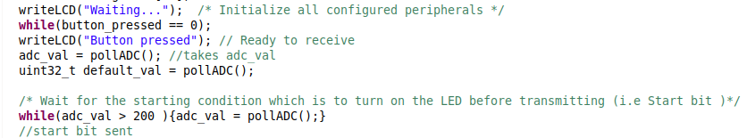

**Snapshot 2:**

1000 is the time the receive and sender takes to transmit or receive one bit of data , you can configure it to a less number I.e 500 if you want fast transmission

* In this snapshot the Variable errorRate indicates the amount of time the the adc value changes in one second
* NOTE : We are not expecting the binary_value to change if we are sending real data , thus this serves as to detect the stoping condition which is to flash the LED in intervals of 100ms for 1s thus if it flashes , see **Snapshot 3**

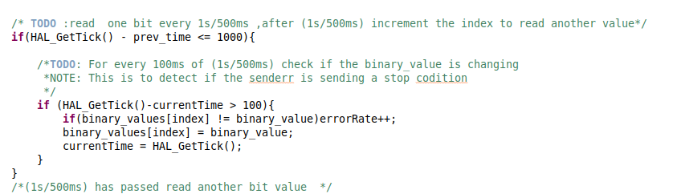

**Snapshot 3 :**

If flashing is detected compare the received counter from the counter we calcuted from the amounts of bits we got

If equal Turn on the LED for 2 seconds and display the decimal values of the received samples

If not Flash the LED for 2 seconds.

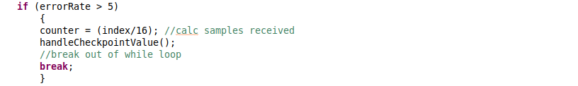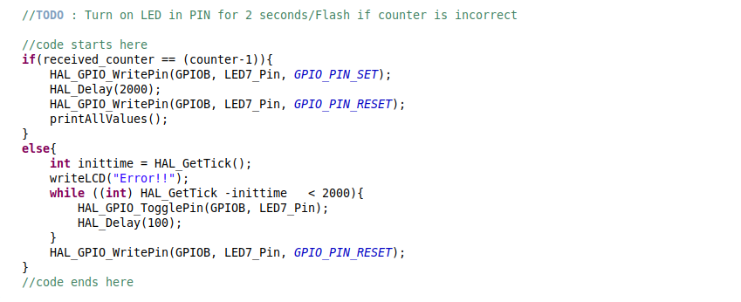

Sender

Screenshot 4

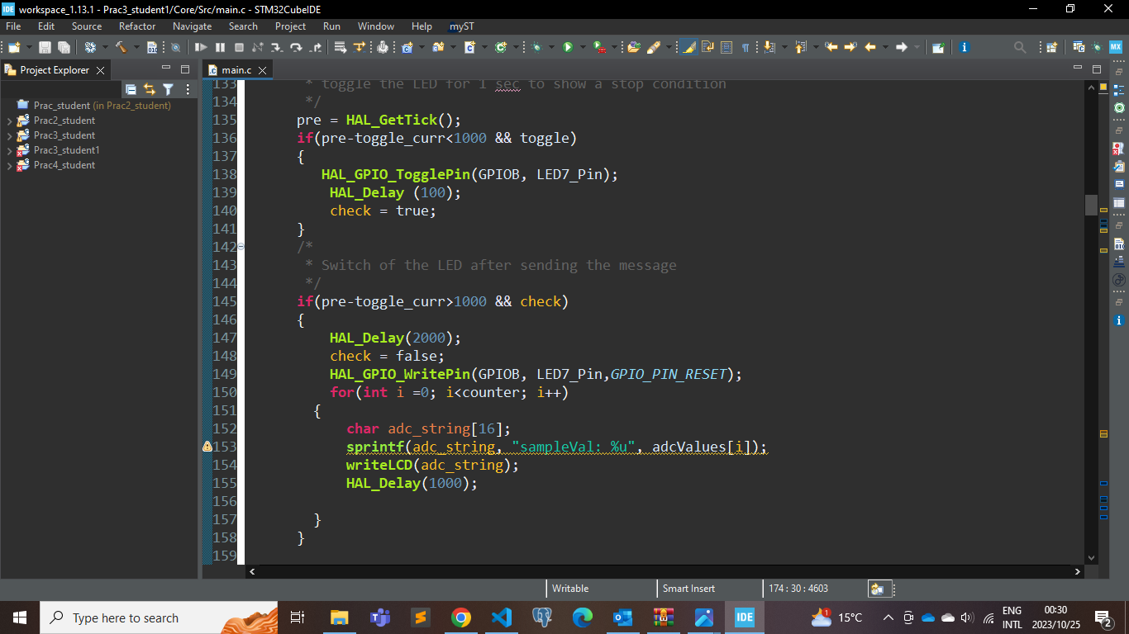

* The second if statement is to make sure the led if off after toggling the led, sending the message.
* For validation we print out all the samples values which will be compared to the receiver