CSS INTRODUCTION:

CSS (cascading style sheets)

Cascading it means applying and deciding priorities of an element when multiple syles applied on the same elemets

Style means visual representation or appearance of an webpage

Sheets means list of style rules together written using seletors in external file

There are mainly three types to apply an style in an element

1.In-line :

Styles are written in inside the element on the opening tag

Example code:

<!DOCTYPE html>

<html lang="en">

<head>

    <meta charset="UTF-8">

    <meta name="viewport" content="width=device-width, initial-scale=1.0">

    <title>Document</title>

</head>

<body>

    <h1  style="color: blueviolet;">CSS INTRODUCTION!!!</h1>

    <p style="color: red;"> CSS IS USED FOR DESSIGING AND STYLING OF WEB PAGES</p>

    <p style="color:green">it controls the look,layout and responsiveness of an webpages,making them adjust to different screen sizes and devices</p>

</body>

</html>

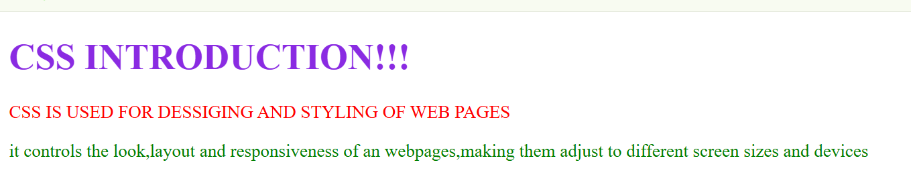

2.internal css:

There are written inside the head section between the style element with mention an tag name

<!DOCTYPE html>

<html lang="en">

<head>

    <meta charset="UTF-8">

    <meta name="viewport" content="width=device-width, initial-scale=1.0">

    <title>Document</title>

    <style>

        h1{

            color: red;

        }

        p{

            color: rgb(82, 15, 252);

        }

        div{

            background-color: pink;

        }

    </style>

</head>

<body>

    <h1>CSS INTRODUCTION!!!</h1>

    <p > CSS IS USED FOR DESSIGING AND STYLING OF WEB PAGES</p>

    <div>

        it controls the look,layout and responsiveness of an webpages,making them adjust to different screen sizes and devices

    </div>

</body>

</html>

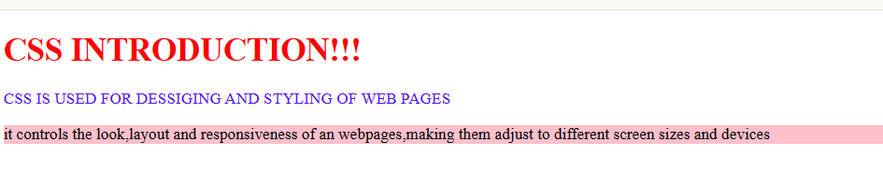

3.extrenal style sheets:

In external css we will create an suparate file for css and we will link it in html file at the head section of an html document by using link element inside head section

Index3.html

<!DOCTYPE html>

<html lang="en">

<head>

    <meta charset="UTF-8">

    <meta name="viewport" content="width=device-width, initial-scale=1.0">

    <title>Document</title>

    <link rel="stylesheet" href="./index31.css">

</head>

<body>

    <h1  >CSS INTRODUCTION!!!</h1>

    <p > CSS IS USED FOR DESSIGING AND STYLING OF WEB PAGES</p>

    <div>it controls the look,layout and responsiveness of an webpages,making them adjust to different screen sizes and devices</div>

</body>

</html>

Index31.css

h1{

            color: orange;

}

p{

    color: brown;

}

div{

    background-color: rgb(203, 193, 210);

}

Output

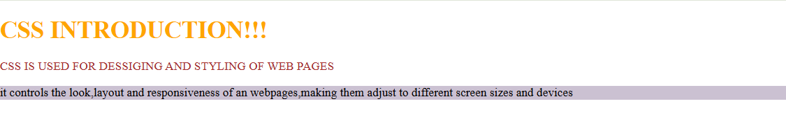

SELECTORS:

A selector is a pattern which is used to select the elements for styling .

Types of selectors:

1.Universal selector:(*)

* {

Color:red;

}

___>selects all the elements and applies same style for everthing

2.type selector:(element name)

P{

Color:red;

}

----🡪 we can select the particular element

3.class selector:

We can give the class name inside the head section of an elements

And we can call the class with . class name

File.css

.highlight {

background-color: yellow;

}

File.html

<p class="highlight">This is highlighted</p>

4.ID selector(#idname):

We can give the id name inside the head section of an elements

And we can call the id with # class name

File.css

#main-title {

color: red;

}

File.html

<h1 id="main-title">Hello</h1>