**Exercise 1: Configuring a Basic Spring Application**

**Step1: pom.xml:**

<project xmlns="http://maven.apache.org/POM/4.0.0" >

<modelVersion>4.0.0</modelVersion>

<groupId>com.library</groupId>

<artifactId>LibraryManagement</artifactId>

<version>1.0-SNAPSHOT</version>

<dependencies>

<!-- Spring Core -->

<dependency>

<groupId>org.springframework</groupId>

<artifactId>spring-context</artifactId>

<version>5.3.31</version> <!-- or the latest 5.x version -->

</dependency>

</dependencies>

</project>

**Step2: applicationContext.xml:**

<?xml version="1.0" encoding="UTF-8"?>

<beans xmlns="http://www.springframework.org/schema/beans"

xmlns:xsi="http://www.w3.org/2001/XMLSchema-instance"

xsi:schemaLocation="

http://www.springframework.org/schema/beans

http://www.springframework.org/schema/beans/spring-beans.xsd">

<bean id="bookRepository" class="com.library.repository.BookRepository" />

<bean id="bookService" class="com.library.service.BookService"/>

</beans>

**Step3:**

**BookService.java:**

package com.library.service;

import com.library.repository.BookRepository;

public class BookService {

private BookRepository bookRepository;

public void setBookRepository(BookRepository bookRepository) {

this.bookRepository = bookRepository;

}

public void addBook(String bookName) {

System.***out***.println("Adding book: " + bookName);

bookRepository.saveBook(bookName);

}

}

**BookRepository.java:**

package com.library.repository;

public class BookRepository {

public void saveBook(String bookName) {

System.***out***.println("Saving book: " + bookName);

}

}

**Step4: MainApp.java:**

package com.library;

import com.library.service.BookService;

import org.springframework.context.ApplicationContext;

import org.springframework.context.support.ClassPathXmlApplicationContext;

public class MainApp {

public static void main(String[] args) {

ApplicationContext context =

new ClassPathXmlApplicationContext("applicationContext.xml");

BookService bookService = (BookService) context.getBean("bookService");

bookService.addBook("Spring Framework Essentials");

}

}

**Output:**

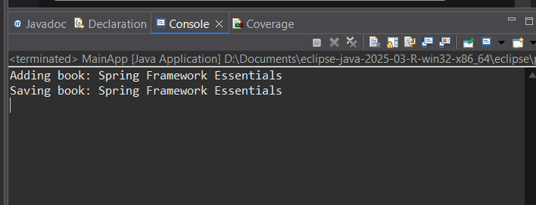

**Exercise 2: Implementing Dependency Injection**

**Step1: applicationContext.xml:**

<?xml version="1.0" encoding="UTF-8"?>

<beans xmlns="http://www.springframework.org/schema/beans"

xmlns:xsi="http://www.w3.org/2001/XMLSchema-instance"

xsi:schemaLocation="http://www.springframework.org/schema/beans

http://www.springframework.org/schema/beans/spring-beans.xsd">

<!-- Bean for BookRepository -->

<bean id="bookRepository" class="com.example.library.repository.BookRepository"/>

<!-- Bean for BookService wiring BookRepository -->

<bean id="bookService" class="com.example.library.service.BookService">

<property name="bookRepository" ref="bookRepository"/>

</bean>

</beans>

**Step2: BookService.java:**

package com.example.library.service;

import com.example.library.repository.BookRepository;

public class BookService {

private BookRepository bookRepository

// Setter for DI

public void setBookRepository(BookRepository bookRepository) {

this.bookRepository = bookRepository;

}

public void addBook(String book) {

System.out.println("BookService: Adding book...");

bookRepository.saveBook(book);

}

}

**Step3:** **BookRepository.java**

package com.example.library.repository;

public class BookRepository {

public void saveBook(String book) {

System.out.println("Saving book: " + book);

}

}

**Step4: LibraryManagementApplication.java:**

package com.example.library;

import com.example.library.service.BookService;

import org.springframework.context.ApplicationContext;

import org.springframework.context.support.ClassPathXmlApplicationContext;

public class LibraryManagementApplication {

public static void main(String[] args) {

ApplicationContext context = new ClassPathXmlApplicationContext("applicationContext.xml");

BookService bookService = (BookService) context.getBean("bookService");

bookService.addBook("Spring in Action");

}

}

**Output:**

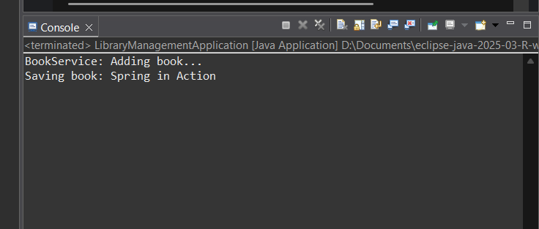

**Exercise 4: Creating and Configuring a Maven Project**

**Step 1: Create a New Maven Project**

Go to File → New → Project…

Select Maven Project → Click Next

Choose Create a simple project (skip archetype selection) → Next

Fill:

* Group Id: com.library
* Artifact Id: LibraryManagement

Click Finish

**Step 2: Add Spring Dependencies in pom.xml & Step 3: Configure Maven Plugins**

<project xmlns="http://maven.apache.org/POM/4.0.0" xmlns:xsi="http://www.w3.org/2001/XMLSchema-instance" xsi:schemaLocation="http://maven.apache.org/POM/4.0.0 https://maven.apache.org/xsd/maven-4.0.0.xsd">

<modelVersion>4.0.0</modelVersion>

<groupId>com.library</groupId>

<artifactId>LibraryManagement</artifactId>

<version>0.0.1-SNAPSHOT</version>

<name>LibraryManagement</name>

<properties>

<project.build.sourceEncoding>UTF-8</project.build.sourceEncoding>

<maven.compiler.source>1.8</maven.compiler.source>

<maven.compiler.target>1.8</maven.compiler.target>

</properties>

<dependencies>

<dependency>

<groupId>org.springframework</groupId>

<artifactId>spring-context</artifactId>

<version>5.3.33</version>

</dependency>

<dependency>

<groupId>org.springframework</groupId>

<artifactId>spring-aop</artifactId>

<version>5.3.33</version>

</dependency>

<dependency>

<groupId>org.springframework</groupId>

<artifactId>spring-webmvc</artifactId>

<version>5.3.33</version>

</dependency>

</dependencies>

<build>

<plugins>

<plugin>

<groupId>org.apache.maven.plugins</groupId>

<artifactId>maven-compiler-plugin</artifactId>

<version>3.8.1</version>

<configuration>

<source>1.8</source>

<target>1.8</target>

</configuration>

</plugin>

</plugins>

</build>

</project>