**Creating Microservices for account and loan**

**Account Microservice:**

**Microservice 1: Account**

**1. Generate Spring Boot Project (Account)**

* Go to: <https://start.spring.io>
* Fill in the details:
  + **Group:** com.cognizant
  + **Artifact:** account
* Add dependencies:
  + Developer Tools > Spring Boot DevTools
  + Web > Spring Web
* Click **Generate**, and download the account.zip.

**2. Extract and Place Project**

* Extract the zip file.
* Move the account folder to:  
  D:\22501A05A0\microservices\account

**3. Build the Project**

* Open **Command Prompt**.
* Run: cd D:\22501A05A0\microservices\account
* mvn clean package

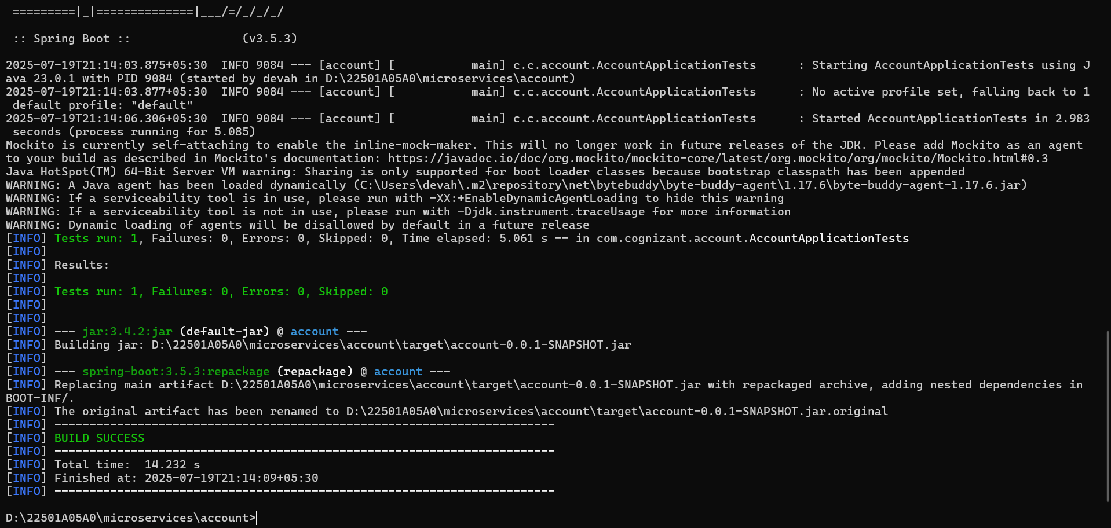

**4. Import into Eclipse**

* Open Eclipse → File → **Import**
  + Select: **Existing Maven Projects**
  + Navigate to: D:\22501A05A0\microservices\account
  + Click **Finish**

**5. Create Account Controller**

Inside Eclipse, in the account project:

**Path:**  
src/main/java/com/cognizant/account/controller/AccountController.java

**AccountController.java**

package com.cognizant.account.controller;

import org.springframework.web.bind.annotation.*;

import java.util.Map;

import java.util.HashMap;

@RestController

@RequestMapping("/accounts")

public class AccountController {

@GetMapping("/{number}")

public Map<String, Object> getAccount(@PathVariable String number) {

Map<String, Object> response = new HashMap<>();

response.put("number", number);

response.put("type", "savings");

response.put("balance", 234343);

return response;

}

}

**AccountApplication.java:**

package com.cognizant.account;

import org.springframework.boot.SpringApplication;

import org.springframework.boot.autoconfigure.SpringBootApplication;

@SpringBootApplication

public class AccountApplication {

public static void main(String[] args) {

SpringApplication.run(AccountApplication.class, args);

}

}

**OUTPUT:**

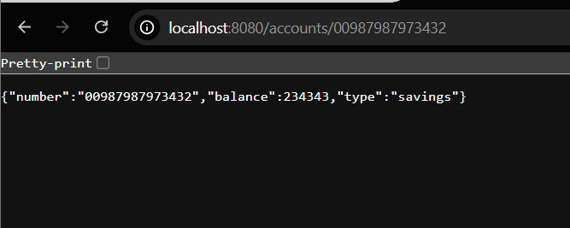

**Microservice 2: Loan**

**1. Generate Spring Boot Project (Loan)**

* Go to: <https://start.spring.io>
* **Fill in the details:**
  + Group: com.cognizant
  + Artifact: loan
* **Add dependencies:**
  + Developer Tools > Spring Boot DevTools
  + Web > Spring Web
* Click Generate, and download the loan.zip.

**2. Extract and Place Project**

* Extract the zip file.
* Move the loan folder to:  
  D:\22501A05A0\microservices\loan

**3. Build the Project**

* Open a new Command Prompt.
* **Run:** cd D:\22501A05A0\microservices\loan
* mvn clean package

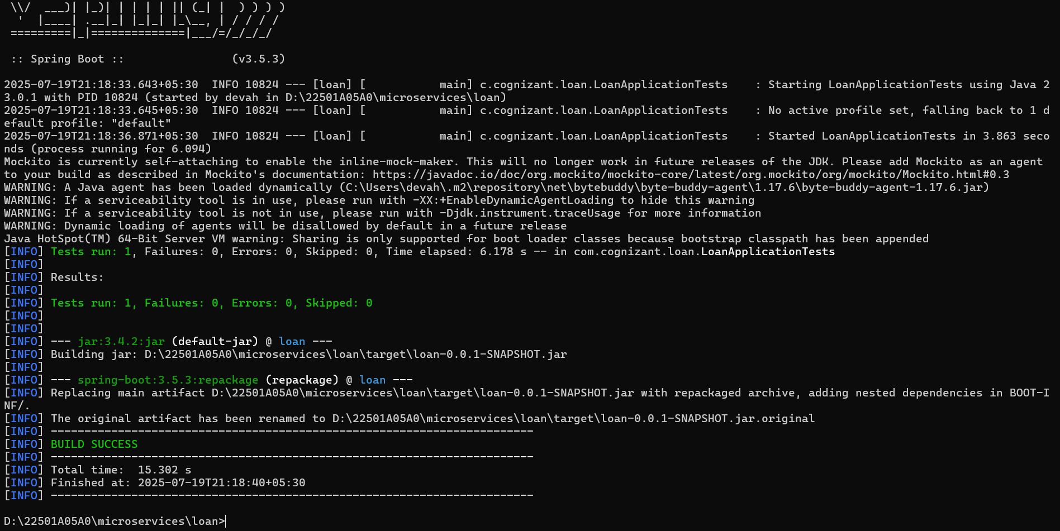

**4. Import into Eclipse**

* File → Import → Existing Maven Projects
* Select folder: D:\22501A05A0\microservices\loan
* Click Finish

**5. Change Port to Avoid Conflict**

**Path:**  
src/main/resources/application.properties

**Add:** server.port=8081

**6. Create Loan Controller**

**Path:**src/main/java/com/cognizant/loan/controller/LoanController.java

**LoanApplication.java:**

package com.cognizant.loan;

import org.springframework.boot.SpringApplication;

import org.springframework.boot.autoconfigure.SpringBootApplication;

@SpringBootApplication

public class LoanApplication {

public static void main(String[] args) {

SpringApplication.run(LoanApplication.class, args);

}

}

**LoanController.java :**

package com.cognizant.loan.controller;

import org.springframework.web.bind.annotation.*;

import java.util.Map;

import java.util.HashMap;

@RestController

@RequestMapping("/loans")

public class LoanController {

@GetMapping("/{number}")

public Map<String, Object> getLoan(@PathVariable String number) {

Map<String, Object> response = new HashMap<>();

response.put("number", number);

response.put("type", "car");

response.put("loan", 400000);

response.put("emi", 3258);

response.put("tenure", 18);

return response;

}

}

**7. Run & Test**

* Run LoanApplication.java class
  + Path: src/main/java/com/cognizant/loan/LoanApplication.java

**OUTPUT:**

