**Exercise-9: “cricketapp” App**

1. Install Nodejs and Npm.

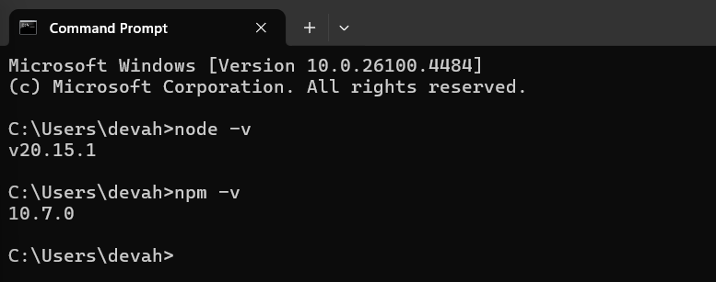

2. Create a React Application with the name of “cricketapp”.Inside my_first_react folder where all compatible requirements for react are already created.

C:\Users\devah\my_first_react>npx create-react-app cricketapp

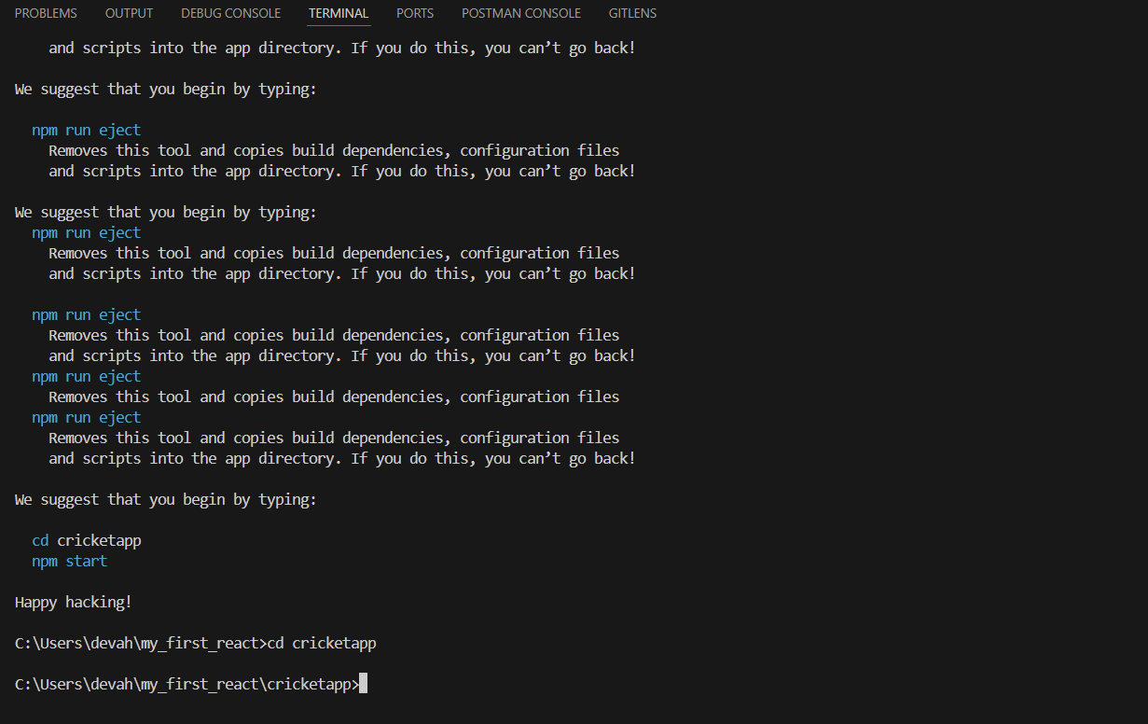

3.create a folder components inside ./src/components and include these files.

**IndianPlayers.js**

import React from "react";

function IndianPlayers() {

  const oddTeam = ["Rohit", "Gill", "KL Rahul"];

  const evenTeam = ["Virat", "SKY", "Jadeja"];

  const [odd1, odd2, odd3] = oddTeam;

  const [even1, even2, even3] = evenTeam;

  const T20players = ["Hardik", "Rishabh", "Bumrah"];

  const RanjiPlayers = ["Pujara", "Ishant", "Saha"];

  const allPlayers = [...T20players, ...RanjiPlayers];

  return (

    <div>

      <h2>Odd Team Players</h2>

      <ul>

        <li>{odd1}</li>

        <li>{odd2}</li>

        <li>{odd3}</li>

      </ul>

      <h2>Even Team Players</h2>

      <ul>

        <li>{even1}</li>

        <li>{even2}</li>

        <li>{even3}</li>

      </ul>

      <h2>All Indian Players (T20 + Ranji)</h2>

      <ul>

        {allPlayers.map((player, index) => (

          <li key={index}>{player}</li>

        ))}

      </ul>

    </div>

  );

}

export default IndianPlayers;

**ListofPlayers.js:**

import React from "react";

function ListofPlayers() {

  const players = [

    { name: "Rohit", score: 85 },

    { name: "Virat", score: 95 },

    { name: "Gill", score: 65 },

    { name: "SKY", score: 70 },

    { name: "KL Rahul", score: 55 },

    { name: "Jadeja", score: 45 },

    { name: "Hardik", score: 90 },

    { name: "Ashwin", score: 72 },

    { name: "Bumrah", score: 60 },

    { name: "Shami", score: 88 },

    { name: "Siraj", score: 50 }

  ];

  const filteredPlayers = players.filter(player => player.score < 70);

  return (

    <div>

      <h2>All Players</h2>

      <ul>

        {players.map((player, index) => (

          <li key={index}>{player.name} - {player.score}</li>

        ))}

      </ul>

      <h2>Players with Score Below 70</h2>

      <ul>

        {filteredPlayers.map((player, index) => (

          <li key={index}>{player.name} - {player.score}</li>

        ))}

      </ul>

    </div>

  );

}

export default ListofPlayers;

**App.js:**

import React from "react";

import ListofPlayers from "./components/ListofPlayers";

import IndianPlayers from "./components/IndianPlayers";

function App() {

const flag = true; // Change to false to test alternate component

return (

<div className="App">

<h1>🏏 Cricket App Dashboard</h1>

{flag ? <ListofPlayers /> : <IndianPlayers />}

</div>

);

}

export default App;

**App.css:**

.App {

  text-align: center;

  font-family: 'Segoe UI', Tahoma, Geneva, Verdana, sans-serif;

  background-color: #f7f9fc;

  min-height: 100vh;

  padding: 20px;

}

h1 {

  color: #2e3c55;

  margin-bottom: 30px;

}

h2 {

  color: #1f6feb;

  margin-top: 20px;

  margin-bottom: 10px;

}

ul {

  list-style-type: none;

  padding: 0;

}

li {

  background-color: #ffffff;

  border: 1px solid #dcdcdc;

  border-radius: 8px;

  margin: 8px auto;

  padding: 10px;

  max-width: 400px;

  font-size: 16px;

  color: #333333;

  transition: transform 0.2s ease;

}

li:hover {

  transform: scale(1.03);

  background-color: #f0f8ff;

}

**OUTPUT:**

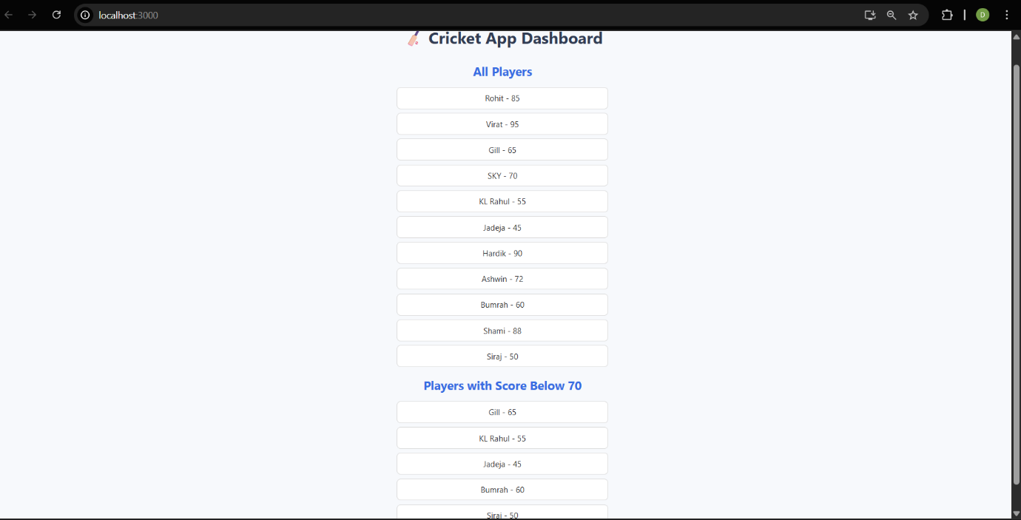

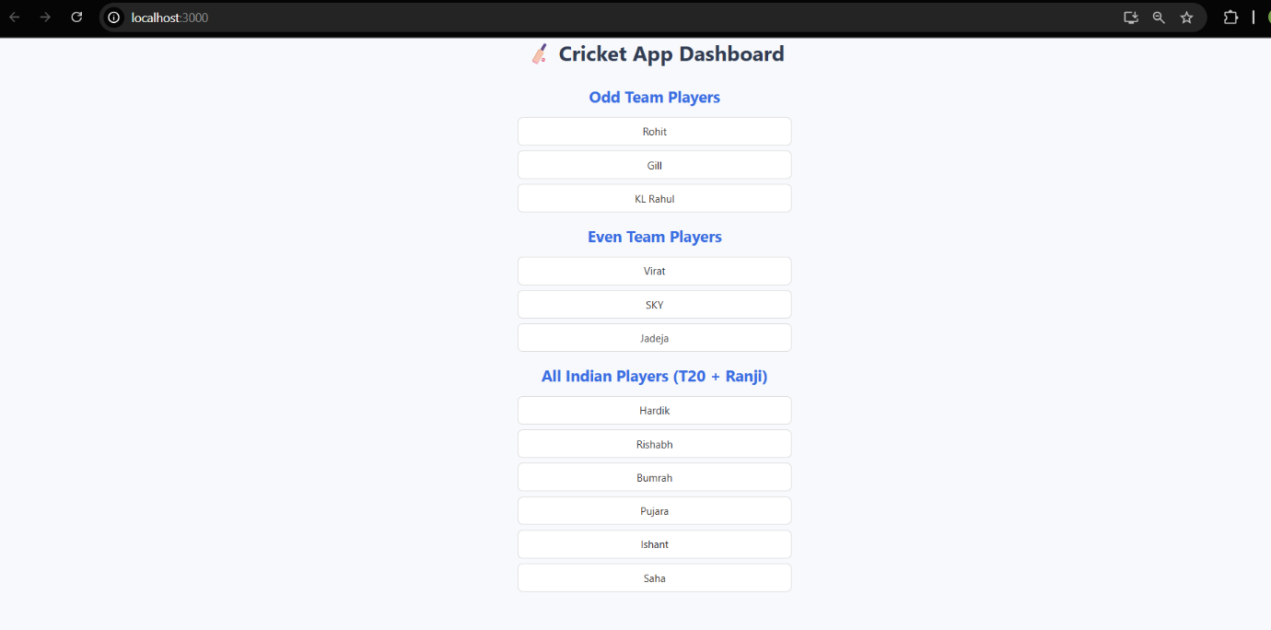

**Exercise-10: “officespacerentalapp” App**

1. Create a React Application with the name of “officespacerentalapp”.Inside my_first_react folder where all compatible requirements for react are already created.

C:\Users\devah\my_first_react>npx create-react-app officespacerentalapp

Creating a new React app in C:\Users\devah\my_first_react\officespacerentalapp.

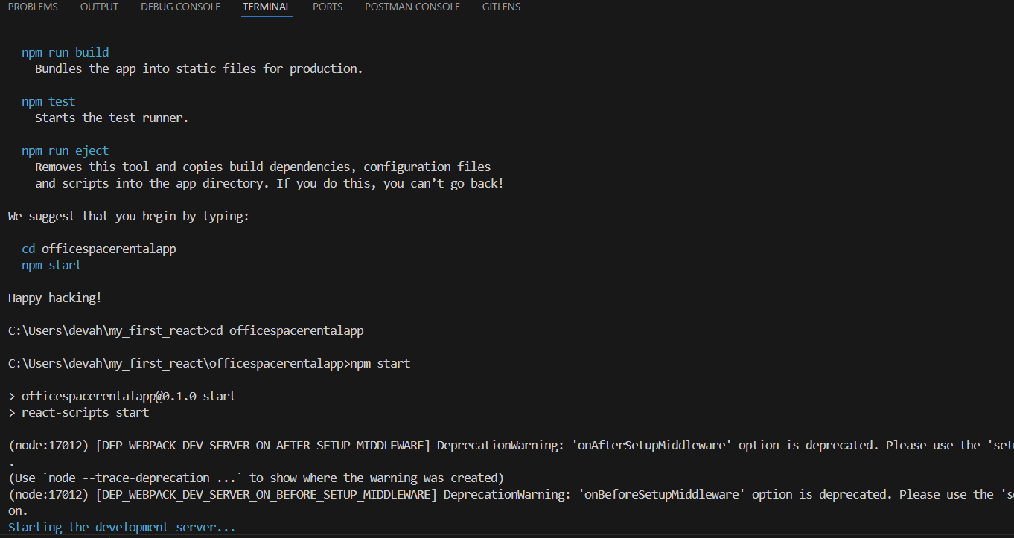

2. create a folder components inside ./src/components and include these files.

**OfficeList.js:**

import React from "react";

import lab1 from "./lab1.jpg";

import lab2 from "./lab2.jpg";

import lab3 from "./lab3.jpg";

function OfficeList() {

  const officeSpaces = [

    {

      name: "Cozy Corner",

      rent: 45000,

      address: "MG Road, Bengaluru",

      image: lab1

    },

    {

      name: "Skyview Workspaces",

      rent: 72000,

      address: "Cyber City, Gurugram",

      image: lab2

    },

    {

      name: "EcoSpace",

      rent: 58000,

      address: "HITEC City, Hyderabad",

      image: lab3

    }

  ];

  const heading = <h2>🏢 Available Office Spaces</h2>;

  return (

    <div>

      {heading}

      {officeSpaces.map((office, index) => {

        const rentStyle = {

          color: office.rent < 60000 ? "red" : "green",

          fontWeight: "bold"

        };

        return (

          <div

            key={index}

            style={{

              marginBottom: "20px",

              padding: "10px",

              border: "1px solid #ccc",

              backgroundColor: "#fff",

              borderRadius: "8px"

            }}>

            <img

              src={office.image}

              alt={office.name}

              style={{ width: "250px", height: "150px", borderRadius: "6px" }}

            />

            <h3>{office.name}</h3>

            <p><strong>Address:</strong> {office.address}</p>

            <p style={rentStyle}><strong>Rent:</strong> ₹{office.rent}</p>

          </div>

        );

      })}

    </div>

  );

}

export default OfficeList;

**App.js:**

import React from "react";

import OfficeList from "./components/OfficeList";

import "./App.css";

function App() {

return (

<div className="App">

<h1>Office Space Rental App</h1>

<OfficeList />

</div>

);

}

export default App;

**App.css:**

.App {

text-align: center;

padding: 20px;

font-family: 'Segoe UI', Tahoma, Geneva, Verdana, sans-serif;

background-color: #f2f2f2;

}

h1 {

color: #2c3e50;

margin-bottom: 30px;

}

3.Run “**npm start**” inside the folder “**officespacerentalapp**”

**OUTPUT:**  
  
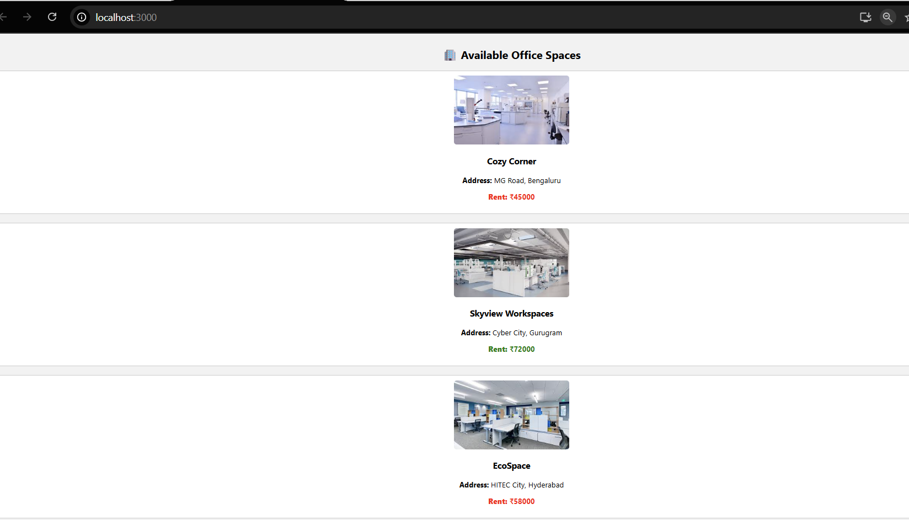

**Exercise-11: “eventexamplesapp” App**

1. Create a React Application with the name of “eventexamplesapp”.Inside my_first_react folder where all compatible requirements for react are already created.

C:\Users\devah\my_first_react>npx create-react-app eventexamplesapp

Creating a new React app in C:\Users\devah\my_first_react\eventexamplesapp

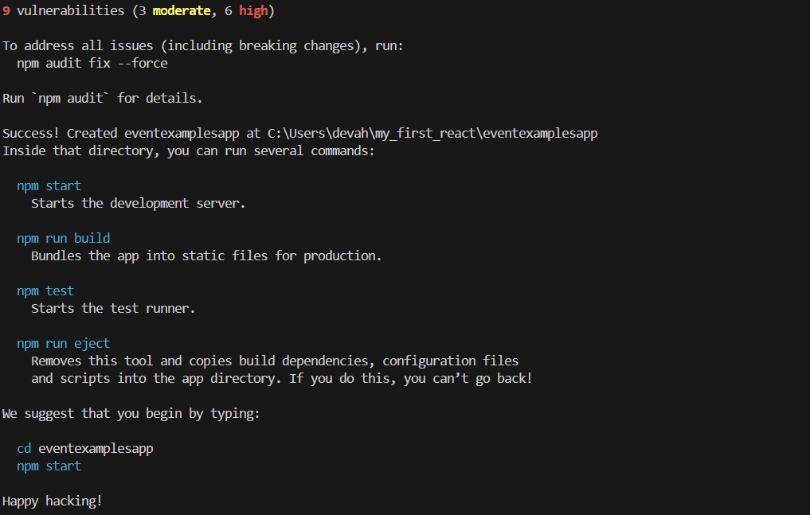

2. create a folder components inside ./src/components and include these files.

**Counter.js:**

import React, { Component } from "react";

class Counter extends Component {

  constructor() {

    super();

    this.state = { count: 0 };

    this.increment = this.increment.bind(this);

    this.sayHello = this.sayHello.bind(this);

  }

  increment() {

    this.setState({ count: this.state.count + 1 });

    this.sayHello();

  }

  decrement = () => {

    this.setState({ count: this.state.count - 1 });

  };

  sayHello() {

    alert("Hello! Value has been increased.");

  }

  render() {

    return (

      <div className="counter-box">

        <h2 className="counter-value">Counter: {this.state.count}</h2>

        <div>

          <button className="counter-button" onClick={this.increment}>Increment</button>

        </div>

        <div>

          <button className="counter-button" onClick={this.decrement}>Decrement</button>

        </div>

      </div>

    );

  }

}

export default Counter;

**CurrencyConvertor.js:**

import React, { useState } from "react";

function CurrencyConvertor() {

  const [amount, setAmount] = useState("");

  const [currency, setCurrency] = useState("Euro");

  const handleSubmit = (e) => {

    e.preventDefault();

    if (!amount || isNaN(amount)) {

      alert("Please enter a valid amount");

      return;

    }

    const convertedAmount = parseFloat(amount) * 80; // ₹80 = 1 Euro (example rate)

    alert(`Converting to ${currency} Amount is ${convertedAmount}`);

  };

  return (

    <div className="component-box">

      <h2 style={{ color: "green" }}>Currency Convertor!!!</h2>

      <form onSubmit={handleSubmit}>

        <div style={{ marginBottom: "10px" }}>

          <label>Amount: </label>

          <input

            type="text"

            value={amount}

            onChange={(e) => setAmount(e.target.value)}

          />

        </div>

        <div style={{ marginBottom: "10px" }}>

          <label>Currency: </label>

          <select

            value={currency}

            onChange={(e) => setCurrency(e.target.value)}

          >

            <option value="Euro">Euro</option>

            {/* Add more currencies if needed */}

          </select>

        </div>

        <button type="submit">Submit</button>

      </form>

    </div>

  );

}

export default CurrencyConvertor;

**SyntheticEventExample.js:**  
import React from "react";

function SyntheticEventExample() {

  function handleClick(event) {

    alert("I was clicked (Synthetic Event)!");

    console.log(event); // synthetic event details

  }

  return (

    <div style={{ marginTop: "20px" }}>

      <button onClick={handleClick}>Click Me</button>

    </div>

  );

}

export default SyntheticEventExample;

**WelcomeButton.js:**

import React from "react";

function WelcomeButton() {

  function showMessage(message) {

    alert(`Message: ${message}`);

  }

  return (

    <div style={{ marginTop: "20px" }}>

      <button onClick={() => showMessage("Welcome")}>Say Welcome</button>

    </div>

  );

}

export default WelcomeButton;

**App.js:**

import React from "react";

import Counter from "./components/Counter";

import WelcomeButton from "./components/WelcomeButton";

import SyntheticEventExample from "./components/SyntheticEventExample";

import CurrencyConvertor from "./components/CurrencyConvertor";

import './App.css';

function App() {

  return (

    <div className="App" style={{ padding: "20px", fontFamily: "sans-serif" }}>

      <h1>Event Handling Examples in React</h1>

      <Counter />

      <WelcomeButton />

      <SyntheticEventExample />

      <CurrencyConvertor />

    </div>

  );

}

export default App;

**App.css:**

/* General App Layout */

.App {

  font-family: 'Segoe UI', Tahoma, Geneva, Verdana, sans-serif;

  padding: 30px 60px;

  background-color: #f4f6f8;

  min-height: 100vh;

  text-align: left; /* Align all text to left */

}

/* Headings */

h1 {

  color: #2c3e50;

  margin-bottom: 40px;

}

h2 {

  color: #007bff;

  margin-top: 30px;

  margin-bottom: 20px;

}

/* Shared Button Styles */

button {

  padding: 10px 20px;

  margin: 10px 10px 10px 0;

  font-size: 16px;

  background-color: #007bff;

  color: white;

  border: none;

  border-radius: 5px;

  cursor: pointer;

  transition: background-color 0.2s ease;

}

button:hover {

  background-color: #0056b3;

}

input[type="number"],

input[type="text"] {

  padding: 8px;

  font-size: 16px;

  margin-right: 10px;

  border: 1px solid #ccc;

  border-radius: 4px;

}

/* Component Containers */

.component-box {

  background-color: white;

  padding: 20px;

  margin: 20px 0;

  max-width: 600px;

  border-radius: 10px;

  box-shadow: 0 2px 8px rgba(0, 0, 0, 0.1);

}  
  
3.Run “**npm start**” inside the folder “**eventexamplesapp**”

**OUTPUTS:**

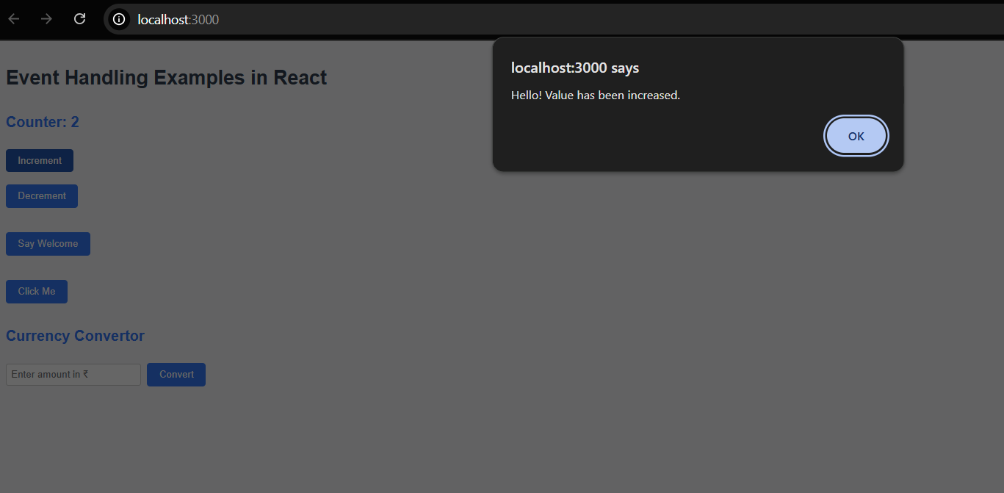

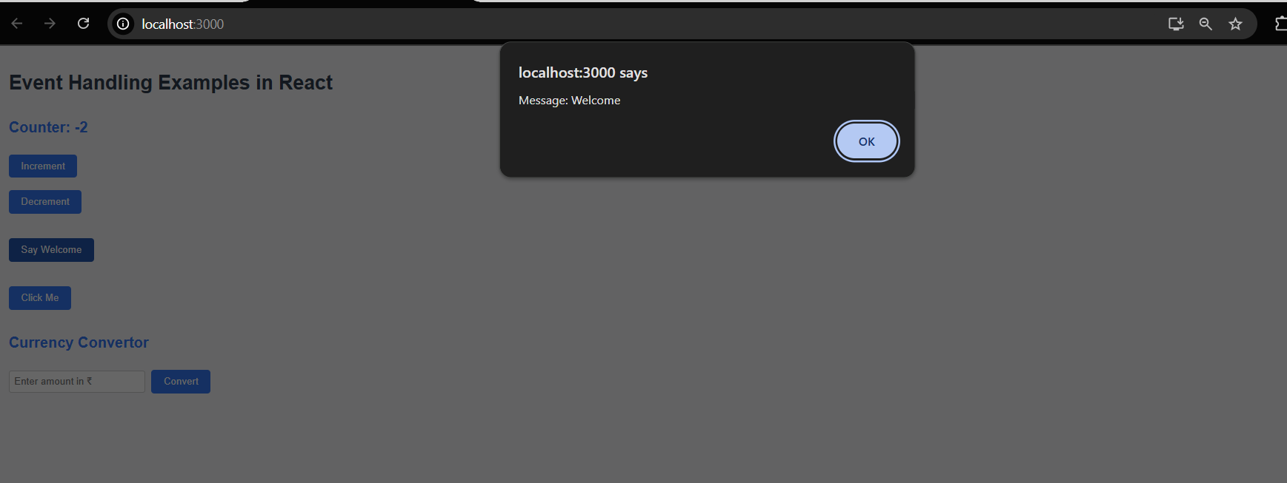

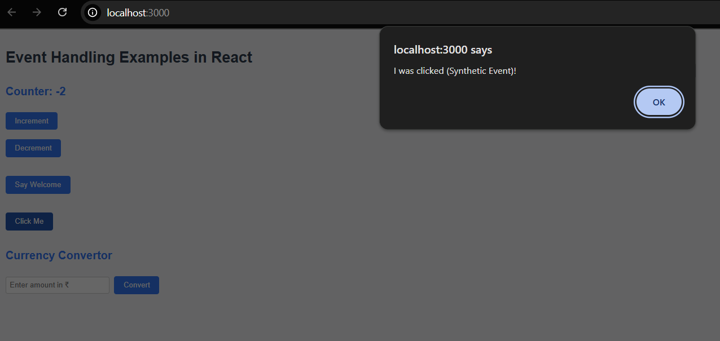

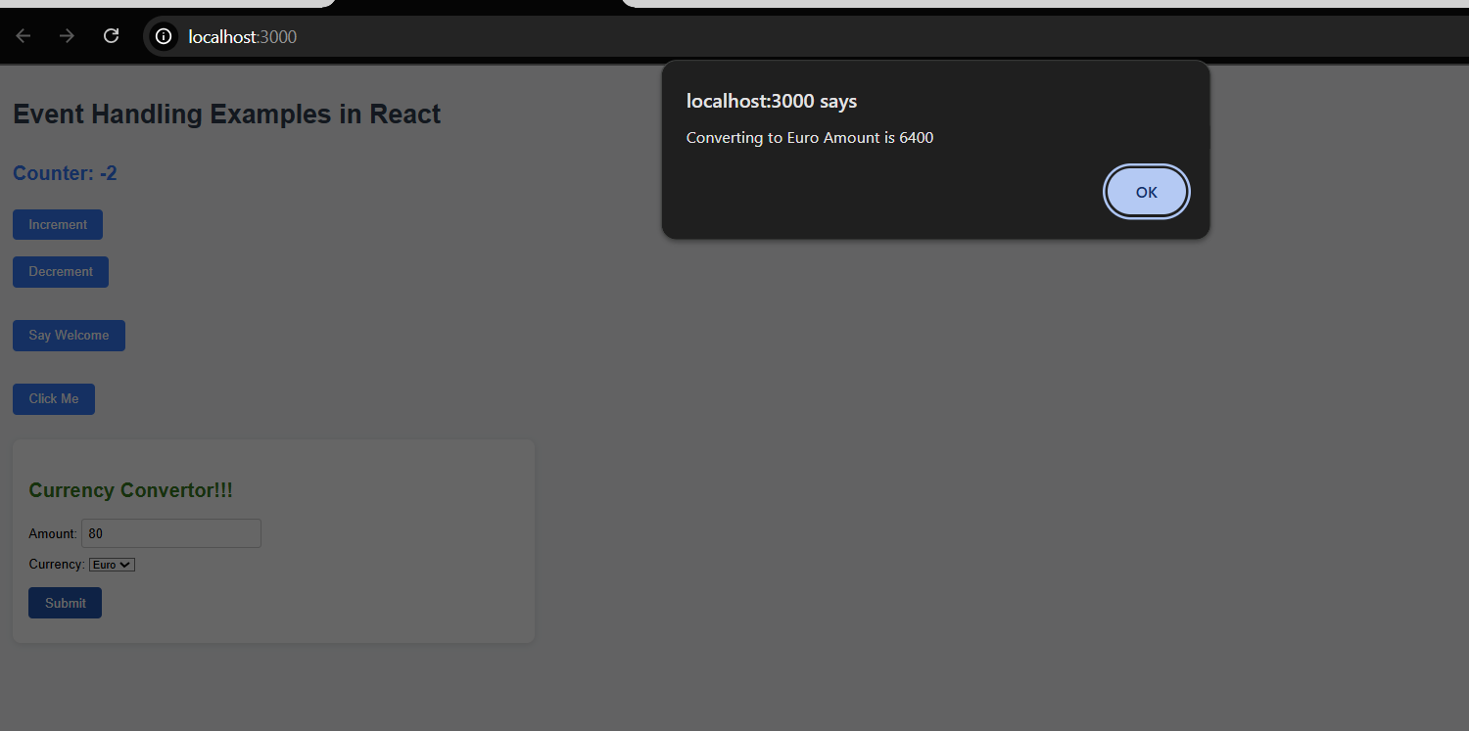

**Exercise-12: “ticketbookingapp” App**

1. Create a React Application with the name of “ticketbookingapp”.Inside my_first_react folder where all compatible requirements for react are already created.

C:\Users\devah\my_first_react>npx create-react-app ticketbookingapp

Creating a new React app in C:\Users\devah\my_first_react\ticketbookingapp

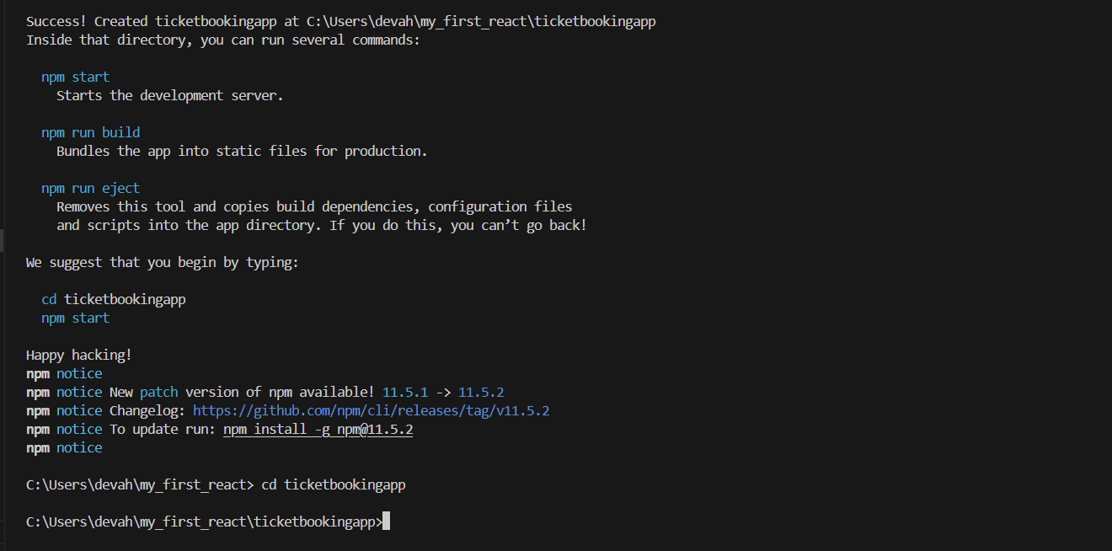

2. create a folder components inside ./src/components and include these files.

**Guest.js:**import React from 'react';

function Guest() {

return (

<div className="component-box">

<h2>Welcome, Guest!</h2>

<p>Browse available flights below:</p>

<ul>

<li>✈️ Flight A – 10:00 AM</li>

<li>✈️ Flight B – 02:30 PM</li>

<li>✈️ Flight C – 09:15 PM</li>

</ul>

</div>

);

}

export default Guest;  
  
**User.js:**

import React from 'react';

function User() {

return (

<div className="component-box">

<h2>Welcome, User!</h2>

<p>You can now book your tickets.</p>

<button>Book Now</button>

</div>

);

}

export default User;

**Header.js:**

import React from 'react';

function Header({ isLoggedIn, onToggle }) {

return (

<div className="header">

<h1>Ticket Booking Portal</h1>

<button onClick={onToggle}>

{isLoggedIn ? 'Logout' : 'Login'}

</button>

</div>

);

}

export default Header;

**App.js:**

import React, { useState } from 'react';

import './App.css';

import Guest from './components/Guest';

import User from './components/User';

import Header from './components/Header';

function App() {

const [isLoggedIn, setIsLoggedIn] = useState(false);

const toggleLogin = () => setIsLoggedIn(!isLoggedIn);

let content;

if (isLoggedIn) {

content = <User />;

} else {

content = <Guest />;

}

return (

<div className="App">

<Header isLoggedIn={isLoggedIn} onToggle={toggleLogin} />

{content}

</div>

);

}

export default App;

**App.css:**.App {

padding: 30px 60px;

font-family: Arial, sans-serif;

background-color: #f4f4f4;

min-height: 100vh;

text-align: left;

}

.header {

display: flex;

justify-content: space-between;

align-items: center;

background-color: #007bff;

padding: 15px 20px;

color: white;

border-radius: 5px;

}

.header button {

background-color: white;

color: #007bff;

padding: 8px 14px;

font-weight: bold;

border: none;

border-radius: 5px;

cursor: pointer;

}

.component-box {

margin-top: 30px;

padding: 20px;

background-color: white;

border-radius: 10px;

box-shadow: 0 0 6px rgba(0,0,0,0.1);

}

3.Run “**npm start**” inside the folder “**ticketbookingapp**”

**OUTPUTS:  
  
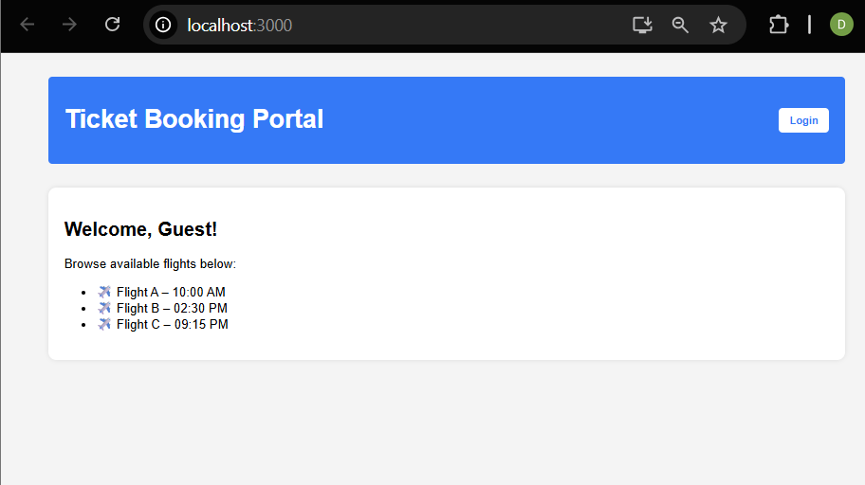**

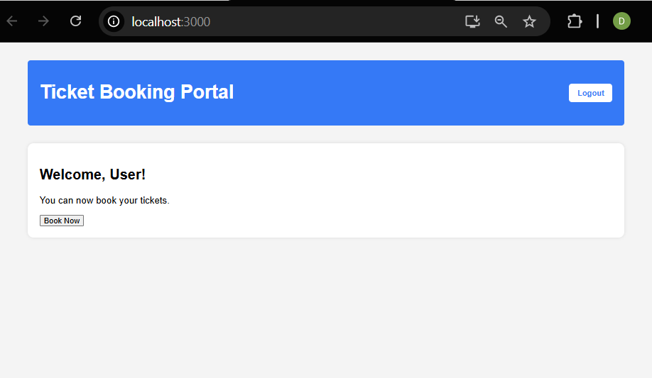

**Exercise-13: “bloggerapp_1” App**

1. Create a React Application with the name of “bloggerapp_1”.Inside my_first_react folder where all compatible requirements for react are already created.

C:\Users\devah\my_first_react>npx create-react-app “bloggerapp_1”

Creating a new React app in C:\Users\devah\my_first_react\bloggerapp_1

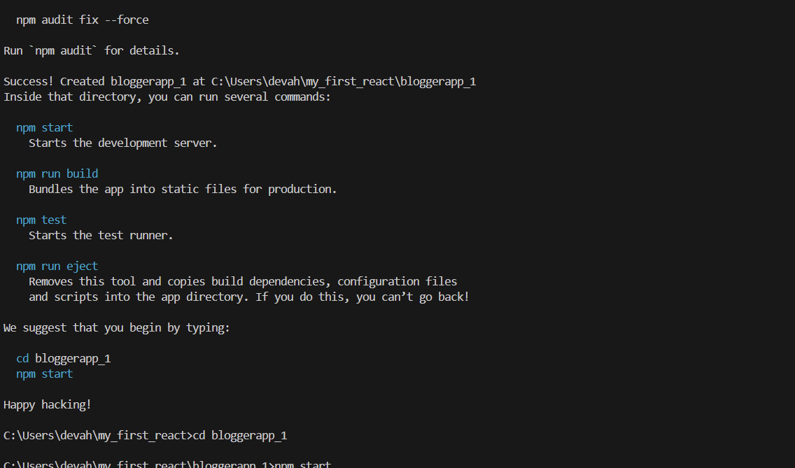2. create a folder components inside ./src/components and include these files.

**ItemCard.js:**

import React from 'react';

function ItemCard({ title, description }) {

return (

<div className="item-card">

<h4>{title}</h4>

<p>{description}</p>

</div>

);

}

export default ItemCard;  
 **BookDetails.js:**

import React from 'react';

import ItemCard from './ItemCard';

function BookDetails({ show }) {

if (!show) return null;

const books = [

{ id: 1, title: "React Explained", description: "Complete React guide." },

{ id: 2, title: "JS Deep Dive", description: "Modern JavaScript essentials." }

];

return (

<div>

<h3>📚 Book Details</h3>

{books.map(book => (

<ItemCard key={book.id} title={book.title} description={book.description} />

))}

</div>

);

}

export default BookDetails;

**BlogDetails.js:**

import React from 'react';

import ItemCard from './ItemCard';

function BlogDetails({ show }) {

const blogs = [

{ id: 1, title: "Why React Rocks", description: "JSX, VDOM & more." },

{ id: 2, title: "Conditional Rendering", description: "Ways to render components." }

];

return show ? (

<div>

<h3>📝 Blog Details</h3>

{blogs.map(blog => (

<ItemCard key={blog.id} title={blog.title} description={blog.description} />

))}

</div>

) : null;

}

export default BlogDetails;  
  
**CourseDetails.js:**import React from 'react';

import ItemCard from './ItemCard';

function CourseDetails({ show }) {

const courses = [

{ id: 1, title: "React Bootcamp", description: "Beginner to Advanced." },

{ id: 2, title: "Fullstack Dev", description: "React + Node + DBs." }

];

return (

show && (

<div>

<h3>🎓 Course Details</h3>

{courses.map(course => (

<ItemCard key={course.id} title={course.title} description={course.description} />

))}

</div>

)

);

}

export default CourseDetails;

**App.js:**

import React, { useState } from 'react';

import './App.css';

import BookDetails from './components/BookDetails';

import BlogDetails from './components/BlogDetails';

import CourseDetails from './components/CourseDetails';

function App() {

  const [showBooks, setShowBooks] = useState(true);

  const [showBlogs, setShowBlogs] = useState(true);

  const [showCourses, setShowCourses] = useState(true);

  return (

    <div className="App">

      <h1>BloggerApp 📘</h1>

      <div className="toggles">

        <button onClick={() => setShowBooks(!showBooks)}>

          {showBooks ? "Hide" : "Show"} Books

        </button>

        <button onClick={() => setShowBlogs(!showBlogs)}>

          {showBlogs ? "Hide" : "Show"} Blogs

        </button>

        <button onClick={() => setShowCourses(!showCourses)}>

          {showCourses ? "Hide" : "Show"} Courses

        </button>

      </div>

      {/* Flex container for your details components */}

      <div className="details-container">

        <BookDetails show={showBooks} />

        <BlogDetails show={showBlogs} />

        <CourseDetails show={showCourses} />

      </div>

    </div>

  );

}

export default App;

**App.css:**

.App {

  padding: 30px 60px;

  font-family: 'Segoe UI', sans-serif;

  background-color: #f8f9fa;

  text-align: left;

  min-height: 100vh;

}

.toggles button {

  margin-right: 10px;

  padding: 10px 15px;

  font-weight: bold;

  background-color: #007bff;

  color: white;

  border: none;

  border-radius: 6px;

  cursor: pointer;

}

.item-card {

  background-color: white;

  padding: 15px 20px;

  margin: 15px 0;

  border-radius: 8px;

  box-shadow: 0 1px 4px rgba(0,0,0,0.1);

}

h1 {

  color: #333;

  margin-bottom: 20px;

}

h3 {

  margin-top: 30px;

  color: #0056b3;

}

.details-container {

  display: flex;

  gap: 24px;            /* Spacing between columns */

  justify-content: center; /* Horizontally center the columns */

  align-items: flex-start; /* Align items to the top */

  margin-top: 24px;

}

.details-container > * {

  flex: 1 1 0;

  min-width: 280px;      background: #fff;

     border-radius: 8px;

     box-shadow: 0 2px 8px #181717;

}

3.Run “**npm start**” inside the folder “**bloggerapp_1**”

**OUTPUT:**

