Lakshit Tyagi
Terraform
DEVOPS | Assignment
Objective: Deploy a Flask backend and an Express frontend on AWS using Terraform, across three configurations — single EC2, separate EC2 instances, and Docker containers via ECR/ECS/VPC.
Part 1: Deploy Both Flask and Express on a Single EC2 Instance.
Objective: Deploy both the Flask backend and the Express frontend on a single EC2 instance using Terraform.
- Provision the EC2 instance with Terraform.
- Configure the instance with: a user-data script or a configuration management tool (e.g., Ansible or Cloud-Init) to install dependencies (Python, Node.js), plus scripts to start the Flask backend and the Express frontend.
- Ensure both applications run on different ports (e.g., Flask on port 5000 and Express on port 3000).
Expected Deliverables
- Terraform configuration files (main.tf, variables.tf, etc.).
- A working EC2 instance with Flask and Express running and accessible via the instance's public IP.
Created a Task1 folder and a Backend & Frontend folder with application files.
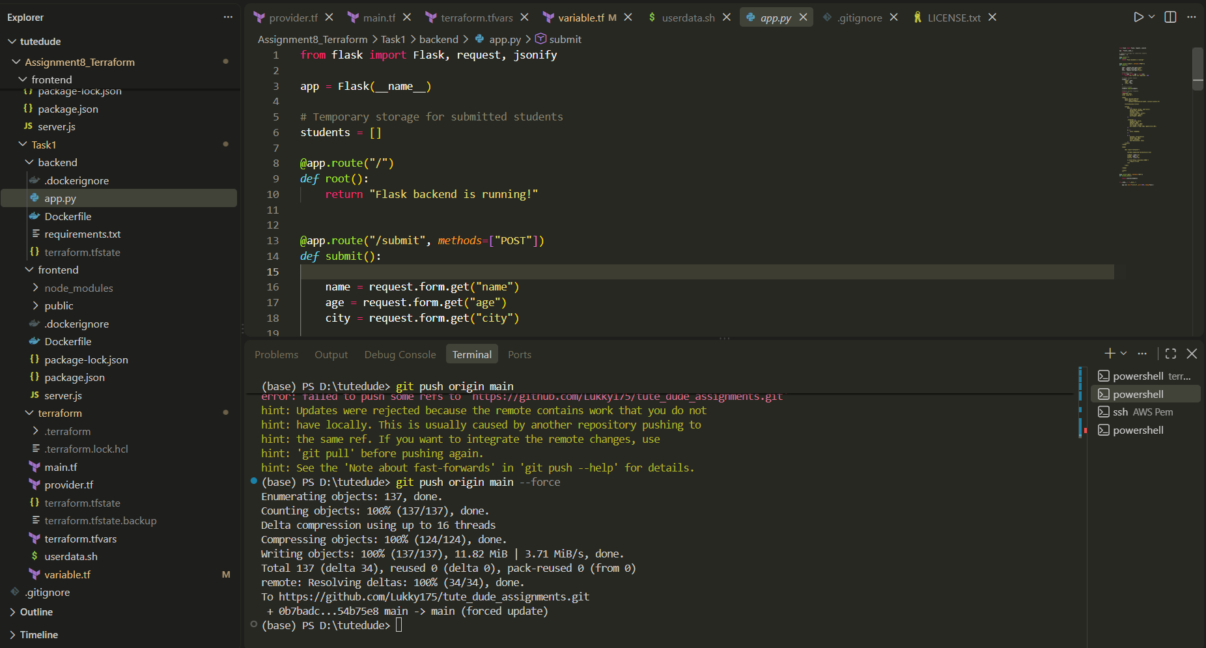

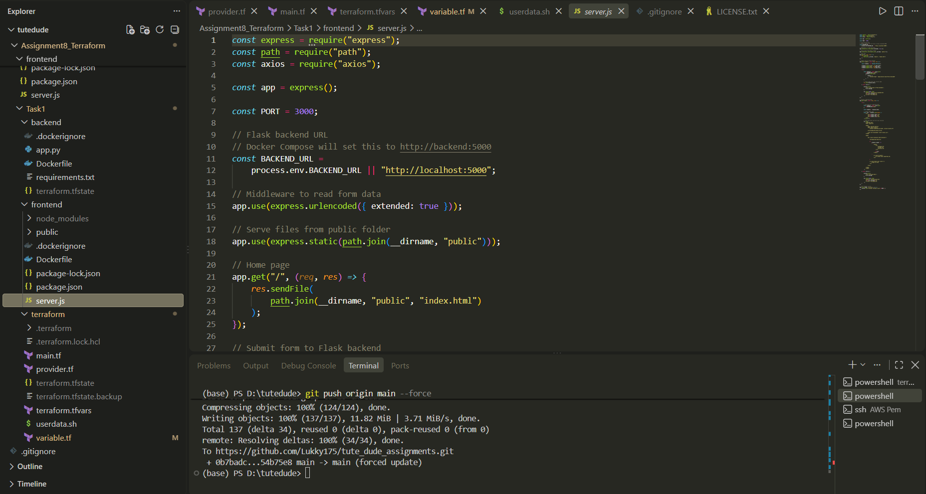
Created a Terraform folder with provider.tf and did terraform init (To initialize backend)
Created main.tf, variable.tf, terraform.tfvars & Userdata.sh. Also variablized everything in main.tf.
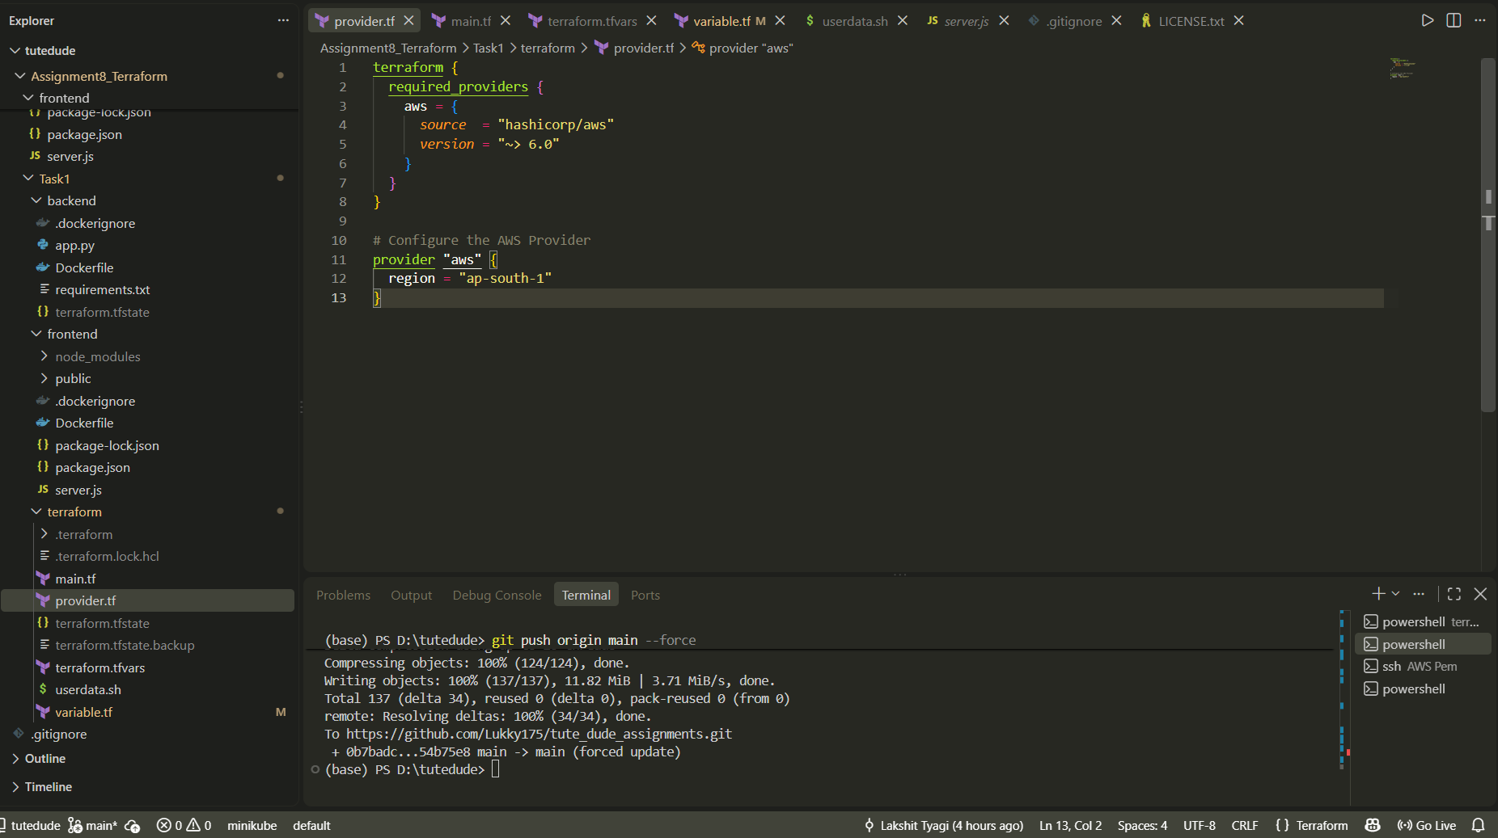
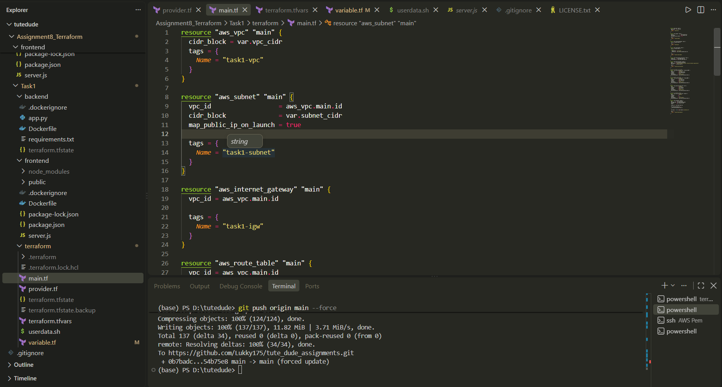
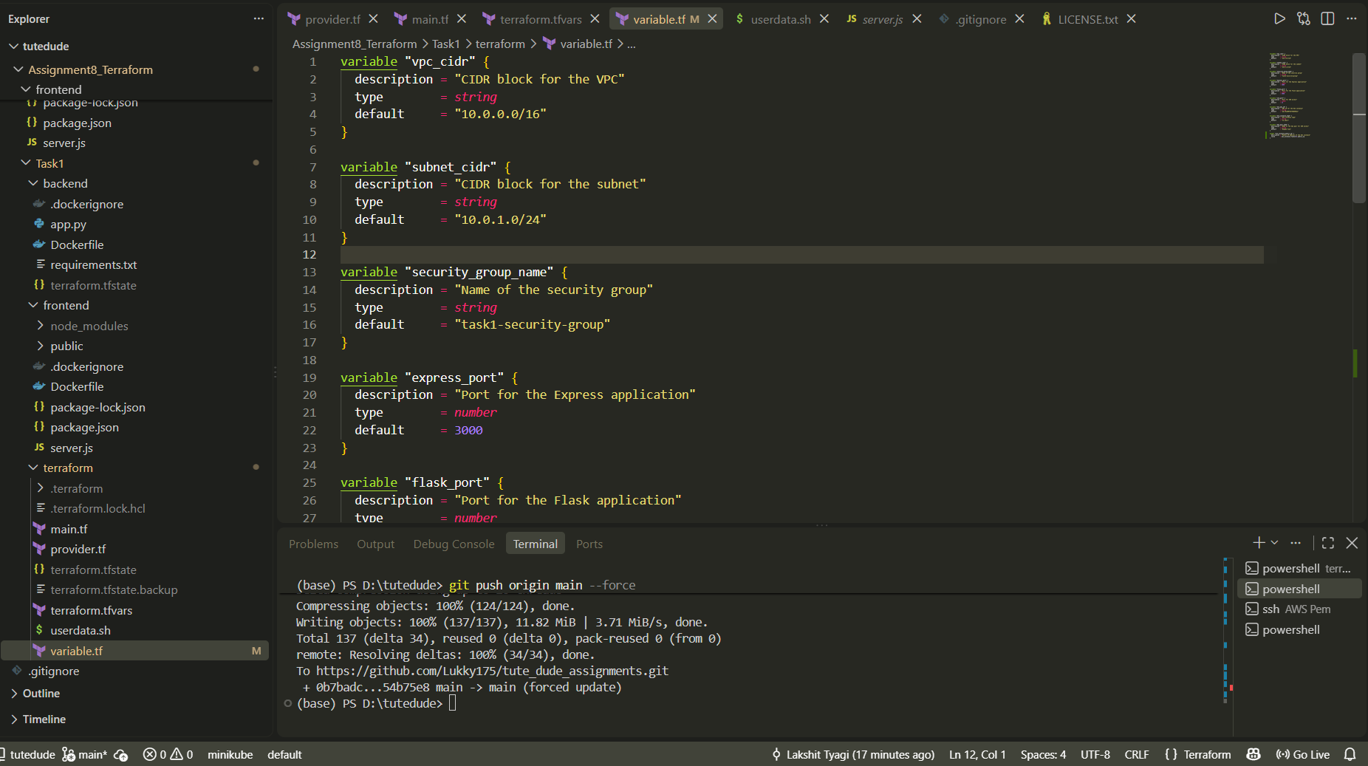
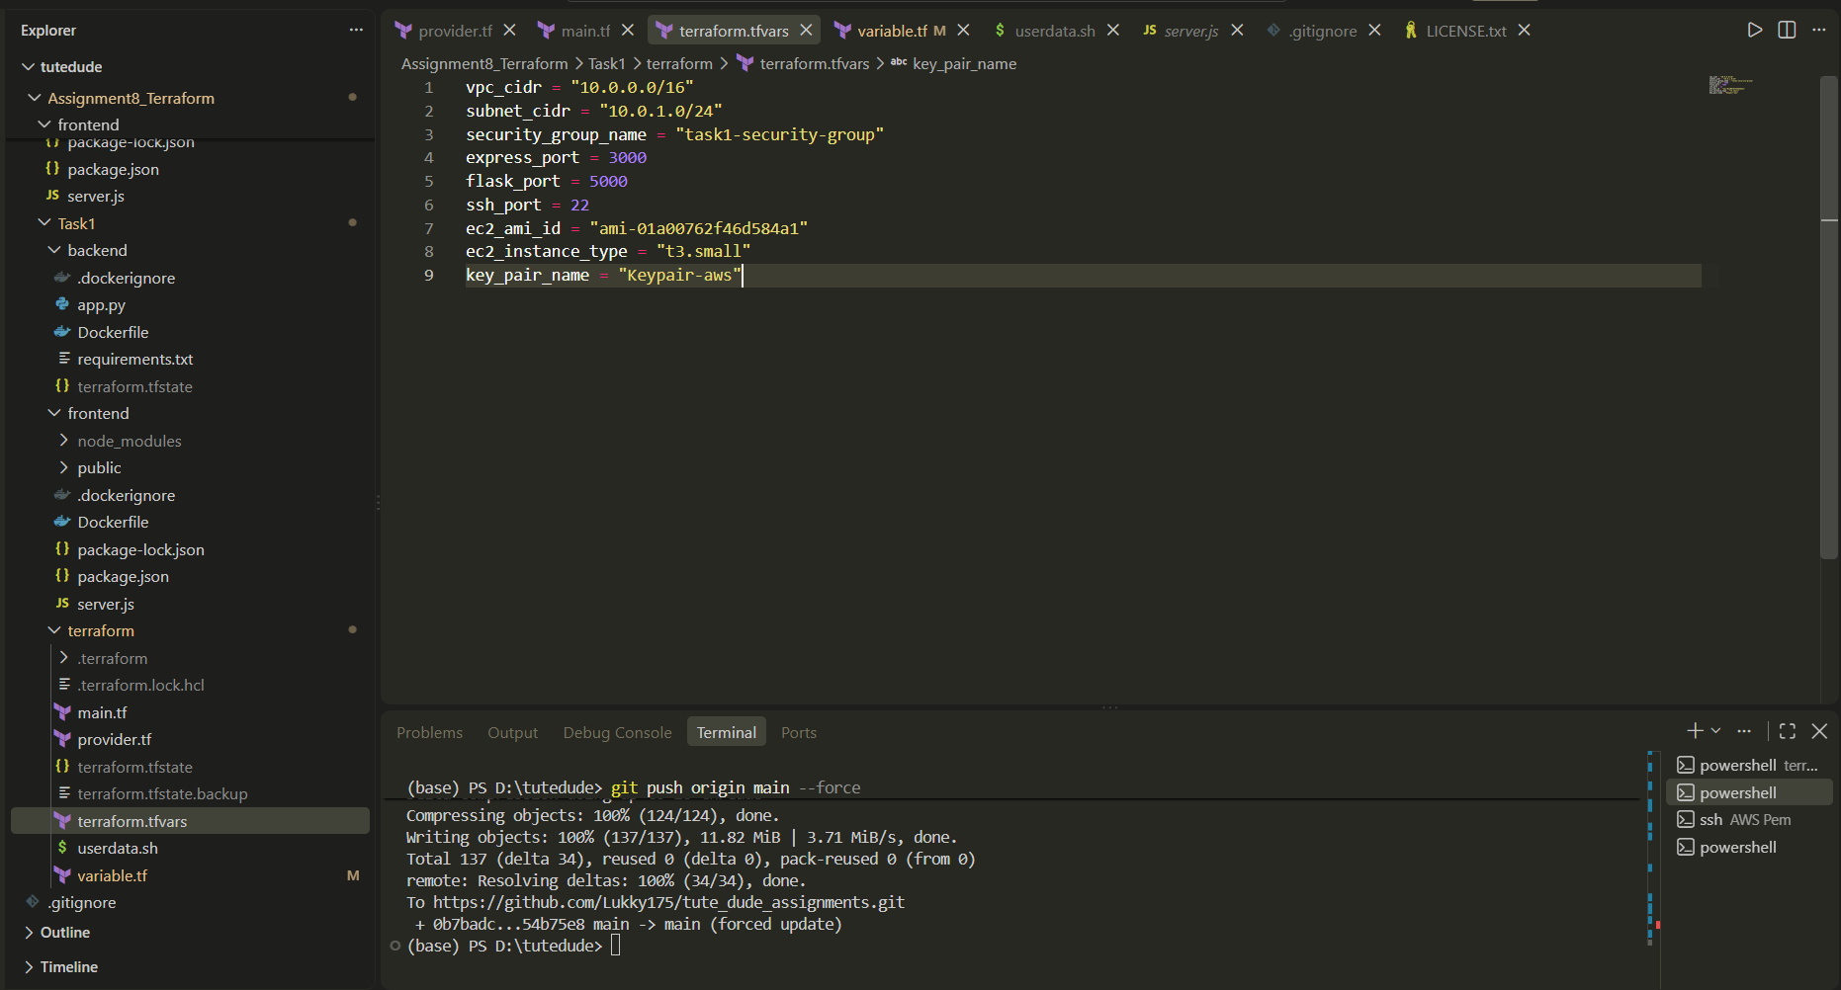
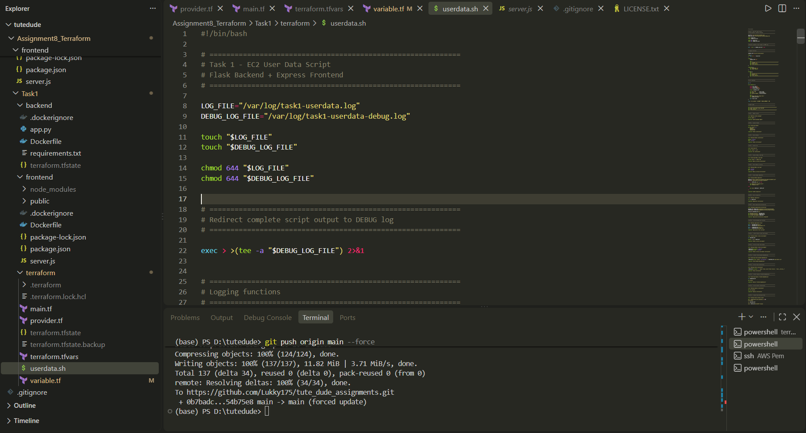

Did `terraform apply -auto-approve`
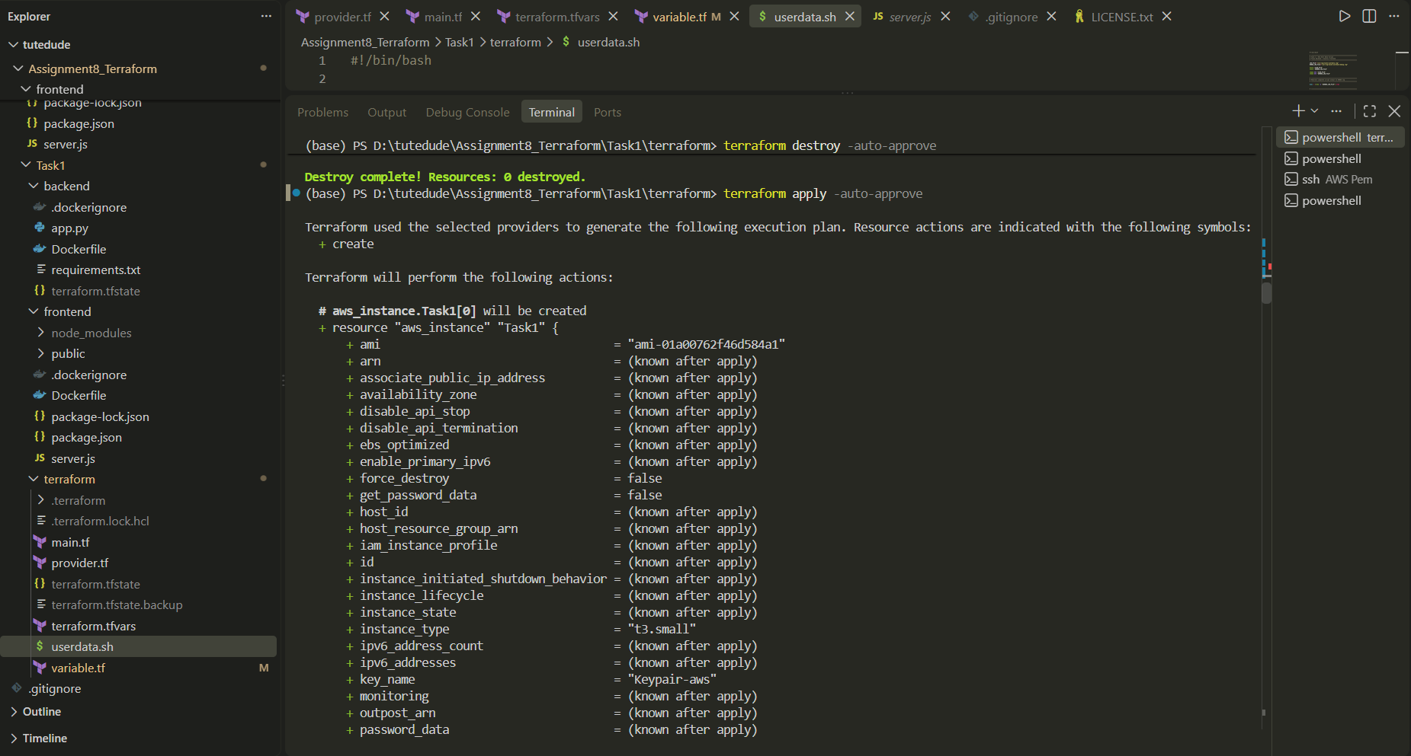
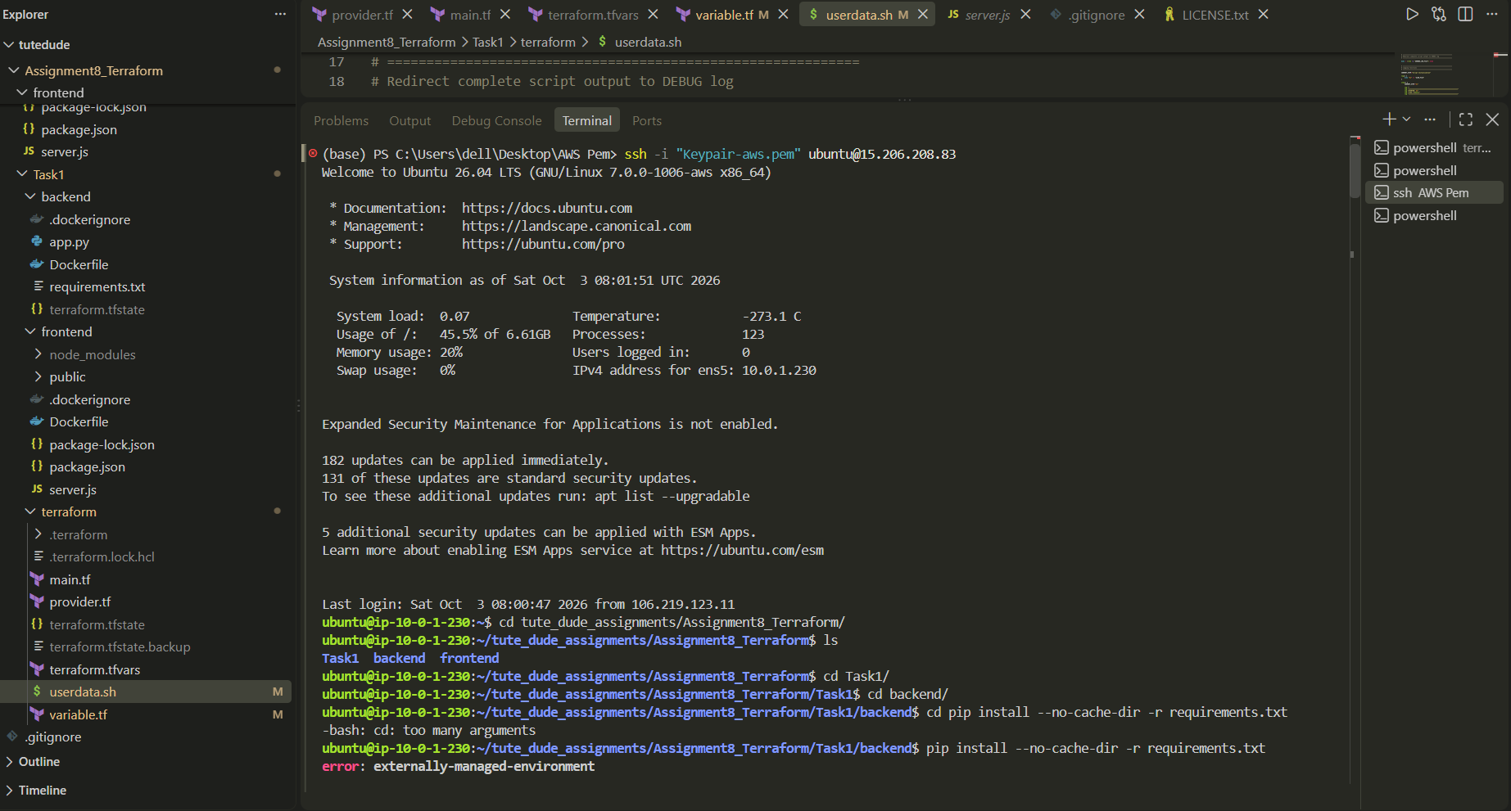

Express endpoint -> http://13.205.15.158:3000/
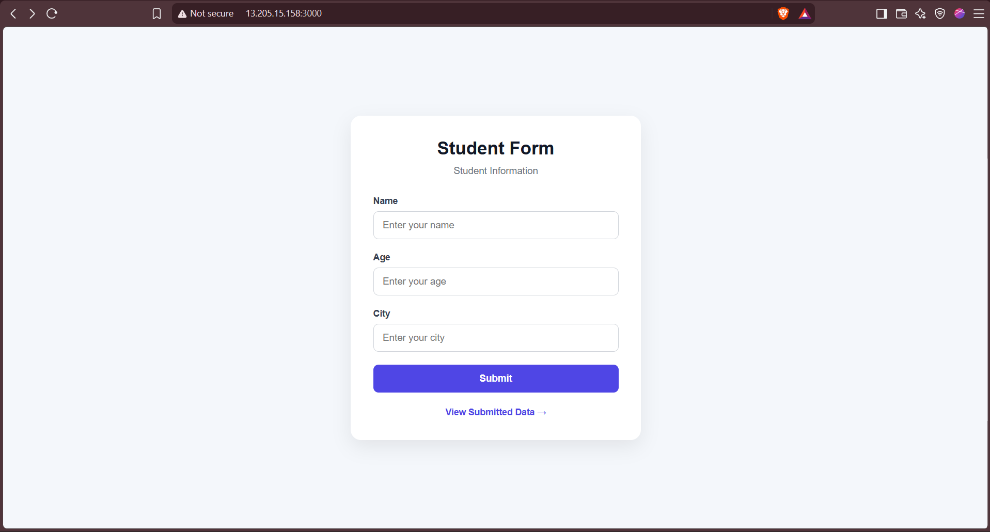
Flask Endpoint - > http://13.205.15.158:5000/
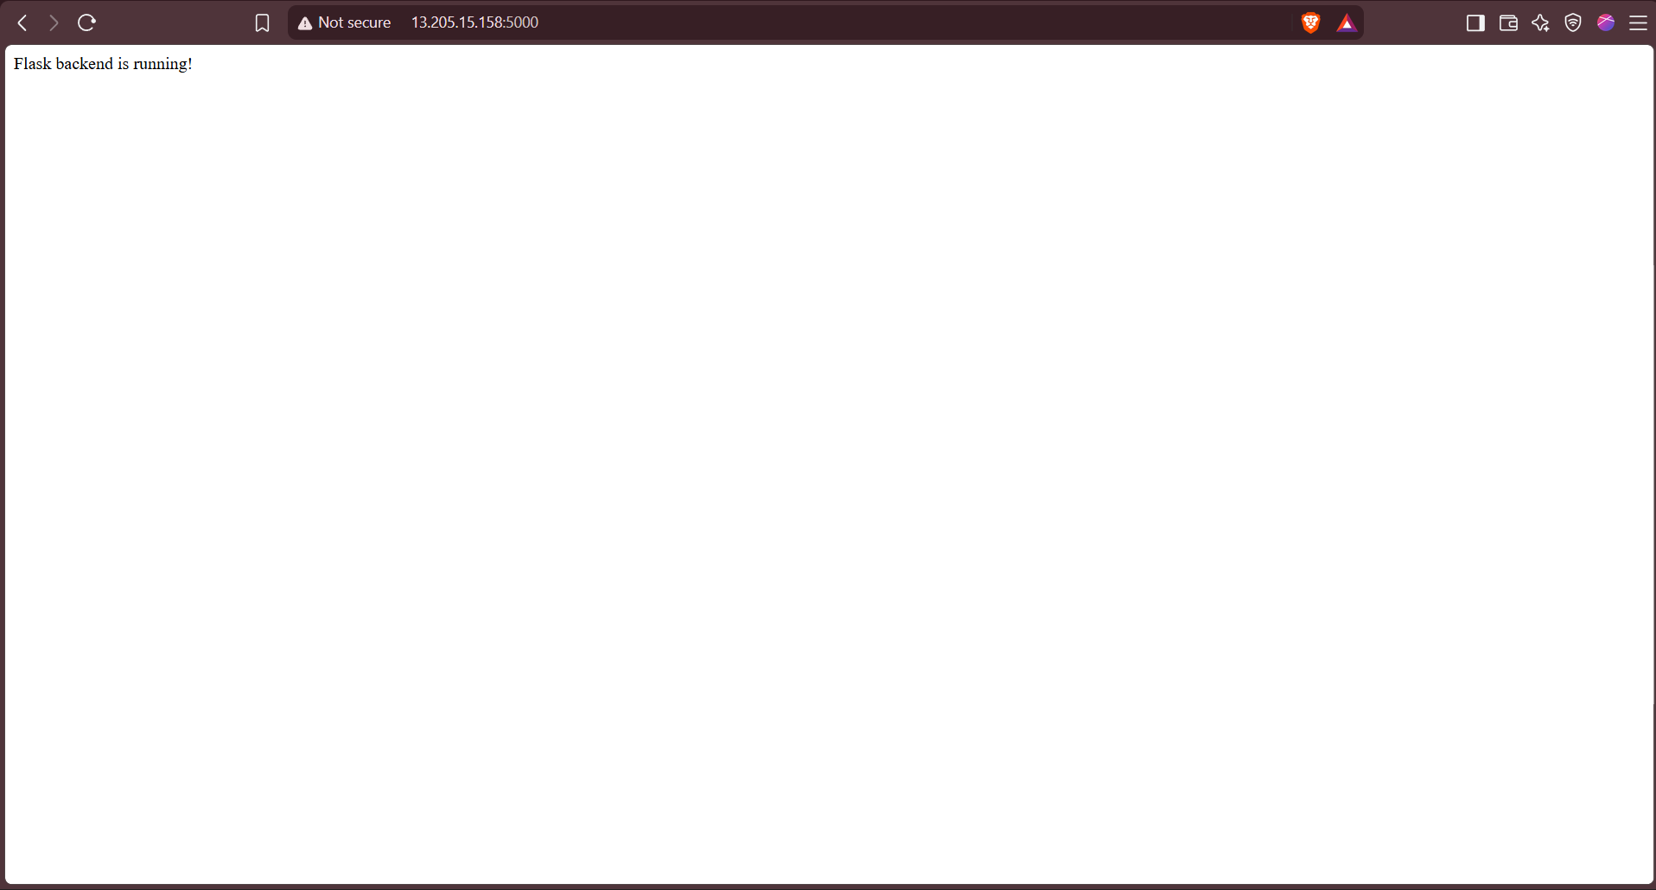
Part1 Completed with all of the deliverables & Everything mentioned.

Part 2: Deploy Flask and Express on Separate EC2 Instances
Objective: Deploy the Flask backend and the Express frontend on two separate EC2 instances using Terraform.
- Provision two EC2 instances using Terraform: one for the Flask backend and one for the Express frontend.
- Configure security groups to: allow communication between the two instances and expose both applications to the internet on their respective ports.
- Configuration: Use Terraform to define networking resources such as VPC, subnets, and security groups. Use user-data scripts to automate installation and startup of both applications.
Expected Deliverables
- Terraform configuration files.
- Two working EC2 instances: one running Flask and one running Express.
- Security groups configured to allow proper communication and public access.
Made Task2 folder, and added Frontend and backend folders with application code.
Created terraform folder in Task2 folder and created provider.tf, main.tf, variables.tf, terraform.tfvars, output.tf, userdata_express.sh and userdata_flask.sh.
Did `terraform init`
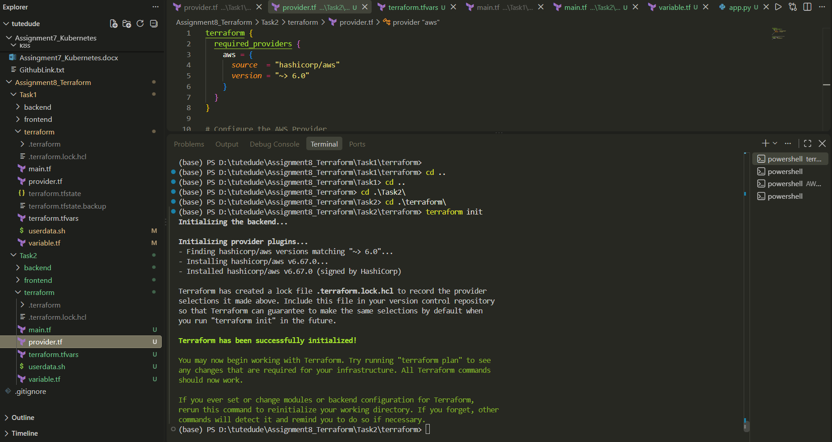

Pushing app code and terraform code (EC2 will pull the Repo)
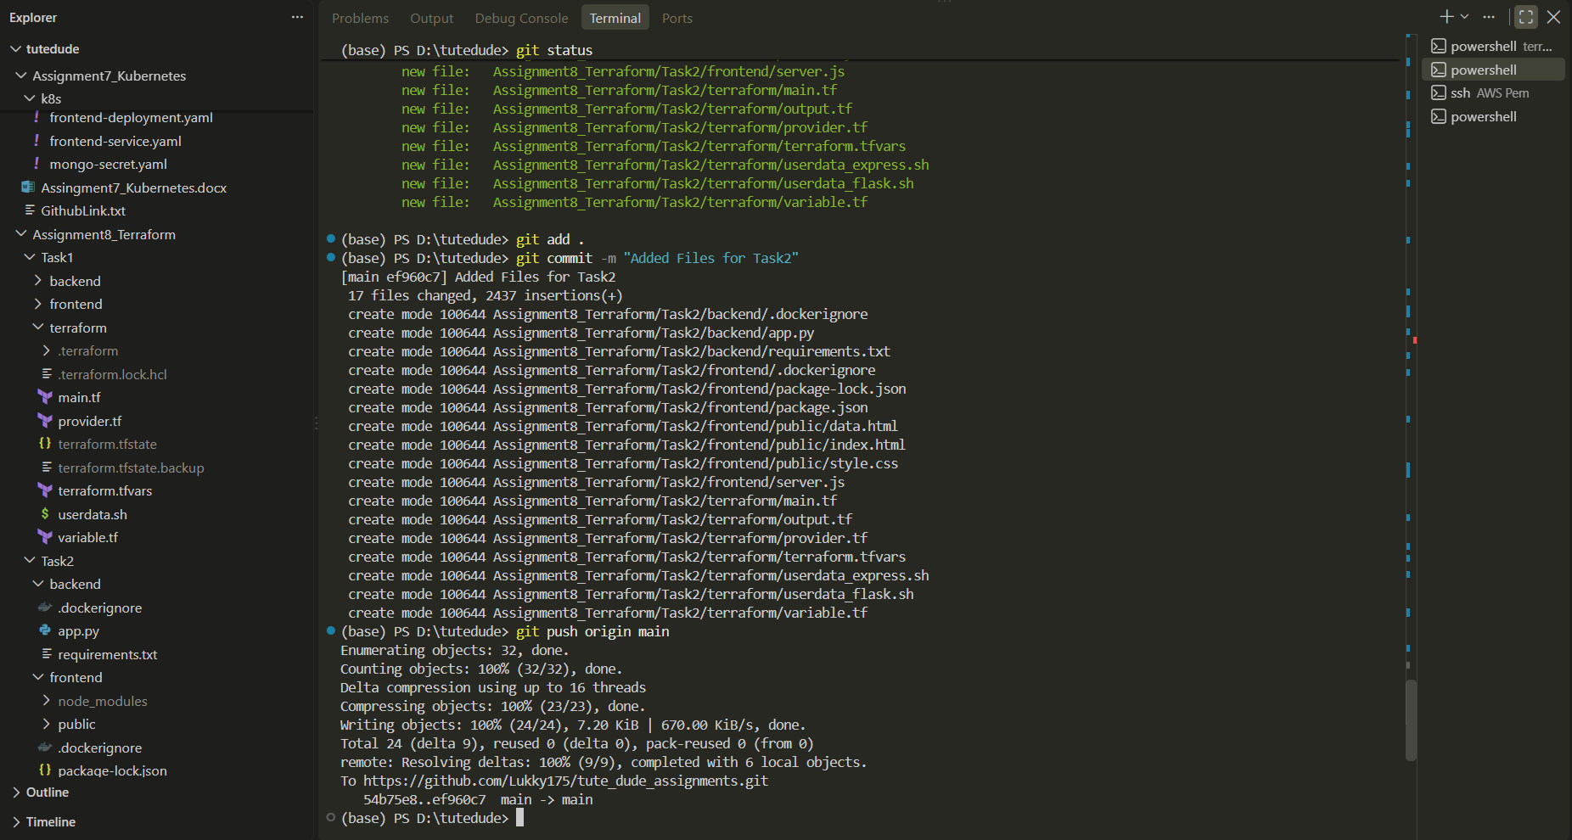
Did `terraform apply`
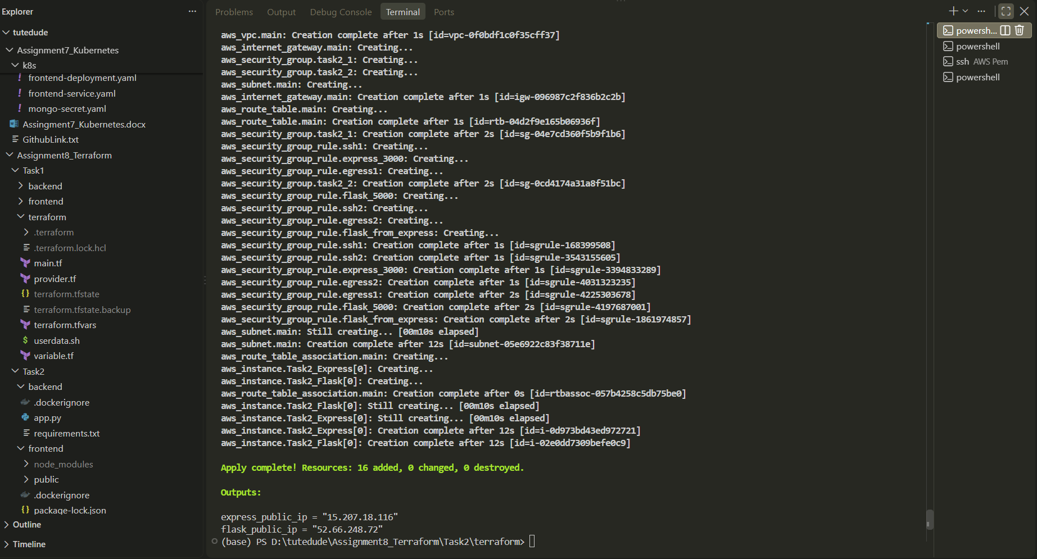

Did ssh in express ec2 instance (To updated backend url in server.js)
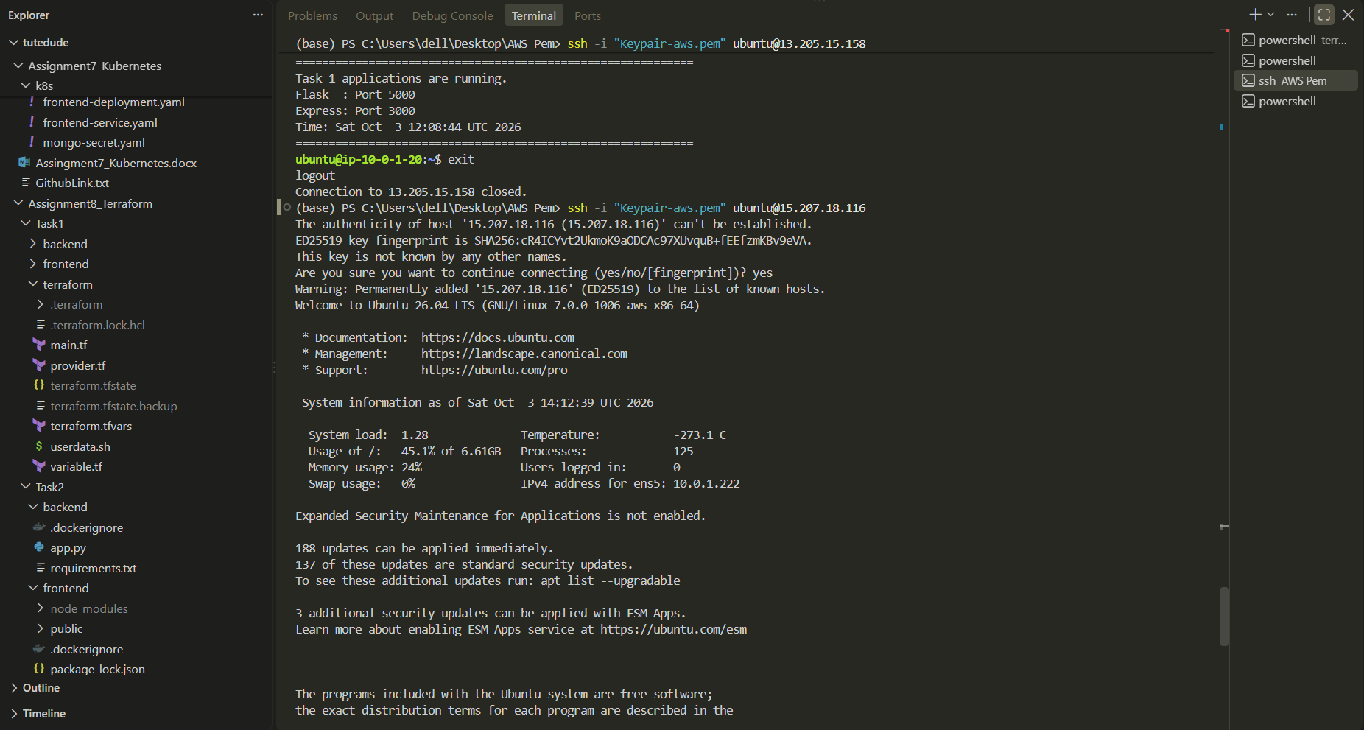
Did vim app.py in task2/frontend in express ec2 and updated backend url in server.js
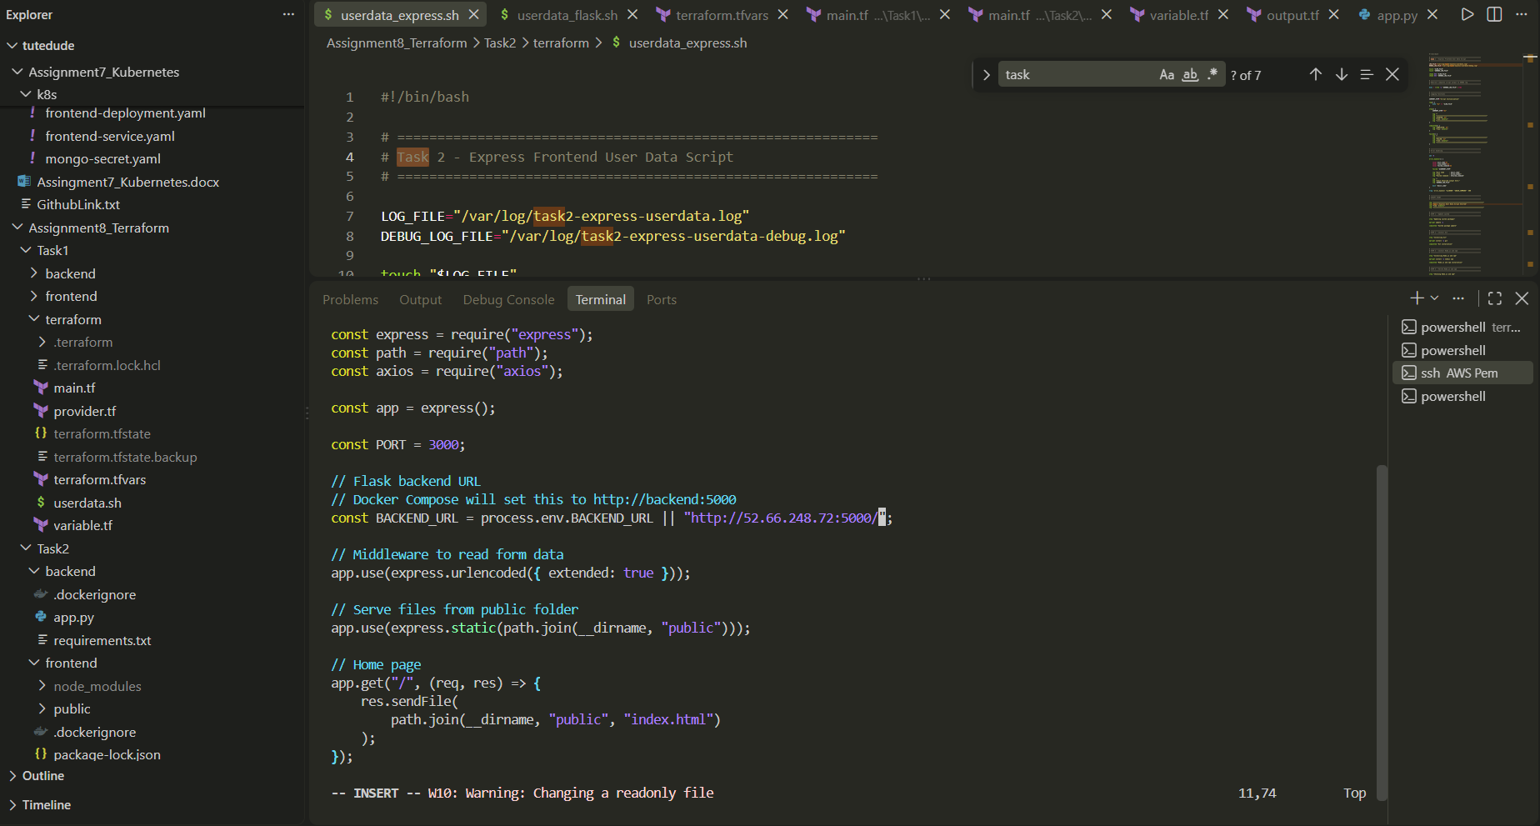

Express public ip -> http://15.207.18.116:3000/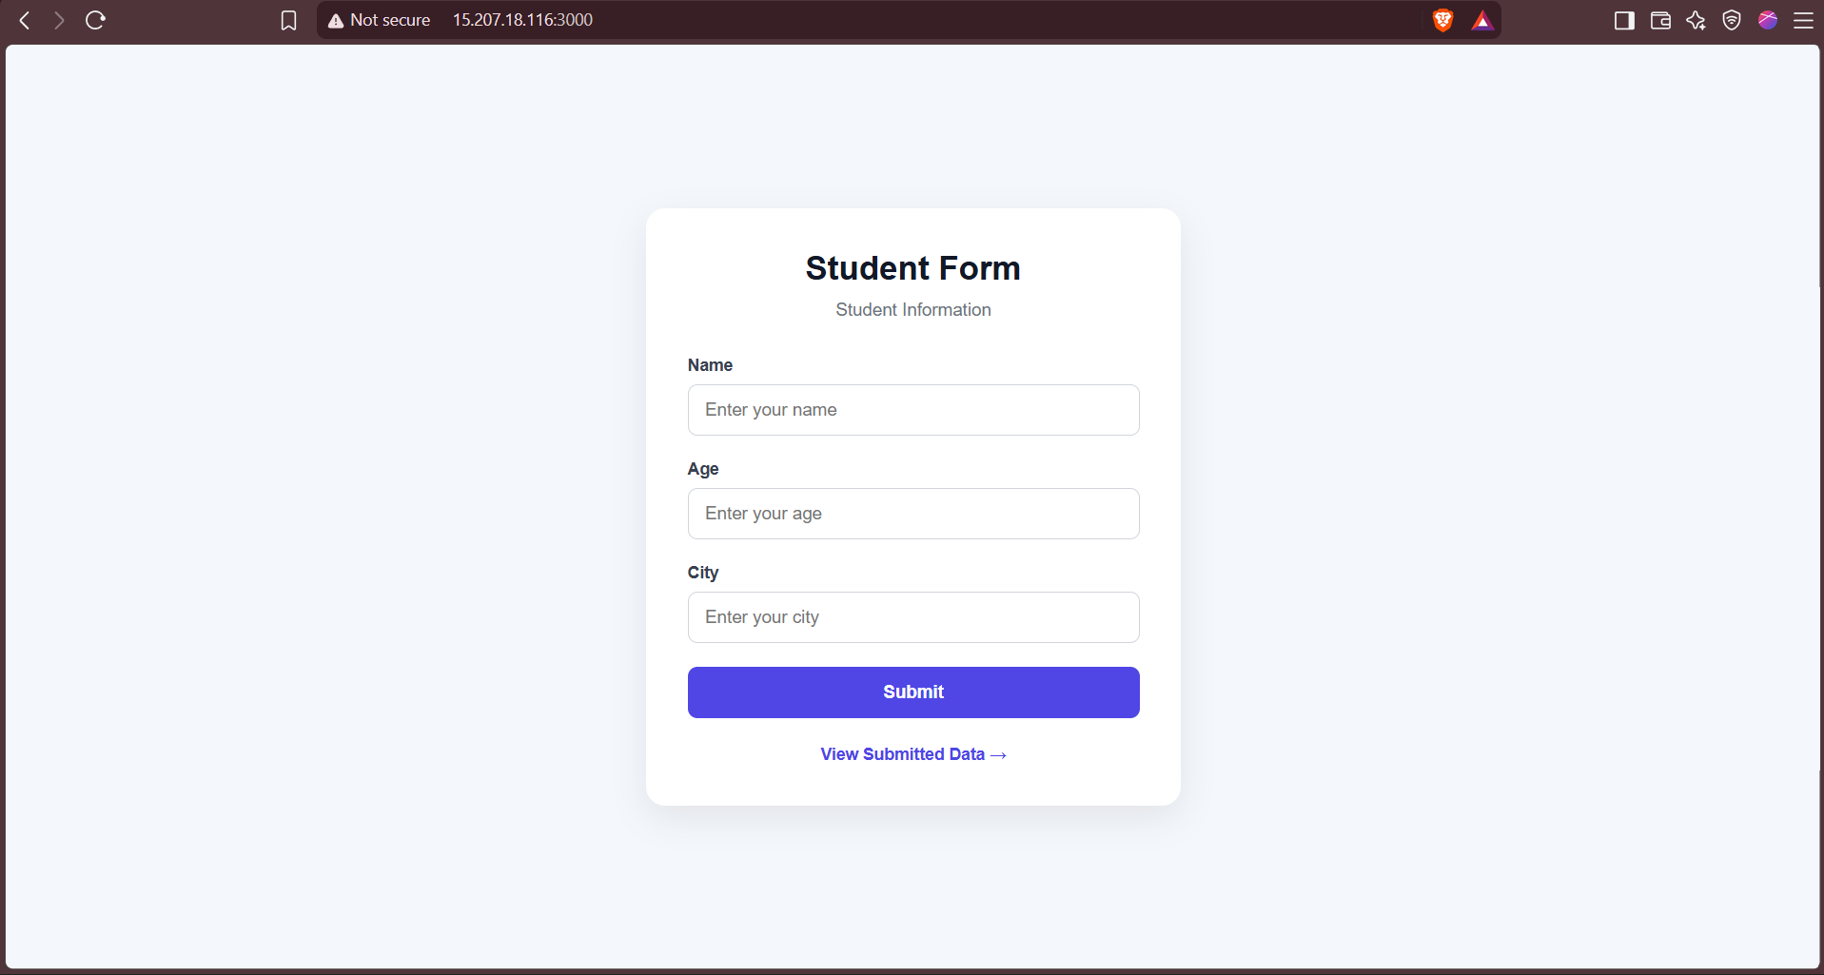
Flask Public ip -> http://52.66.248.72:5000/
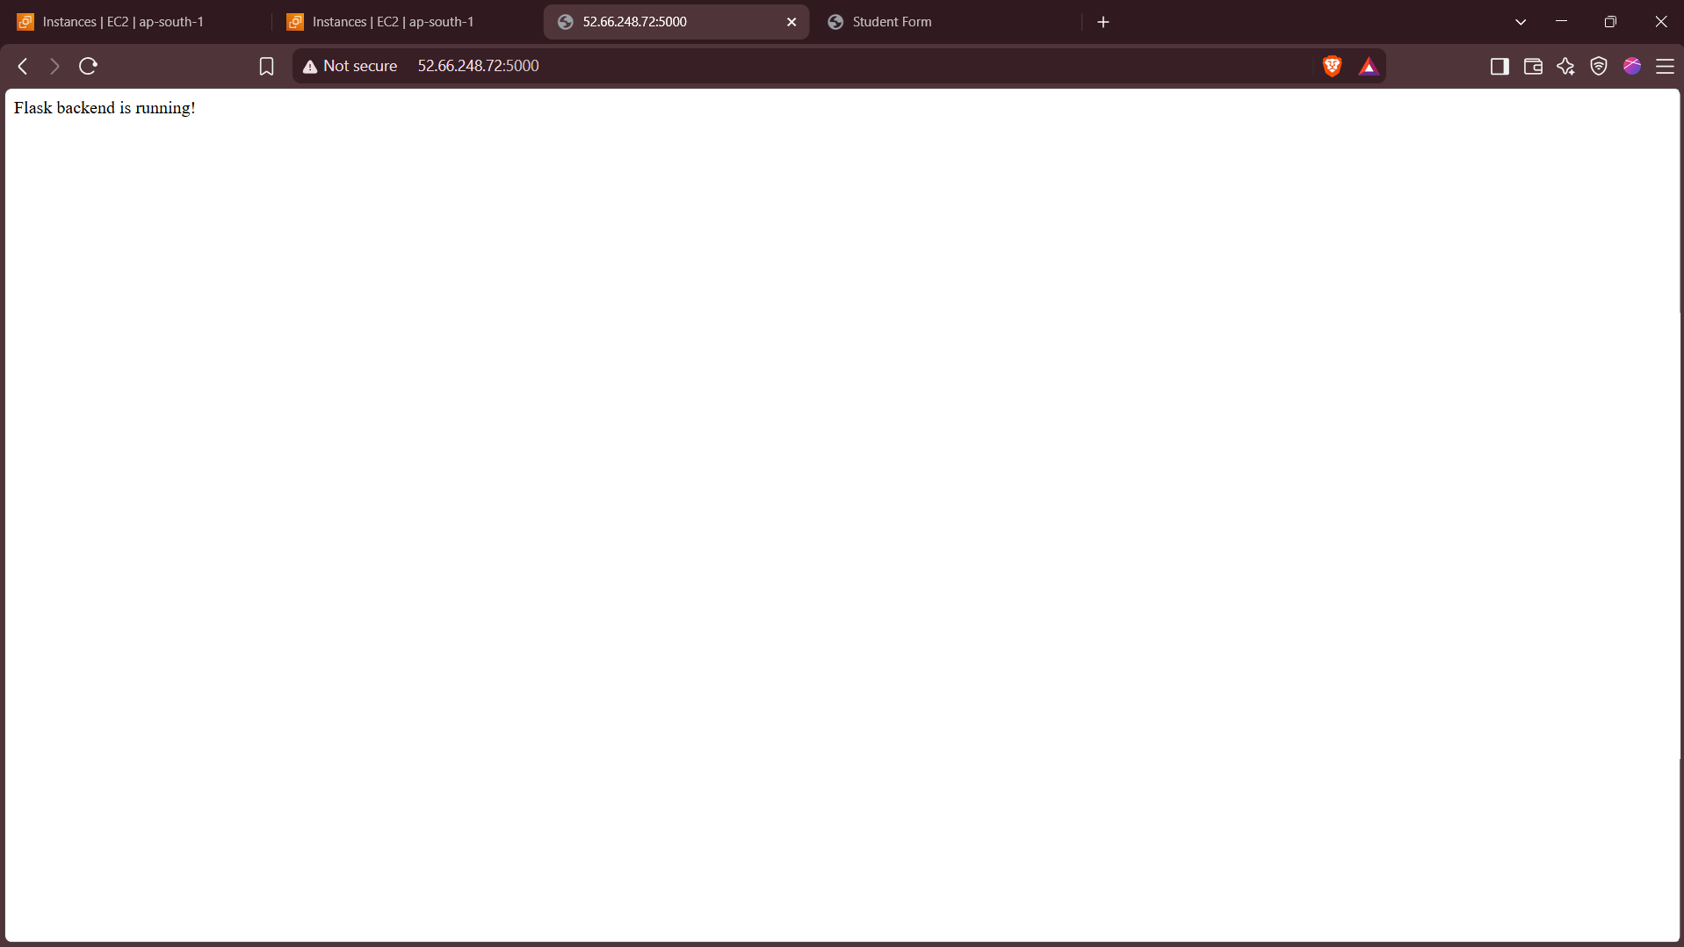

Part2 Completed with all deliverables and Required Files

Part 3: Deploy Flask and Express Using Docker and AWS Services
Objective: Deploy Flask and Express as Docker containers using AWS ECR, ECS, and VPC with Terraform.
- ECR: Use Terraform to create two Elastic Container Registry (ECR) repositories — one for the Flask backend and one for the Express frontend. Build Docker images for both and push them to their respective ECR repositories.
- VPC: Use Terraform to create a VPC with subnets, route tables, and security groups.
- ECS: Use Terraform to set up an ECS cluster and create two ECS services — one for Flask and one for Express — using ECS Fargate or the EC2 launch type to deploy the containers.
- Load Balancer: Use Terraform to provision an Application Load Balancer (ALB) and configure ALB listeners to route requests to the appropriate ECS service.
Expected Deliverables
- Terraform configuration files for ECR, ECS, VPC, and ALB setup.
- Docker images pushed to ECR.
- ECS services running and accessible via the ALB.
General Requirements
- Ensure all Terraform configurations follow best practices, including the use of variables.tf and outputs.tf.
- Use Terraform State (e.g., an S3 backend) for state management.
- Use terraform plan and terraform apply to validate and deploy infrastructure.
- Document the deployment process in a README.md file.
Created a folder Task3 and added frontend & backend folder
Created app.py in backend for flask, Created server.js in frontend for express.js
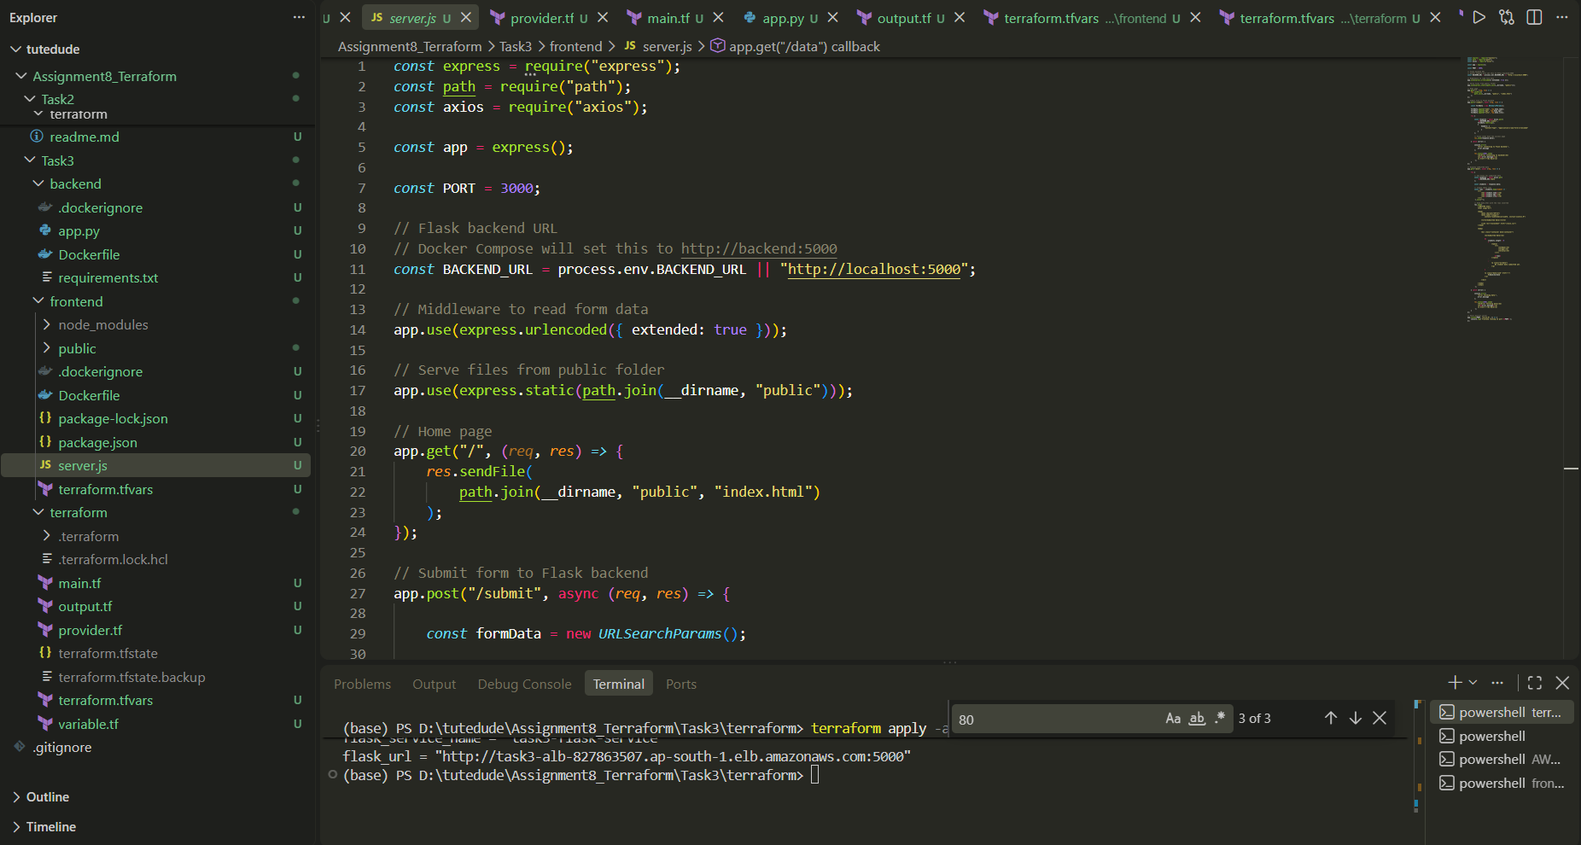

Created a Private ECR Repository
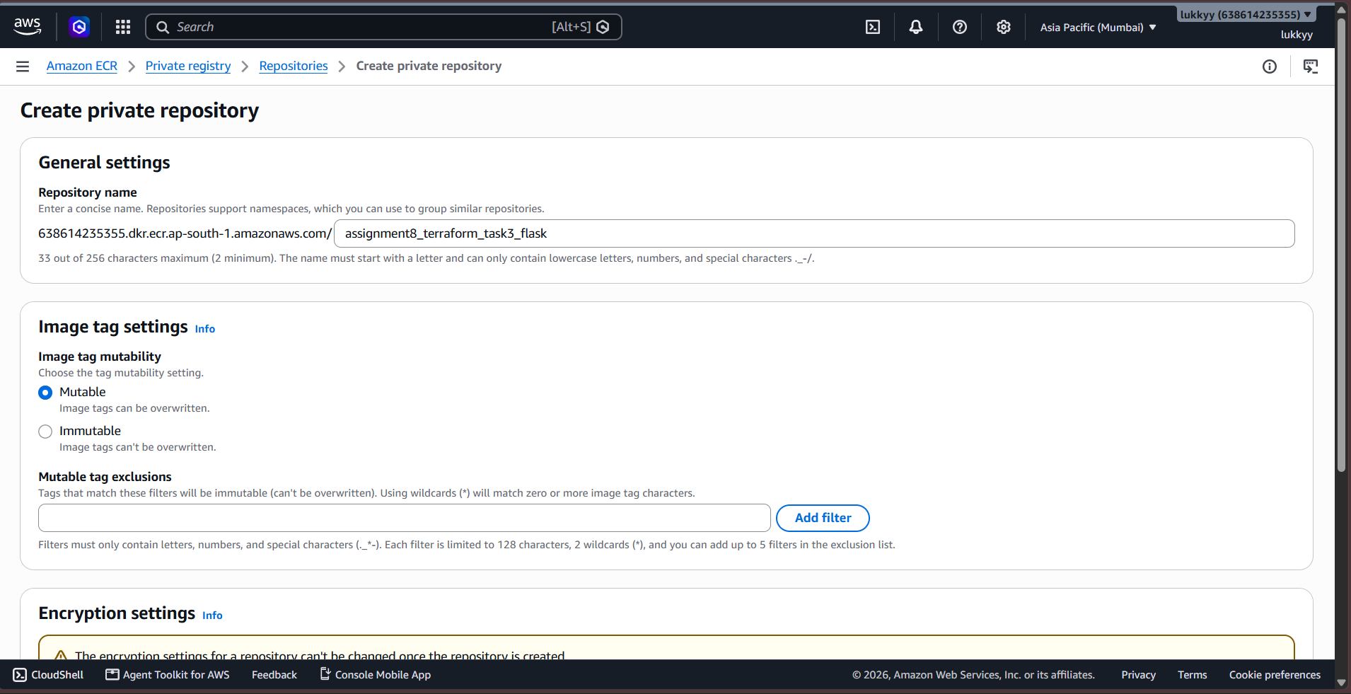

Created an image for flask backend, and pushed to ecr
`docker build -t assignment8_terraform_task3_flask .`

`aws ecr get-login-password --region ap-south-1 | docker login --username AWS --password-stdin 638614235355.dkr.ecr.ap-south-1.amazonaws.com`

`docker tag assignment8_terraform_task3_flask:latest 638614235355.dkr.ecr.ap-south-1.amazonaws.com/assignment8_terraform_task3_flask:latest`

`docker push 638614235355.dkr.ecr.ap-south-1.amazonaws.com/assignment8_terraform_task3_flask:latest`

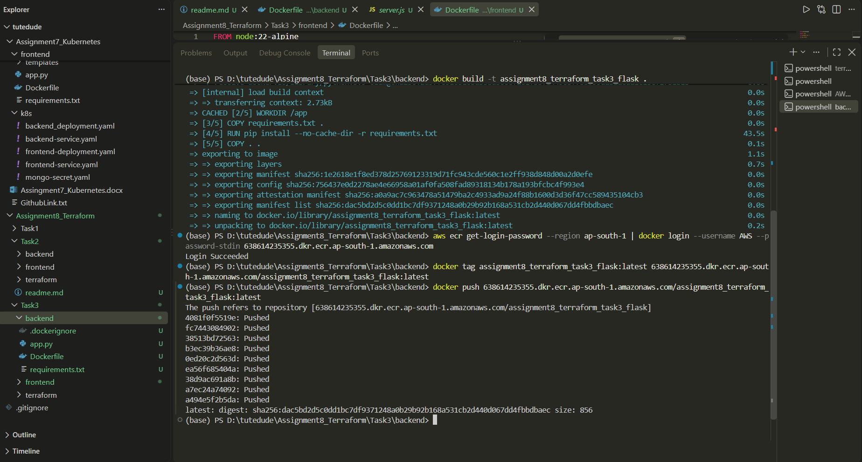

Created a private ECR for Express
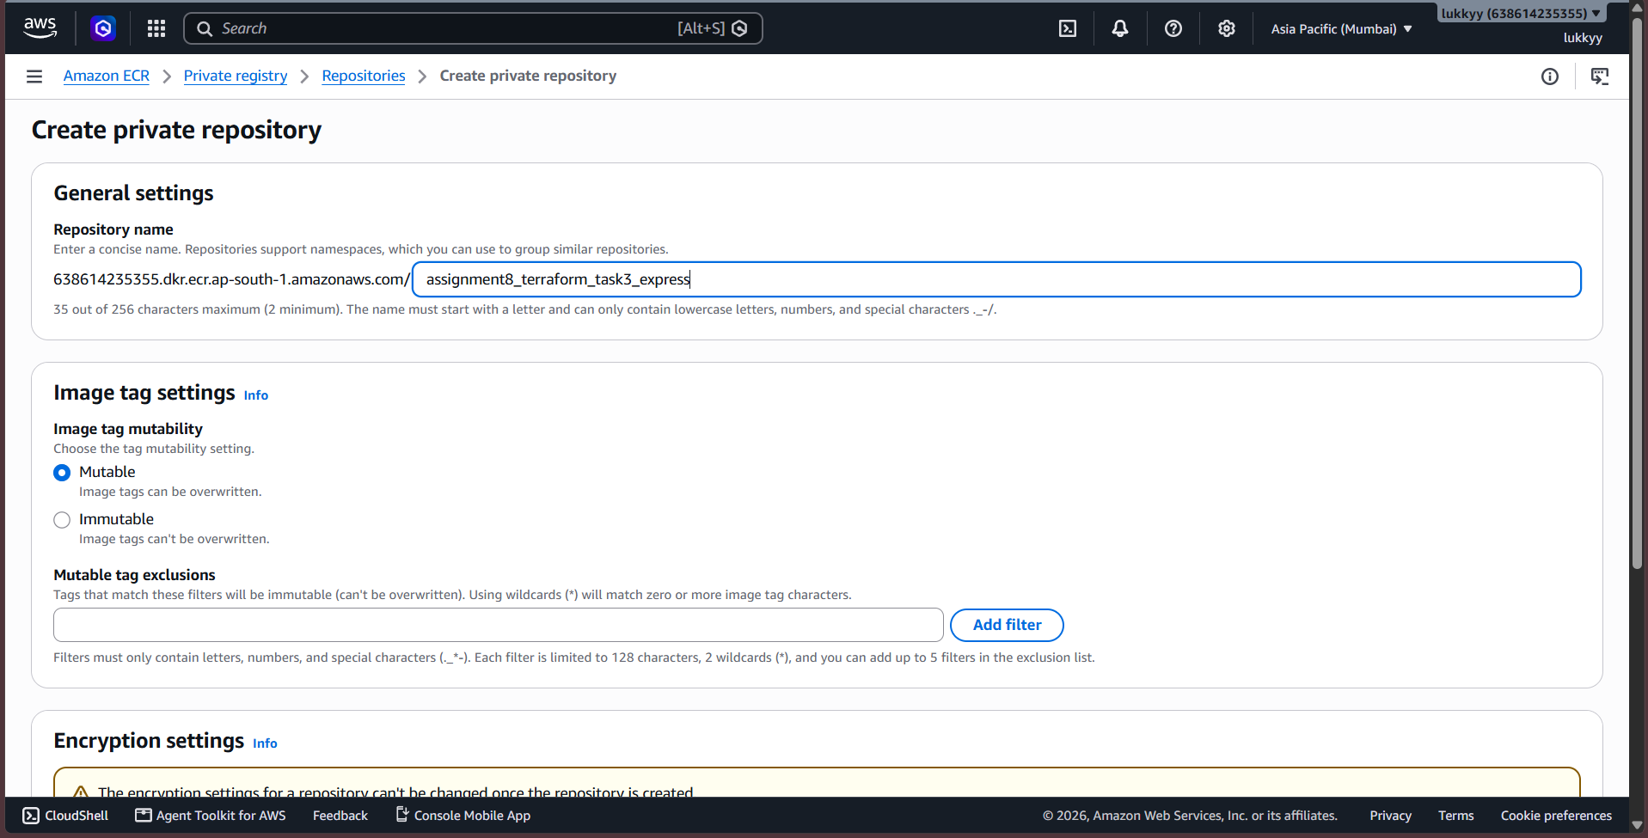

Pushed Express Image to ECR
docker build -t assignment8_terraform_task3_express .

aws ecr get-login-password --region ap-south-1 | docker login --username AWS --password-stdin 638614235355.dkr.ecr.ap-south-1.amazonaws.com

docker tag assignment8_terraform_task3_express:latest 638614235355.dkr.ecr.ap-south-1.amazonaws.com/assignment8_terraform_task3_express:latest

docker push 638614235355.dkr.ecr.ap-south-1.amazonaws.com/assignment8_terraform_task3_express:latest
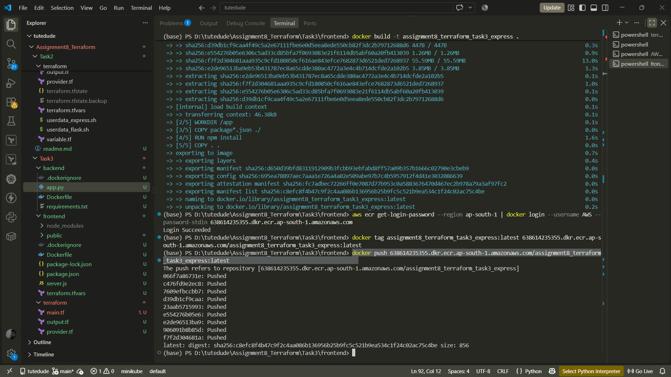
Initialized terraform backend
`terraform init`
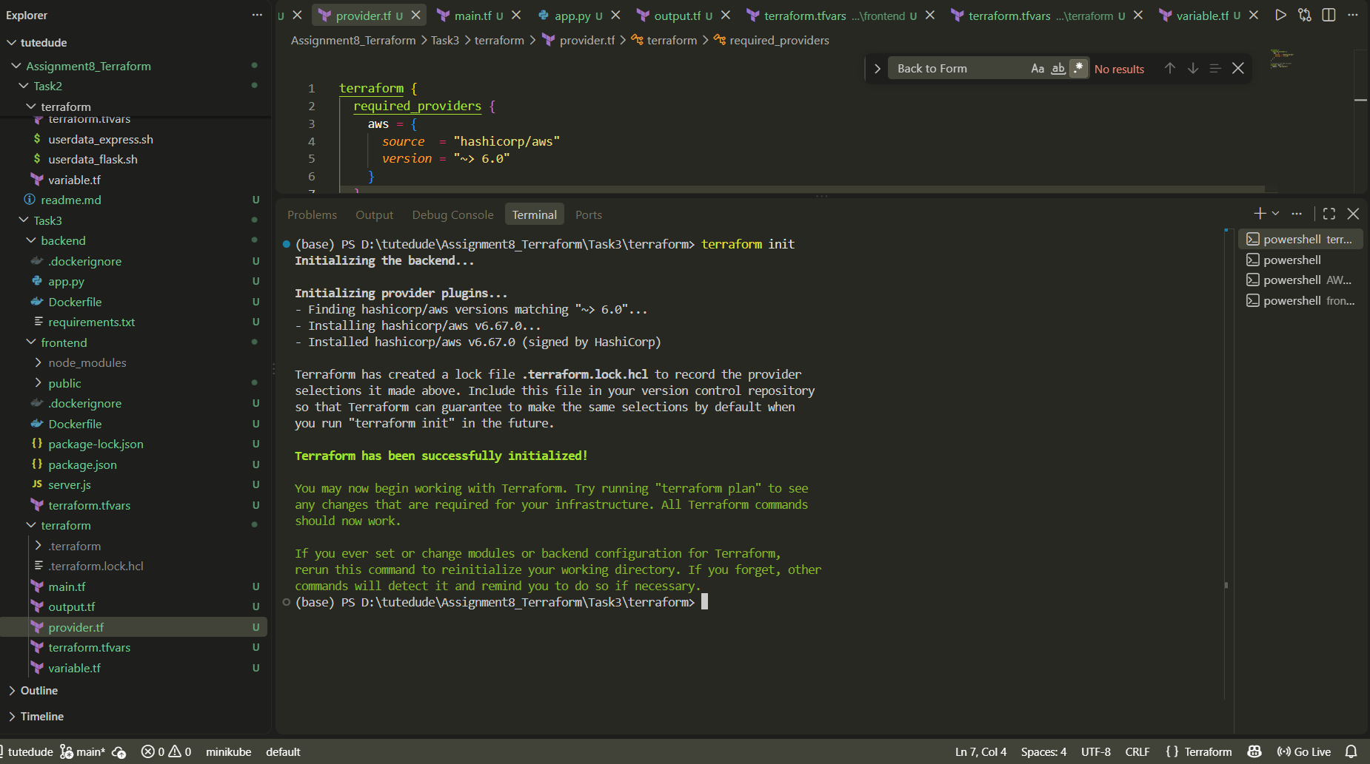

Imported already created Flask ECR and Express ECR
terraform import aws_ecr_repository.flask assignment8_terraform_task3_flask
terraform import aws_ecr_repository.express assignment8_terraform_task3_express
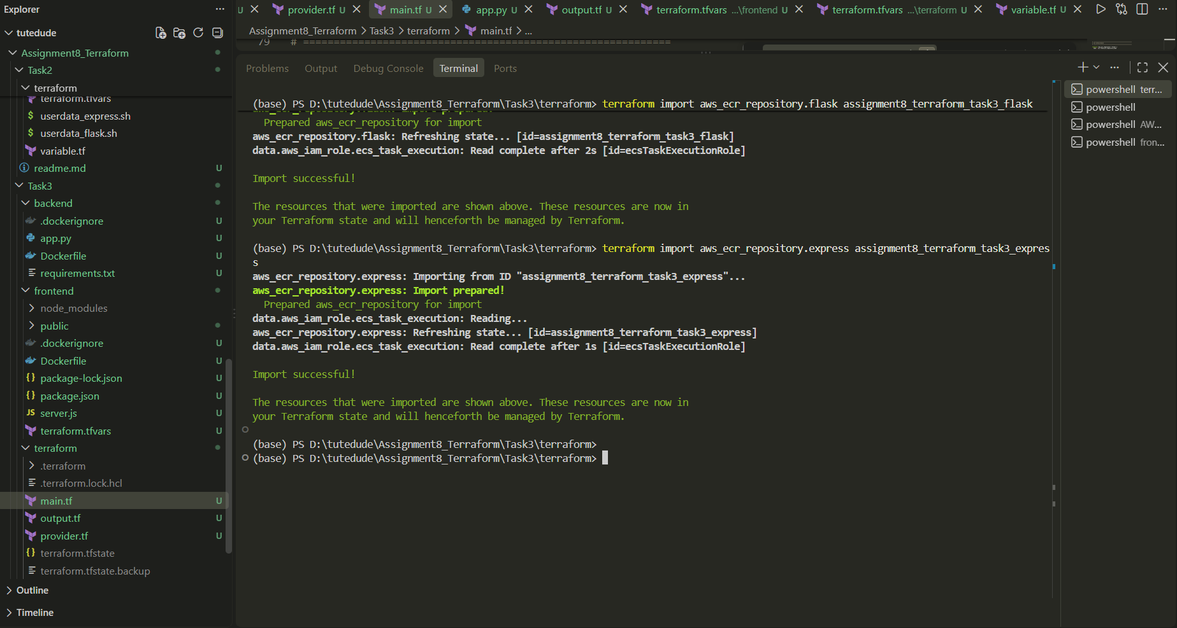

Created provider.tf, main.tf, variable.tf, terraform.tfvars, output.tf. And did terraform plan and the `terraform apply`
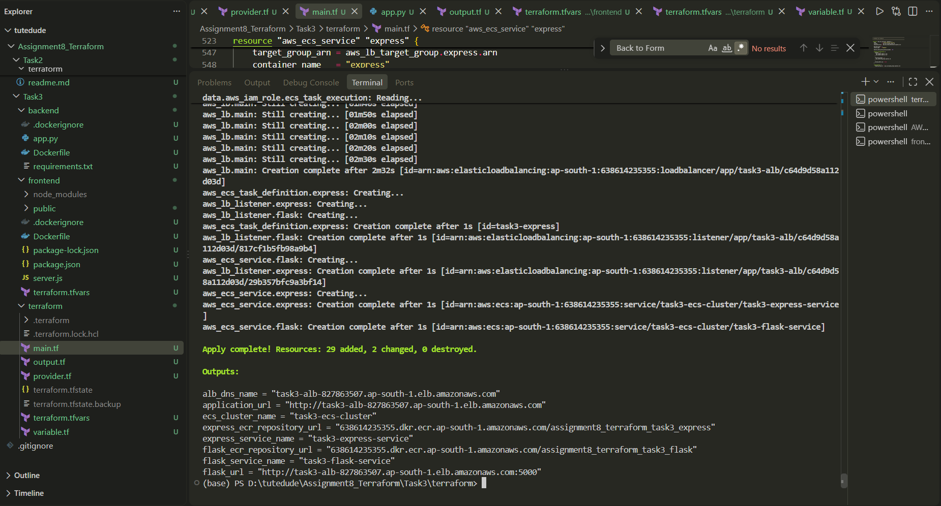

Express IP -> http://task3-alb-827863507.ap-south-1.elb.amazonaws.com/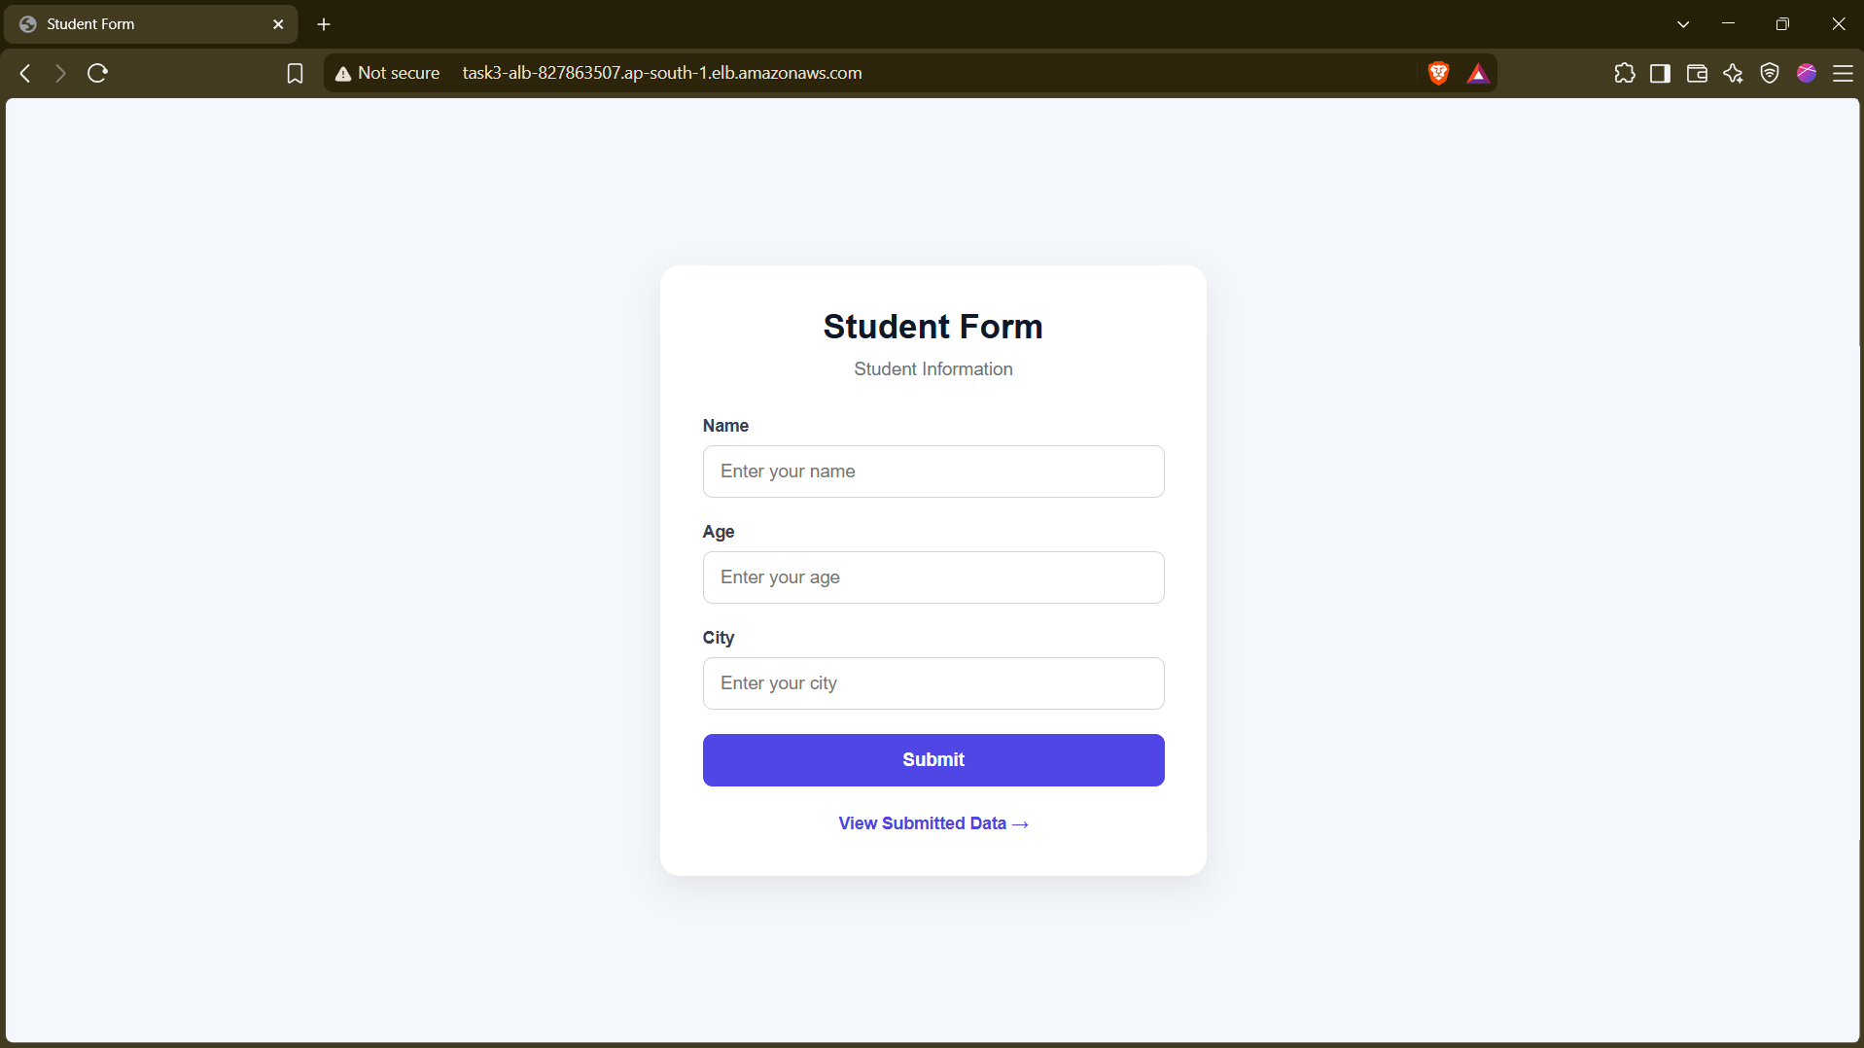

Flask ip -> http://task3-alb-827863507.ap-south-1.elb.amazonaws.com:5000/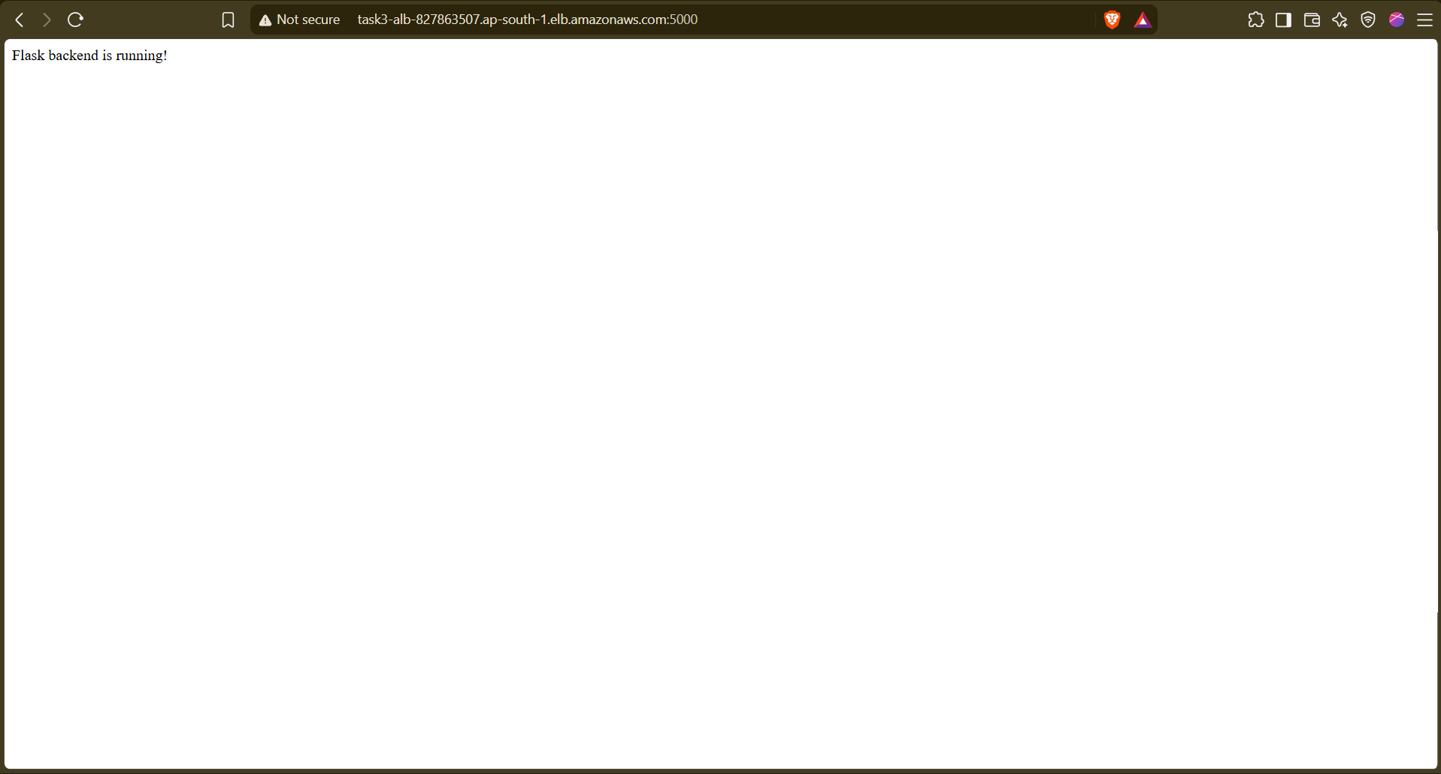

Remote state backend management.
aws s3api create-bucket `
--bucket task3-terraform-state-638614235355 `
--region ap-south-1 `
--create-bucket-configuration LocationConstraint=ap-south-1

Then

aws s3api put-bucket-versioning `
--bucket task3-terraform-state-638614235355 `
--versioning-configuration Status=Enabled

Verify
aws s3api get-bucket-versioning `
--bucket task3-terraform-state-638614235355

Then

backend.tf
terraform {
backend "s3" {
bucket = "task3-terraform-state-638614235355"
key = "task3/terraform.tfstate"
region = "ap-south-1"
}
}

Now save it and do `terraform init` in terminal with terraform files.
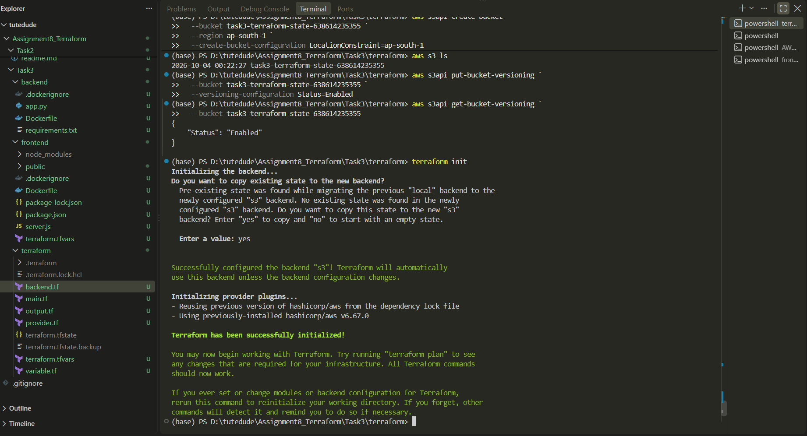
Now backend is initialised on s3 bucket (Remote state management is completed)

