Docker
DEVOPS | Assignment
Objective: Containerize a full-stack application — a Node.js/Express frontend and a Flask backend — using Docker and Docker Compose, then push the images to Docker Hub and the code to GitHub.

1. Frontend (Node.js with Express)
- Create a frontend using Express and Node.js.
Wrote data.html, index.html, style.css (Attached in Zip file)
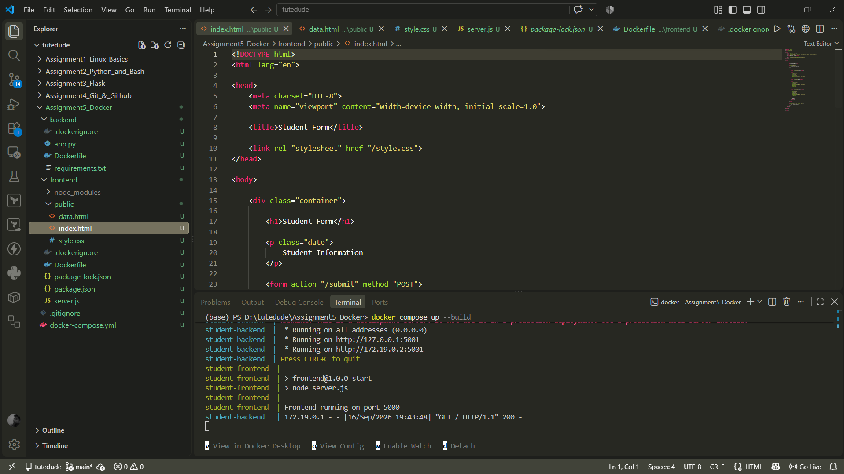

- Include a form similar to the one from the Flask Assignment 2.

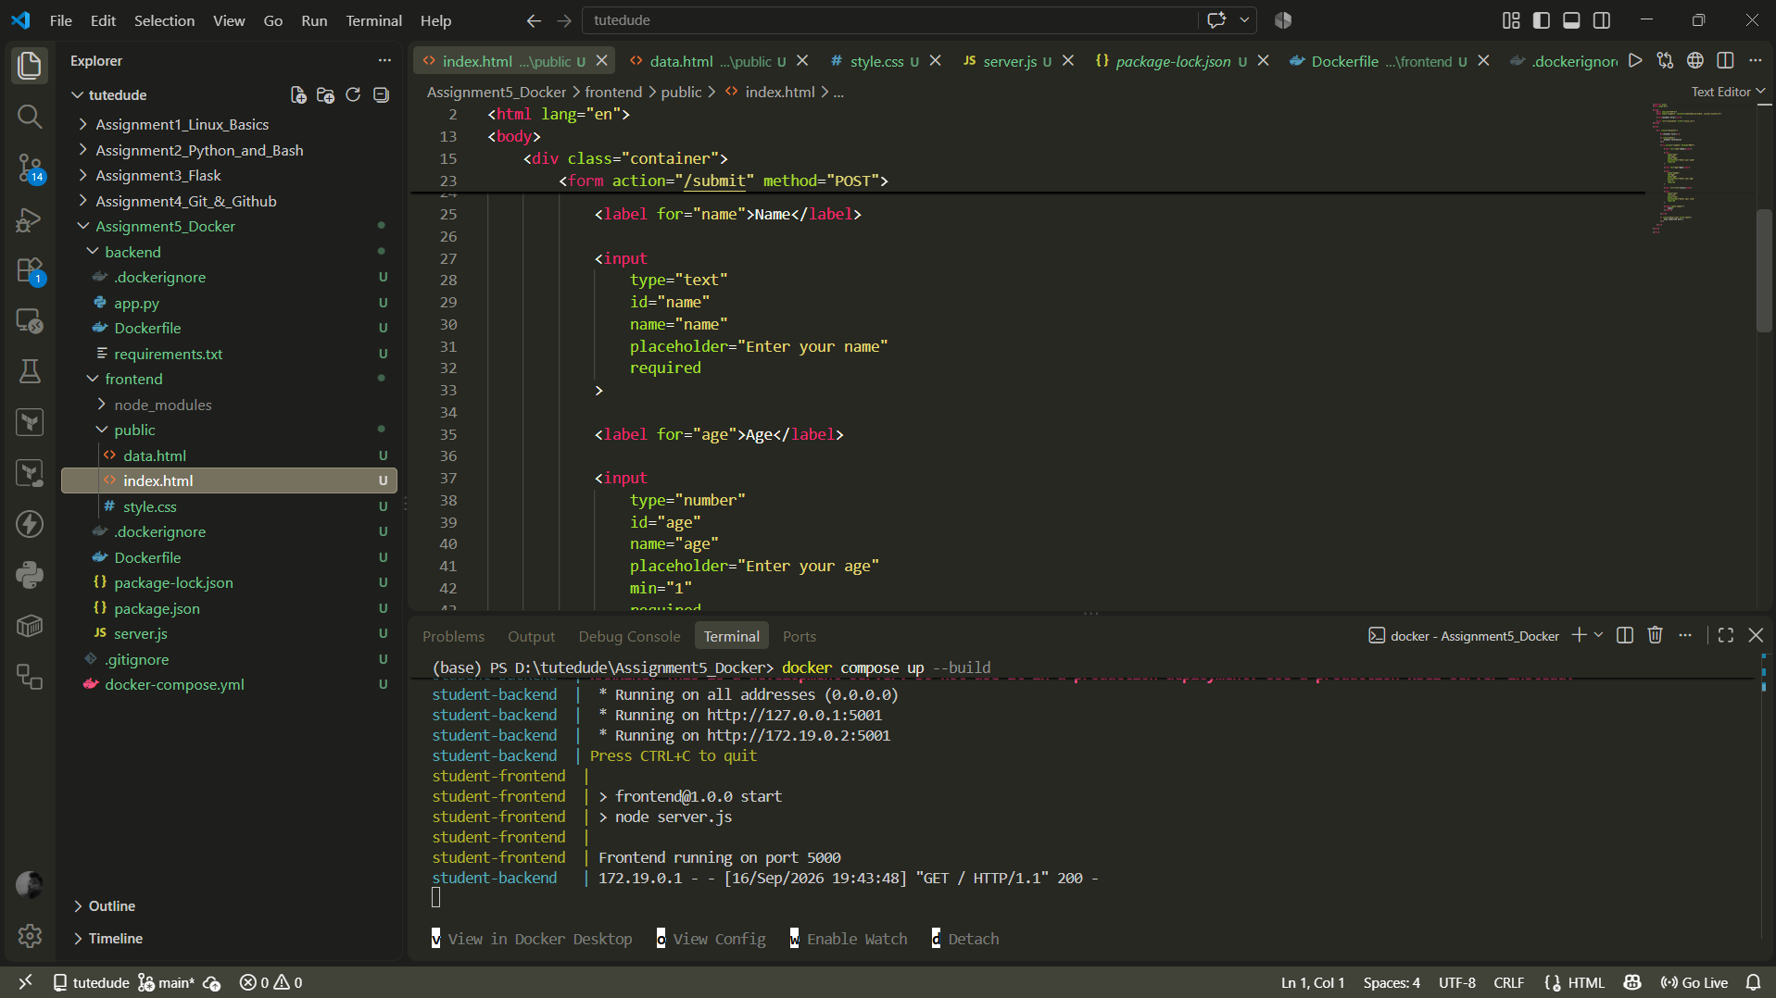

- Configure the form to send a request to the Flask backend.
Done (<form action="/submit" method="POST">)

2. Backend (Flask)
- Use the Flask backend to handle the form submission and process the data.
Done
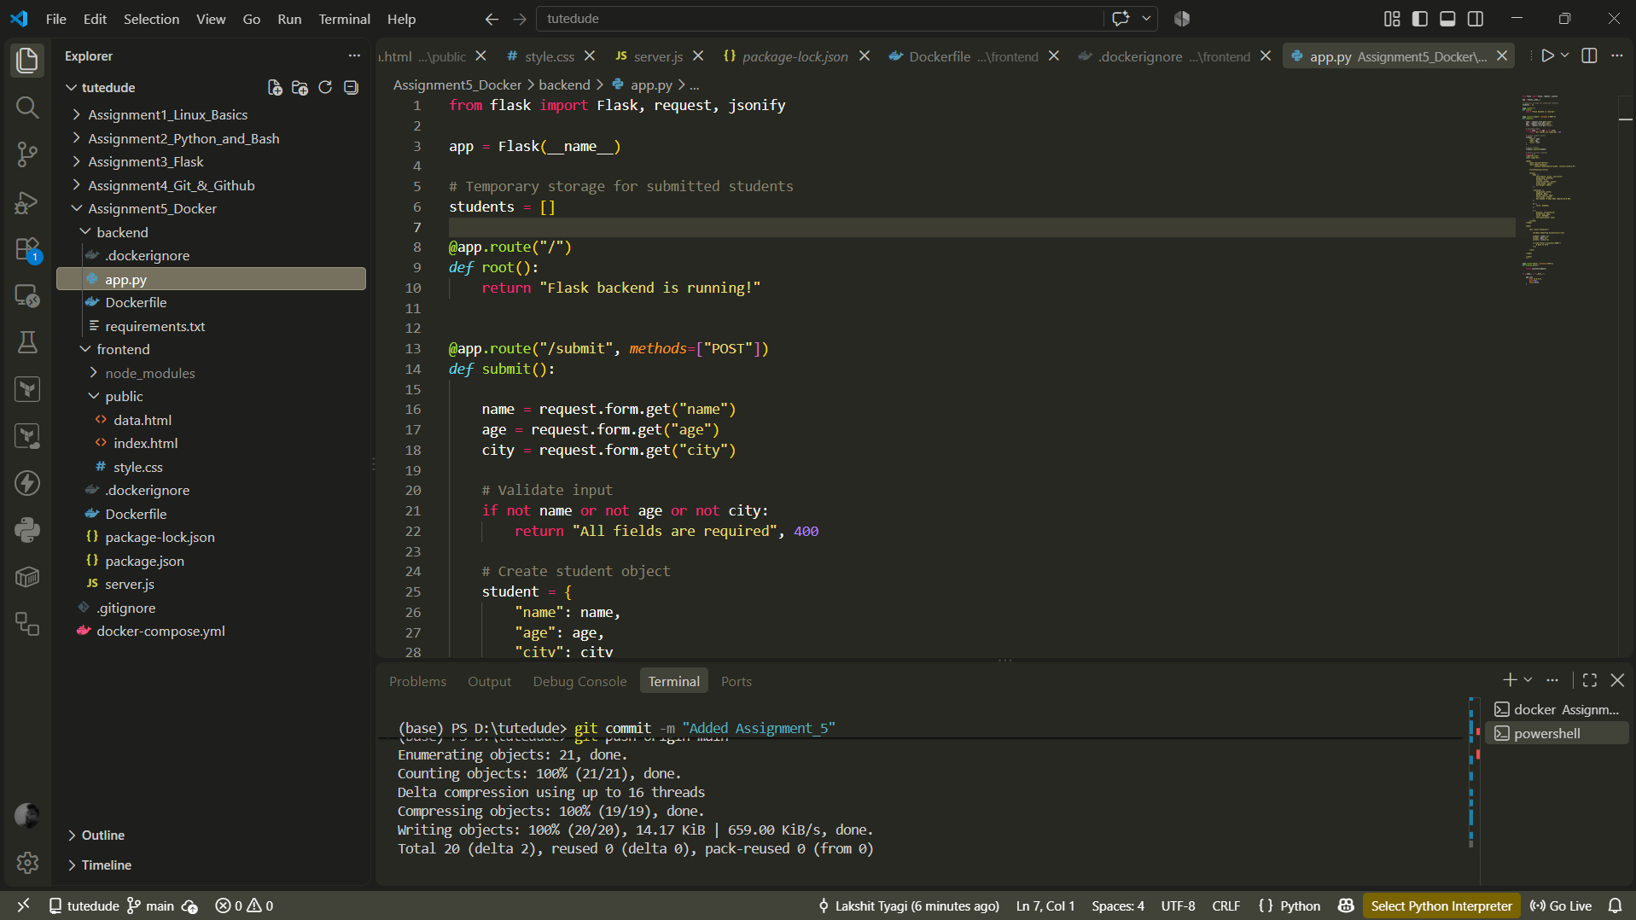

3. Folder Structure
- Organize the project with separate folders for the frontend and backend.
Done
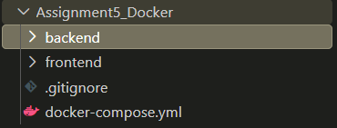
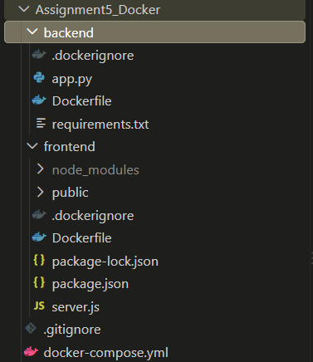

4. Docker Configuration
- Create a Dockerfile for both the frontend and backend. (Done)

\backend\Dockerfile
FROM python:3.12-slim

WORKDIR /app

COPY requirements.txt .

RUN pip install --no-cache-dir -r requirements.txt

COPY . .

EXPOSE 5001

CMD ["python", "app.py"]
\frontend\Dockerfile
FROM node:22-alpine

WORKDIR /app

COPY package*.json ./

RUN npm install

COPY . .

EXPOSE 5000

CMD ["npm", "start"]

- Write a .yaml file (Docker Compose) to connect both services in the same network.

Assignment5_Docker\docker-compose.yml

services:

frontend:
build:
context: ./frontend
dockerfile: Dockerfile

container_name: student-frontend

ports:
- "5000:5000"

environment:
BACKEND_URL: http://backend:5001

depends_on:
- backend

networks:
- student-network

backend:
build:
context: ./backend
dockerfile: Dockerfile

container_name: student-backend

ports:
- "5001:5001"

networks:
- student-network

networks:
student-network:
driver: bridge

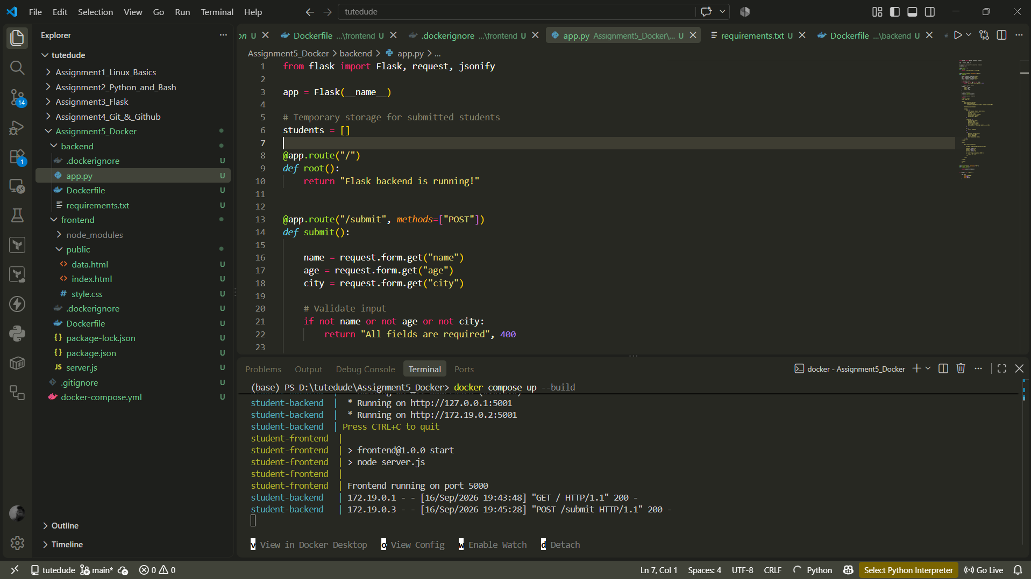

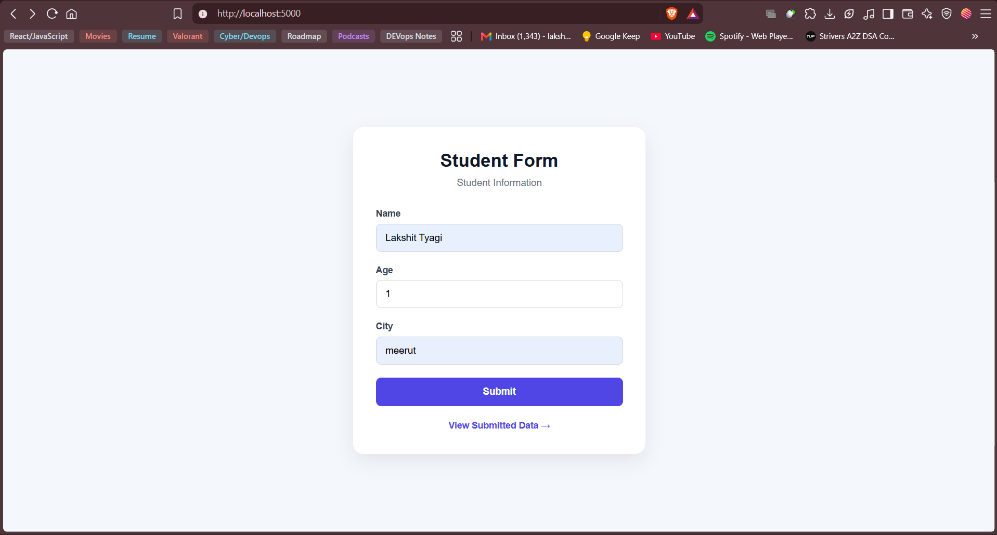

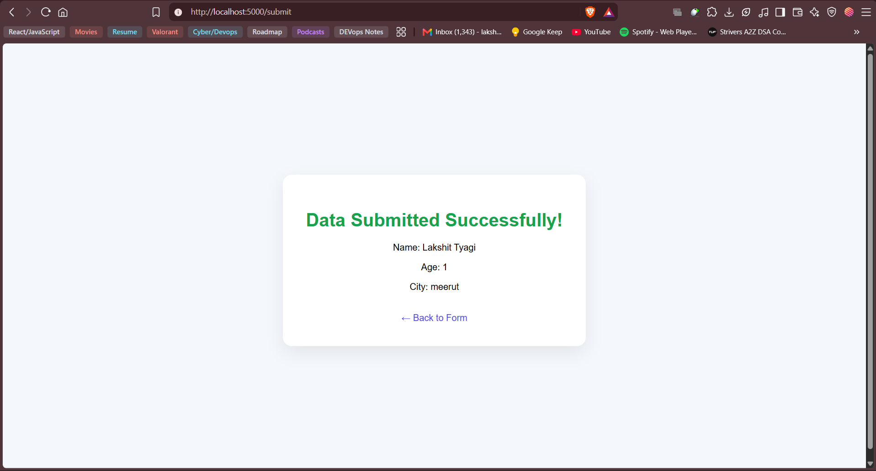

- Upload both images to Docker Hub, and push your whole code to GitHub. Add node_modules and other non-required files (e.g., .vscode) to .gitignore.
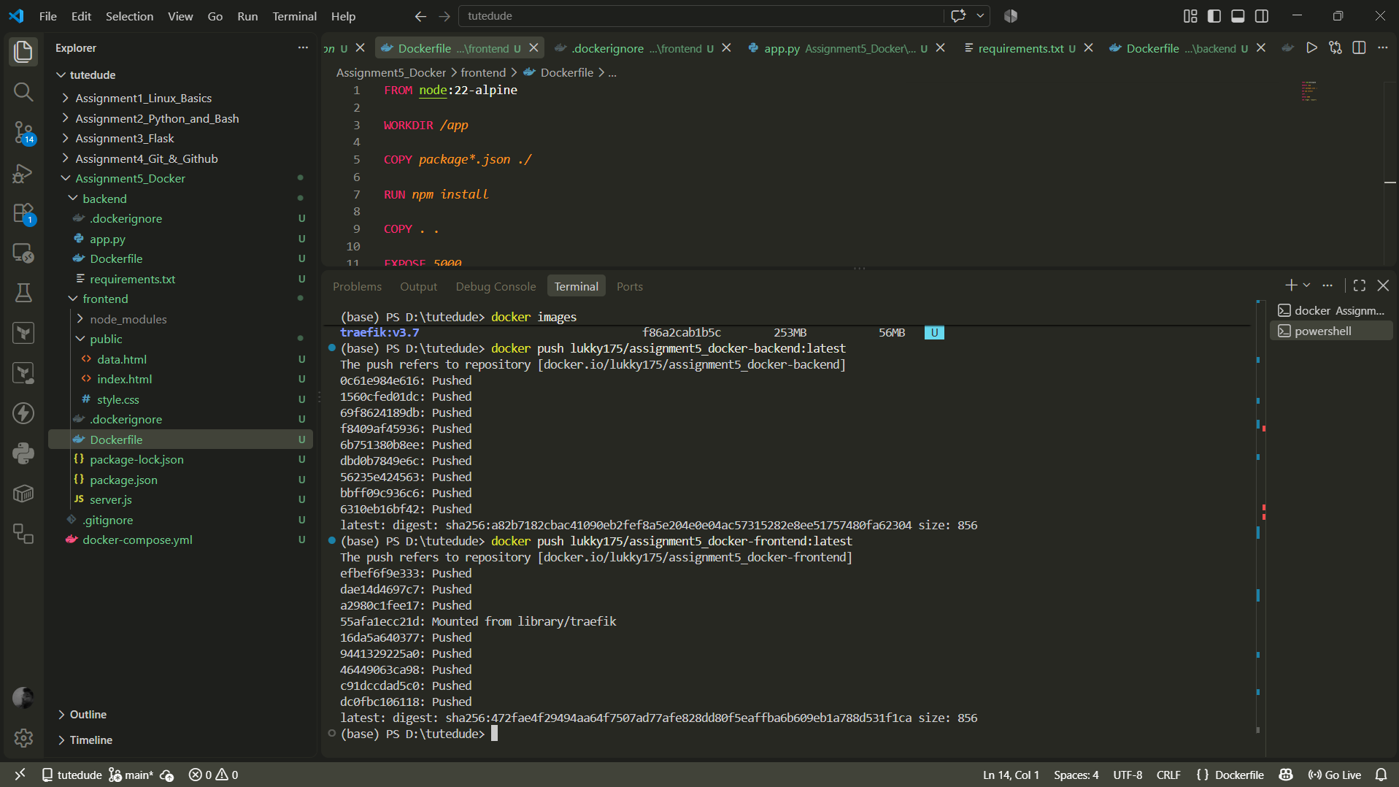

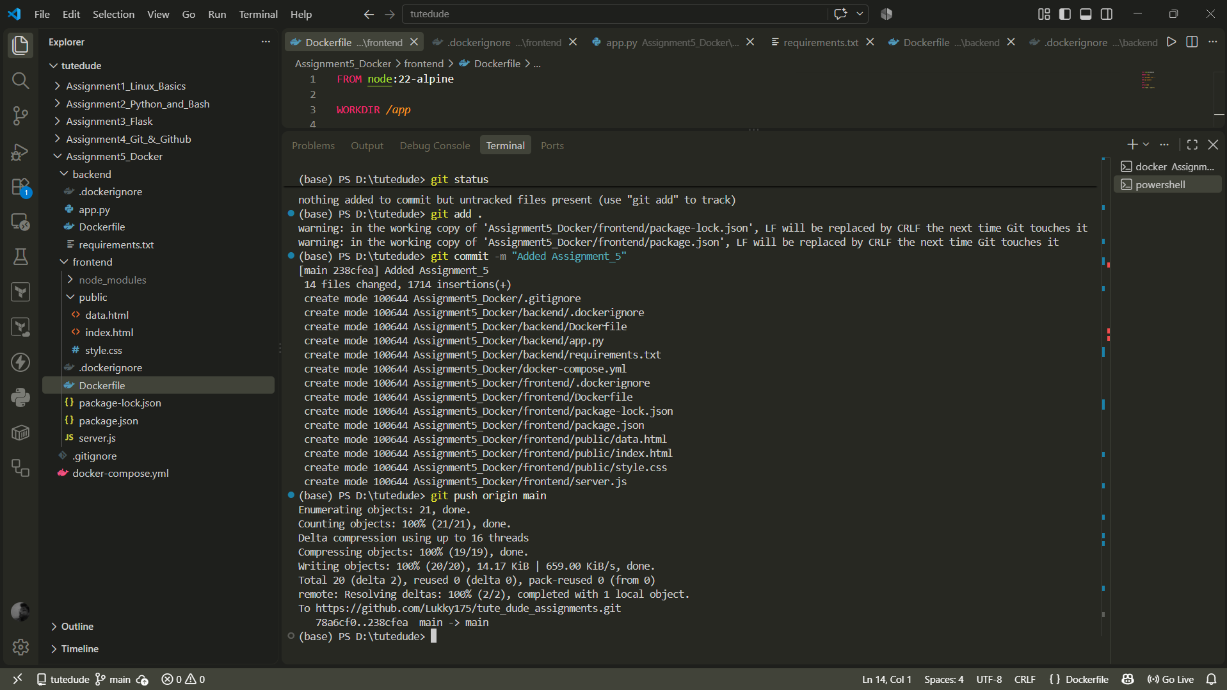
Reference: https://github.com/Toto3107/flaskp
(base) PS D:\tutedude> git add .
warning: in the working copy of 'Assignment5_Docker/frontend/package-lock.json', LF will be replaced by CRLF the next time Git touches it
warning: in the working copy of 'Assignment5_Docker/frontend/package.json', LF will be replaced by CRLF the next time Git touches it
(base) PS D:\tutedude> git commit -m "Added Assignment_5"
[main 238cfea] Added Assignment_5
14 files changed, 1714 insertions(+)
create mode 100644 Assignment5_Docker/.gitignore
create mode 100644 Assignment5_Docker/backend/.dockerignore
create mode 100644 Assignment5_Docker/backend/Dockerfile
create mode 100644 Assignment5_Docker/backend/app.py
create mode 100644 Assignment5_Docker/backend/requirements.txt
create mode 100644 Assignment5_Docker/docker-compose.yml
create mode 100644 Assignment5_Docker/frontend/.dockerignore
create mode 100644 Assignment5_Docker/frontend/Dockerfile
create mode 100644 Assignment5_Docker/frontend/package-lock.json
create mode 100644 Assignment5_Docker/frontend/package.json
create mode 100644 Assignment5_Docker/frontend/public/data.html
create mode 100644 Assignment5_Docker/frontend/public/index.html
create mode 100644 Assignment5_Docker/frontend/public/style.css
create mode 100644 Assignment5_Docker/frontend/server.js
(base) PS D:\tutedude> git push origin main
Enumerating objects: 21, done.
Counting objects: 100% (21/21), done.
Delta compression using up to 16 threads
Compressing objects: 100% (19/19), done.
Writing objects: 100% (20/20), 14.17 KiB | 659.00 KiB/s, done.
Total 20 (delta 2), reused 0 (delta 0), pack-reused 0 (from 0)
remote: Resolving deltas: 100% (2/2), completed with 1 local object.
To https://github.com/Lukky175/tute_dude_assignments.git
78a6cf0..238cfea main -> main
(base) PS D:\tutedude>

&&

(base) PS D:\tutedude> docker tag assignment5_docker-backend:latest lukky175/assignment5_docker-backend:latest
(base) PS D:\tutedude> docker tag assignment5_docker-frontend:latest lukky175/assignment5_docker-frontend:latest
(base) PS D:\tutedude> docker images
i Info → U In Use
IMAGE ID DISK USAGE CONTENT SIZE EXTRA
assignment5_docker-backend:latest a82b7182cbac 222MB 54MB U
assignment5_docker-frontend:latest 472fae4f2949 249MB 61MB U
grafana/grafana:latest ac461fb352ab 1.92GB 476MB U
localcontainerserviceplatform-cont-1:latest f6218eab68a1 209MB 51.3MB U
localcontainerserviceplatform-cont-2:latest f3ea103815b1 209MB 51.3MB U
localcontainerserviceplatform-cont-3:latest 4d765ee75ad6 209MB 51.3MB U
lukky175/assignment5_docker-backend:latest a82b7182cbac 222MB 54MB U
lukky175/assignment5_docker-frontend:latest 472fae4f2949 249MB 61MB U
lukky175/student-backend:latest a82b7182cbac 222MB 54MB U
lukky175/student-frontend:latest 472fae4f2949 249MB 61MB U
postgres:16 33f923b05f64 642MB 166MB U
prom/prometheus:latest 5ce7540c3c00 372MB 109MB U
redis:7 a8f08480e1f8 170MB 46MB U
traefik:v3.5 16acb89c6db3 235MB 51.5MB
traefik:v3.7 f86a2cab1b5c 253MB 56MB U
(base) PS D:\tutedude> docker push lukky175/assignment5_docker-backend:latest
The push refers to repository [docker.io/lukky175/assignment5_docker-backend]
0c61e984e616: Pushed
1560cfed01dc: Pushed
69f8624189db: Pushed
f8409af45936: Pushed
6b751380b8ee: Pushed
dbd0b7849e6c: Pushed
56235e424563: Pushed
bbff09c936c6: Pushed
6310eb16bf42: Pushed
latest: digest: sha256:a82b7182cbac41090eb2fef8a5e204e0e04ac57315282e8ee51757480fa62304 size: 856
(base) PS D:\tutedude> docker push lukky175/assignment5_docker-frontend:latest
The push refers to repository [docker.io/lukky175/assignment5_docker-frontend]
efbef6f9e333: Pushed
dae14d4697c7: Pushed
a2980c1fee17: Pushed
55afa1ecc21d: Mounted from library/traefik
16da5a640377: Pushed
9441329225a0: Pushed
46449063ca98: Pushed
c91dccdad5c0: Pushed
dc0fbc106118: Pushed
latest: digest: sha256:472fae4f29494aa64f7507ad77afe828dd80f5eaffba6b609eb1a788d531f1ca size: 856

