
Kubernetes
DEVOPS | Assignment

Task
- Deploy your previous assignment's Flask frontend and Express backend in a Kubernetes cluster locally using minikube.
Created Assignment7/backend/app.py
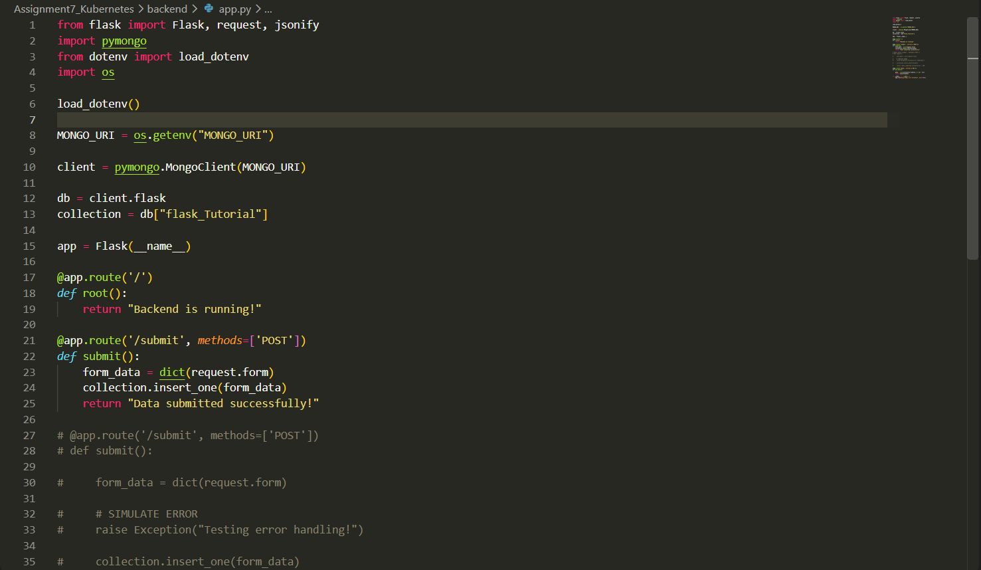

Created a .env and requirements.txt file
Created backend/Dockerfile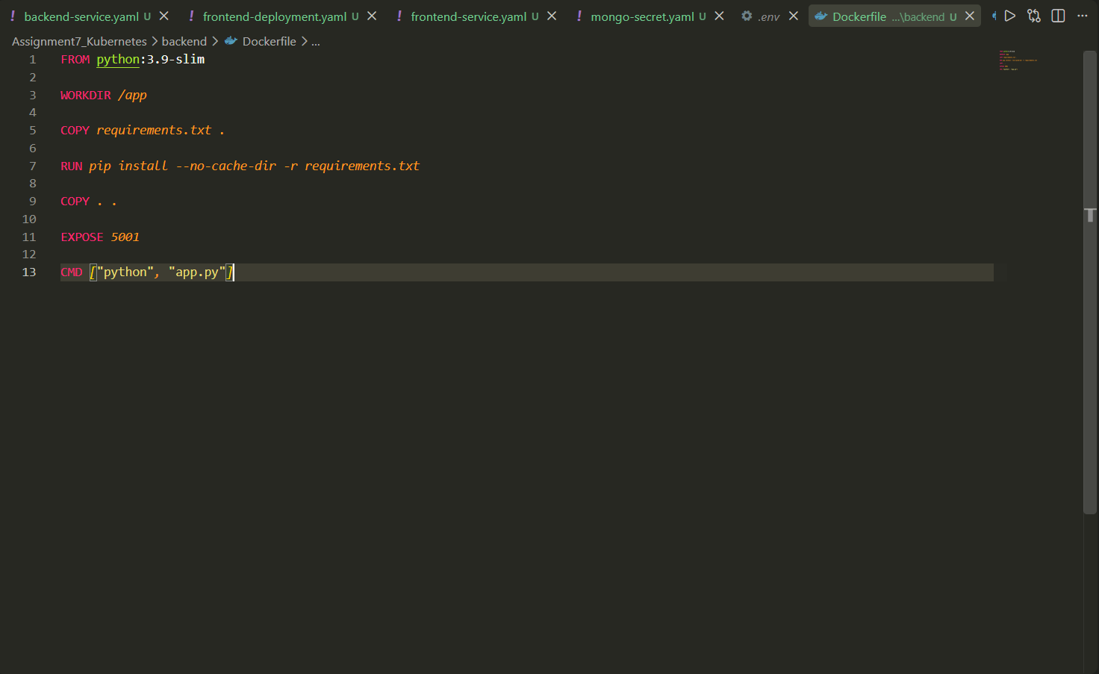
Created Frontend/app.py
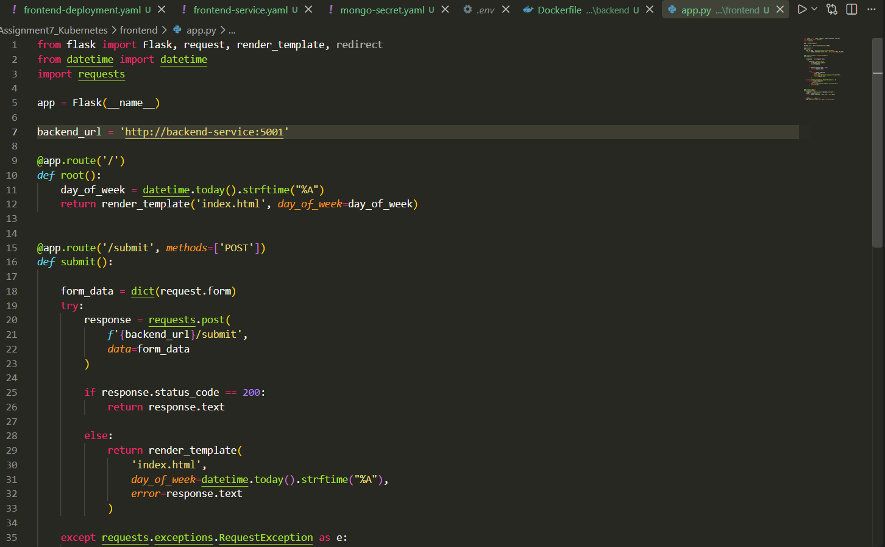
Created requirements.txt
Created a Dockerfile
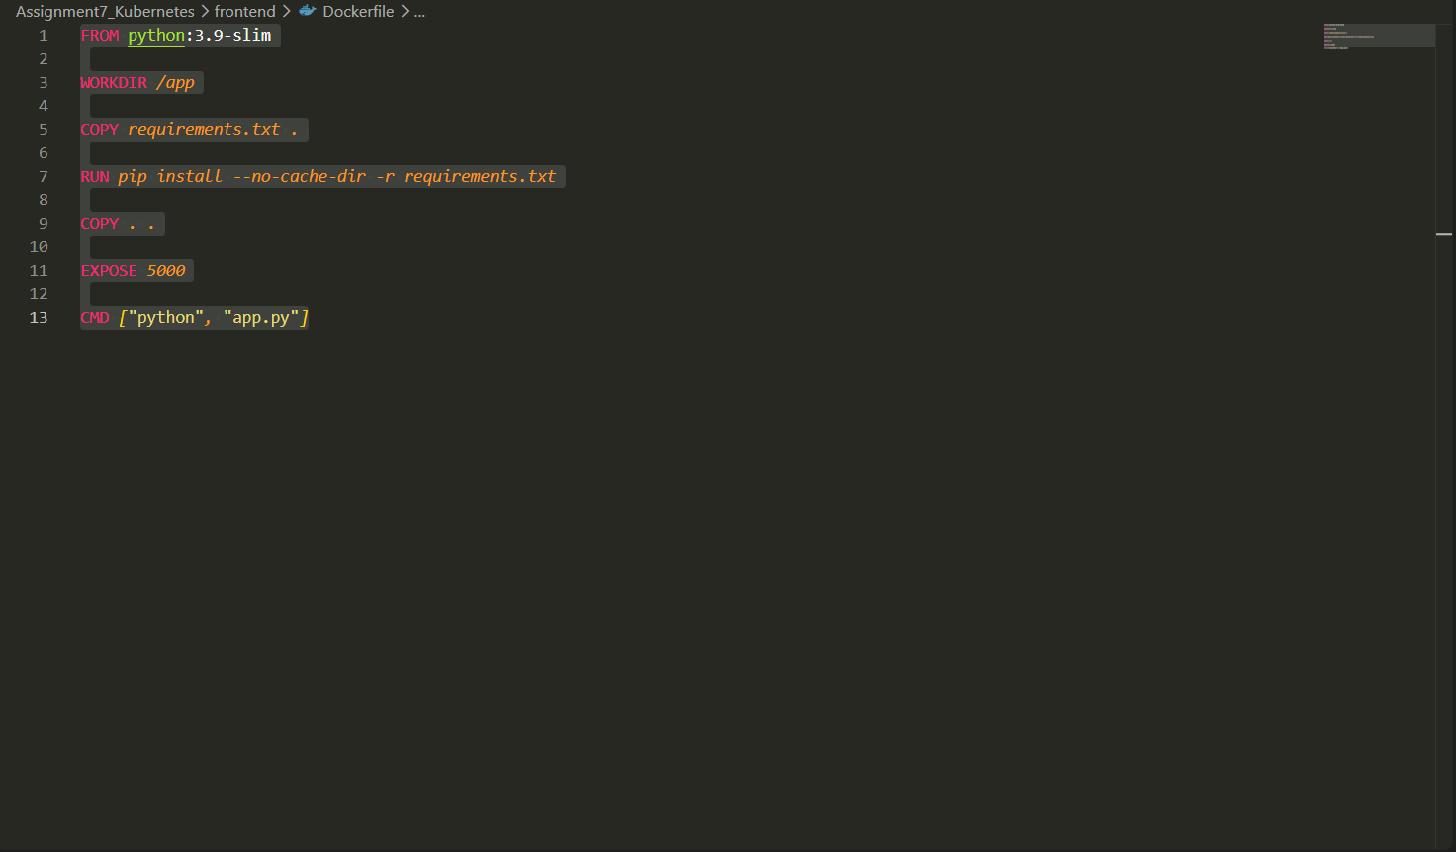
Frontend and Backend is Created for both the files along with Dockerfiles.

Now Both Applications are Dockerised so Created Docker images for both and pushing on Dockerhub
Created Docker Images, now pushing on Dockerhub

Backend
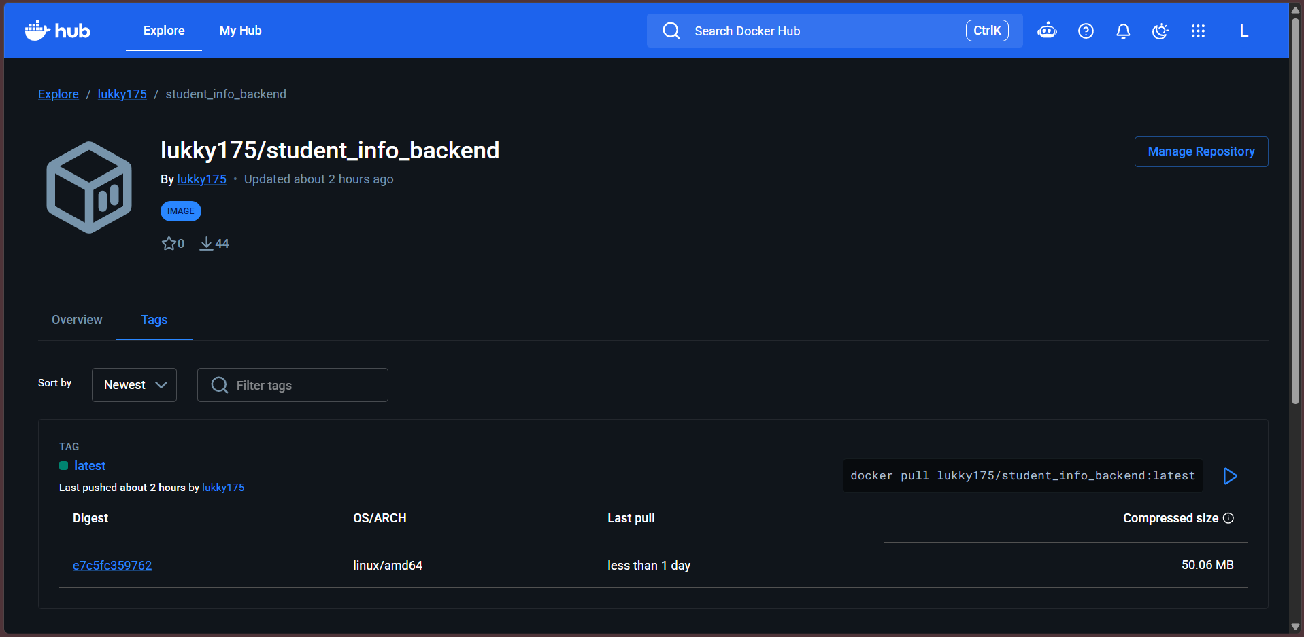
Frontend
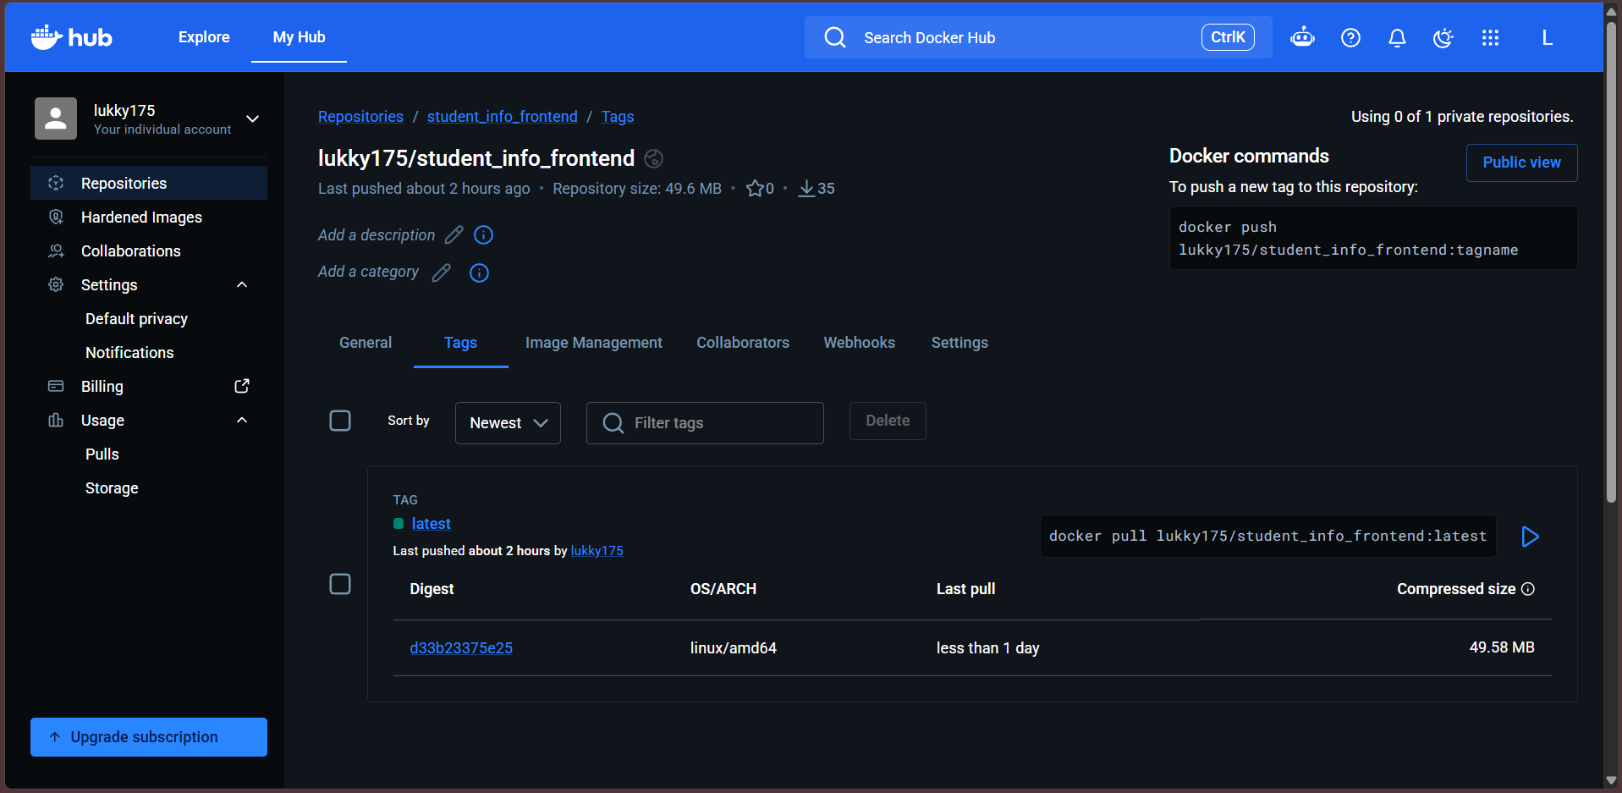

Created k8s/backend_deployment.yaml
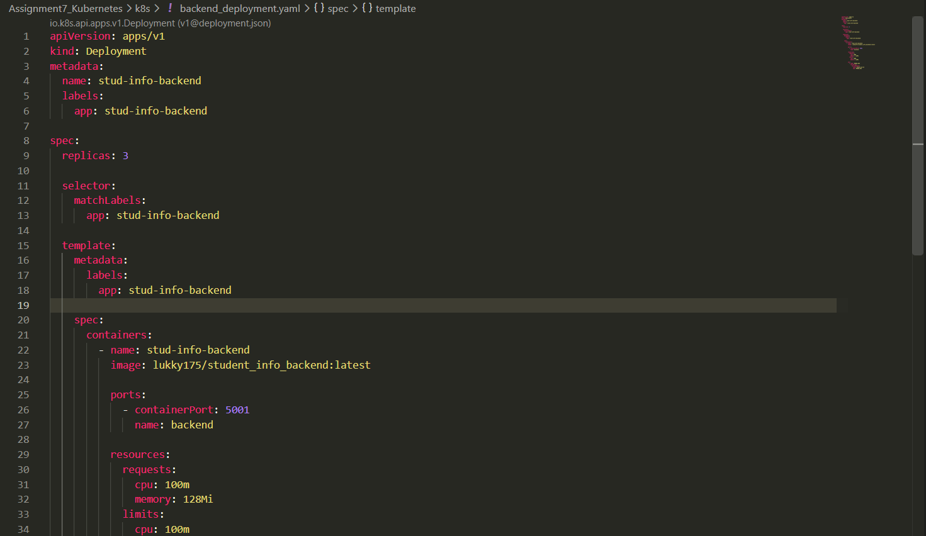

Created k8s/frontend-deployment.yaml
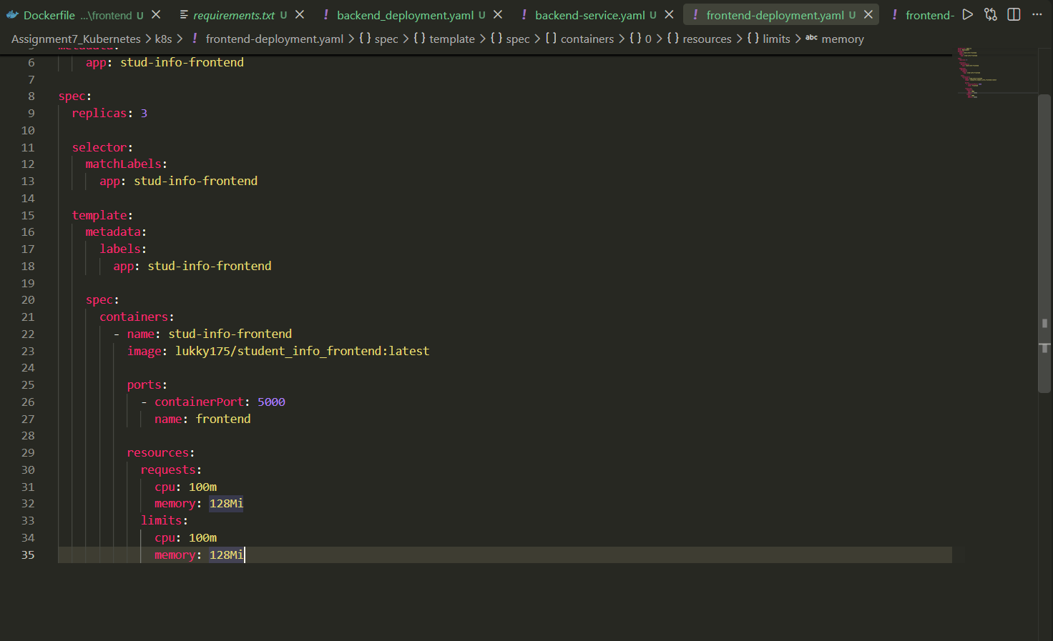

Created k8s/backend-service.yaml
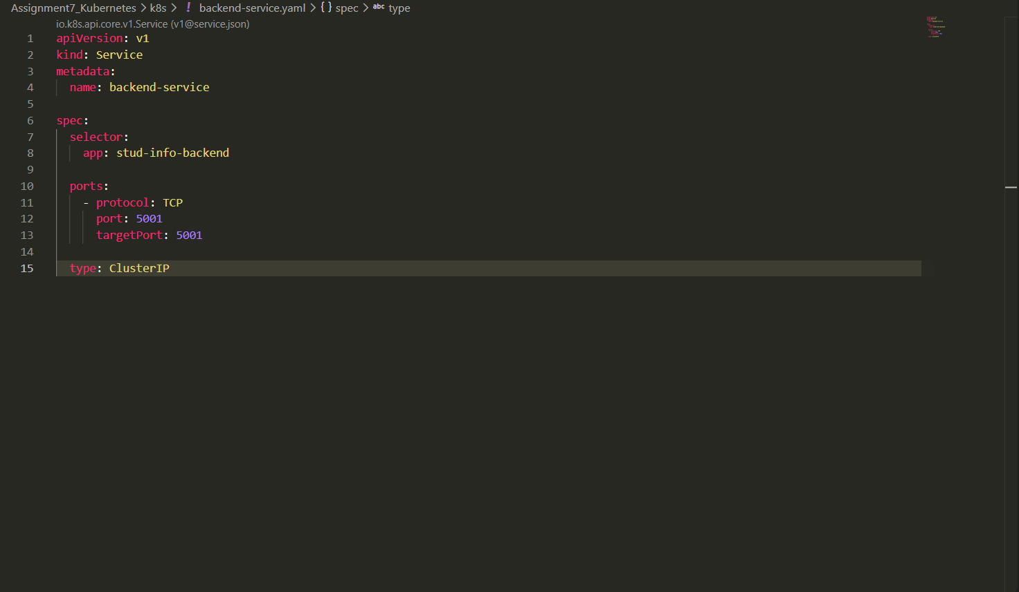

Created k8s/frontend-service.yaml
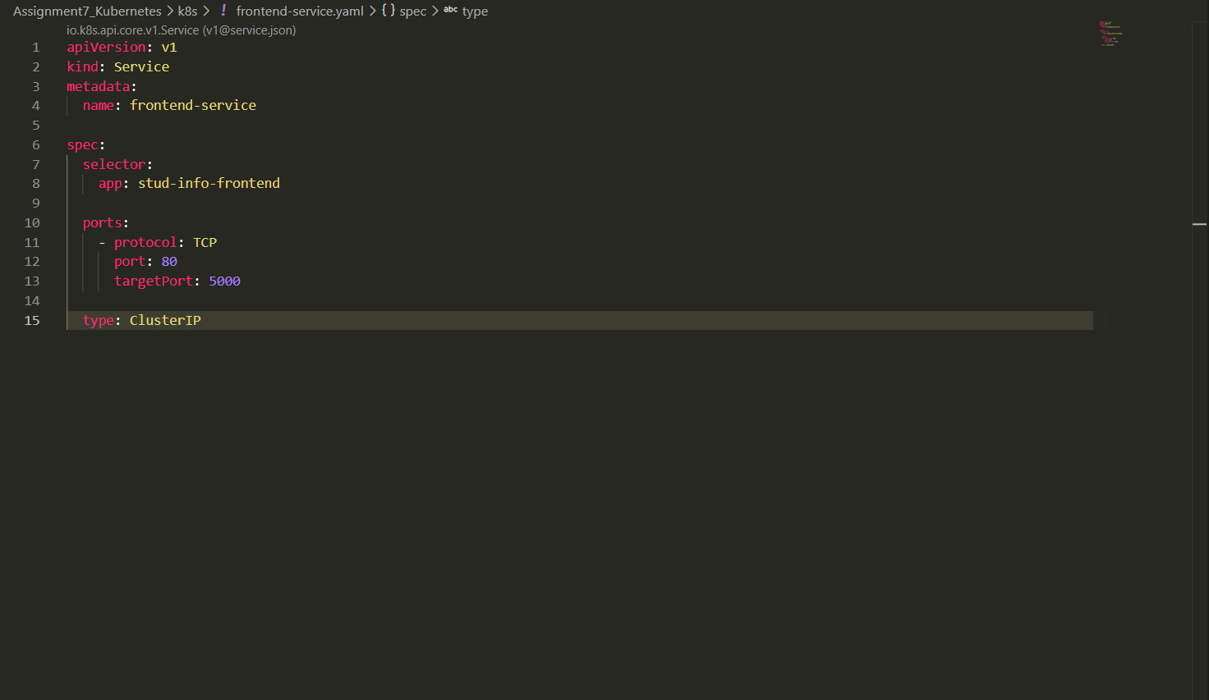
Created k8s/mongo-secret.yaml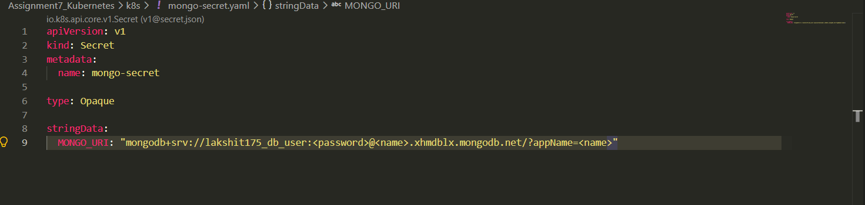

Created a K8s Cluster with `minikube start --node 2`
Checking status of minikube cluster with `minikube status`
Applying files with minikube apply -f k8s/
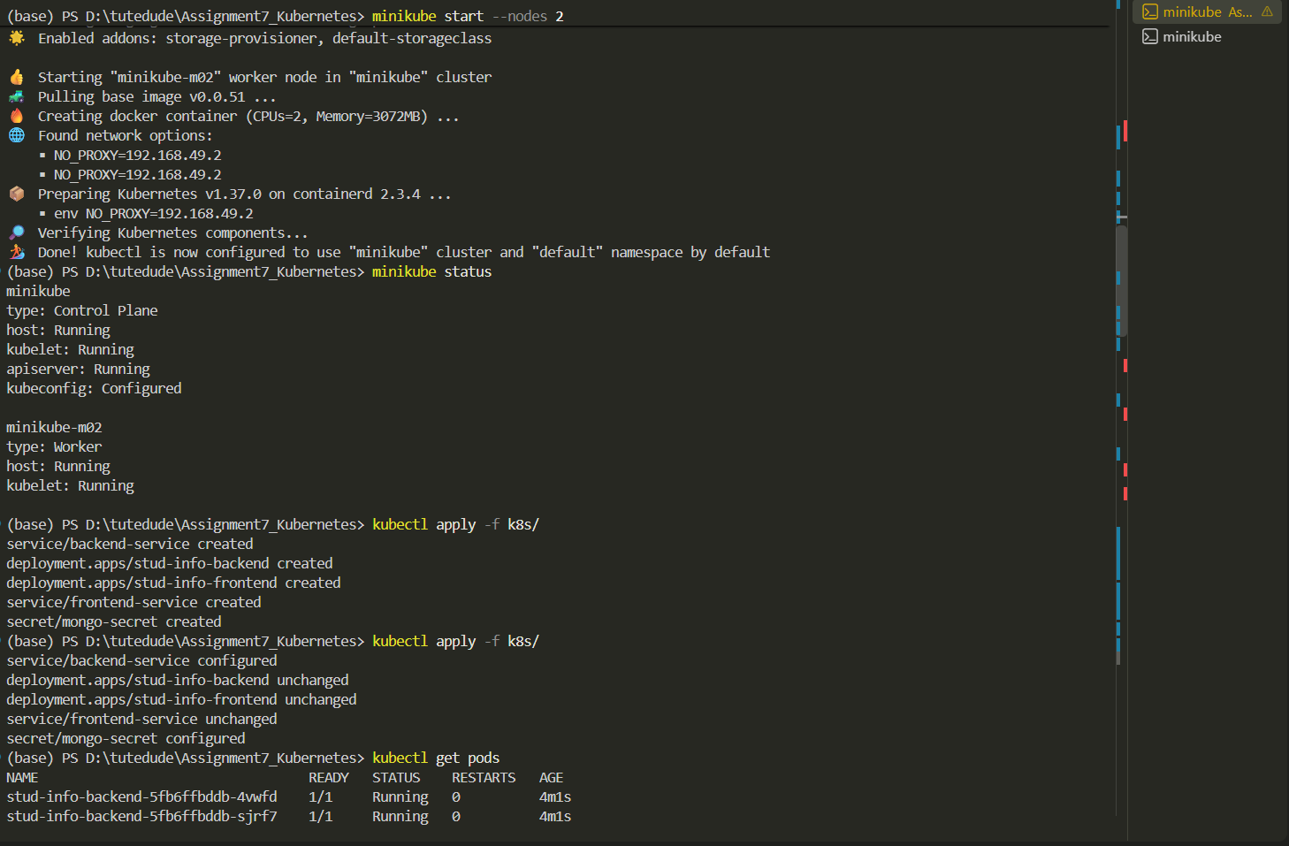

Frontend
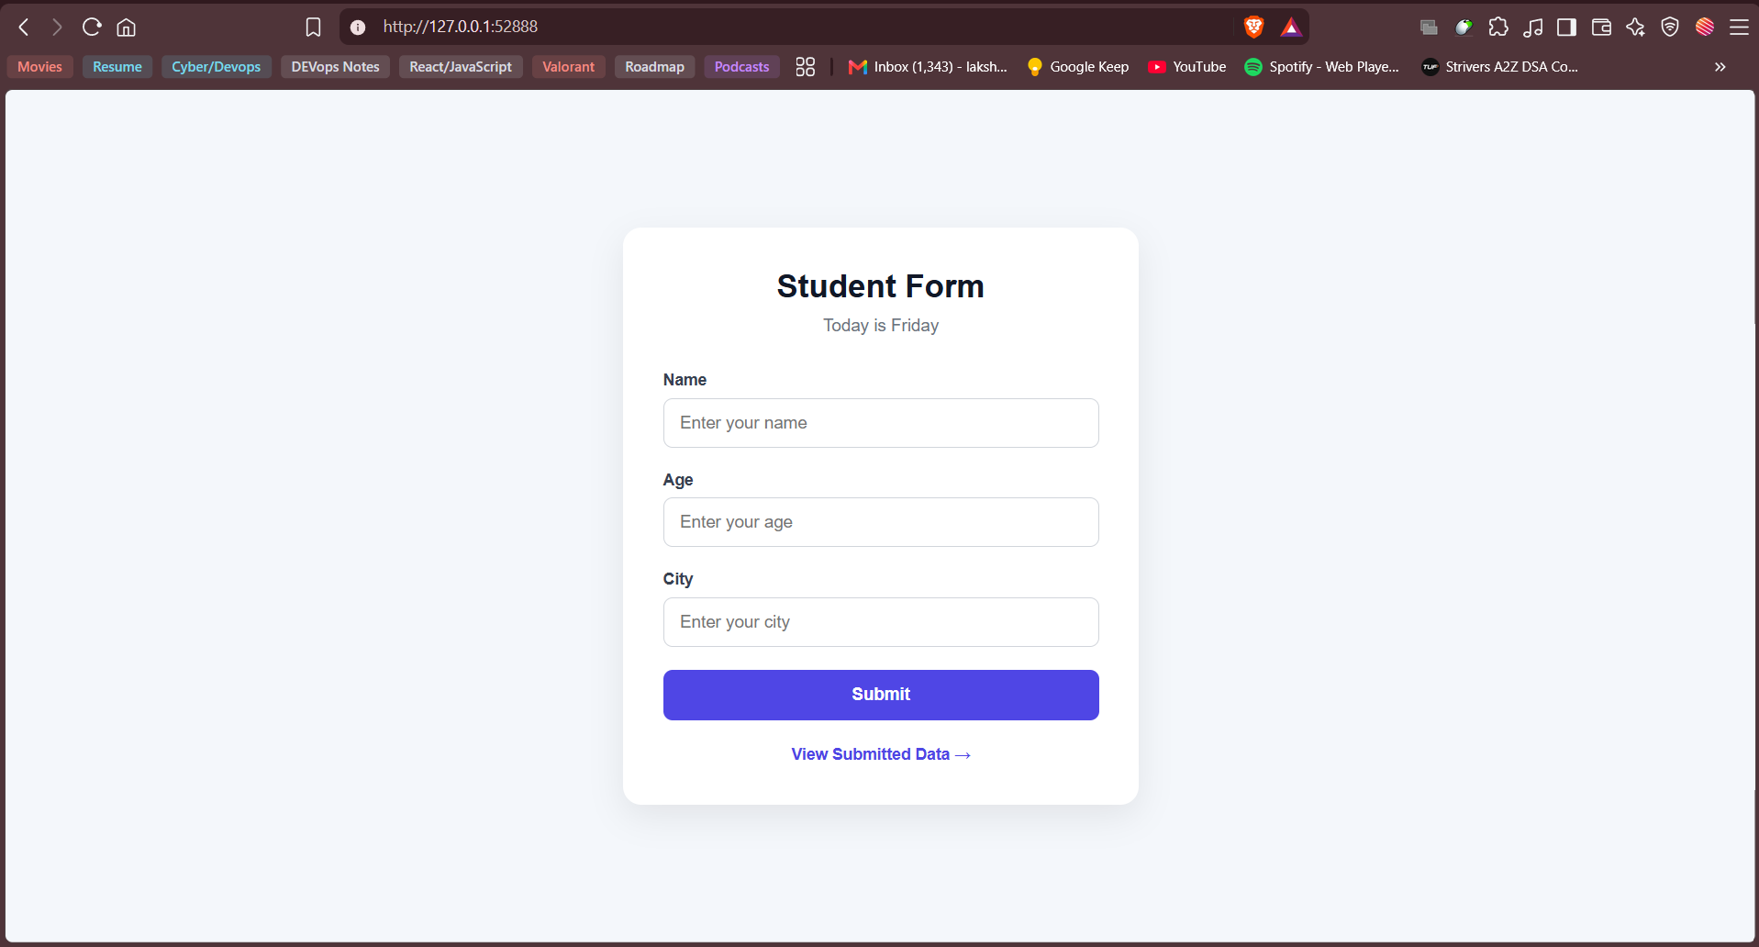
Backend
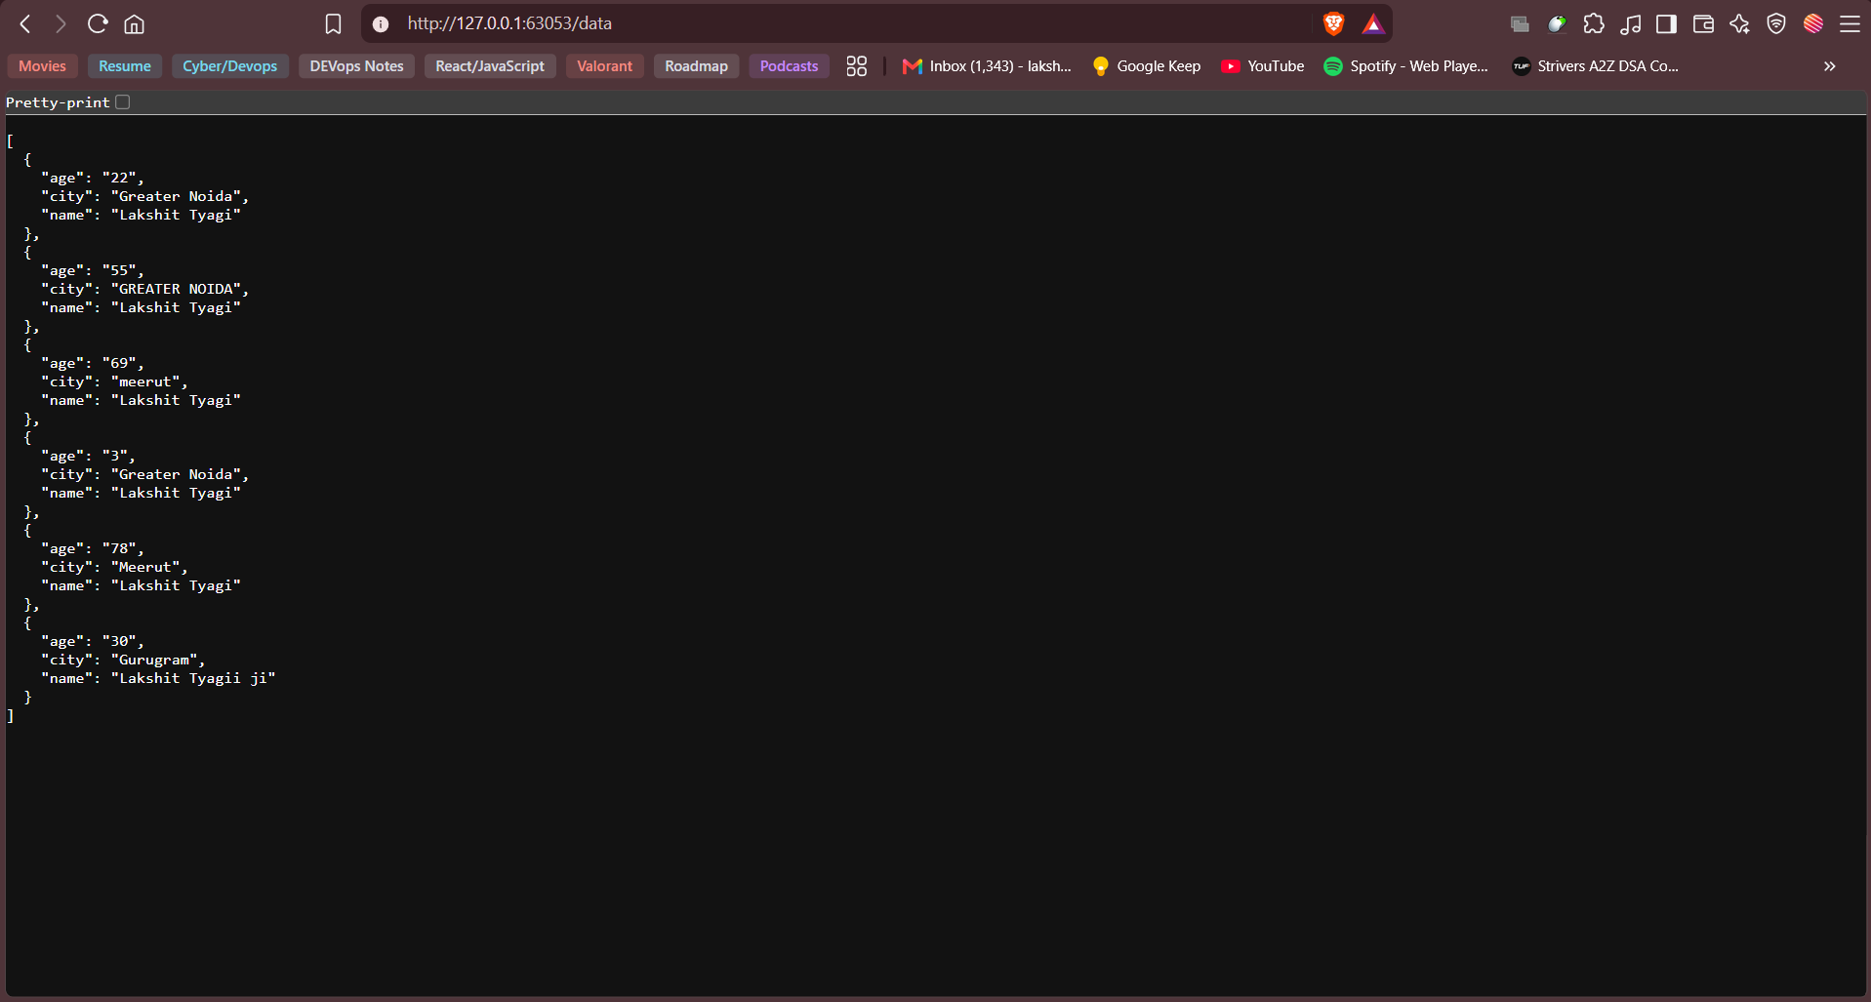

Kubernetes Dashboard
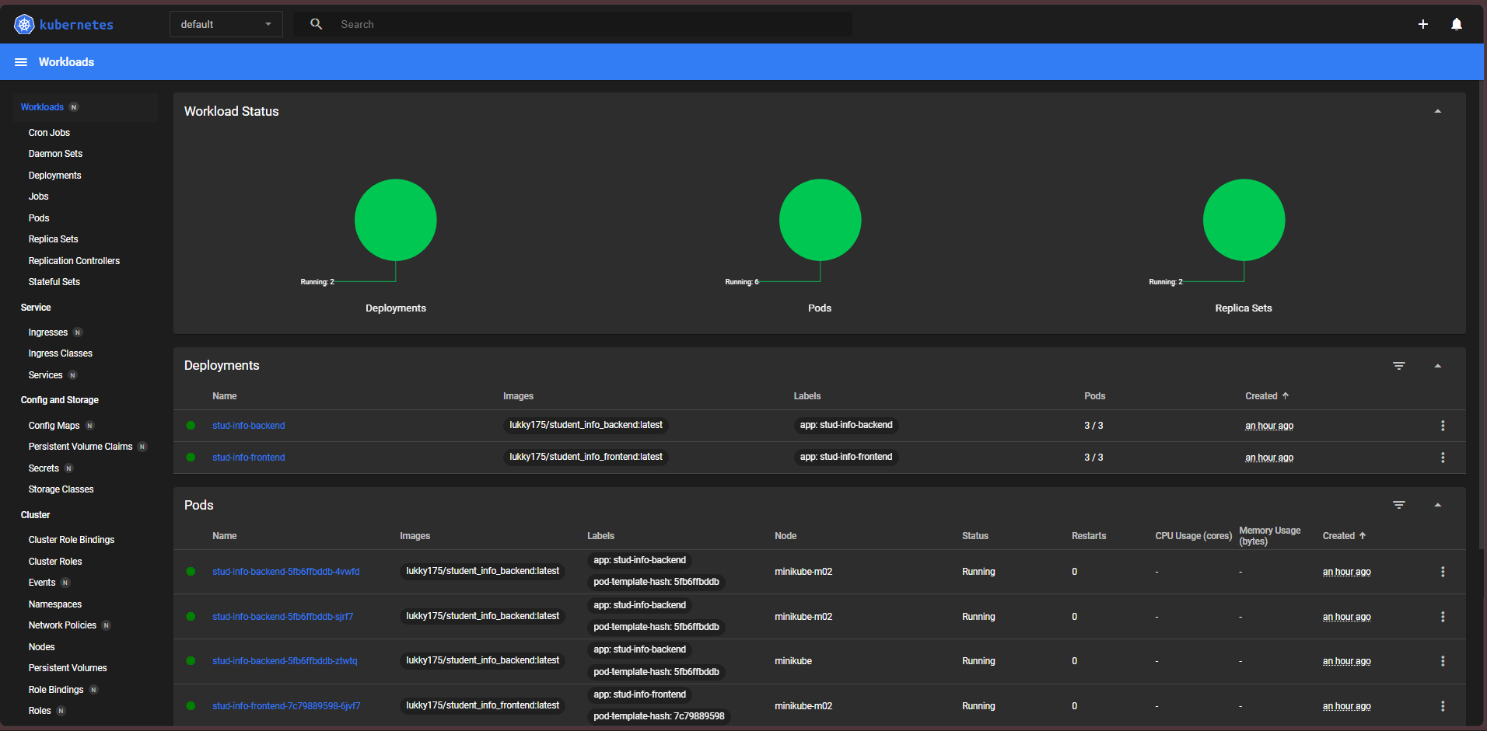

6 pods (3 Backend, 3 Frontend)
2 Deployment, 2services, 2 replicasets

All Tasks are completed as per the task. Kubernetes is Done.

