**Name: Lukman Nagma Bharmal**

**Student Id:** **AF0454236**

**Assignment 2**

**1. Use HLOOKUP to find the sales for Product A in March.**

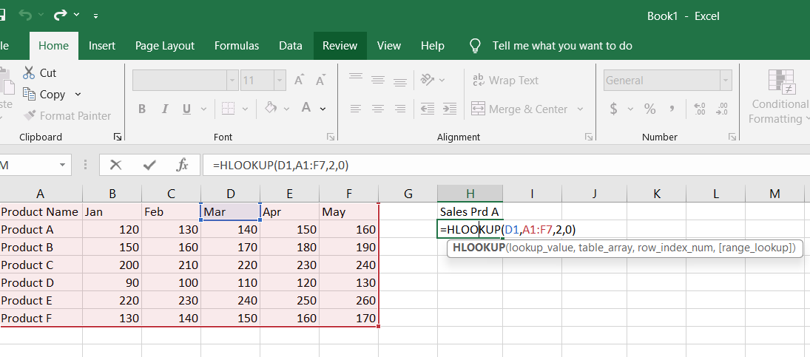

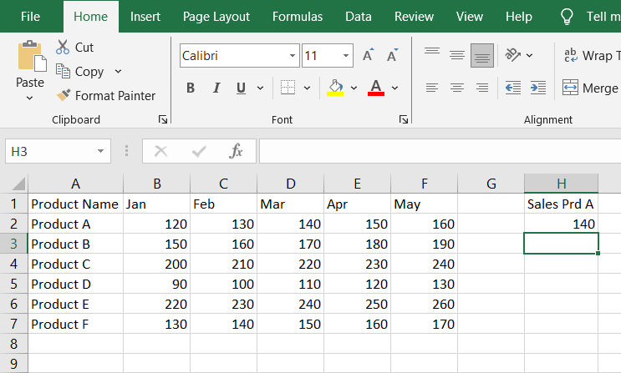

**2. Use HLOOKUP to find the sales for Product D in May.**

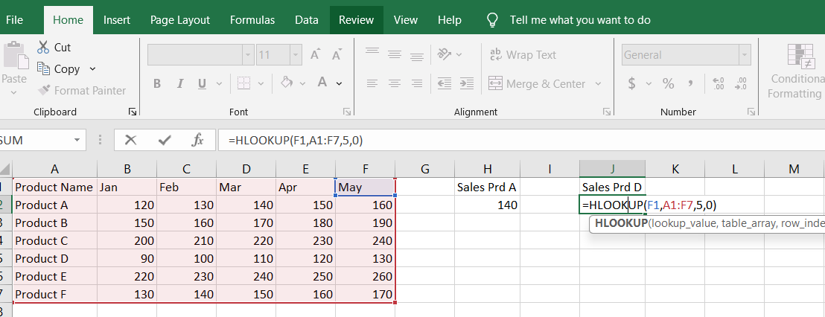

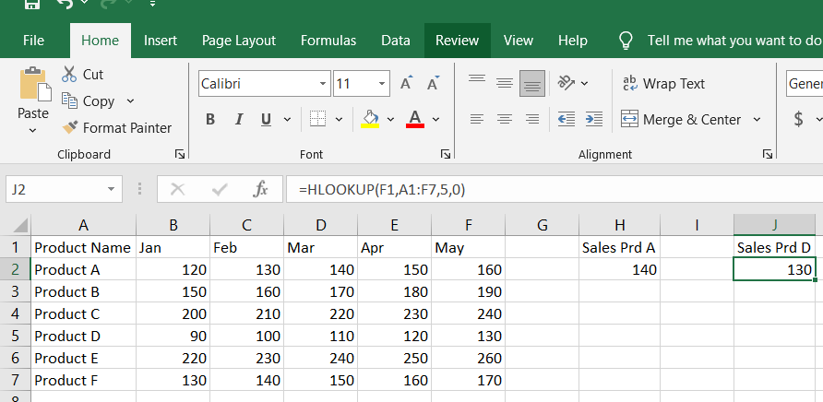

**3. Use HLOOKUP to find the sales for Product C in February.**

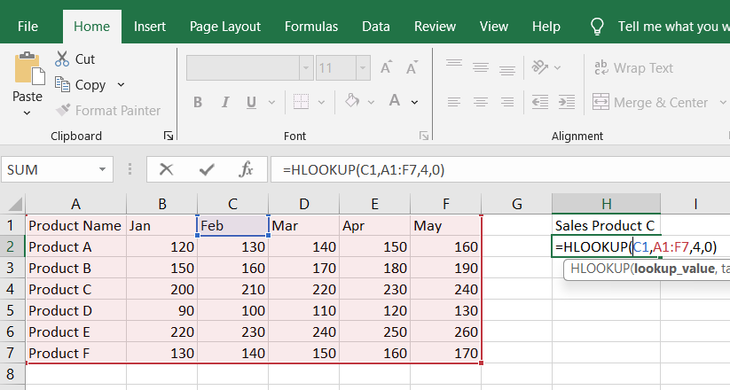

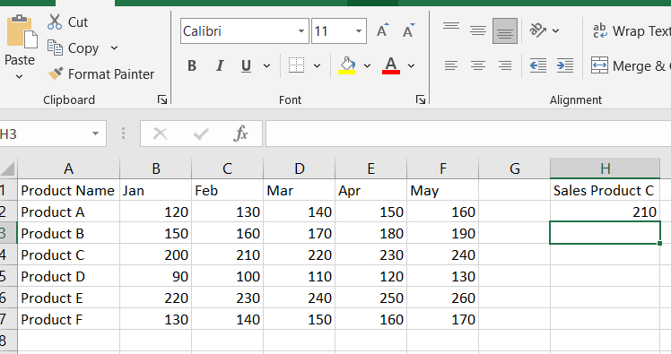

**4.Find the sales for each month for a product and calculate total sales**:

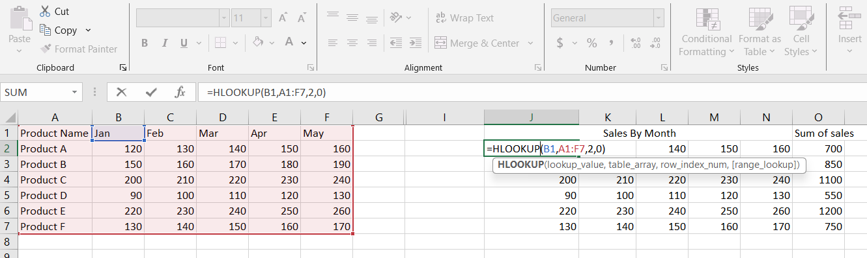

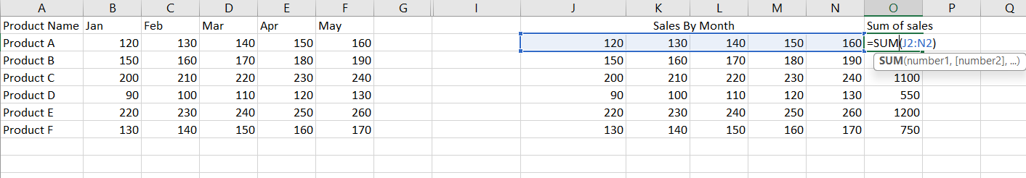

**5 Find the maximum sales value for Product B across all months**

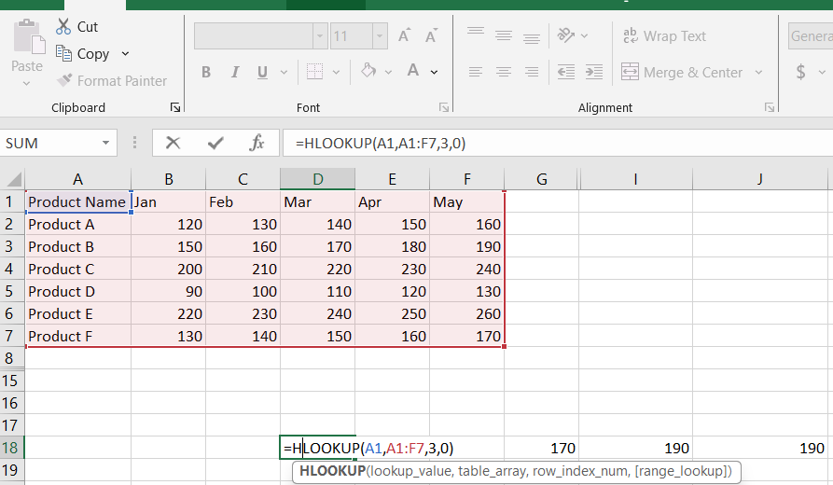

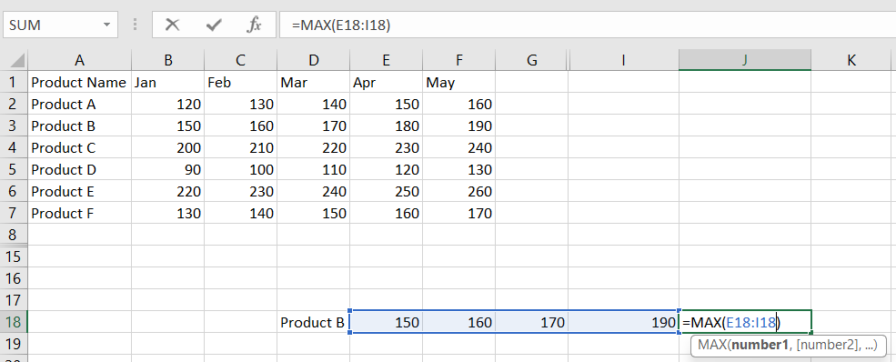

**6. Find the minimum sales value for Product F across all months**:

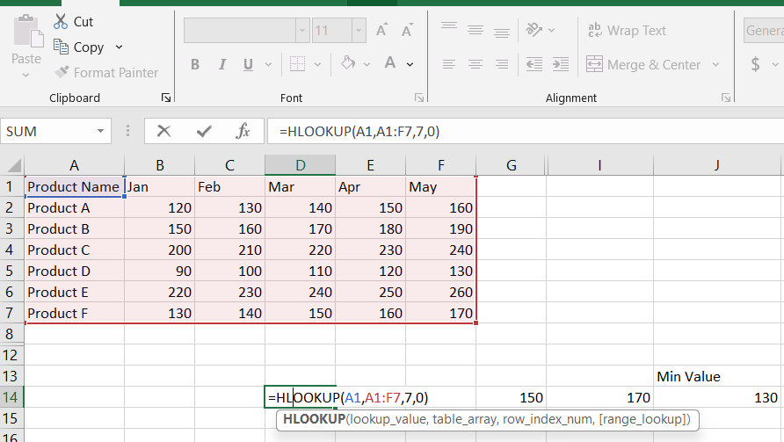

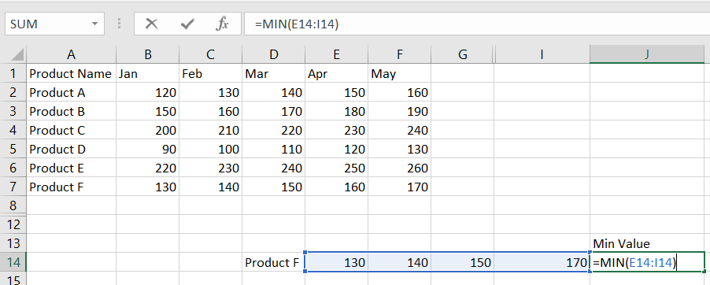

**7.** **Find the average sales value for Product E across all months**: 